Product Requirements Document (PRD)
Image Recognition-Based 2D Material Thickness Detection Device
1. Background
Researchers frequently need to measure the thickness of samples from different batches. Traditional methods are tedious, time-consuming, and require dedicated maintenance. Existing detection equipment (such as atomic force microscopy) is expensive and complex to operate, making it difficult to meet rapid testing needs.

2. Product Goal
To develop an image recognition-based device for 2D material thickness detection that enables fast, automated thickness measurement, reduces detection costs, and improves testing efficiency.

3. Core Requirements
Functional
Automatically detect the thickness of 2D materials using image recognition technology.
Performance
High detection accuracy and fast inference speed, meeting experimental requirements.
Cost
Hardware cost must be lower than traditional detection equipment (e.g., atomic force microscopy).
Maintainability
Simple operation with no dedicated maintenance required.

4. Proposed Solution
- Adopt optical imaging + algorithm fitting as an alternative to atomic force microscopy (AFM)
- Use AI models for thickness detection
- Explore low-cost detection technology pathways
- Utilize data augmentation, transfer learning, and other techniques to reduce AI training difficulty

5. Constraints
Dataset
Current dataset is limited; data augmentation and preprocessing are required.
Team Capability
Members need to learn relevant skills including AI model training, 3D printing, and engineering drawing.
Timeline
The project must be completed in phases according to the course schedule.
Cost
Hardware procurement costs must be controlled.

6. Key Decisions
- Use optical imaging + algorithm fitting to replace AFM, reducing hardware costs
- Adopt transfer learning and data augmentation strategies to lower AI training difficulty
- Use 3D printing to create a light shielding box for controlling the image acquisition environment

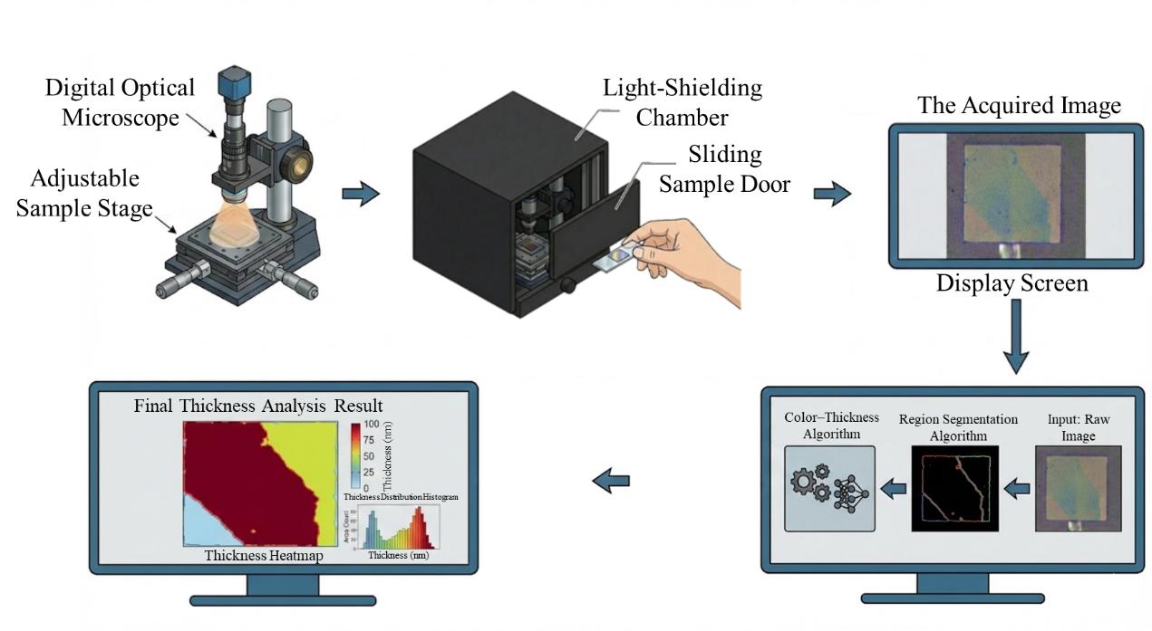
Workflow for Thickness Measurement System

