WisdomTool REST Client

Author | : Yudong (Dom) Wang
Version | : 1.1
Date | : Oct 1, 2017
Email | : wisdomtool@outlook.com

Contents
1. Prerequisite 3
2. REST Client 3
2.1 Menu Bar View 4
2.1.1 Menu [File] 5
2.1.2 Menu [Edit] 5
2.1.3 Menu [Test] 6
2.1.1 Menu [Apidoc] 6
2.1.2 Menu [Help] 7
2.2 HTTP Request View 7
2.3 HTTP Response View 11
2.4 HTTP History View 12
3. FAQ 17

Prerequisite
- Prerequisite
Java | 1.7 or higher
OS | Windows
Browser | IE 9 or higher  Firefox 51.0 or higher  Chrome 53.0 or higher

REST Client
- REST Client View
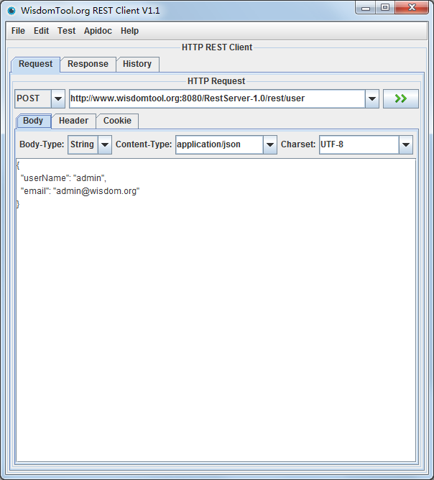
- REST Client View
View | Component
Menu Bar View | File  Edit  Test  Apidoc  Help
HTTP Request View | Method  URL  Body  Header  Cookie
HTTP Response View | Status  Body  Header  Raw Text
HTTP History View | Request  Response  Date  Time  Assert Body

Menu Bar View
- Menu Bar View

- Menu Bar View
Menu | Menu Item
File | Import  Export  Exit
Edit | Reset Request  Reset Response  Reset All  Remove All
Test | Start Test  Stop Test  Test Report
Apidoc | Create  Open
Help | Help Contents  Report Issue  About Tool

Menu [File]

- Menu [File]
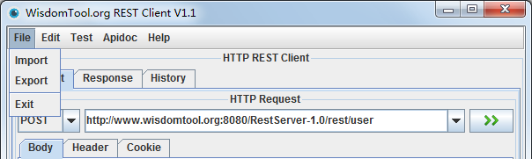

- Menu [File]
Menu Item | Detail
Import | Import history file that export before
Export | Export current HTTP history to a file
Exit | Exit REST Client

Menu [Edit]

- Menu [Edit]
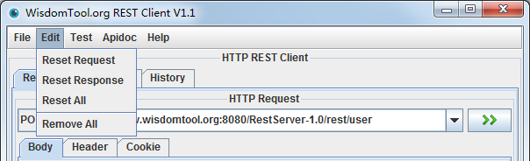

- Menu [Edit]
Menu Item | Detail
Reset Request | Reset request view
Reset Response | Reset response view
Reset All | Reset both request and response view
Remove All | Remove all the HTTP history

Menu [Test]

- Menu [Test]
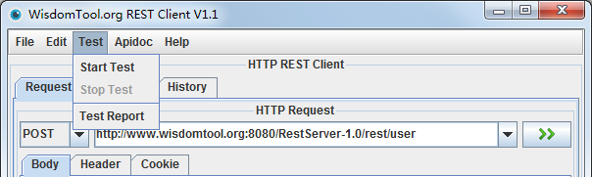

- Menu [Test]
Menu Item | Detail
Start Test | Start testing HTTP history
Stop Test | Stop testing HTTP history
Test Report | Open testing report of HTTP history

Menu [Apidoc]

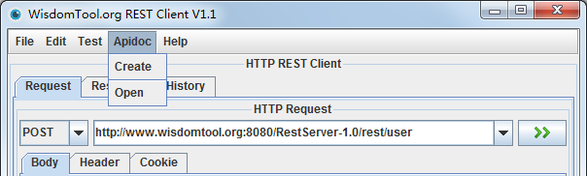

- Menu [Apidoc]
Menu Item | Detail
Create | Create API document based on history
Open | Open API document generated last time

Menu [Help]

- Menu [Help]
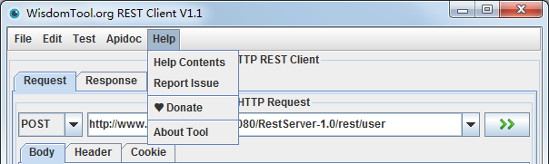

- Menu [Help]
Menu Item | Detail
Help Contents | Open help contents to get help
Report Issue | Report issue for the REST client tool
About Tool | Know about the REST client tool

HTTP Request View
- Method & URL
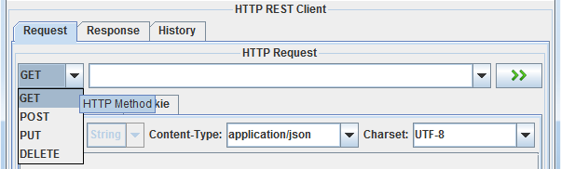

- Body->Body Type->String
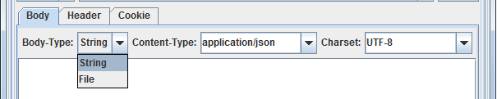

- Body->Body Type->File
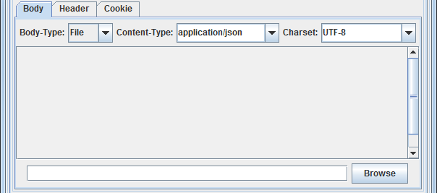

- Body->Content Type
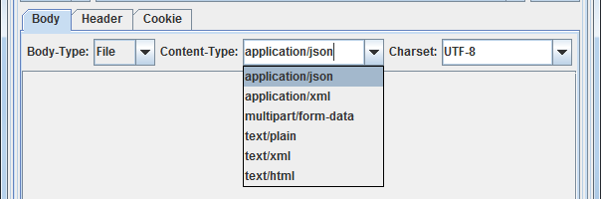

- Body->Charset
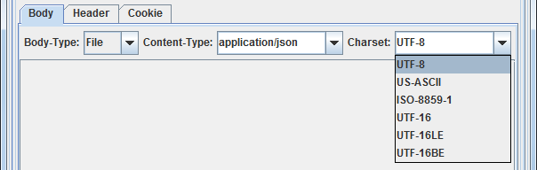

- Body->Content
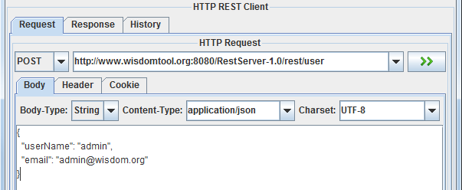

- Header
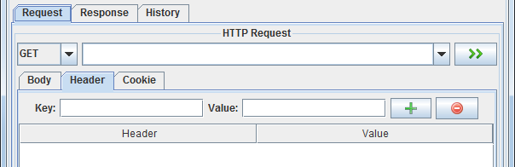

- Cookie
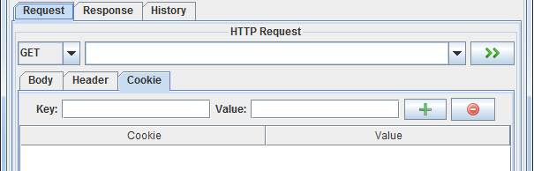

- Request View
Component | Detail
Method | Supported methods:  GET  POST  PUT  DELETE
URL | Supported protocol:  HTTP  HTTPS
Body | Body Type | String – Get body by inputting string  File - Get body by loading a file
Body | Body Content | Supported to input string or load file to get body content.
Body | Content Type | application/json  application/xml  multipart/form-data  text/plain  text/xml  text/html  If all the above content types are not met, supported to input custom type.
Body | Charset | UTF-8  US-ASCII  ISO-8859-1  UTF-16  UTF-16LE  UTF-16BE  If all the above charsets are not met, supported to input custom type.
Header | Add or remove headers with key/value pair
Cookie | Add or remove cookies with key/value pair  *Note*: some web container is supported to add session ID to cookie, thus can access restful API without logon application.  For example:  JSESSIONID=D82DC5F78710A36E60E038B047F4A435  For apache tomcat, user can add JSESSIONID to cookie to access restful API directly by REST client tool.  User can batch update JSESSIONID in file  work/http_history.json.

HTTP Response View
- Response
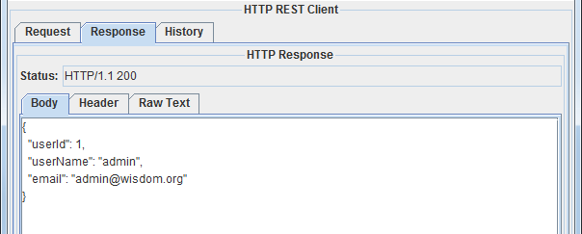

- Status
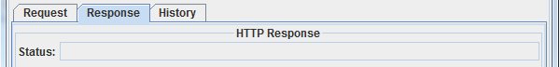

- Body
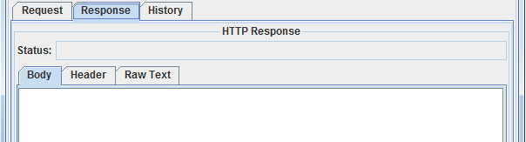

- Header
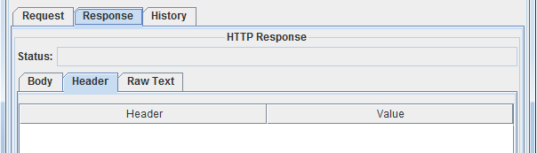

- Raw Text
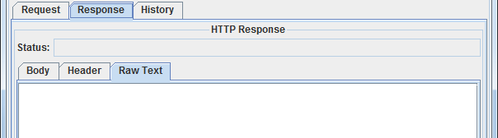

- Response View
Component | Detail
Status | HTTP status code
Body | Response body
Header | Response header
Raw Text | Raw text which contains HTTP request information (HTTP method, URL, header, body) and HTTP response information (HTTP status, header, body)

HTTP History View
- HTTP History View
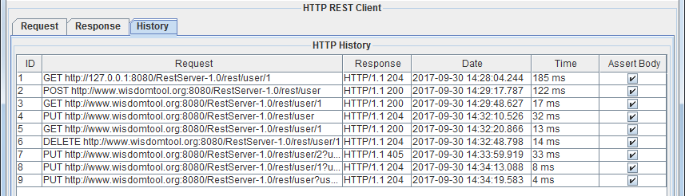

- Test HTTP History
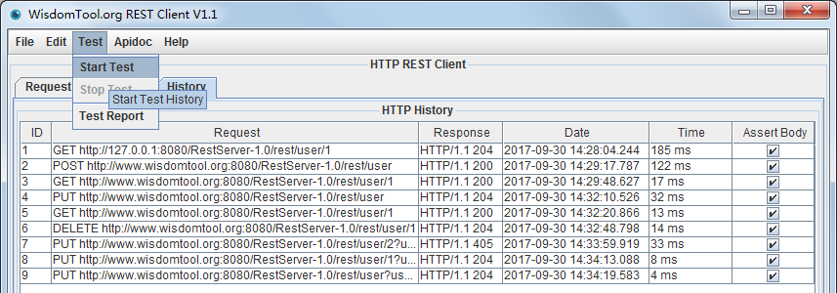

- Report of Test History
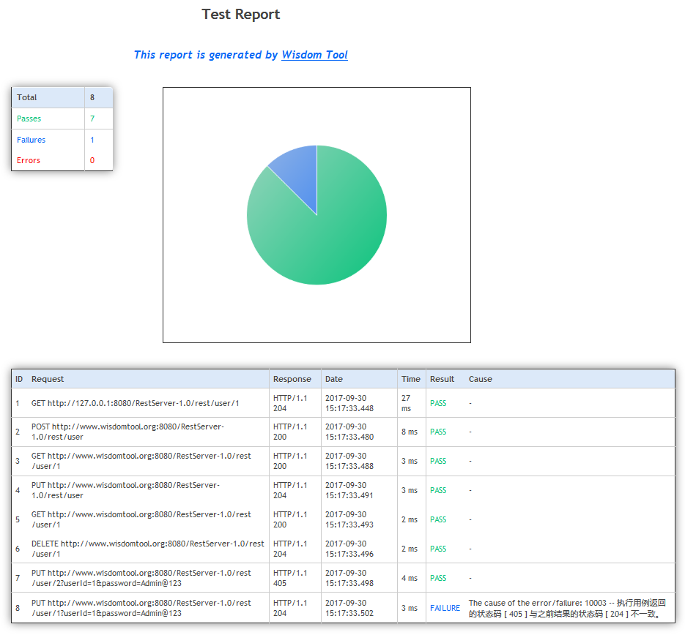

- Create API Document Based on History
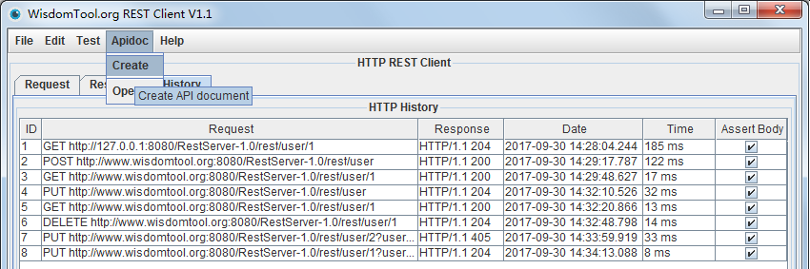

- RESTful API Document
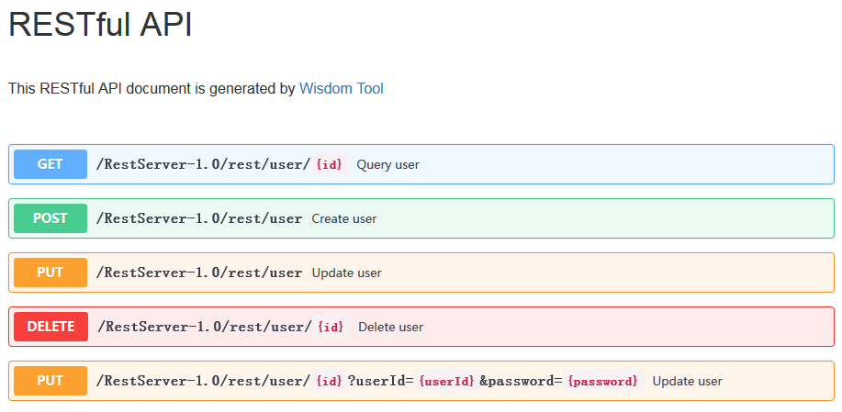
- RESTful API Details
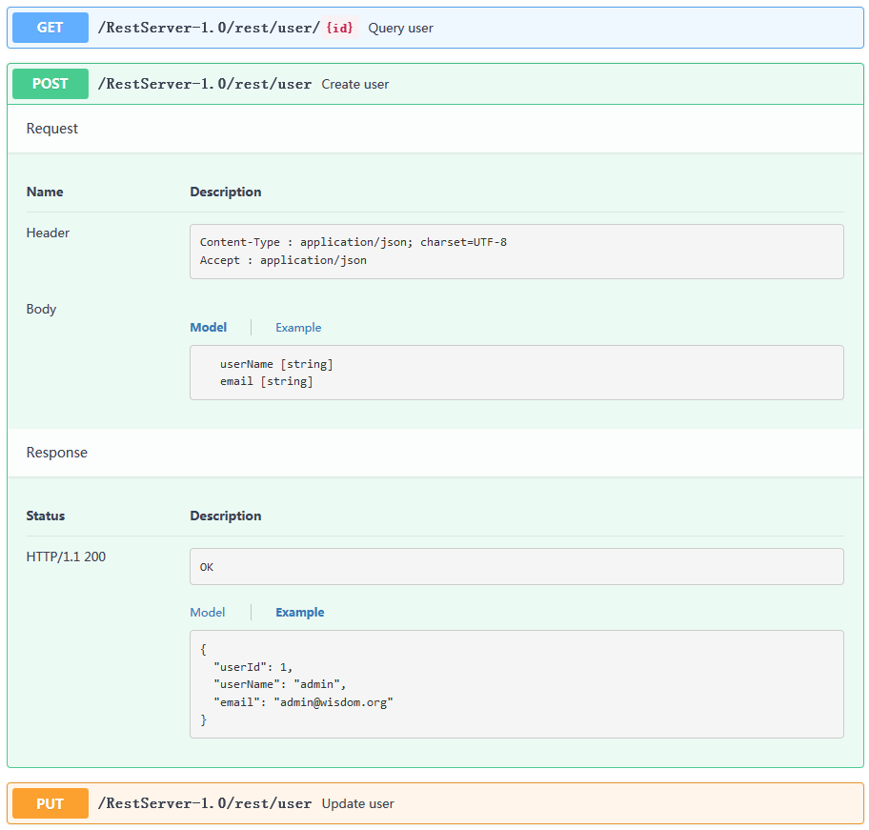

- Response View
Feature | Detail
Assert Body | The default is selected to compare response body with the history case. If some case is not applicable to body comparison, please deselect it.
Start test | Test all the HTTP history
Stop test | Stop test while testing is running
Test report | Output test report, display in default browser
Remove selected history | Remove selected one or multiple history
Remove all history | Remove all the history
Select history | If selected one history, the history (HTTP request & response) can be set on both request view and response view.
Export history | Export current HTTP request & response to a file as JSON format.
Import history | Import a history file that export before to refresh current REST client view.

FAQ
This tool is developed by individual.
https://github.com/wisdomtool/rest-client
Please contact by e-mail for any insightful feedbacks, feature requests and bugs.
Author: Yudong (Dom) Wang
E-mail: wisdomtool@outlook.com

- About Tool
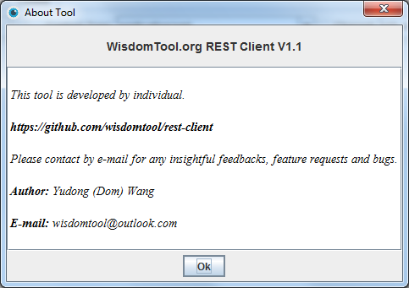

- Issues
Issue ID | Detail

