11/1/2017

|  |  |
| --- | --- |
| Dundee and Angus College | Software Development: Developing Small Scale Standalone Applications - H17W 34 |

|  |
| --- |
| Outcomes 2-4 Task 1 | Ed Lynch |

**Assessment task 1**

**Outcomes covered 2, 3 and 4**

**Assessment task instructions**

**Open-book assessment — Grade summary app completion exercise**

**Note: The supplied app, in its current state, has not been tested.**

In this task you are required to complete the code for the GradeSummary page for the given GradeSummary App. You should use the given designs to help you code the methods **calcHighest** and **calcLowest**. You should also ensure that the Main page button click event allows the app to navigate back to the main page. When you have completed the coding, you should undertake the given partial test plan to ensure that the app works as expected.

You should hand in a copy of the code for the PageSummary page along with the completed partial test plan including details of how you fixed any errors. (Hint — you should identify at least one error as the given code does include an error!)

**Design Algorithm CalcLowest**

Set the form variable lowest to first value in the global array numberList

For currentIndex=1 up to count-1

If value at index currentIndex is less than lowest

Set lowest to value at index currentIndex

End if

End loop

**Design Algorithm CalcHighest**

Set the form variable highest to first value in the global array numberList

For currentIndex=1 up to count-1

If value at index currentIndex is greater than highest

Set highest to value at index currentIndex

End if

End loop

**Partial test plan PageSummary page**

Start the Grade Summary App and in the MainPage add in the following test values 5, 10, 25, 60 and 80

|  |  |  |  |  |
| --- | --- | --- | --- | --- |
|  | **Action** | **Expected Result** | **Actual Result** | **Pass/Fail** |
| **1** | **Click or tap on page summary in main page.** | **Page summary page opens with the following values.**  **Number marks: 5**  **Total marks: 180**  **Average mark: 36**  **Highest: 80**  **Lowest: 5** | **Page summary page opens with the following values.**  **Number marks: 5**  **Total marks: 180**  **Average mark: 36**  **Highest: 80**  **Lowest: 5** | **Pass**  **Pass**  **Pass**  **Pass**  **Pass** |
| **2** | **Click or tap on main page button in PageSummary page.** | **Main page should display** | **Main page displays** | **Pass** |

Details of any errors discovered

Initially the highest and lowest functions displayed incorrect values due to incorrectly looping through the elements in the array.

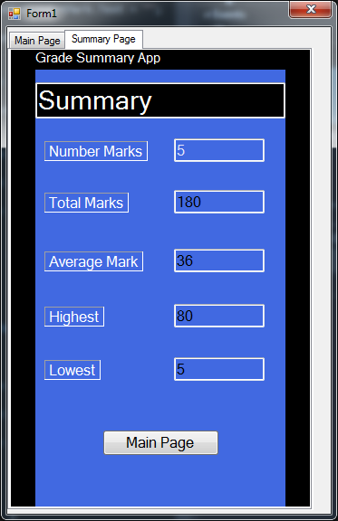

Name of tester: Finn Turnbull

Date of test: 24/11/2017

Test passed/failed: Pass