Finn Turnbull

Dundee and angus college

Inventory Management System

Test Plan

Table of Contents

Test Strategy 2

Functionality 2

Usability 2

Test Summaries 3

Production - Inserting Stock 3

Production - Viewing Stock 3

Packaging - Bottling Stock 3

Packaging - Labelling Stock 3

Packaging - Viewing Stock 4

Packaging - Viewing Duty Records 4

Sales - Selling Stock 4

Sales - Viewing Stock 4

Test Results 5

Test: Production - Inserting Stock 5

Test: Production - Viewing Stock 12

Test: Packaging - Bottling Stock 13

Test: Packaging - Labelling Stock 20

Test: Packaging - Viewing Stock 26

Test: Packaging – Duty Records 27

Test: Sales – Sell Stock 28

Test: Sales – View Available 30

# Test Strategy

White box testing will be used to test the functionality of each component of the program, as my knowledge as the developer is required to fully assess and understand what to test and how to completely test functionality.

Black box testing could be used for usability, and is perhaps better, as getting a potential user who doesn’t already know how to use the system will reveal much better how user friendly the UI is, as they will have to learn from intuition and the user guide how to use and make the most of the system.  
That said, due to limited time and resources white box testing will also be used for usability.

## Functionality

The aim of these tests is to ensure each component of the system provides the functionality expected and required of it.

## Usability

The aim of these tests is the ensure that the sum of components required to complete a task can be understood and used in a simple and timely manner for most users.

Please not that a basic understanding of technology is expected, in that the user is familiar with navigating a simple user interface.

# Test Summaries

List of each test to be run, why it’s being run, what is being tested, expected result.

### Production - Inserting Stock

Overall, how easy is it to complete this task from the perspective of a user who has read the user guide, but has had no prior use of the app?

There are five components to this tab, each must be tested to test their individual functionality.

Additionally, the submit button will be tested to test the components’ connection to the database.

### Production - Viewing Stock

The only testing required here is to ensure that the relevant records are up to date and displayed concisely.

### Packaging - Bottling Stock

Overall, how easy is it to complete this task from the perspective of a user who has read the user guide, but has had no prior use of the app?

There are five components to this tab, each must be tested to test their individual functionality.

Additionally, the submit button will be tested to test the components’ connection to the database.

### Packaging - Labelling Stock

Overall, how easy is it to complete this task from the perspective of a user who has read the user guide, but has had no prior use of the app?

There are six components to this tab, each must be tested to test their individual functionality.

Additionally, the submit button will be tested to test the components’ connection to the database.

### Packaging - Viewing Stock

The only testing required here is to ensure that the relevant records are up to date and displayed concisely.

### Packaging - Viewing Duty Records

The only testing required here is to ensure that the relevant records are up to date and displayed concisely.

### Sales - Selling Stock

Overall, how easy is it to complete this task from the perspective of a user who has read the user guide, but has had no prior use of the app?

There is one component to this tab, which must be tested to test its individual functionality.

Additionally, the submit button will be tested to test the components’ connection to the database.

### Sales - Viewing Stock

The only testing required here is to ensure that the relevant records are up to date and displayed concisely.

# Test Results

List of each test showing input, expected result and actual result, as well as any notes to be made on the difference between actual and expected result.

Show screenshots as proof.

### Test: Production - Inserting Stock

|  |  |  |  |
| --- | --- | --- | --- |
| Test | Expected Result | Actual Result | Notes |
| Select alcohol to insert | Dropdown menu shows list of products, for a single item to be selected | Dropdown menu shows list of products, for a single item to be selected | Pass |

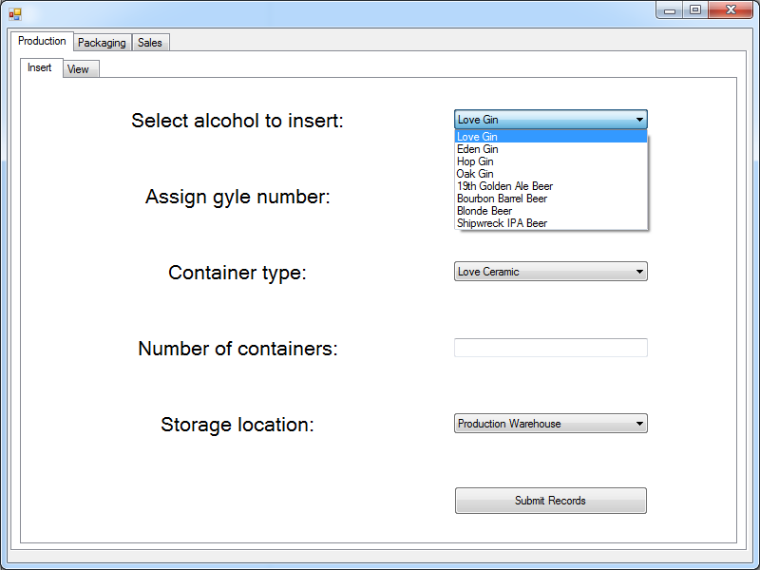

|  |  |  |  |
| --- | --- | --- | --- |
| Test | Expected Result | Actual Result | Notes |
| Assign gyle number | Text box allows for a string to be entered | Text box allows for a string to be entered | Pass |

|  |  |  |  |
| --- | --- | --- | --- |
| Test | Expected Result | Actual Result | Notes |
| Select alcohol to insert | Dropdown menu shows list of bottles and containers, for a single option to be selected | Dropdown menu shows list of bottles and containers, for a single option to be selected | Pass |

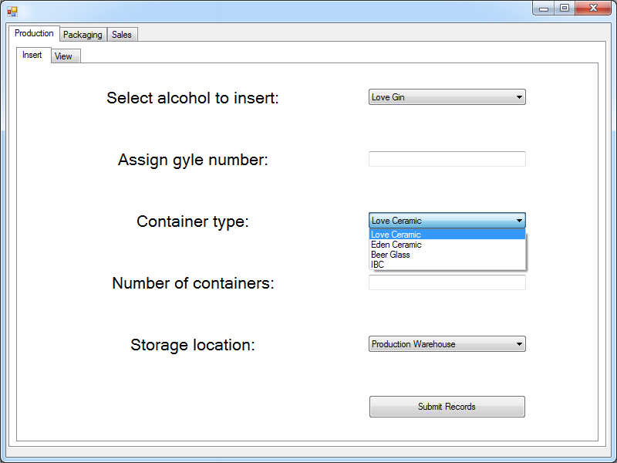

|  |  |  |  |
| --- | --- | --- | --- |
| Test | Expected Result | Actual Result | Notes |
| Enter the number of containers | Text box allows for a integer to be entered | Text box allows for a integer to be entered | Pass |

|  |  |  |  |
| --- | --- | --- | --- |
| Test | Expected Result | Actual Result | Notes |
| Select storage location | Dropdown menu shows list of locations, for a single option to be selected | Dropdown menu shows list of locations, for a single option to be selected | Pass |

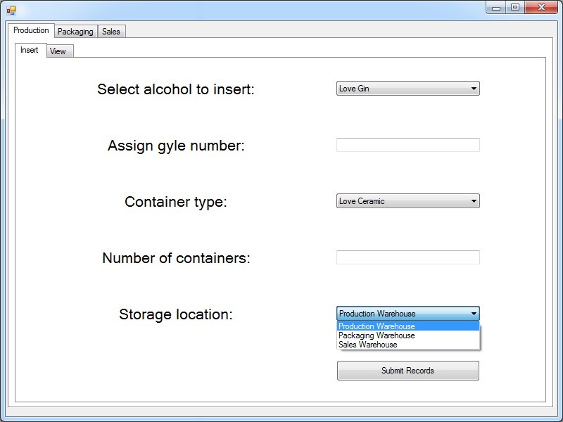

|  |  |  |  |  |
| --- | --- | --- | --- | --- |
| Test | Values | Expected Result | Actual Result | Notes |
| Submit records button | Love Gin  ‘L042A’  IBC  ‘792’  Production Warehouse | Popup stating the record was entered successfully | Popup stating the record was entered successfully | Pass |
|  | Love Gin  ‘L042A’  IBC  ‘792’  Production Warehouse | Error message stating a violation of a primary key constraint, then requesting a new gyle be entered | Error message stating a violation of a primary key constraint, then requesting a new gyle be entered | Pass |
|  | Eden Gin  ‘’  Eden Ceramic  ‘720’  Packaging Warehouse | Error requesting a gyle be entered | Error requesting a gyle be entered | Pass  Text boxes do not reset to blank |
|  | Shipwreck IPA Beer  ‘G072CT3’  Beer Glass  ‘’  Sales Warehouse | Error requesting an integer number of containers be entered | Error requesting an integer number of containers be entered | Pass  Text boxes do not reset to blank |
|  | Love Gin  ‘G072CT3#3436*"()£*sdifjoidsgjoajfdgij’  Love Ceramic  ‘100’  Production Warehouse | Error stating the string would be truncated, then suggests entering a new gyle | Error stating the string would be truncated, then suggests entering a new gyle | Pass |
|  | Love Gin  ‘L077C’  Love Ceramic  ‘9999999999999999999999999999999’  Production Warehouse | Error stating the integer number of containers is too large | Error requesting an integer number of containers is input | Fail – misleading error message is displayed. |

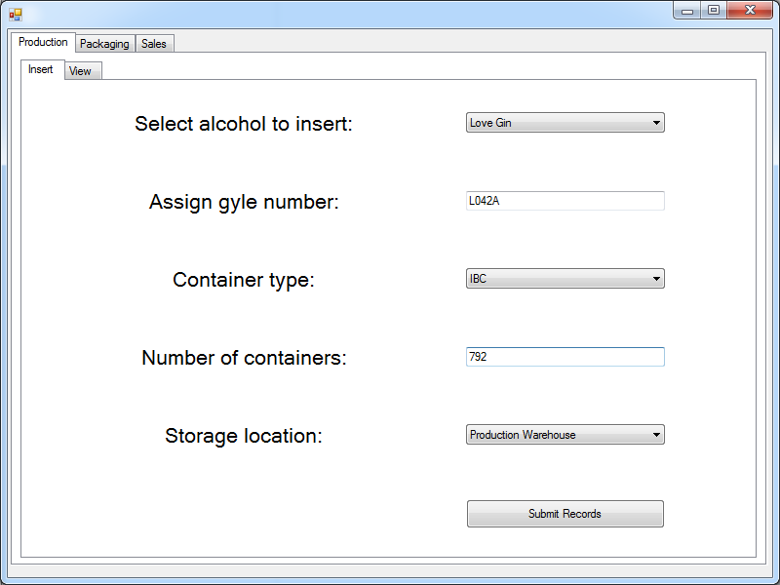

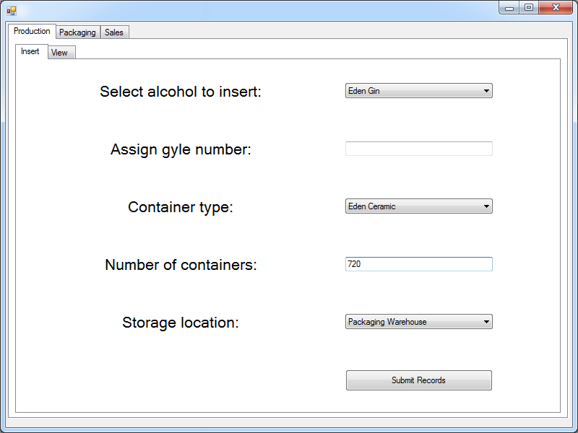

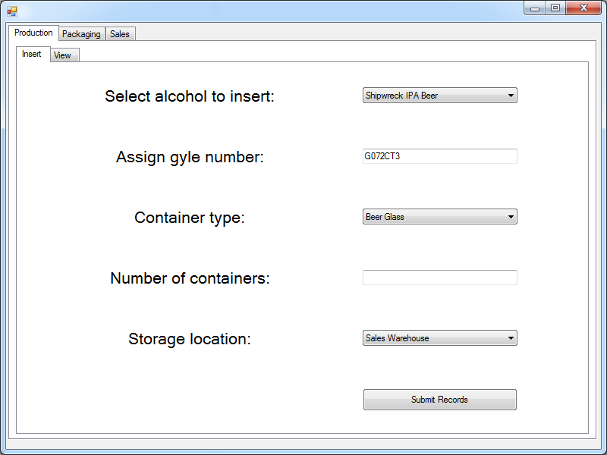

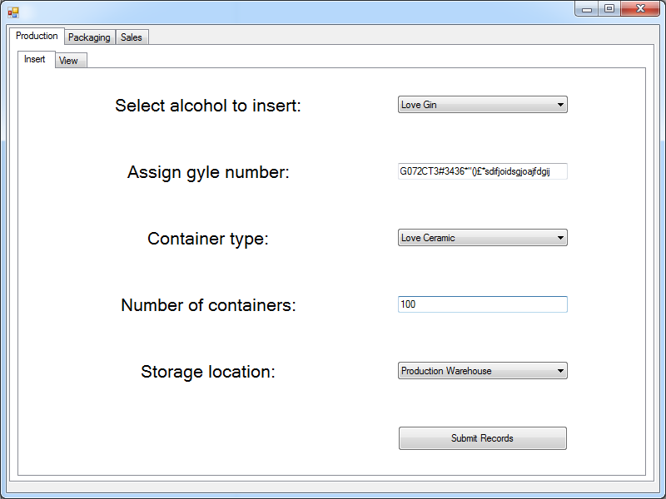

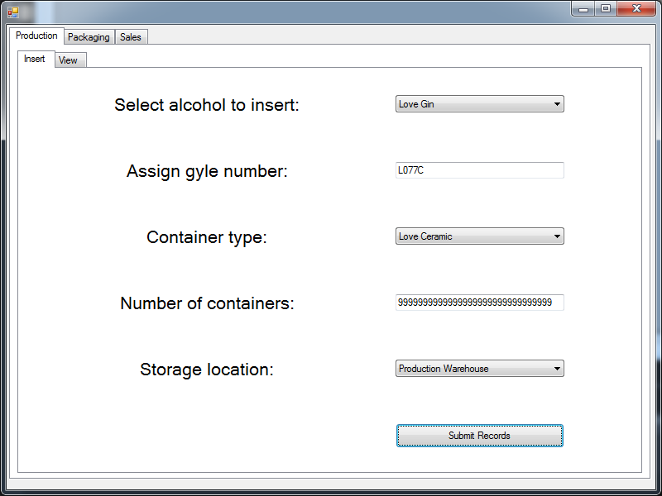

### Test: Production - Viewing Stock

|  |  |  |  |
| --- | --- | --- | --- |
| Test | Expected Result | Actual Result | Notes |
| Display records selected from the database | Show Gyle, Drink, ABV, Quantity, Container, Size | Show Gyle, Drink, ABV, Quantity, Container, Size | Pass |
|  | Data is updated when a new record is entered on an insert page | Data is updated when a new record is entered on an insert page | Pass |

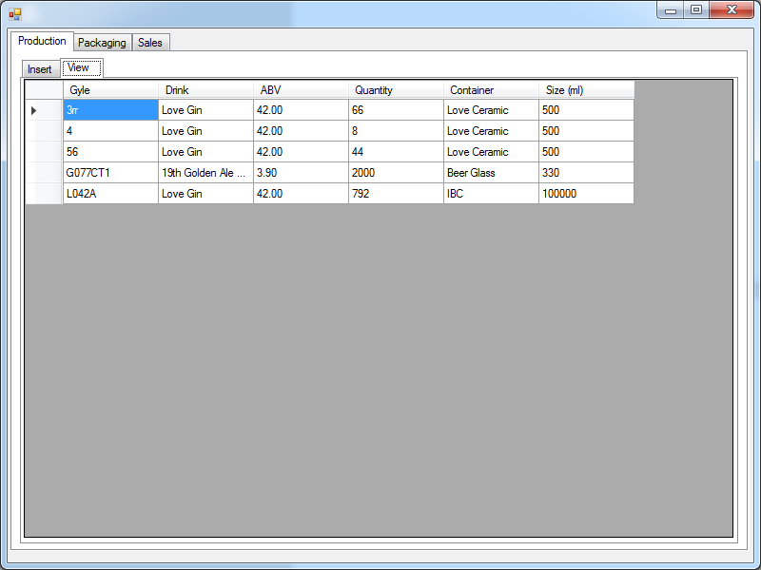

### Test: Packaging - Bottling Stock

|  |  |  |  |
| --- | --- | --- | --- |
| Test | Expected Result | Actual Result | Notes |
| Select gyle number | Dropdown menu shows list of gyle numbers, for a single option to be selected | Dropdown menu shows list of gyle numbers, for a single option to be selected | Pass |

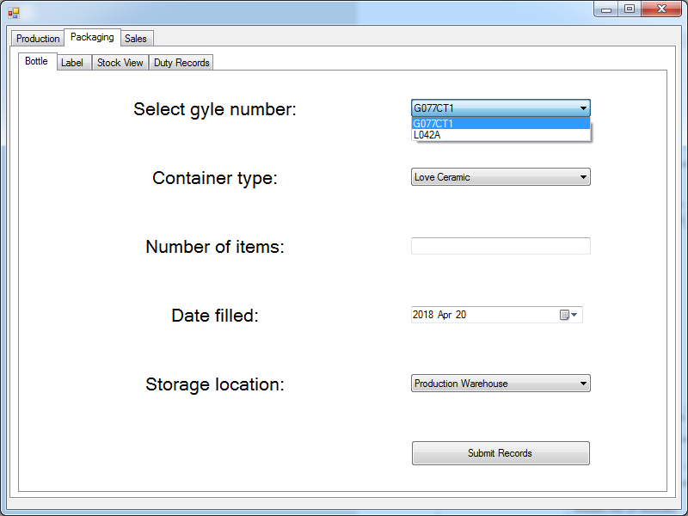

|  |  |  |  |
| --- | --- | --- | --- |
| Test | Expected Result | Actual Result | Notes |
| Select container type | Dropdown menu shows list of containers, for a single option to be selected | Dropdown menu shows list of containers, for a single option to be selected | Pass |

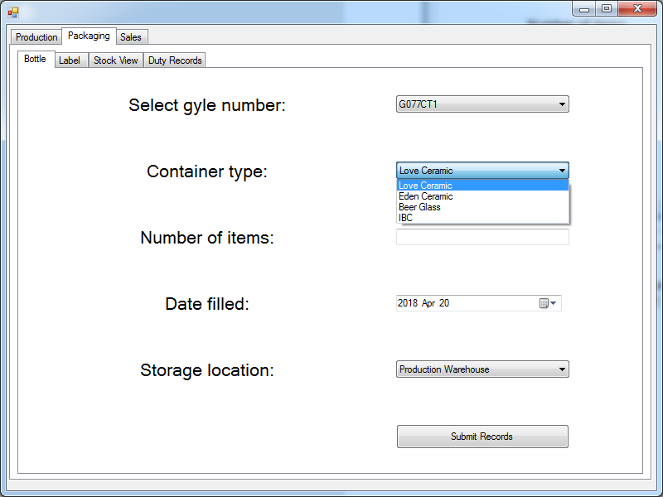

|  |  |  |  |
| --- | --- | --- | --- |
| Test | Expected Result | Actual Result | Notes |
| Select number of items | Text box allows for a integer to be entered | Text box allows for a integer to be entered | Pass |

|  |  |  |  |
| --- | --- | --- | --- |
| Test | Expected Result | Actual Result | Notes |
| Date filled | A calendar that allows a single date to be selected. Defaults to current day, earliest option is 2018/01/01 | A calendar that allows a single date to be selected. Defaults to current day, earliest option is 2018/01/01 | Pass |

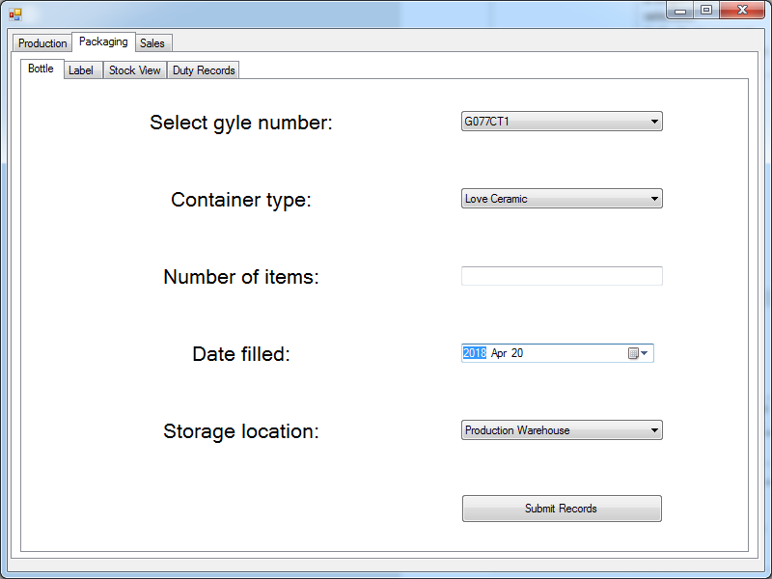

|  |  |  |  |
| --- | --- | --- | --- |
| Test | Expected Result | Actual Result | Notes |
| Select storage location | Dropdown menu shows list of locations, for a single option to be selected | Dropdown menu shows list of locations, for a single option to be selected | Pass |

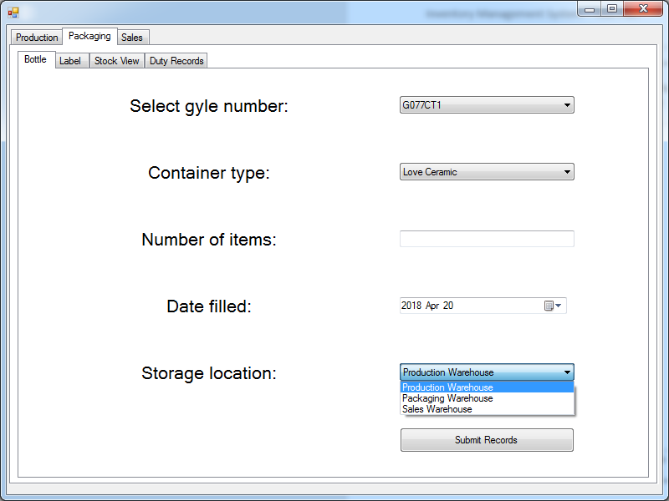

|  |  |  |  |  |
| --- | --- | --- | --- | --- |
| Test | Values | Expected Result | Actual Result | Notes |
| Submit records button | L042A  Love Ceramic  ‘792’  2018/04/20  Production Warehouse | Popup stating the record was entered successfully | Popup stating the record was entered successfully | Pass  Records correctly update |
|  | G077CT1  Beer Glass  ‘teststring’  2018/01/01  Sales Warehouse | Error requesting an integer number of items be entered | Error requesting an integer number of items be entered | Pass  Textbox is not reset |
|  | G077CT1  Beer Glass  ‘99999999999999999999999999999999’  2018/01/01  Sales Warehouse | Error stating the integer number of containers is too large | Error requesting an integer number of containers is input | Fail – misleading error message is displayed. |

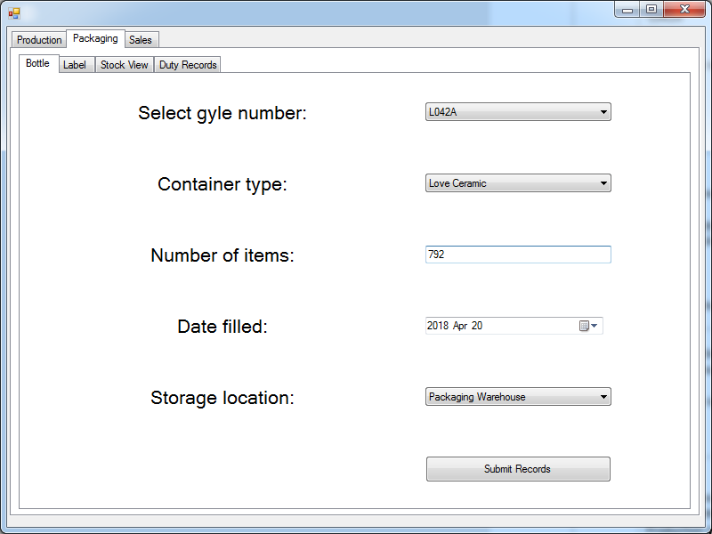

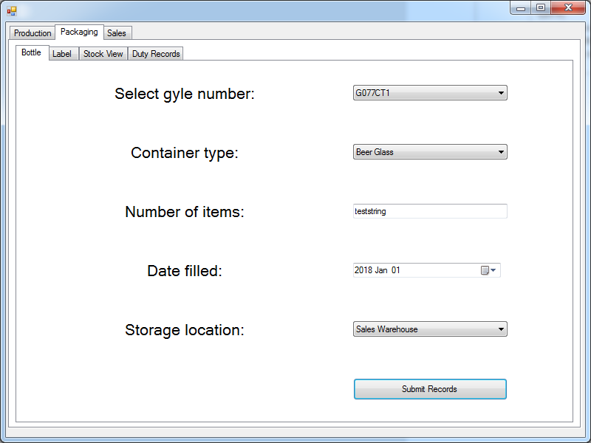

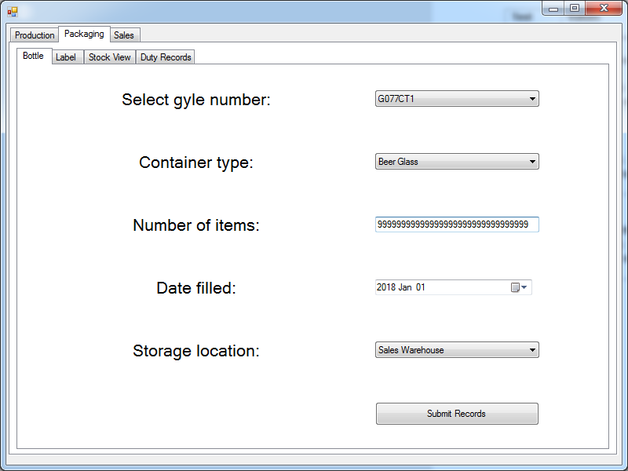

### Test: Packaging - Labelling Stock

|  |  |  |  |
| --- | --- | --- | --- |
| Test | Expected Result | Actual Result | Notes |
| Select gyle number | Dropdown menu shows list of gyle numbers, for a single option to be selected | Dropdown menu shows list of gyle numbers, for a single option to be selected | Pass |

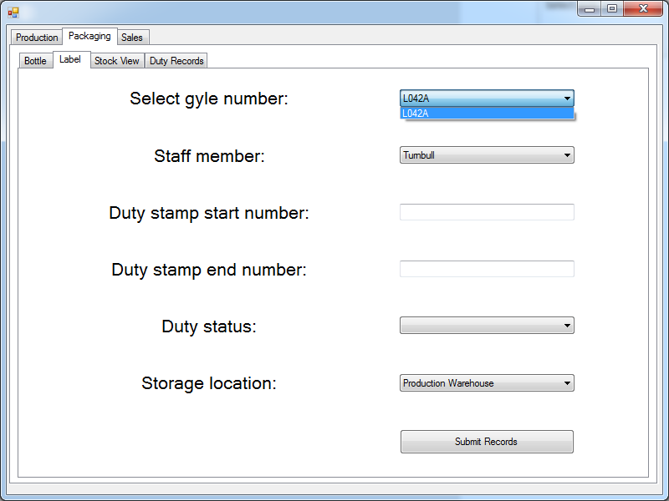

|  |  |  |  |
| --- | --- | --- | --- |
| Test | Expected Result | Actual Result | Notes |
| Select staff member | Dropdown menu shows list of staff members, for a single option to be selected | Dropdown menu shows list of staff members, for a single option to be selected | Pass |

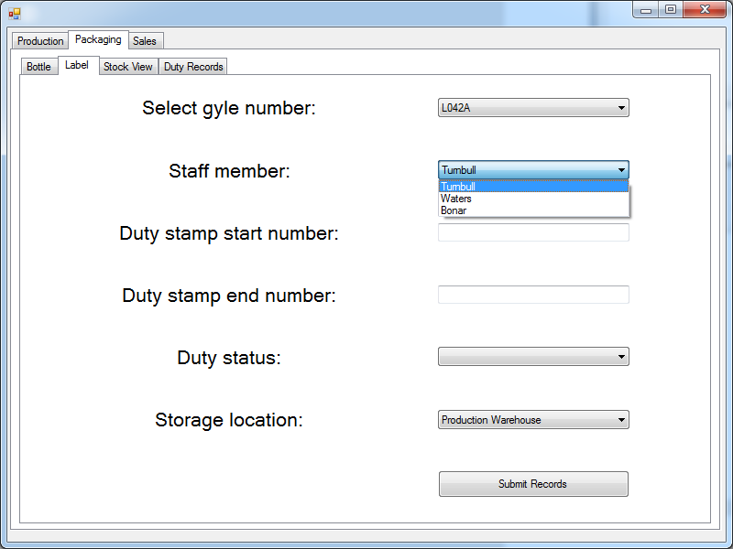

|  |  |  |  |
| --- | --- | --- | --- |
| Test | Expected Result | Actual Result | Notes |
| Type duty stamp start number | Text box allows for a string to be entered | Text box allows for a string to be entered | Pass |

|  |  |  |  |
| --- | --- | --- | --- |
| Test | Expected Result | Actual Result | Notes |
| Type duty stamp end number | Text box allows for a string to be entered | Text box allows for a string to be entered | Pass |

|  |  |  |  |
| --- | --- | --- | --- |
| Test | Expected Result | Actual Result | Notes |
| Select duty status | Dropdown menu shows list of duty status’, for a single option to be selected | Dropdown menu shows list of duty status’, for a single option to be selected | Pass |

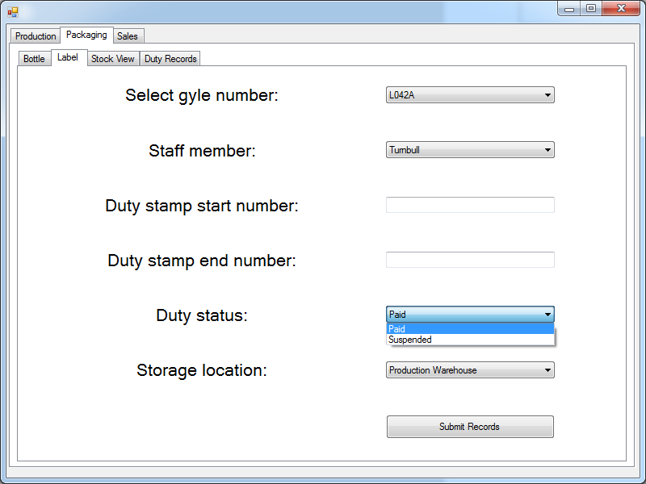

|  |  |  |  |
| --- | --- | --- | --- |
| Test | Expected Result | Actual Result | Notes |
| Select storage location | Dropdown menu shows list of locations, for a single option to be selected | Dropdown menu shows list of locations, for a single option to be selected | Pass |

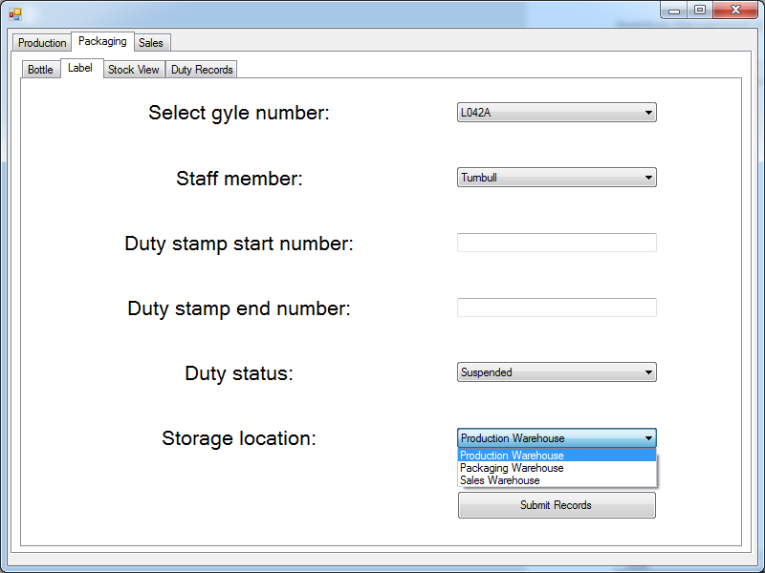

|  |  |  |  |  |
| --- | --- | --- | --- | --- |
| Test | Values | Expected Result | Actual Result | Notes |
| Submit records button | G077CT1  Turnbull  ‘G2002 543 1003’  ‘G5002 543 2203’  Paid  Sales Warehouse | Popup stating the record was entered successfully | Popup stating the record was entered successfully | Pass  Records correctly update |
|  | G077CT1  Waters  ‘0394ut409ut049ut04ut0545iut04t0it0i0i4t’  ‘9843wutrwp['akg)(£)I$£Tjergijeorijgeojgjj’  Suspended  Packaging Warehouse | Error stating the string would be truncated, so the statement has been terminated.  Suggestion to try a new start/end number | Error stating the string would be truncated, so the statement has been terminated | Fail  Although the error message is displayed, there is no suggested remedy  Additionally, the update was made, even though the labelling record failed. |

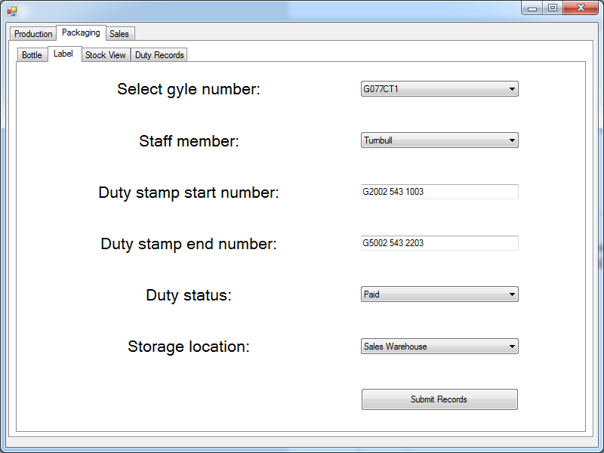

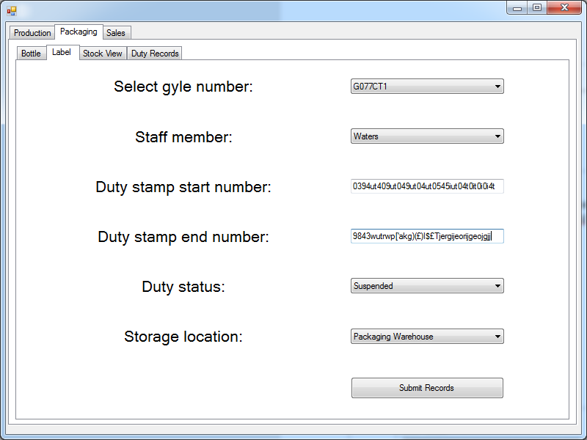

### Test: Packaging - Viewing Stock

|  |  |  |  |
| --- | --- | --- | --- |
| Test | Expected Result | Actual Result | Notes |
| Display records selected from the database | Show Gyle, Drink, Container, Quantity, Packaged, Location, Filled, Date Filled | Show Gyle, Drink, Container, Quantity, Packaged, Location, Filled, Date Filled | Pass |
|  | Data is updated when a new record is entered on an insert page | Data is updated when a new record is entered on an insert page | Pass |

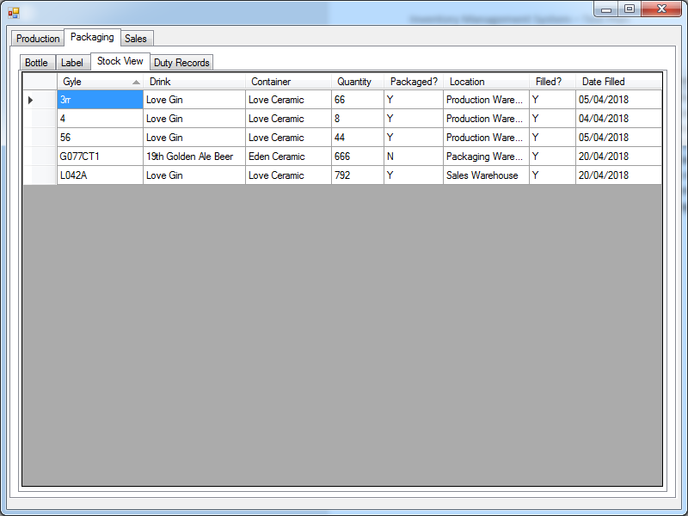

### Test: Packaging – Duty Records

|  |  |  |  |
| --- | --- | --- | --- |
| Test | Expected Result | Actual Result | Notes |
| Display records selected from the database | Show Gyle, Start Number, End Number, Status, Employee | Show Gyle, Start Number, End Number, Status, Employee | Pass |
|  | Data is updated when a new record is entered on an insert page | Data is updated when a new record is entered on an insert page | Pass |

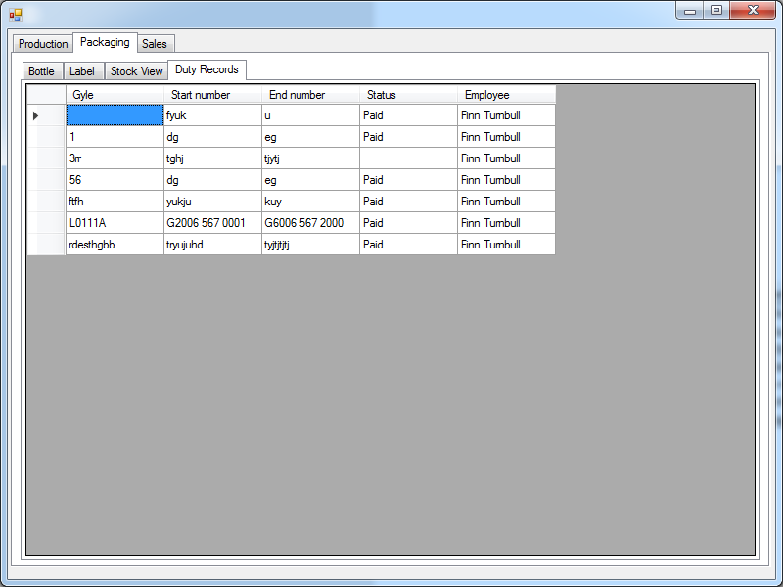

### Test: Sales – Sell Stock

|  |  |  |  |
| --- | --- | --- | --- |
| Test | Expected Result | Actual Result | Notes |
| Select storage location | Dropdown menu shows list of gyle numbers, for a single option to be selected | Dropdown menu shows list of gyle numbers, for a single option to be selected | Pass |

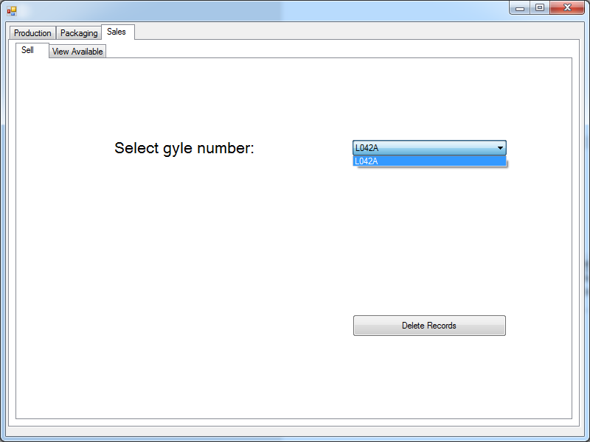

|  |  |  |  |  |
| --- | --- | --- | --- | --- |
| Test | Values | Expected Result | Actual Result | Notes |
| Submit records button | L042A | Popup asking for confirmation that the records are to be deleted. | Popup asking for confirmation that the records are to be deleted. | Pass |
|  | Selecting yes to confirmation box | Popup stating the record was sold, ie. Deleted, successfully. | Popup stating the record was sold, ie. Deleted, successfully. | Pass |
|  | Selecting no to confirmation box | No records are deleted | No records are deleted | Pass |

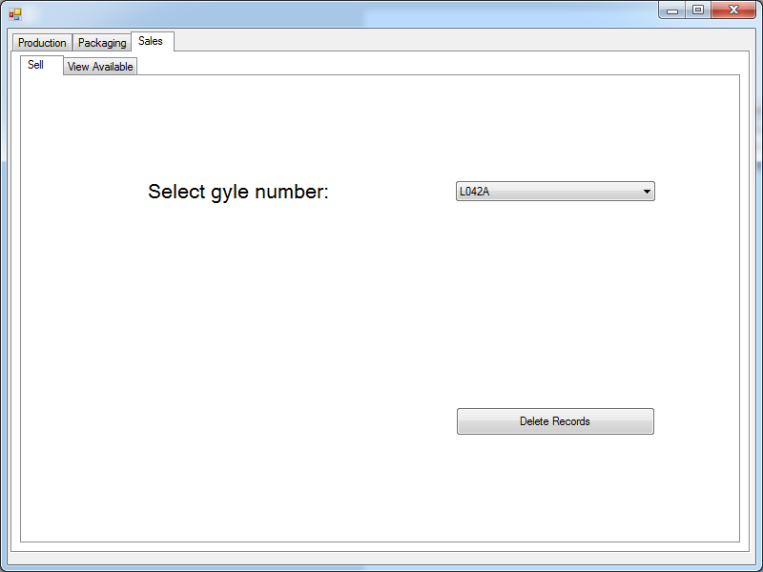

### Test: Sales – View Available

|  |  |  |  |
| --- | --- | --- | --- |
| Test | Expected Result | Actual Result | Notes |
| Display records selected from the database | Show Gyle, Drink, Container, Quantity | Show Gyle, Drink, Container, Quantity | Pass |
|  | Data is updated when a new record is entered on an insert page | Data is updated when a new record is entered on an insert page | Pass |

