Finn Turnbull

Dundee and angus College

Inventory Management System

User Guide

Table of Contents

**Type chapter title (level 1)1**

Type chapter title (level 2)2

Type chapter title (level 3)3

**Type chapter title (level 1)4**

Type chapter title (level 2)5

Type chapter title (level 3)6

# Running the program

Navigate to the location that the programmed is stored.  
Once there, you will see something like this:

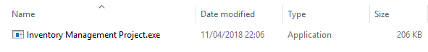

Double click on the .exe file, or alternatively right click the file and select ‘Open’ from the list of options.

The program should now open successfully.

# Closing the program

With the program open the window will look something like this.

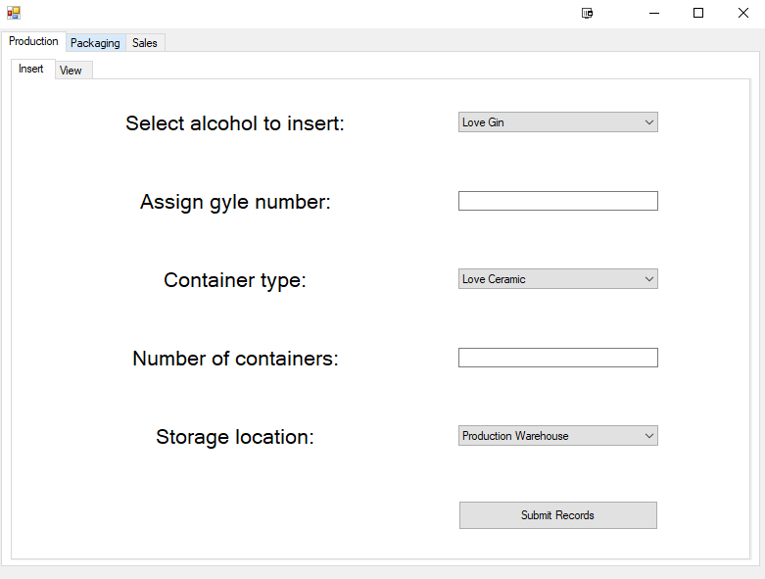

Move your cursor to the top right of the window and single click the ‘X’ icon, which will turn red when the cursor hovers over it.

The program should now exit successfully.

# Production

1. Navigate to the Production tab.

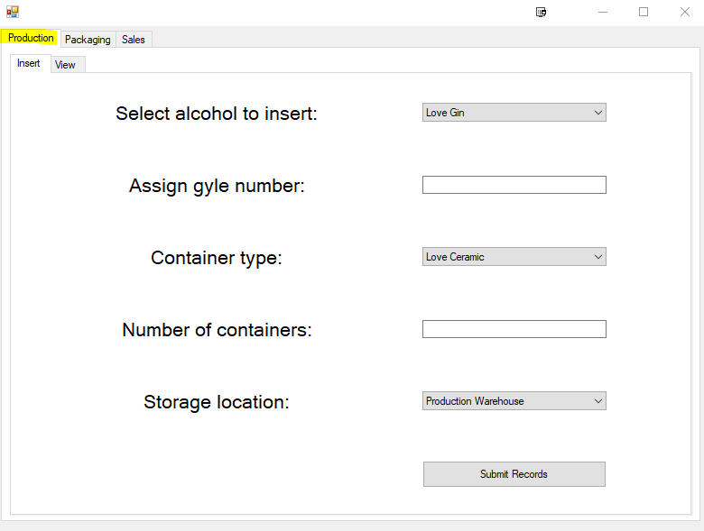

## Insert Records

1. Navigate to the Insert tab

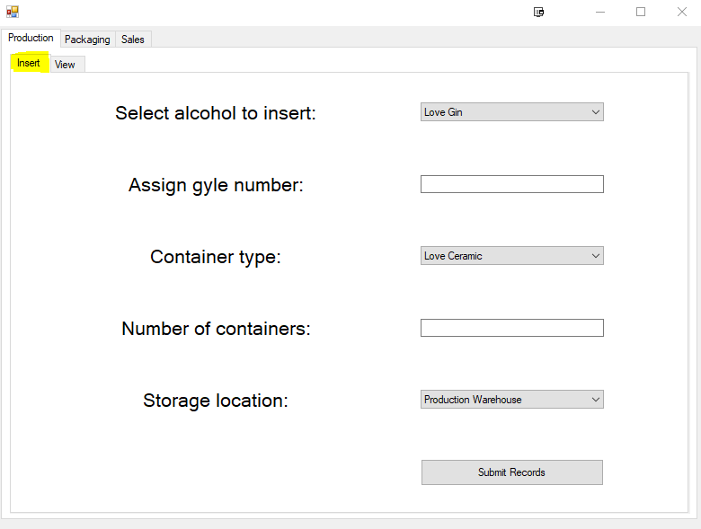

1. Select from a dropdown list which alcohol is to be recorded.
2. Type in the gyle number for this batch.
3. Select from a dropdown list the container type that the liquid is currently stored in.
4. Type the number of containers that this batch is made up of.
5. Select from a dropdown list where the batch is currently stored.
6. Lastly, click submit records to enter the data into the database.

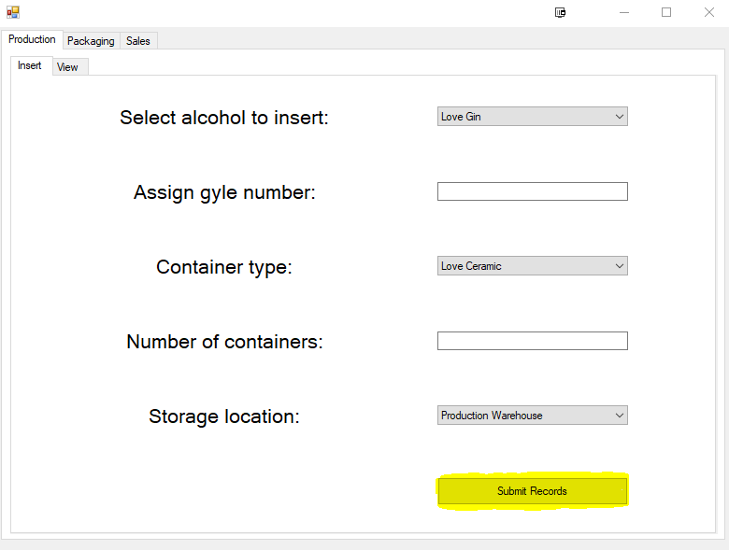

## View Records

1. Navigate to the View tab by single clicking the highlighted area.

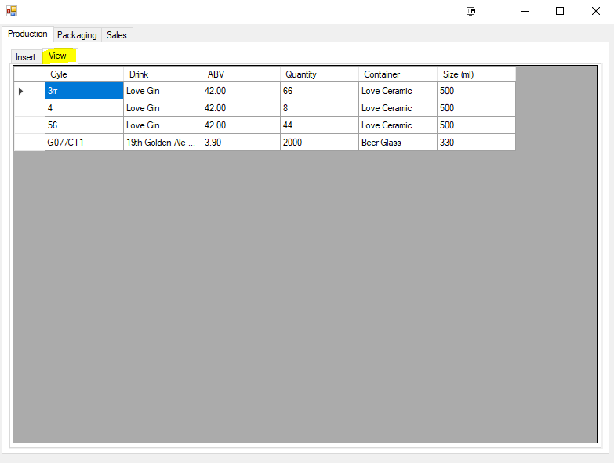

1. You can now view all the stock relevant to the production staff.
2. It is possible to order records by a specific column by single clicking the column header.  
   Click again to reverse the order.

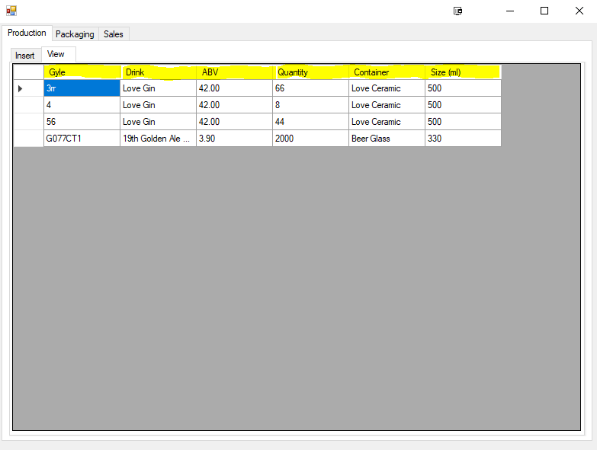

# Packaging

Navigate to the Packaging tab.

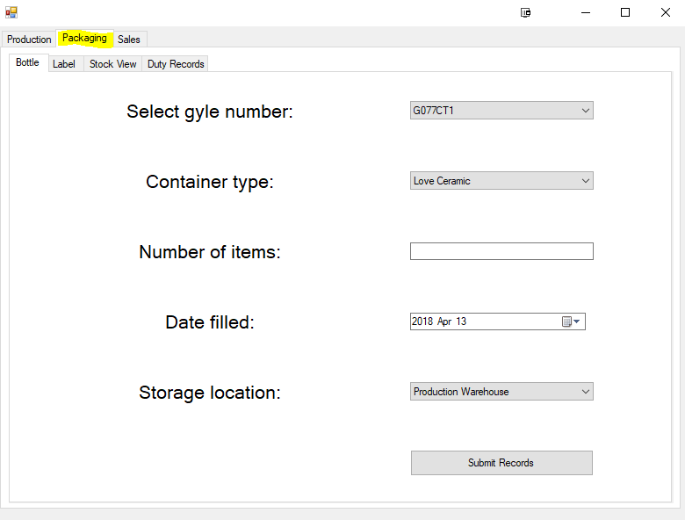

## Bottle

1. Navigate to the Bottle tab

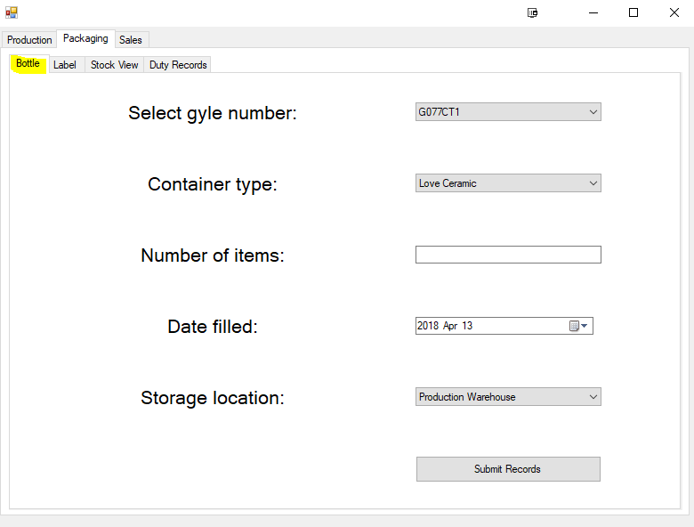

1. Select from a dropdown list which alcohol is to be recorded.
2. Type in the gyle number for this batch.
3. Select from a dropdown list the container type that the liquid is currently stored in.
4. Type the number of containers that this batch is made up of.
5. Select from a dropdown list where the batch is currently stored.
6. Lastly, click submit records to enter the data into the database.



## Label

## Stock View

## Duty Records

# Sales