UtahWells Database Management System (UW-DMS)

Developer: Lei Xu

PI: Brian McPherson

Supervisor: Richard Esser

Energy & Geoscience Institute (EGI)  
University of Utah  
Salt Lake City, UT 84108

April 14, 2022

Revision 1

Revision history

|  |  |  |  |
| --- | --- | --- | --- |
| Date | Description | Revision | Note |
| 04/14/2022 | Created the document | 1 | Temporary name: UtahWellsDB. |

Contents

1 Introduction 4

1.1 Background 4

1.2 Purpose 4

1.3 Key personnel 4

2 Database Design 5

2.1 Assumptions 5

2.2 Constraints 5

2.3 System environment 5

2.4 Demo 5

2.5 Component diagram 6

2.6 Deployment diagram 6

2.7 Class diagram 7

2.8 Database schema diagram 7

2.7 User interface design 9

2.8 Function for each Element 9

2.9 Other technical details design 11

# 1 Introduction

## 1.1 Background

Several databases have been developed for geological research, including [SDC](https://data.usgs.gov/datacatalog/) and [CO2Viewer](https://co2public.er.usgs.gov/viewer/) from United States Geological Survey (USGS), [DataExplorer](https://dataexplorer.ogm.utah.gov/) from Utah Department of Nature Resources Division of Oil, and Gas and Mining (UDOGM), [NatCarbViewer](https://edx.netl.doe.gov/geocube/#natcarbviewer) from Department of Energy (DOE). Most of these databases are based on geographic information system (GIS), which uses data attached to a unique location. These databases contain details data in their own area with user friendly interface; however, no single database is built with all related data for the topic of CO2 capture and storage (CCS). Therefore, it is necessary and helpful to develop a database specific to CCS project (temporarily named UtahWellsDB).

## 1.2 Purpose

The purpose of UtahWellsDB is to build a database with data related to CCS project. Related data includes storage methods (enhanced oil recovery, EOR; saline; depleted oil/gas wells), storage location, storage amount, cost, etc. As all the data is related to location, this database will be build as a GIS based database, which means all the data can be displayed and operated in an interactive map (like Google map).

## 1.3 Key personnel

Table 1.1 shows the roles of people for the database.

Table 1 Roles of UtahWellsDB

|  |  |  |  |  |
| --- | --- | --- | --- | --- |
| Role | Name | Email | Phone number | Note |
| DB administrator (DBA) | Brian McPherson |  |  |  |
| DB administrator | Rich Esser |  |  |  |
| DB administrator | Lei Xu |  |  |  |
|  |  |  |  |  |

1.4 Data owners

Table 1.2 shows the data owners.

Table 2 Data owners

|  |  |  |  |  |
| --- | --- | --- | --- | --- |
| Data type | Name | Email | Phone number | Note |
|  |  |  |  |  |
|  |  |  |  |  |
|  |  |  |  |  |
|  |  |  |  |  |

# 2 Database Design

## 2.1 Assumptions

This database is developed on Windows 10 Operation System (OS) and assumes that it will be run by the DBA within the given environment. It is assumed that only DBAs have the right to insert, update, and delete the data in the database, and users can only query from the database. Users is assumed to visit database from a browser through a given url (version 1.0). Data is limited to the state of Utah (version 1.0).

## 2.2 Constraints

Time: the database will be implemented, tested, and refactored based on feedback and evolving requirements over one year. The database will be deployed and maintained over the CSS project.

Cost: the database will be designed with funding from CSS project.

Scope: the database will implement the following features:

For users:

1 User can visit the database from a browser through a given url.

2 User can select several base map styles.

3 User can select several feature layers on the base map (like gas and oil wells in Utah state).

4 User can query targeted data from the database with key words.

5 In each layer, details for a selected feature can be popped out for display.

6 User can compare details for several selected features in the same layer.

7 User can output data from the database in CSV format.

For DBAs:

1 DBA can set the privilege level for users.

2 DBA can insert, update, and delete data from database.

3 DBA can maintain the database during lifecycle.

4 DBA can add new features to the database if necessary.

## 2.3 System environment

The user can visit the database through a web browser from any device. DBA must run the database in a Windows 10 environment.

## 2.4 Demo

## 2.5 Component diagram

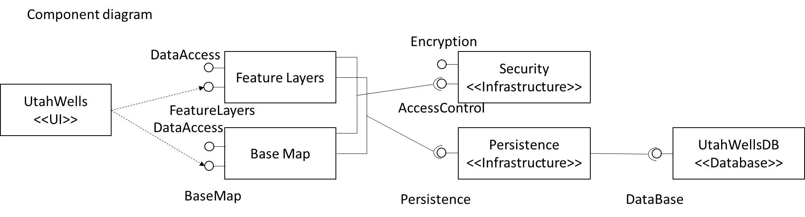

Figure 2.1 Component diagram of UtahWellsDB.

## 2.6 Deployment diagram

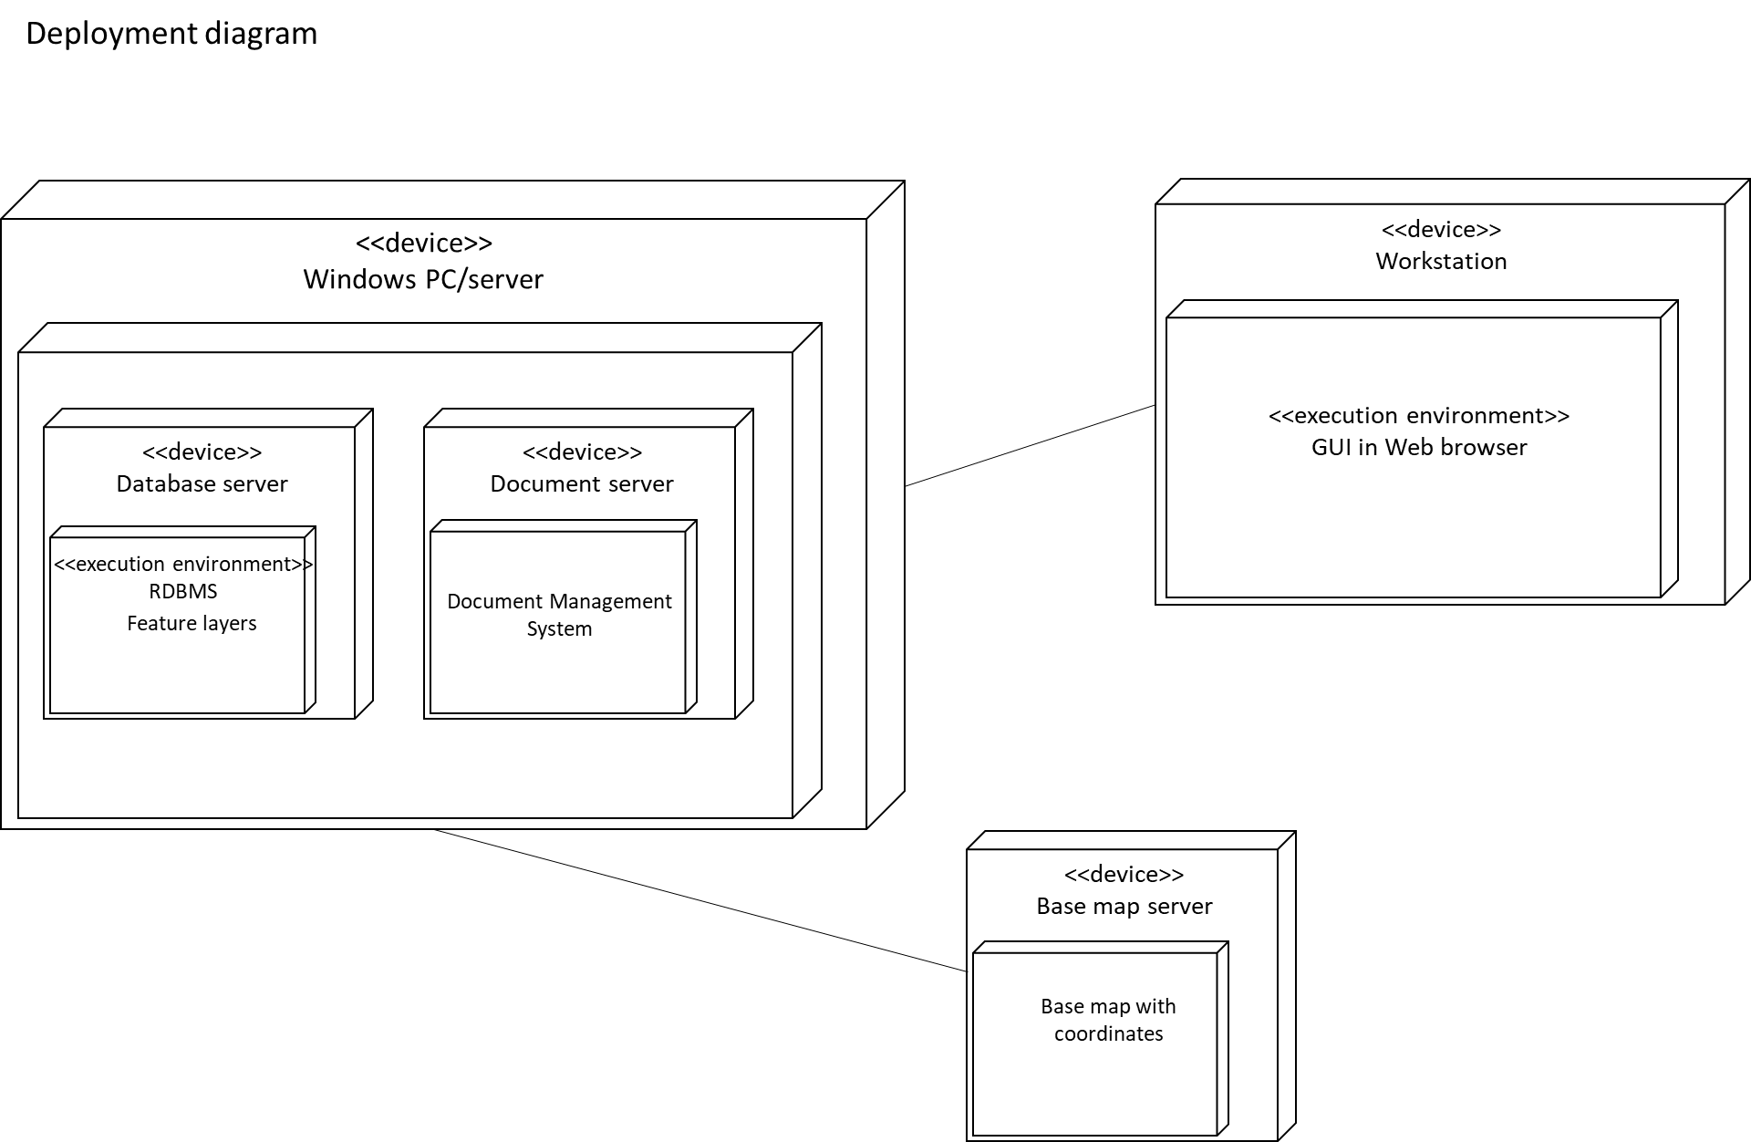

Figure 2.2 Deployment diagram of UtahWellsDB.

## 2.7 Class diagram

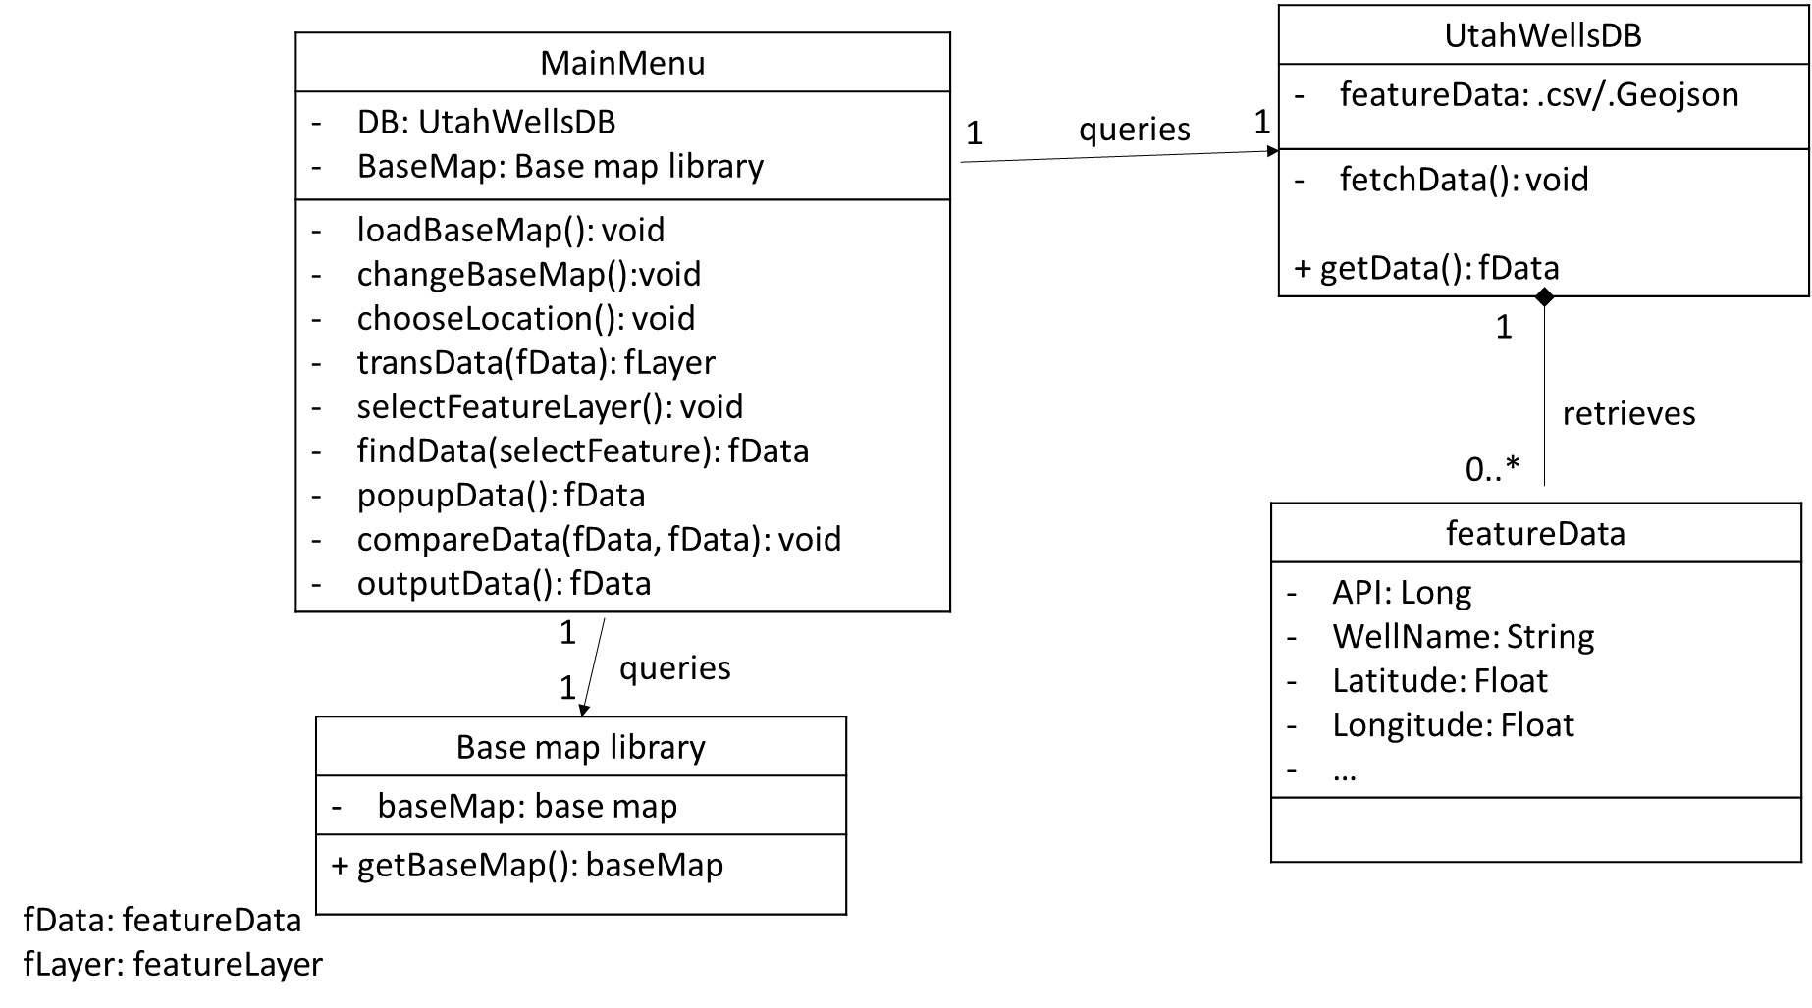

Figure 2.3 Class diagram for UtahWellsDB.

## 2.8 Database schema diagram

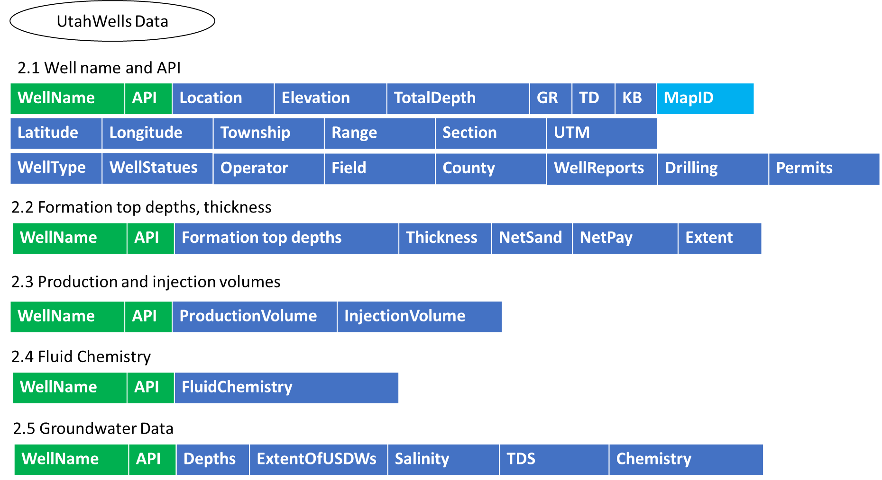

Figure 2.4 Database schema diagram for wells in UtahWellsDB.

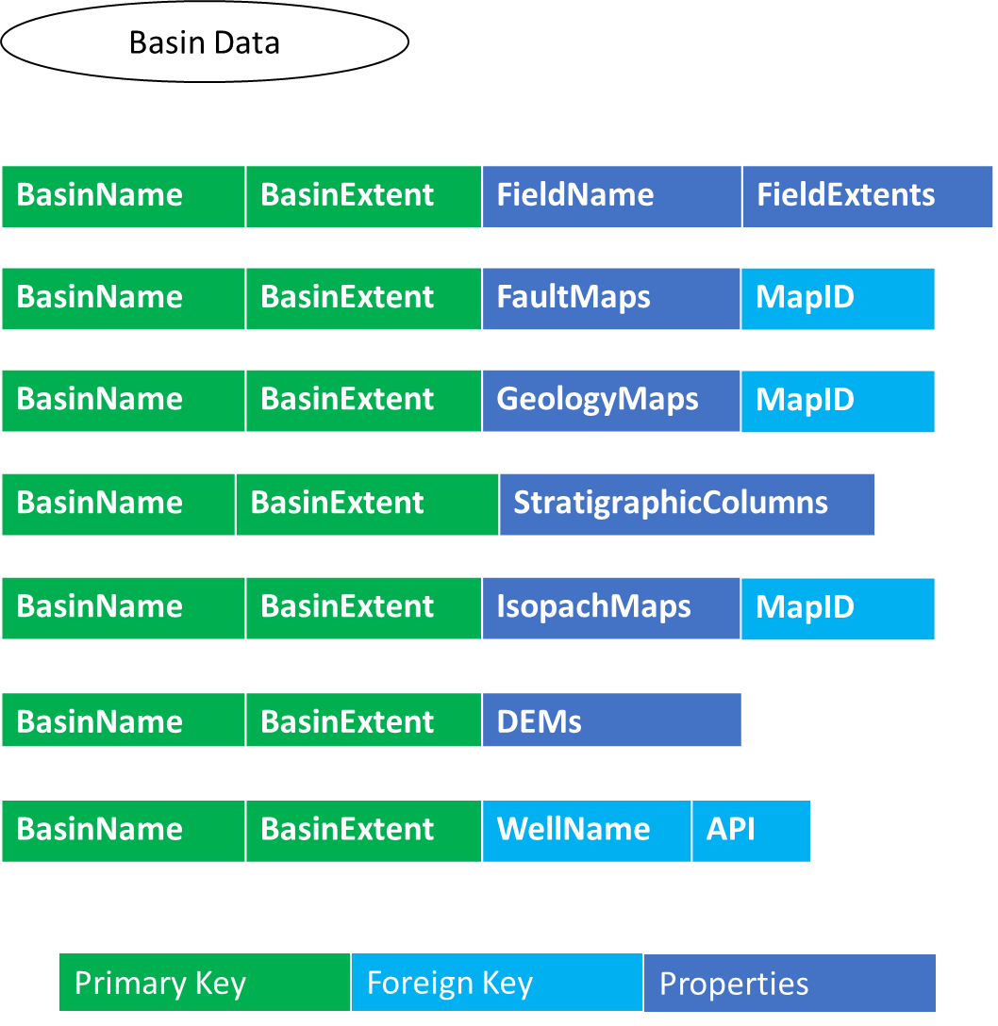

Figure 2.5 Database schema diagram for basin in UtahWellsDB.

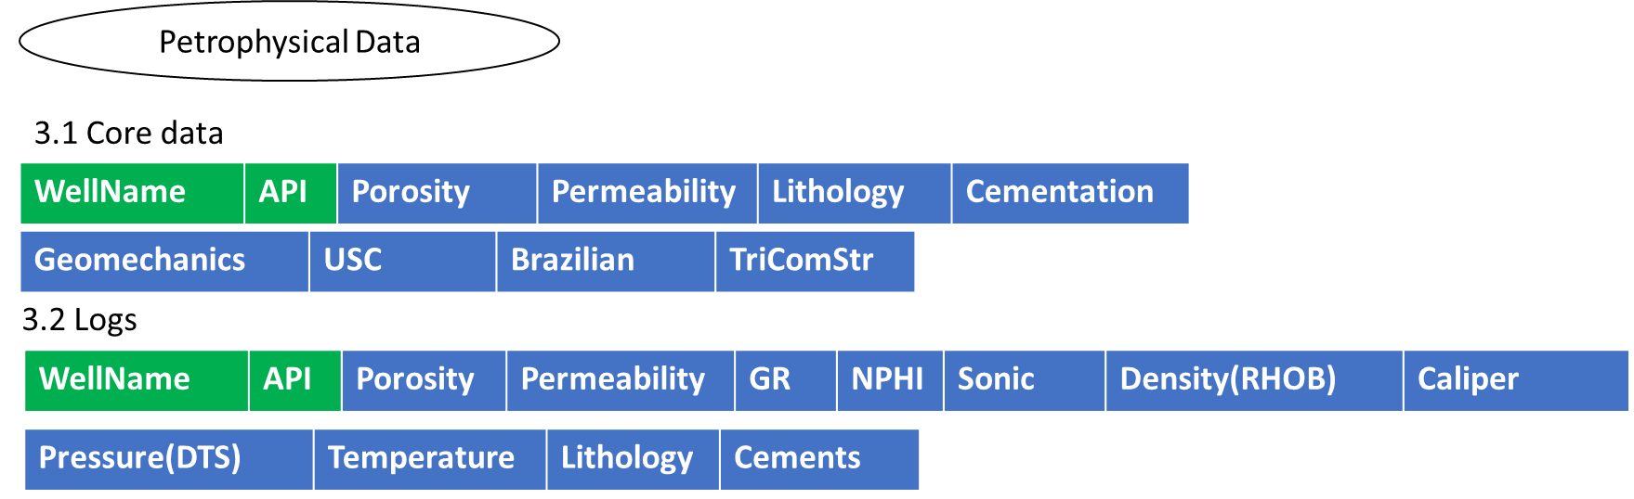

Figure 2.6 Database schema diagram for petrophysical data in UtahWellsDB.

## 2.7 User interface design

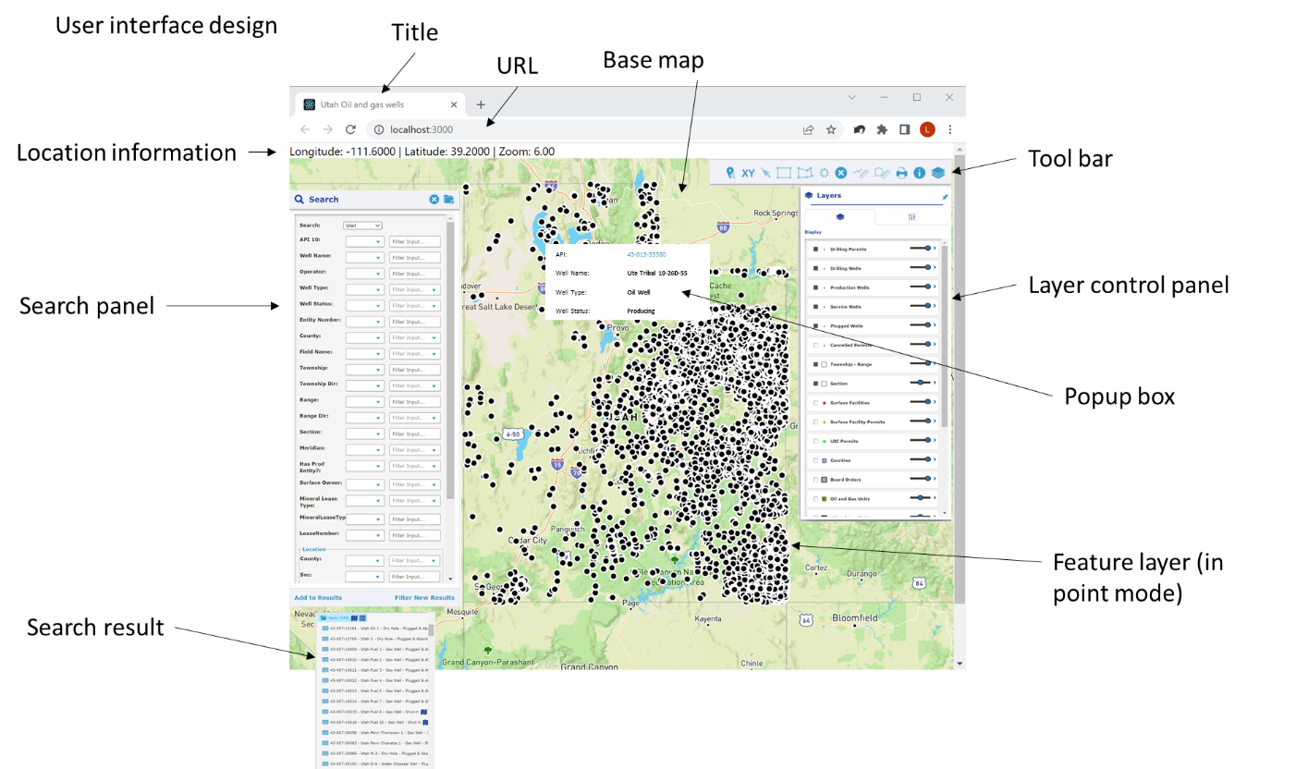

Figure 2.7 User interface design for UtahWellsDB.

## 2.8 Function for each Element

Table 2.1 shows the functions for elements in user interface.

Table 2.1 Function for each element

|  |  |  |  |  |
| --- | --- | --- | --- | --- |
| Element ID | Element class | Element type | Function | Note |
|  | siteHeaderRect | Div | Contain all page | style="height:40px;width:100%; margin: 0px 0px 10px 0px;" |
|  | Header2Text | Td | Show head information | style="font-weight: bold; padding: 10px;" |
|  | headerTd | B | Head information | style="white-space:nowrap; |
|  | icons | td | Show icons in the page | style="padding:10px 5px;" |
| alertIconDiv | icons | td | Show alert information |  |
| helpDiv | Icons | Td | Show help information |  |
| reportingIconDiv | icons | td | Show report | style="padding:10px 10px 7px 5px;" |
| reportTop | material-icons-outlined | span | Show report | style="cursor:pointer;"  uib-popover-template="'reportingTemplate.html'"  onClick="$('#accordion').accordion({ active: 0 }); clearDetails(); setTimeout(function () { refreshTree(); }, 100);" |
|  | login | td | Show login button | style="min-width:50px" |
| logInBtn | btn btn-primary | button | Log in | data-toggle="modal" data-target="#loginDialog" |
| logOutBtn | btn btn-primary | button | Log out | style="display:none" |
| tableSearch |  | table |  | style="box-sizing:border-box; width: 100%; margin: 0px 0px 0px 0px; padding: 0px 10px;" |
| trSearchMap |  | tr |  | style="margin-bottom:10px; display:block;" |
| tdSearch |  | td | Query input | style="height:100%; padding-right:10px;" align="center" |
| divSearch | contentContainerRect ui-resizable | div |  | style="width: 350px; padding: 0px; " |
|  | headerRect | div |  | style="height:40px;" |
|  |  |  |  |  |
| Search div (This part can be done by JS, so not all search parts are shown here) | | | | |
| searchBy | uiOperatorComboBox | select | Select search type | Default: Well.  onchange="SearchBySelectionChange(this) |
|  | filterPrompt | td | Show search labels |  |
| compareAPI10 | uiOperatorComboBox | select | Select API10 operation (like or =) | onchange="opSelectionChanged(this);" |
| API10 | uiTextBox | input | Get user input for API search value | onkeyup="textChanged(this);" |
|  | clearSelectedIcon | div |  | style="display:none; cursor:pointer;"  onclick="clearFilterInput(this);" |
| compareWellName | uiOperatorComboBox | select | Select well name operation | onchange="opSelectionChanged(this);" |
| WellName | uiTextBox | Input | Get user input for well name search value | onkeyup="textChanged(this);" |
| Search results | | | | |
| btnAdd | linkText | span | Add current result to all result | style="cursor: pointer; padding:10px;float:left; font-weight:bold;vertical-align:middle;"   onclick="filterSearch(true);" |
| btnApply | linkText | span | Apply for new search | style="cursor: pointer; padding:10px;float:right; font-weight:bold;vertical-align:middle;"  onclick="filterSearch(false);" |
| Map | | | | |
| Map title | | | | |
| mapTd |  | td | Contain all map elements |  |
| divMap | contentContainerRect | div | A div in mapTd |  |
| addressIcon |  | i | Show search by address | onclick=" $(this).hide(); $('#addressHideIcon').show(); $('#addressPopoverTemplate').show();" |
| addressHideIcon |  | i | Hide search by address | onclick="$(this).hide(); $('#addressIcon').show(); $('#addressPopoverTemplate').hide();" |
| xyIcon |  | i | Show xy to locate in a new coordinate | onclick=" $(this).hide(); $('#xyHideIcon').show(); $('#xyPopoverTemplate').show();" |
| xyHideIcon |  | i | Hide xy to locate in a new coordinate | onclick="$(this).hide(); $('#xyIcon').show(); $('#xyPopoverTemplate').hide();" |
| activePointSelectIcon |  |  | Show cursor select well by mouse point | onclick="resetSelectIcons(); $(this).hide(); $('#deactivatePointSelectIcon').show(); arby.activateSelectControl($('#cboActiveLayer').val(), 'pointSelectControl'); setTooltip(false);" |
| deactivatePointSelectIcon |  |  | Hide cursor select well by mouse point | onclick="$(this).hide(); $('#activePointSelectIcon').show(); arby.deactivateSelectControl('pointSelectControl'); setTooltip(toolTip);" |
| activeRectangleSelectIcon |  |  | Show rectangle select well by mouse point | onclick="resetSelectIcons(); $('#deactivateRectangleSelectIcon').show(); $(this).hide(); arby.activateSelectControl($('#cboActiveLayer').val(), 'wmsGetFeatureControl'); setTooltip(false);" |
| deactivateRectangleSelectIcon |  |  | Hide rectangle select well by mouse point | onclick="$(this).hide(); $('#activeRectangleSelectIcon').show(); arby.deactivateSelectControl('wmsGetFeatureControl'); setTooltip(toolTip);" |
| activePolygonSelectIcon |  |  | Show polygon select well by mouse point | onclick="resetSelectIcons(); $(this).hide(); $('#deactivatePolygonSelectIcon').show(); arby.activateSelectControl($('#cboActiveLayer').val(), 'polySelectControl'); setTooltip(false);" |
| deactivatePolygonSelectIcon |  |  | Hide | onclick="$(this).hide(); $('#activePolygonSelectIcon').show(); arby.deactivateSelectControl('polySelectControl'); setTooltip(toolTip);" |
| bufferIcon |  |  | Choose feature from the selected layers that are within certain distance from the selected feature | onclick=" $(this).hide(); $('#bufferHideIcon').show(); $('#bufferPopoverTemplate').show();" |
| bufferHideIcon |  |  |  | onclick="$(this).hide(); $('#bufferIcon').show(); $('#bufferPopoverTemplate').hide();" |
| activeMapClearIcon |  |  |  | onclick="arby.clearSelection(); markerLayer.getSource().clear(); wellFilter.getSource().clear();" |
| activeMeasureDistanceIcon |  |  | Measure distance | onclick="resetSelectIcons(); $(this).hide(); $('#deactivateMeasureDistanceIcon').show(); arby.activateControl('measureDistanceControl'); $('#distanceUnitDiv').show(); setTooltip(false);" |
| deactivateMeasureDistanceIcon |  |  |  | onclick="$(this).hide(); $('#activeMeasureDistanceIcon').show(); arby.deactivateSelectControl('measureDistanceControl'); $('#distanceUnitDiv').hide(); setTooltip(toolTip);" |
| activeMeasureAreaIcon |  |  |  | onclick="resetSelectIcons(); $(this).hide(); $('#deactivateMeasureAreaIcon').show(); arby.activateControl('measureAreaControl'); $('#areaUnitDiv').show(); setTooltip(false);" |
| deactivateMeasureAreaIcon |  |  |  | onclick="$(this).hide(); $('#activeMeasureAreaIcon').show(); arby.deactivateSelectControl('measureAreaControl'); $('#areaUnitDiv').hide(); setTooltip(toolTip);" |
| printIcon |  |  |  | onclick=" $(this).hide(); $('#printHideIcon').show(); $('#printPopoverTemplate').show(); printDialog(); setTooltip(false);" |
| printHideIcon |  |  |  | onclick="$('#printHideIcon').hide(); $('#printIcon').show(); $('#printPopoverTemplate').hide(); setTooltip(toolTip);" |
| layersIcon |  |  |  | onclick=" $(this).hide(); $('#layersHideIcon').show(); $('#layersPopoverTemplate').show(); $('#cboActiveLayer_chosen').show(); layersExpanded = true;" |
| layersHideIcon |  |  |  | onclick="$(this).hide(); $('#layersIcon').show(); $('#layersPopoverTemplate').hide(); $('#cboActiveLayer_chosen').show(); layersExpanded = false;" |
| olMap |  | div | Display map |  |
|  |  |  |  |  |
|  |  |  |  |  |
|  |  |  |  |  |
|  |  |  |  |  |
|  |  |  |  |  |
|  |  |  |  |  |
|  |  |  |  |  |
|  |  |  |  |  |
|  |  |  |  |  |
|  |  |  |  |  |
|  |  |  |  |  |
|  |  |  |  |  |
|  |  |  |  |  |

## 2.9 Other technical details design

|  |  |  |
| --- | --- | --- |
| Technical name | Detail name | Note |
| DBMS | PostgreSQL 11 |  |
| Backend | Spring boot + Java |  |
| Frontend | React + Typescript |  |