https://en.wikipedia.org/wiki/.NET_Framework_version_history

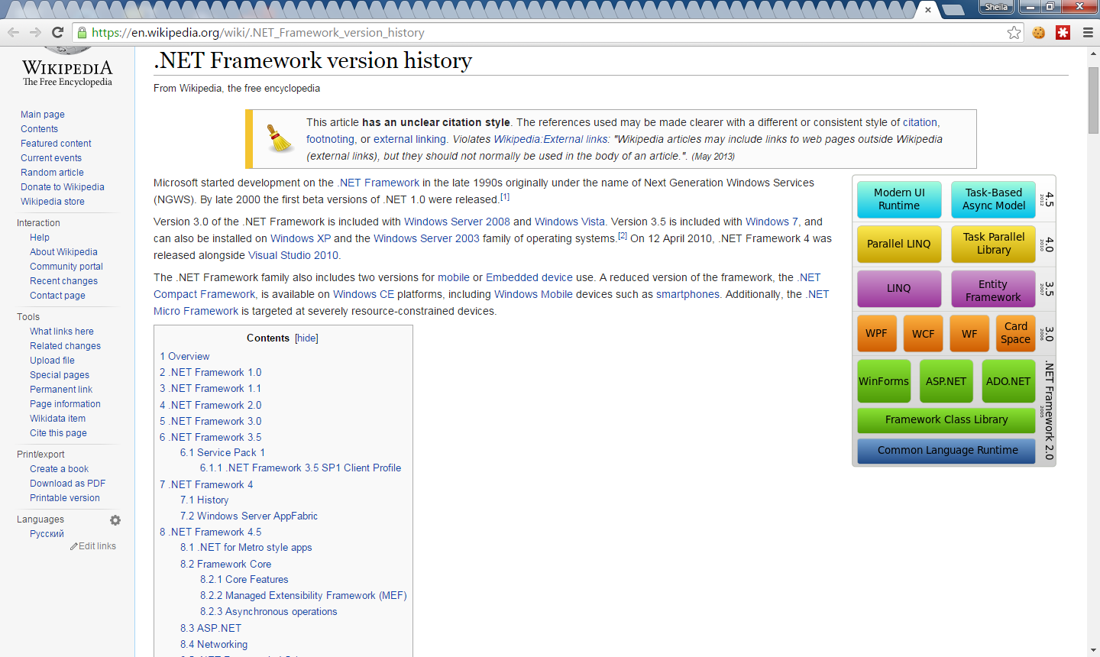

Overview[[edit](https://en.wikipedia.org/w/index.php?title=.NET_Framework_version_history&action=edit&section=1)]

|  |  |  |  |  |  |  |
| --- | --- | --- | --- | --- | --- | --- |
| **Overview of .NET Framework release history**[[3]](https://en.wikipedia.org/wiki/.NET_Framework_version_history#cite_note-depend-3)[[4]](https://en.wikipedia.org/wiki/.NET_Framework_version_history#cite_note-inclusion-4) | | | | | | |
| **Version number** | [**CLR**](https://en.wikipedia.org/wiki/Common_Language_Runtime) **version** | **Release date** | **Development tool** | **Included in** | | **Replaces** |
| **Windows** | **Windows Server** |
| [1.0](https://en.wikipedia.org/wiki/.NET_Framework_version_history#.NET_Framework_1.0) | 1.0 | 2002-02-13 | [Visual Studio .NET](https://en.wikipedia.org/wiki/Visual_Studio_.NET)[[5]](https://en.wikipedia.org/wiki/.NET_Framework_version_history#cite_note-new-vs2003-5) | [XP](https://en.wikipedia.org/wiki/Windows_XP)[[a]](https://en.wikipedia.org/wiki/.NET_Framework_version_history#endnote_a1none) | N/A | N/A |
| [1.1](https://en.wikipedia.org/wiki/.NET_Framework_version_history#.NET_Framework_1.1) | 1.1 | 2003-04-24 | [Visual Studio .NET 2003](https://en.wikipedia.org/wiki/Visual_Studio_.NET_2003)[[5]](https://en.wikipedia.org/wiki/.NET_Framework_version_history#cite_note-new-vs2003-5) | N/A | [2003](https://en.wikipedia.org/wiki/Windows_Server_2003) | 1.0[[6]](https://en.wikipedia.org/wiki/.NET_Framework_version_history#cite_note-6) |
| [2.0](https://en.wikipedia.org/wiki/.NET_Framework_version_history#.NET_Framework_2.0) | 2.0 | 2005-11-07 | [Visual Studio 2005](https://en.wikipedia.org/wiki/Visual_Studio_2005)[[7]](https://en.wikipedia.org/wiki/.NET_Framework_version_history#cite_note-new-vs2005-7) | N/A | [2003](https://en.wikipedia.org/wiki/Windows_Server_2003), [2003 R2](https://en.wikipedia.org/wiki/Windows_Server_2003_R2),[[8]](https://en.wikipedia.org/wiki/.NET_Framework_version_history#cite_note-8) [2008 SP2](https://en.wikipedia.org/wiki/Windows_Server_2008_SP2), [2008 R2 SP1](https://en.wikipedia.org/wiki/Windows_Server_2008_R2_SP1) | N/A |
| [3.0](https://en.wikipedia.org/wiki/.NET_Framework_version_history#.NET_Framework_3.0) | 2.0 | 2006-11-06 | [Expression Blend](https://en.wikipedia.org/wiki/Microsoft_Blend)[[9]](https://en.wikipedia.org/wiki/.NET_Framework_version_history#cite_note-new-blend-9)[[b]](https://en.wikipedia.org/wiki/.NET_Framework_version_history#endnote_b1none) | [Vista](https://en.wikipedia.org/wiki/Windows_Vista) | [2008 SP2](https://en.wikipedia.org/wiki/Windows_Server_2008_SP2), [2008 R2 SP1](https://en.wikipedia.org/wiki/Windows_Server_2008_R2_SP1) | 2.0[[3]](https://en.wikipedia.org/wiki/.NET_Framework_version_history#cite_note-depend-3) |
| [3.5](https://en.wikipedia.org/wiki/.NET_Framework_version_history#.NET_Framework_3.5) | 2.0 | 2007-11-19 | [Visual Studio 2008](https://en.wikipedia.org/wiki/Visual_Studio_2008)[[10]](https://en.wikipedia.org/wiki/.NET_Framework_version_history#cite_note-new-vs2008-10) | [7](https://en.wikipedia.org/wiki/Windows_7), [8](https://en.wikipedia.org/wiki/Windows_8),[[c]](https://en.wikipedia.org/wiki/.NET_Framework_version_history#endnote_c1none) [8.1](https://en.wikipedia.org/wiki/Windows_8.1)[[c]](https://en.wikipedia.org/wiki/.NET_Framework_version_history#endnote_c2none) | [2008 R2 SP1](https://en.wikipedia.org/wiki/Windows_Server_2008_R2_SP1) | 2.0, 3.0[[3]](https://en.wikipedia.org/wiki/.NET_Framework_version_history#cite_note-depend-3) |
| [4.0](https://en.wikipedia.org/wiki/.NET_Framework_version_history#.NET_Framework_4) | 4 | 2010-04-12 | [Visual Studio 2010](https://en.wikipedia.org/wiki/Visual_Studio_2010)[[11]](https://en.wikipedia.org/wiki/.NET_Framework_version_history#cite_note-new-vs2010-11) | N/A | N/A | N/A |
| [4.5](https://en.wikipedia.org/wiki/.NET_Framework_version_history#.NET_Framework_4.5) | 4 | 2012-08-15 | [Visual Studio 2012](https://en.wikipedia.org/wiki/Visual_Studio_2012)[[12]](https://en.wikipedia.org/wiki/.NET_Framework_version_history#cite_note-new-vs2012-12) | [8](https://en.wikipedia.org/wiki/Windows_8) | [2012](https://en.wikipedia.org/wiki/Windows_Server_2012) | 4.0[[3]](https://en.wikipedia.org/wiki/.NET_Framework_version_history#cite_note-depend-3) |
| [4.5.1](https://en.wikipedia.org/wiki/.NET_Framework_version_history#.NET_Framework_4.5.1) | 4 | 2013-10-17 | [Visual Studio 2013](https://en.wikipedia.org/wiki/Visual_Studio_2013)[[13]](https://en.wikipedia.org/wiki/.NET_Framework_version_history#cite_note-new-vs2013-13) | [8.1](https://en.wikipedia.org/wiki/Windows_8.1) | [2012 R2](https://en.wikipedia.org/wiki/Windows_Server_2012_R2) | 4.0, 4.5[[3]](https://en.wikipedia.org/wiki/.NET_Framework_version_history#cite_note-depend-3) |
| [4.5.2](https://en.wikipedia.org/wiki/.NET_Framework_version_history#.NET_Framework_4.5.2) | 4 | 2014-05-05 | N/A | N/A | N/A | 4.0, 4.5, 4.5.1[[3]](https://en.wikipedia.org/wiki/.NET_Framework_version_history#cite_note-depend-3) |
| [4.6](https://en.wikipedia.org/wiki/.NET_Framework_version_history#.NET_Framework_4.6) | 4 | 2015-07-20 | [Visual Studio 2015](https://en.wikipedia.org/wiki/Visual_Studio_2015)[[14]](https://en.wikipedia.org/wiki/.NET_Framework_version_history#cite_note-14) | [10](https://en.wikipedia.org/wiki/Windows_10) | [2016](https://en.wikipedia.org/wiki/Windows_Server_2016) | 4.0, 4.5, 4.5.1, 4.5.2 |