VTrack Database Documentation
BJMP Virac District Jail — Visitor Management System
Database engine: SQLite | Prepared: September 2026

1. Overview
VTrack currently uses SQLite as its database engine, configured through the DB_CONNECTION environment variable and stored as a single file at database/database.sqlite. SQLite requires no separate database server, which keeps local development and grading simple.
The database contains two kinds of tables: application tables, which hold VTrack's actual business data, and framework tables, which Laravel creates automatically to support its own internal features (authentication sessions, caching, and background jobs). The environment file also directs three of Laravel's internal subsystems to store their data in the database instead of a separate service such as Redis:
- SESSION_DRIVER=database — login sessions are stored in the sessions table
- CACHE_STORE=database — cached values are stored in the cache table
- QUEUE_CONNECTION=database — background jobs are stored in the jobs table

2. Application Tables
These two tables make up VTrack's actual data model — the tables that were deliberately designed for this project, and the ones shown in the Entity Relationship Diagram at the end of this document.

2.1 users
Stores the login accounts for VTrack staff/administrators. This is the table Laravel authenticates against when someone logs in through /login. There is currently one seeded account for testing (test@example.com).
Field | Type | Key | Description
id | bigint | PK | Auto-incrementing unique identifier
name | varchar |  | Staff member's display name
email | varchar | Unique | Login email address
email_verified_at | timestamp, nullable |  | When the email was verified (unused for now)
password | varchar |  | Hashed password (never stored in plain text)
remember_token | varchar, nullable |  | Token used for “remember me” logins
created_at / updated_at | timestamp |  | Standard Laravel record timestamps

2.2 facility_requests
This is VTrack's core CRUD entity. It stores onboarding requests submitted through the public “Request VTrack for Your Facility” form (/request) by other BJMP facilities interested in adopting the system. Logged-in admins review, update the status of, and delete these requests from the protected /facility-requests area.
Field | Type | Key | Description
id | bigint | PK | Auto-incrementing unique identifier
facility_name | varchar |  | Name of the requesting facility, e.g. “Legazpi City Jail”
region | varchar |  | Region / province of the facility
contact_name | varchar |  | Full name of the requester
position | varchar |  | Requester's position or rank
contact_number | varchar |  | Requester's phone number
email | varchar |  | Requester's email address
message | text, nullable |  | Optional additional details from the requester
status | enum, default 'pending' |  | pending / contacted / approved / declined
admin_notes | text, nullable |  | Internal notes added by an admin (not shown publicly)
created_at / updated_at | timestamp |  | Standard Laravel record timestamps

3. Framework (System) Tables
The tables below were not designed for VTrack specifically — Laravel creates them by default in every project so that its authentication, caching, and queue systems have somewhere to store data. They should not be included in an application ERD, since they are not part of VTrack's own business data model.

3.1 migrations
Tracks which migration files have already been run, so that running “php artisan migrate” again never re-applies the same migration twice. Columns: id, migration, batch.

3.2 password_reset_tokens
Created by Laravel Breeze to support the “Forgot your password?” flow. Stores a hashed reset token per email address so a reset link can be verified before allowing a new password to be set. Columns: email (primary key), token, created_at.

3.3 sessions
Holds one row per active browser session, since SESSION_DRIVER=database. This is how VTrack knows who is currently logged in between page loads. Columns: id (primary key), user_id (foreign key → users.id, nullable), ip_address, user_agent, payload, last_activity.

3.4 cache and cache_locks
Backs Laravel's cache facade (Cache::remember(), rate limiting counters, etc.) since CACHE_STORE=database. cache stores the actual cached key/value pairs with an expiration time. cache_locks prevents two requests from writing to the same cache key at the same instant. Both are currently empty in normal use — they only fill up once something in the app calls Cache::.

3.5 jobs, job_batches, and failed_jobs
Backs Laravel's queue system, since QUEUE_CONNECTION=database. jobs holds background tasks waiting to run; job_batches groups related jobs together; failed_jobs records any job that threw an exception during processing, along with the exception message, for later retry or inspection. VTrack does not currently dispatch any queued jobs, so these tables are empty.

4. Entity Relationship Diagram
The diagram below shows only VTrack's application tables (users and facility_requests). No foreign key currently connects the two: facility_requests are anonymous public submissions and are not tied to a user account. The one real foreign key in the overall schema belongs to a framework table — sessions.user_id → users.id — which Laravel uses internally to track logins and is not part of the application data model.
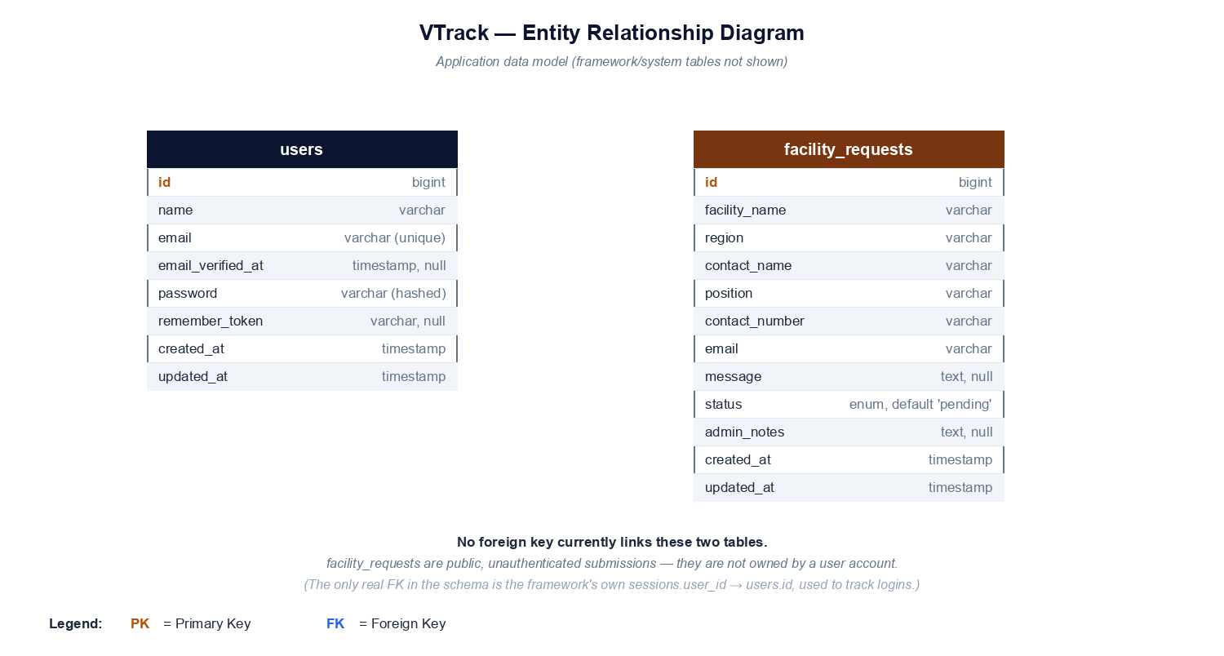
Figure 1. VTrack Entity Relationship Diagram

