Sarah Dowd
January 2, 2025
CS 230

Module 1 Assignment

UML Class Diagram

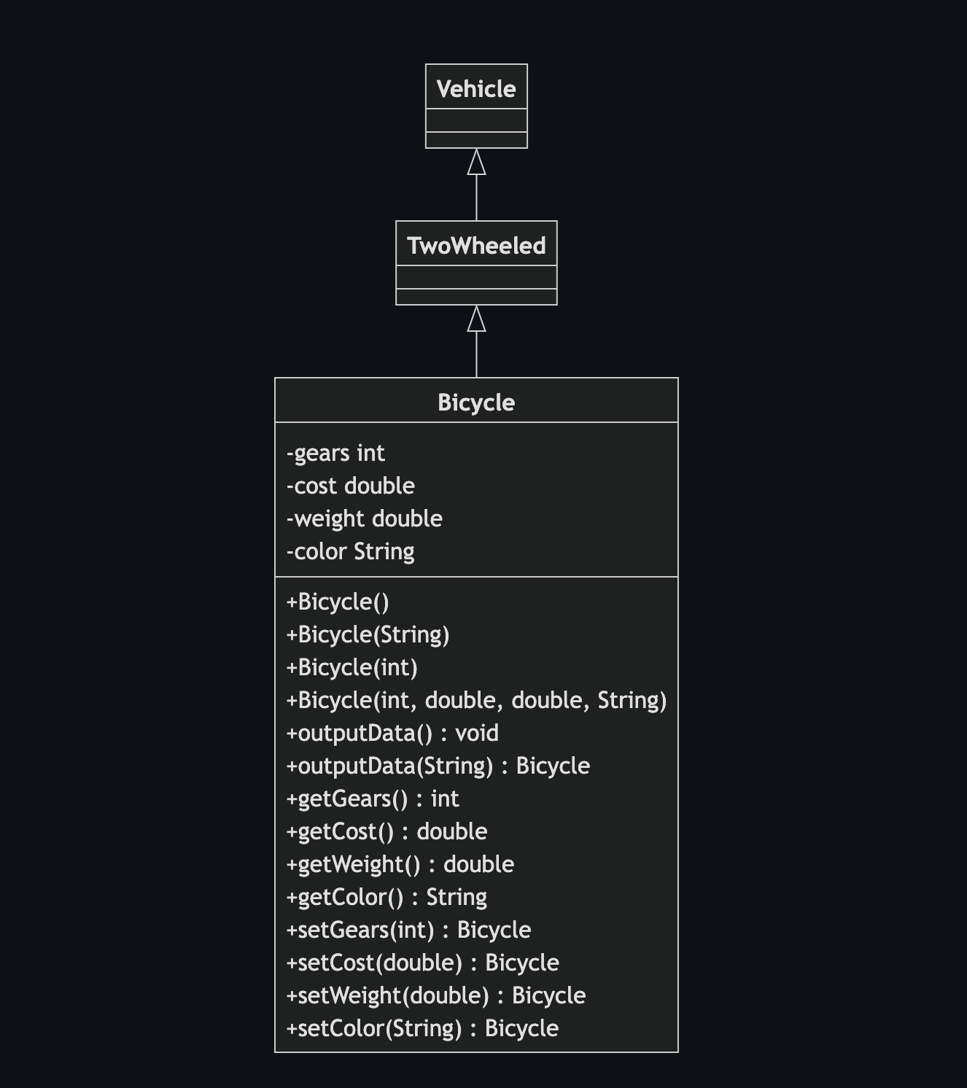
Object-Oriented Programming Principles

Several key object-oriented programming principles are illustrated in this class diagram:

1. Inheritance
- There's a clear inheritance hierarchy: Bicycle inherits from TwoWheeled, which inherits from Vehicle
- This demonstrates the "is-a" relationship (as tested in the Driver.java): a Bicycle is-a TwoWheeled vehicle, which is-a Vehicle
- The Driver.java's instanceof checks confirm these relationships

2. Encapsulation
- The Bicycle class demonstrates encapsulation by:
- Making all instance variables private (shown with `-` in the diagram)
- Providing public getters and setters (shown with `+` in the diagram)
- This ensures that the internal state can only be accessed through controlled interfaces

3. Method Overloading
- The Bicycle class shows method overloading in two ways:
- Multiple constructors with different parameter lists
- Two versions of outputData(): one with no parameters and one taking a String parameter

4. Method Chaining
- All setter methods return the Bicycle instance (return type Bicycle)
- This enables fluent interface design as shown in Driver.java where methods can be chained:
myBike5.setColor("Peach").setGears(32).outputData("Number 5");

5. Abstraction
- The Vehicle and TwoWheeled classes are abstract in nature (though not formally abstract classes)
- They provide a hierarchical abstraction of what it means to be a vehicle and a two-wheeled vehicle
- The specific implementation details are left to the Bicycle subclass

These principles work together to create a clean, maintainable, and extensible design where:
- New vehicle types could easily be added to the hierarchy
- The Bicycle class's implementation details are protected from outside interference
- The interface is flexible and user-friendly through method overloading and chaining

The Driver.java file demonstrates how these principles make the code more usable and robust through various instantiation patterns and type checking.

