HOW TO COMPUTE SSS MONTHLY CONTRIBUTION

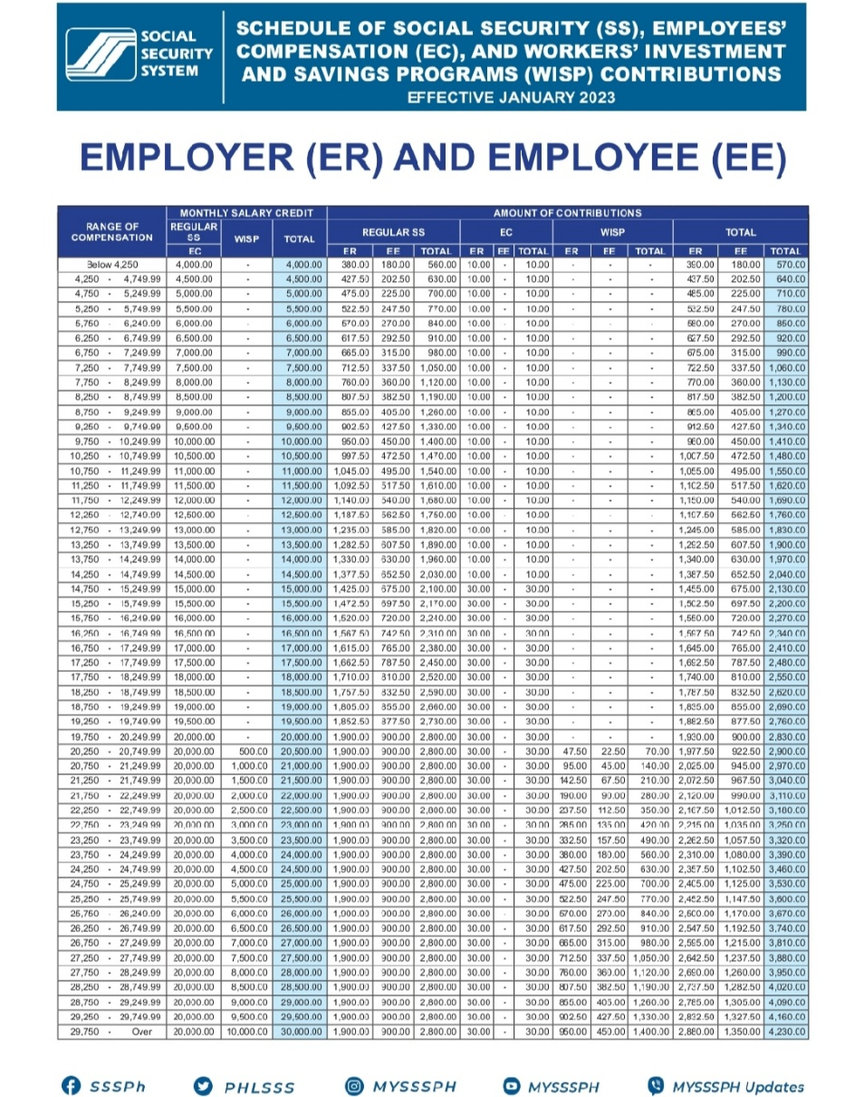

25000 monthly salary (check on table what range of compensation is covered)

(Monthly salary credit EC \* 4.5% ) + (EC FOR EE + WISP FOR EE)

= (20,000 \* 4.5%) + ( 0 + 225)

=900 + 225

= 1125 ( sss monthly contribution)

PAGIBIG MONTHLY CONTRIBUTION REMAINS 100 PESOS ONLY

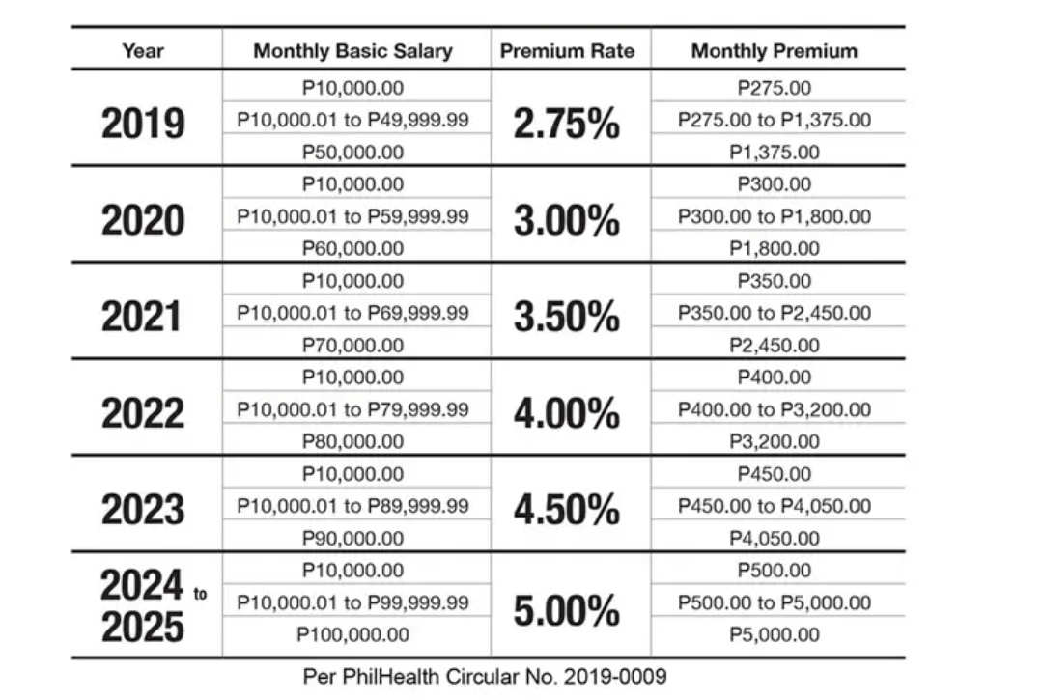HOW TO COMPUTE PHILHEALTH MONTHLY CONTRIBUTION

Basic Salary x 5% (0.05) = Premium Rate.

= ₱25,000 x 0.05 = ₱1,250

= ₱1,250 (Monthly premium) ÷ 2

= ₱625 (Employee's share)

HOW TO COMPUTE INCOME TAX

Monthly Salary: ₱25,000

Base on that, your monthly contributions would be:

SSS: ₱1,125.00

PhilHealth: ₱625.00

Pag-IBIG: ₱100

You have to add them all up to get your total deductions.

Total Deductions = SSS + PhilHealth + Pag-IBIG

= ₱1,125.00 + ₱625.00 + ₱100

= ₱1,850.00

So what’s next? Subtract your total deductions to your monthly salary, the result will be your taxable income.

Taxable Income = Monthly Salary – Total Deductions

= ₱25,000 - ₱1,850.00

= ₱23,150

Base on our sample computation, if you are earning ₱25,000/month, your taxable income would be ₱23,150.

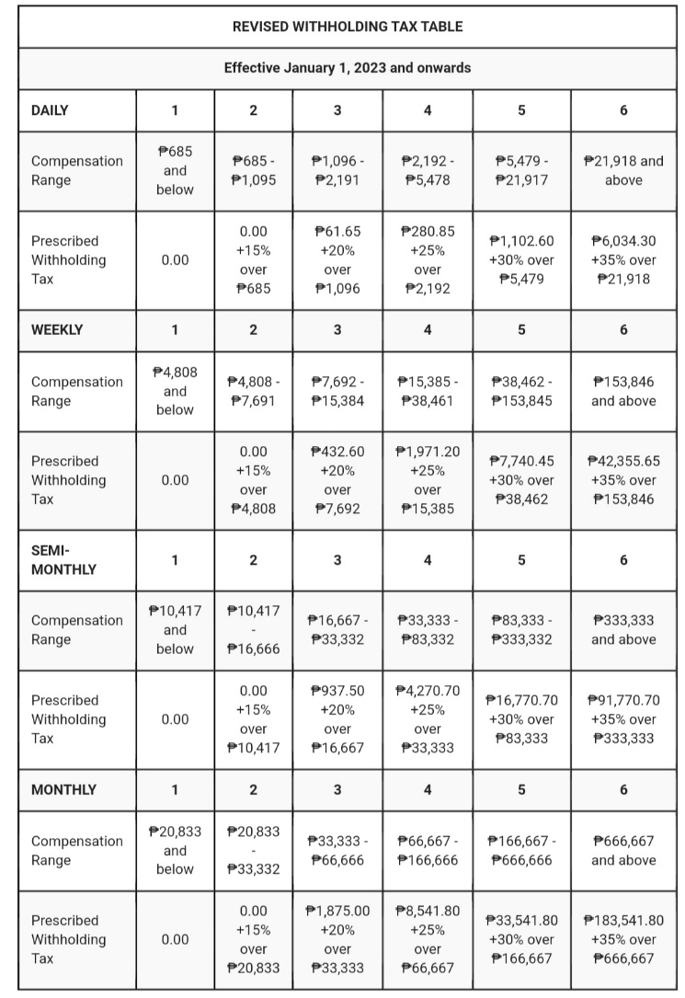

15% over Compensation Level = (Taxable Income – Compensation Level) x 15%

= (₱23,150 - ₱20,833) x 15%

= ₱2,317 x 15%

= ₱347.55

So we got the “15% over Compensation Level”. It’s time to get the real income tax.

Base on the tax table, our income tax would be:

Income Tax = ₱0.00 + 15% over Compensation Level (CL)

= ₱0.00 + ₱347.55

= ₱347.55