Sang Hwa Lee

INST 354

November 6, 2022

Exercise 3

1. A local company in Maryland makes two products: cabinets and tables. Making each cabinet requires 22 hours of carpentry and 8 hours of finishing. Making each table requires 12 hours of carpentry and 8 hours of finishing. Each cabinet brings $1220 of profit, and each table brings $820. The company’s carpentry shop has a capacity of 160 hours per week, and its finishing shop has a capacity of 80 hours per week. The company wishes to determine the product mix that **maximizes profit.**

Decision Variable Materials

Cabinet = C Carpentry (Material 1)

Table = T Finishing (Material 2)

**A) Build a table that shows the capacity usage breakdown and profit contribution of the two products.**

|  |  |  |
| --- | --- | --- |
|  | **Product** | |
| **Materials** | Cabinet | Table |
| Carpentry | 22 | 12 |
| Finishing | 8 | 8 |
| Profit | $1220 | $820 |

**B) Formulate a linear optimization model for this problem.**

Objective Function = Max. 1220C + 820T

Constraints =

S.t(Subject to) 22C + 12T ≤ 160

8C + 8T ≤ 80

C + T ≥ 0

**C) Build a spreadsheet representation of the model.**

**D) A way has been found in the company’s carpentry shop to reduce the time needed for making each table from 12 hours to 10. Reformulate the linear problem and represent it on another worksheet in the same Excel file.**

**Q) What is the optimal solution? In one sentence, comment on why, you think, the product mix changed in this way.**

* After changed table carpentry hours from 12 to 10, the total profit going to $ 10,200, therefore, second is more optimal solution.

2. Newly recruited employees at a company, UM Electronics, are required to complete a probational training program that include either a three-hours session on “teaming” OR a two-hours session on “problem solving.” The manager of quality improvement requested that at least 6 sessions on “teaming” and at least 12 sessions on “problem solving” be offered during the next one month. In addition, senior-level management specified that at least a total of 20 probational training programs must be offered during this period. UM Electronics uses a consultant to teach the training programs. During the next month, the consultant has 60 hours of time available. Each session on “teaming” costs $12,000 and each session on “problem solving” costs $10,000.

|  |  |  |
| --- | --- | --- |
|  | **Training Program( Sessions)** | |
| **Materials** | Teaming(3hours) | Problem solving(2hours) |
| Manager of quality improvement | 6(sessions) | 12(sessions) |
| Senior level management | 20(sessions) | |
| Cost | $12,000 | $10,000 |

**A) Formulate a linear programming model that can be used to determine the number of sessions on “teaming” and the number of sessions on “problem solving” that should be offered in order to minimize total cost.**

Objective Function = Min. 12000T + 10000P

Constraints =

S.t(Subject to) T ≥ 6

P ≥ 12

T + P ≥ 20

3T + 2P ≤ 60

T, P ≥ 0

B) Build a spreadsheet representation of the model, and then solve it using Solver. Keep the solution as part of your spreadsheet.

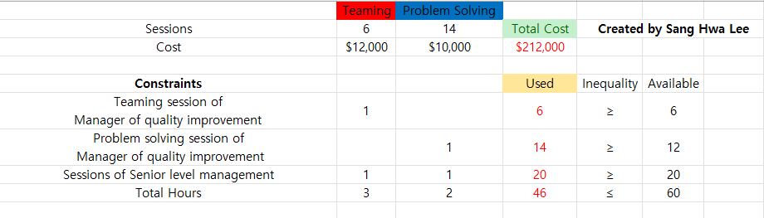

Q) In one or two sentences, write your answer in words. You answer should indicate how many training programs of each kind should be offered, and what the total cost will be.

There are 6 sessions of ‘Teaming’ and 14 sessions of ‘Problem Solving’ which should consist of a total of 20 sessions. Therefore, the total cost going to be $212,000.