Sang Hwa Lee

INST 354

September 25, 2022

Exercise 1

SCENARIO 1 - Amelia is a college student majoring in Information Science, which she decided to pursue because of her love of technology. Growing up she also enjoyed cooking, particularly making French-inspired dishes. However, at this point in her life, she doesn't have any formal culinary training and cooks only as a hobby, even though she has always dreamt of owning a restaurant. As a college student getting ready to graduate and move on to the next stage of her life, Amelia needs to figure out if she would make more income continuing towards a career in Information Science or switching her career path and trying to become a chef of her own restaurant. Suppose the payoffs from her decision are a function of the economic climate in the next year. The economy can be weak or strong. High-end restaurants tend to do well only in strong economies whereas the number of tech jobs are expected to stay relatively stable in either type of economy. For the restaurant, she has estimated her annual salary to be $95,000 in a strong economy and $25,000 in a weak economy. For the tech job, she has estimated her annual salary to be $64,000 in a strong economy and $61,000 in a weak economy. She has estimated the probability of a declining economy at 60% and an expanding economy at 40%.

**A. What are the alternatives in this decision?**

1. Getting tech job
2. Opening restaurant.

**B. Make a payoff matrix for this problem.**

|  |  |  |  |
| --- | --- | --- | --- |
|  |  | Type of economy | |
|  |  | Strong economy | Weak economy |
| Career Options | Restaurant | $ 95,000 | $ 25,000 |
| Tech job | $ 64,000 | $ 61,000 |

**C. What decision should she make according to the maximax decision rule?**

Open restaurant maximum = $ 95,000

Getting tech job maximum = $ 64,000

Then, maximax decision rule = $ 95,000

**D. What decision should she make according to the maximin decision rule?**

**Open restaurant minimum = $ 25,000**

**Getting tech job minimum = $ 61,000**

**Then, maxmin decision rule = $ 61,000**

**E. What decision should you make according to the expected value decision rule? Please show your calculations.**

**Case 1 – If she chooses restaurant**

**EV = {(95000 * 0.4) + (25000 * 0.6)} = 38000 + 15000 = 53000**

**Case 2 – If she gets tech job**

EV = {(64000 * 0.4)+(61000 * 0.6)} = 25600 + 36600 = 62200

**F. If Amelia can hire a consultant to perfectly predict the economic climate before she decides what to do, what is the most that she should be willing to pay the consultant? Show your calculations.**

**EVPI = 95000 * ( strong econ) + 61000 * (weak econ)**

**= (95000 * 0.4) + (61000 * 0.6) = 38000 + 36600 = 74600**

**74600 – EV best =**

**74600 – 62200 = 12400**

**G. Make a strategy table of what decision she should make as you change her annual salary in a strong economy for a restaurant job from $85,000 to $105,000 in increments of $10,000, and as you change the probability of an expanding economy from 30% to 50% in increments of 10 percentage points. Assume her objective is to maximize the expected value of her salary. Show your work (i.e., how you computed the expected values need to make a choice for each cell). But in the table, just enter "restaurant" or "tech" in each cell**

**Hints: For an example strategy table, see lecture 3.4, slides 7-8 (you might want to   
see R2 sub-section 14.12.2). You can put the salaries in the rows ($85,000, $95,000,   
...). There should be 3 different salary values. You can put the probabilities of a   
strong economy in the columns (30%, 40%...). There should be 3 different   
probabilities. Finally, you can do calculations for each of the 9 cells to determine   
what she should do according to the expected value decision.**

**Restaurant**

|  |  |  |  |
| --- | --- | --- | --- |
| **Salary**  **Probability of**  **an expanding** | **$ 85,000** | **$ 95,000** | **$ 105,000** |
| **0.3** | **25,500** | **28,500** | **31,500** |
| **0.4** | **34,000** | **38,000** | **42,000** |
| **0.5** | **42,500** | **47,500** | **52,500** |

**Then, get EV**

**If strong econ = 0.3, and weak econ = 0.6**

1. **(85000 * strong econ) + ( 25000 * weak econ) = 25500 + 15000 = 40500**

**If strong econ = 0.4, and weak econ = 0.6**

1. (85000 * strong econ) + (**25000 * weak econ**) = 34000 + 15000 = 49000

If **strong econ = 0.5, and weak econ = 0.6**

1. (85000 * strong econ) + (**25000 * weak econ**) = 42500 + 15000 = 57500

If **strong econ = 0.3, and weak econ = 0.6**

1. (95000 * strong econ) + (**25000 * weak econ**) = 28500 + 15000 = 43500

If **strong econ = 0.4, and weak econ = 0.6**

1. (95000 * strong econ) + (**25000 * weak econ**) = 38000+ 15000 = 53000

If **strong econ = 0.5, and weak econ = 0.6**

1. (95000 * strong econ) + (**25000 * weak econ**) = 47500 + 15000 = 62500

If **strong econ = 0.3, and weak econ = 0.6**

1. (105000 * strong econ) + (**25000 * weak econ**) = 31500 + 15000 = 46500

If **strong econ = 0.4, and weak econ = 0.6**

1. (105000 * strong econ) + (**25000 * weak econ**) = 42000 + 15000 = 57000

If **strong econ = 0.5, and weak econ = 0.6**

1. (105000 * strong econ) + (**25000 * weak econ**) = 52500 + 15000 = 67500

**Tech Job**

|  |  |
| --- | --- |
| **Salary**  **Probability**  **of an expanding** | **$ 64,000** |
| **0.3** | **19,200** |
| **0.4** | **25,600** |
| **0.5** | **32,000** |

**Then get EV**

**If strong econ = 0.3, and weak econ = 0.6**

1. (64000 * strong econ) + (61000 * weak econ) = 19200 + 36600 = 55800

**If strong econ = 0.4, and weak econ = 0.6**

1. (64000 * strong econ) + (61000 * weak econ) = 25600 + 36600 = 62200

**If strong econ = 0.5, and weak econ = 0.6**

1. (64000 * strong econ) + (61000 * weak econ) = 32000 +36600 = 68600

**Maximize the EV**

**Restaurant**

If **strong econ = 0.5, and weak econ = 0.6**

EV = (105000 * strong econ) + (**25000 * weak econ**)

(10500 * 0.5) + (25000 * 0.6) = 52500 + 15000 = 67500

**Tech job**

**If strong econ = 0.5, and weak econ = 0.6**

(64000 * strong econ) + (61000 * weak econ)

(64000 * 0.5) + (61000 * 0.6) = 32000 +36600 = 68600

**H. Briefly describe two potential pitfalls of using decision analysis to determine what Amelia should do (3-5 sentences)**

Difficult to specify subjective and value components. It is too narrow to judge with only two alternatives. Also, need to think about the sunk cost. Assuming that the restaurant was opened, if it was closed again due to economic weakness, the investment cost goanna be mostly sunk costs.

SCENARIO - II Suppose that you are deciding whether to buy a $1 lottery ticket. The jackpot is $1.1 million and there is a 1/1,000,000 chance of winning. In addition, you may choose to receive the jackpot as a lump sum immediately or in yearly payments over 4 years. If you choose the lump sum, you only get 75% of the money but you get it all at once. If you choose the yearly payments, you will receive a payment of $275,000 over 4 years with the first payment made in one year. The interest rate is 4% per year.

**A. Determine expected present value of the payoff associated with the yearly payments   
option. In other words, determine the present value of 1.1 million paid out over 4 years.   
Show your work.**

Present Value = $PV= \frac{FV}{{(1+r)}^{n}}$

Then, $PV= \frac{275,000}{{(1+0.04)}^{4}} = \frac{275,000}{1.16985856}$ = 235,071.1525331746

Therefore 235,071.1525331746 * 4 = 940,284.6101326984 - 1 (lottery ticket price)

= 940,283.6101326984, about $ 940,284

**B. Draw the decision tree for this problem. Use the present value of the payoffs. In your   
diagram, just include the payoffs and not the expected values or probabilities. You can   
create the decision tree by hand (and snap a photo) or use computer software. Paste the   
diagram here.**

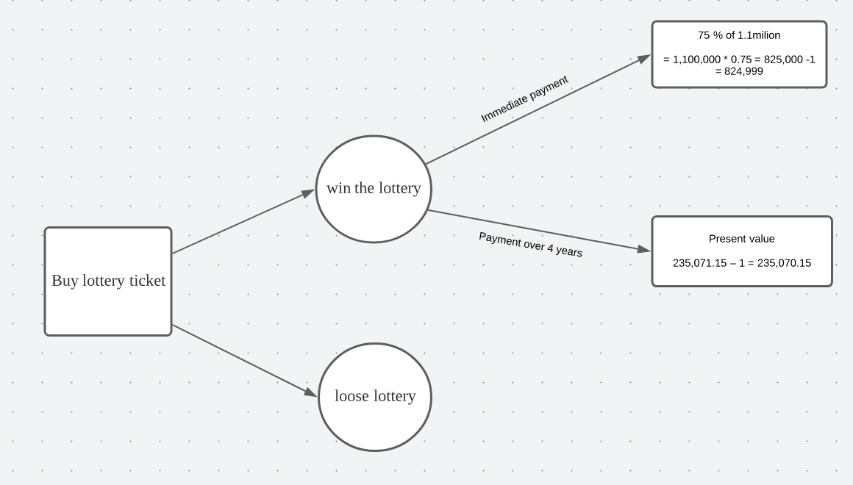

**C. Solve the decision tree to determine the correct decision(s) based on an expected present   
value. Show your calculations of the expected value for each alternative.**

1) EV of Immediate payment

(Probability of winning * Payoff of winning) + (Probability of losing * Payoff of losing)

= (1/ 1,000,000 * 825,000) + [(1- (1/1,000,000)) * (-1)]

= (0.000001 * 825,000) + (-0.999999)

= (0.825 – 0.999999) = - 0.174999

2) EV of payment over 4 years

(Probability of winning * Payoff of winning) + (Probability of losing * Payoff of losing)

= (1/ 1,000,000 * 940,284) + [(1- (1/1,000,000)) * (-1)]

= (0.000001 * 940,284) + (-0.999999)

= (0.940284 – 0.999999) = -0.059715

When I calculate the EV, it turns out that payment over 4 years much larger than Immediate payment. Therefore, payment over 4 years is better choice.