# Belkin - Case Study: eCommerce Data Analyst Hiring Process [Sangho Lee]

[**https://business-analytics-slee.shinyapps.io/belkin_shiny/**](https://business-analytics-slee.shinyapps.io/belkin_shiny/)

### *Please go to the link provided to see the full rationale of the analysis*

### Summary of the Regression model

Identified the key drivers of revenue by analyzing the p-values and coefficients to determine the most significant predictors from the regression model

# Show the regression model  
summary(model)

##   
## Call:  
## lm(formula = ordered_revenue_amount ~ ., data = data_train)  
##   
## Residuals:  
## Min 1Q Median 3Q Max   
## -77579 -612 -189 396 118367   
##   
## Coefficients: (2 not defined because of singularities)  
## Estimate Std. Error t value Pr(>|t|)   
## (Intercept) 5867.940130 14735.909116 0.398 0.6905   
## week_ending -0.364153 0.743986 -0.489 0.6245   
## asin 0.011511 0.001368 8.416 <0.0000000000000002 ***  
## ordered_units 20.675258 0.205555 100.583 <0.0000000000000002 ***  
## asp 31.373871 0.967078 32.442 <0.0000000000000002 ***  
## category.a 30.402476 106.148560 0.286 0.7746   
## category.b -3.528137 106.208459 -0.033 0.9735   
## category.c 180.248411 106.282564 1.696 0.0899 .   
## category.d NA NA NA NA   
## subcategory.aa -106.172324 118.636310 -0.895 0.3708   
## subcategory.bb 164.342191 118.622853 1.385 0.1660   
## subcategory.cc 5.252084 118.383693 0.044 0.9646   
## subcategory.dd -21.019948 118.537029 -0.177 0.8593   
## subcategory.ee NA NA NA NA   
## marketing_spend -0.034668 0.032283 -1.074 0.2829   
## views 0.079425 0.067711 1.173 0.2408   
## ---  
## Signif. codes: 0 '***' 0.001 '**' 0.01 '*' 0.05 '.' 0.1 ' ' 1  
##   
## Residual standard error: 4067 on 11762 degrees of freedom  
## Multiple R-squared: 0.485, Adjusted R-squared: 0.4845   
## F-statistic: 852.2 on 13 and 11762 DF, p-value: < 0.00000000000000022

From this model, I found that the most significant predictors of revenue are:

* Number of units ordered (ordered_units): Coefficient = 20.67. This indicates that for each additional unit ordered, revenue increases by $20.67 (p-value < 0.00002).
* Average selling price (asp): Coefficient = 31.37. This means that for each $1 increase in the average selling price, revenue increases by $31.37 (p-value < 0.00002).
* Product identification number (asin): With a p-value of 0.00002, this predictor is also significant.

Although there are other predictors with high absolute coefficients, they are not as significant in terms of the p-value, indicating that they are not as reliable in this model.

Now that I have identified the key drivers according to the model, we have redesigned it using only the significant variables to enhance its strength.

# Show the refiend model that I created in the previous question  
summary(refined_model)

##   
## Call:  
## lm(formula = ordered_revenue_amount ~ asin + ordered_units +   
## asp, data = data_train)  
##   
## Residuals:  
## Min 1Q Median 3Q Max   
## -77609 -597 -203 387 118636   
##   
## Coefficients:  
## Estimate Std. Error t value Pr(>|t|)   
## (Intercept) -1306.511753 94.473524 -13.829 <0.0000000000000002 ***  
## asin 0.011480 0.001364 8.414 <0.0000000000000002 ***  
## ordered_units 20.671226 0.205513 100.584 <0.0000000000000002 ***  
## asp 31.411177 0.966556 32.498 <0.0000000000000002 ***  
## ---  
## Signif. codes: 0 '***' 0.001 '**' 0.01 '*' 0.05 '.' 0.1 ' ' 1  
##   
## Residual standard error: 4068 on 11772 degrees of freedom  
## Multiple R-squared: 0.4845, Adjusted R-squared: 0.4844   
## F-statistic: 3688 on 3 and 11772 DF, p-value: < 0.00000000000000022

Then added the predicted_revenue column to the dataset. With this, we can now categorize the areas that overperformed and underperformed according to the model’s predictions.

predicted_revenue_table

| week_ending | asin | ordered_revenue_amount | ordered_units | asp | marketing_spend | views | predicted_revenue |
| --- | --- | --- | --- | --- | --- | --- | --- |
| 19728 | 99345 | 1902.66 | 95 | 20.02800 | 3741 | 111 | 2426.7939 |
| 19728 | 91686 | 224.15 | 12 | 18.67917 | 2309 | 185 | 580.7918 |
| 19728 | 90798 | 437.74 | 9 | 48.63778 | 4781 | 253 | 1449.6195 |
| 19728 | 28305 | 4.95 | 1 | 4.95000 | 1643 | 1069 | -805.4265 |
| 19728 | 52947 | 13.49 | 1 | 13.49000 | 3206 | 347 | -254.2959 |
| 19728 | 40959 | 13064.52 | 597 | 21.88362 | 1292 | 323 | 12191.7913 |
| 19728 | 57942 | 612.19 | 34 | 18.00559 | 3432 | 1876 | 627.0348 |
| 19728 | 58053 | 602.36 | 44 | 13.69000 | 1284 | 408 | 699.4636 |
| 19728 | 60495 | 280.14 | 6 | 46.69000 | 3930 | 1156 | 978.5589 |
| 19728 | 59385 | 1816.13 | 69 | 26.32072 | 4519 | 1673 | 1628.2810 |

Then I moved on to the second question to dive deeper into which specific products to focus on. Before visualizing the data, I explained why we should focus on predicted revenue from the model instead of relying solely on actual sales data.

##### Benefits of Utilizing Model Prediction Data Instead of Relying on Actual Sales Data

* Identify potential issues like stock shortages.
* Optimize marketing strategies.
* Adjust pricing to match market demand.
* Improve product listings to enhance conversions.
* Prepare for seasonal demand.
* Estimate potential success for new product launches.

This approach is crucial for identifying potential issues like stock shortages, optimizing marketing strategies, adjusting pricing to match market demand, improving product listings to enhance conversions, preparing for seasonal demand, and estimating potential success for new product launches.

# Show the plot of Actual vs. Predicted Revenue  
plot_actual_vs_predicted_revenue

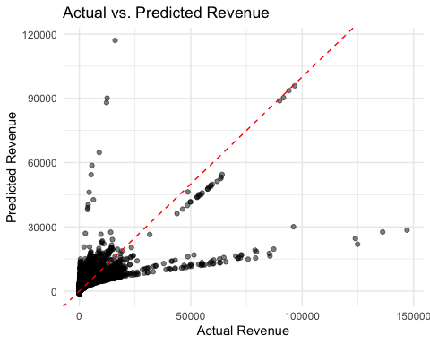

Looking at this plot, I was able to identify areas where actual revenue was higher or lower than predicted revenue. This information helps us focus on specific products that may require further analysis or action to improve sales performance.

To pinpoint the specific products that overperformed or underperformed, I set a threshold for the outliers in the plot. The identified products are shown in the visualization below.

# Show the plot of Actual vs. Predicted Revenue with Critical Score by Actual Revenue  
plot_actual_vs_predicted_revenue_critical

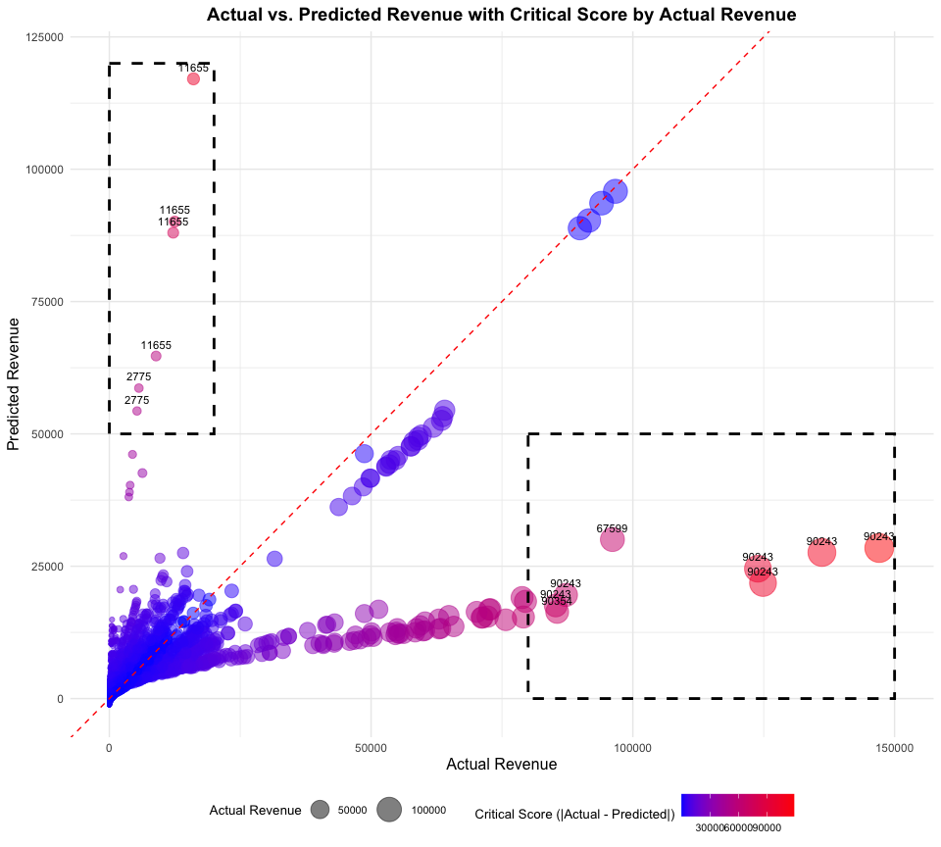

Next, I categorized the products into two focus areas based on the plot criteria:

* Focus Area 1: Products with high predicted revenue but low actual revenue. These products likely have potential, but something may be missing to maximize their profit.
* Focus Area 2: Products with low predicted revenue but high actual revenue. We need to investigate why these products are performing better than predicted. Understanding the reasons behind their success can help replicate it for other products or minimize risks in the future.

segmented_data_table

| asin | focus_area | check_items |
| --- | --- | --- |
| 2775 | Focus Area 1 (High Prediction, Low Revenue) | Investigate Stock Levels, Enhance Marketing Strategies, Improve Product Listings |
| 11655 | Focus Area 1 (High Prediction, Low Revenue) | Investigate Stock Levels, Enhance Marketing Strategies, Improve Product Listings |
| 67599 | Focus Area 2 (Low Prediction, High Revenue) | Examine Sales Trends, Optimize Stock Management, Replicate Success |
| 90243 | Focus Area 2 (Low Prediction, High Revenue) | Examine Sales Trends, Optimize Stock Management, Replicate Success |
| 90354 | Focus Area 2 (Low Prediction, High Revenue) | Examine Sales Trends, Optimize Stock Management, Replicate Success |

### Conclusion

Based on the analysis of this dataset, we identified the key drivers by examining statistical indicators from the model, pinpointed products that are overperforming or underperforming, and segmented the products into two focus areas for further investigation. Using this approach, I recommend investing further in the following five products to maximize revenue by either boosting sales or preventing revenue decline.

Extra Visualizations

### 1. Revenue vs. Marketing Spend vs. Views / 2. Revenue Over Time vs. Views Over Time

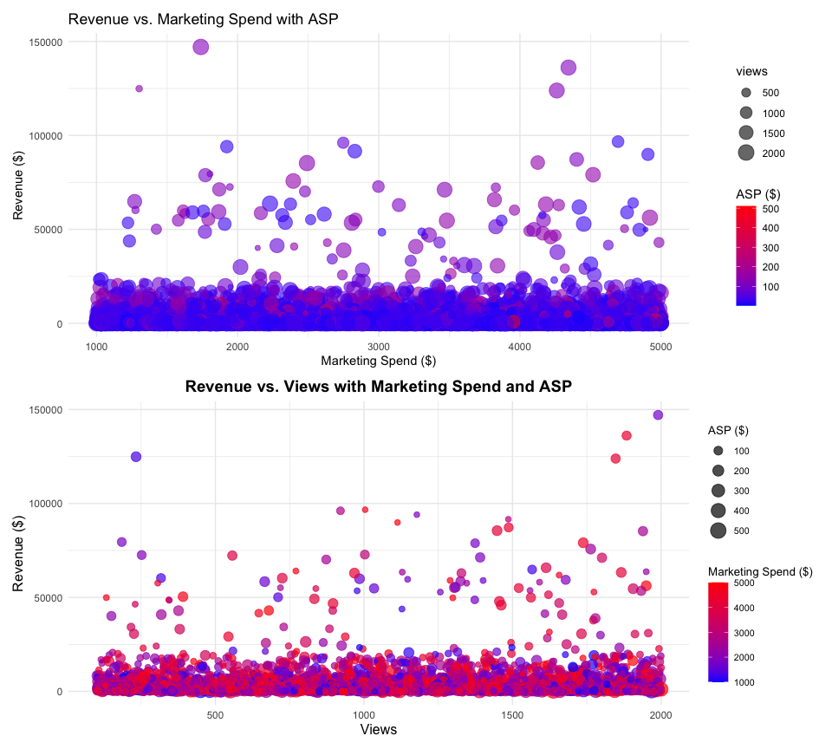

### Key Takeaways from first plots:

- Optimize Marketing Spend: Since revenue does not consistently increase with higher marketing spend, it's important to evaluate the effectiveness of marketing campaigns and reallocate budget towards more impactful strategies.

- More Views Generally Lead to More Revenue: Products with higher views tend to generate more revenue, suggesting that increasing product visibility can positively impact sales.

### Recommendations from second plots

- Analyze January Strategies: Understand and replicate successful marketing strategies from January to boost revenue in other months.

- Address February Decline: Investigate and address factors contributing to the revenue decline in February. Adjust marketing and pricing strategies accordingly.

- Convert Views to Sales in April and May: Optimize product listings, run effective promotions, and provide incentives to convert higher views into sales during these months.

- Sustain Growth in June: Maintain and enhance successful strategies from June to ensure continued revenue growth.

**Bonus Question:**

If we can gain API access to the raw data from Amazon, we will be able to automate the data extraction process and integrate it into the solution I have suggested here. In this case, I will provide a quick solution to automate the creation of views for all visualizations and statistical model summaries developed in this case study by uploading the raw data, the provided XLSX case study file.

If multiple data sets need to be sliced for hours of work, this simple web tool can also automate that process as well.