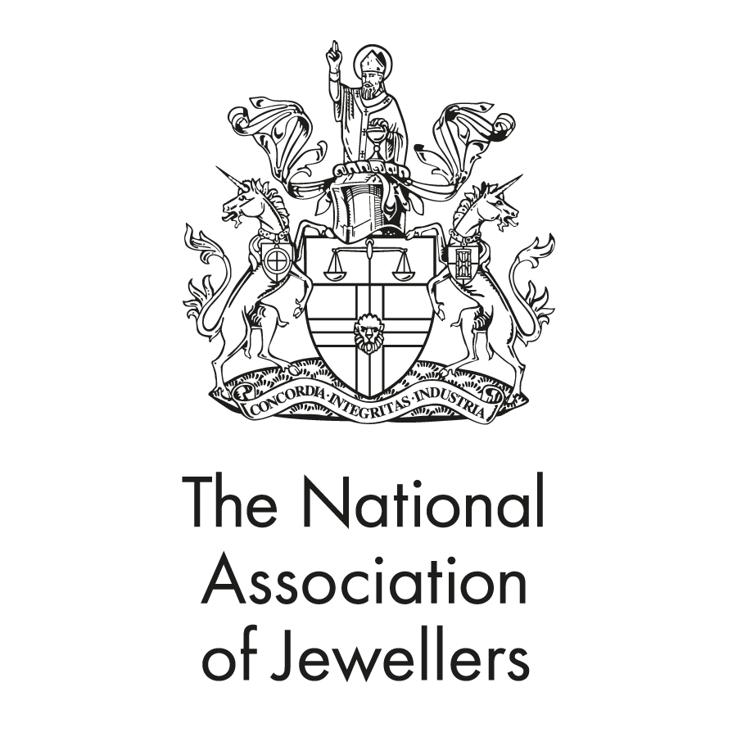

**Jewellery Education & Training from the National Association of Jewellers**

**JET CERTIFICATE**

**Welcome to the JET Certificate**

Welcome to the JET Certificate. We are really pleased that you have decided to study with the NAJ and we hope that you have an enjoyable and valuable learning experience. We hope that you find the following information useful. Please get in touch with the Education Team at [jet@naj.co.uk](mailto:jet@naj.co.uk) if we can help you in any way.

# Assignments

There are four assignments and a project, to be completed over a maximum period of 6 months. Your tutor will send you a timetable to help you to plan and structure your workload. If you identify any issues in sticking to the timetable, please contact your tutor or the NAJ straightaway. The assignments can be accessed by clicking on the Assignments tab on the welcome page of your learning portal. Please read the assignments carefully before starting your course work.

The recommended word count is around 1200-1500 for the first four assignments. The project itwill require a greater level of coverage than the four standard assignments and a word count of around 2000 words is recommended. Students are advised to commence preparing for this project early on in their courses by researching and storing suitable content in readiness to meet the projects requirements.

It is very important that your assignments are written in your own words. You must not copy and paste chunks of text from the books and websites that you use to do your research. Neither must you copy and paste from another student’s work. Plagiarism, `the practice of taking someone else's work or ideas and passing them off as one's own ‘, is a very serious offence which could result in failure of the assignment in question, or even the entire qualification.

Each month an Award, sponsored by Clarity and Success Jeweller Management software, is given to the student who submits the best project. The twelve Clarity and Success award winners receive their awards at the annual NAJ Presentation of Awards ceremony.

# Tutor support

Remember that help is just a phone call away. Should you have any queries regarding the course or assignments please email or telephone your tutor for assistance. If there is no one available, please leave your name, telephone number and brief details about the nature of your call and the tutor will call you back as soon as they can.

# Study Pack

Your study pack will be posted out to you, and includes a 10x loupe, a copy of Bradbury’s Book of Hallmarks, a copy of Diamonds by Marijan Dundek and a copy of ‘Gemstones’ by Cally Hall. These are of the utmost importance to your studies and you should refer to them throughout.

We do hope you enjoy your JET Certificate studies and wish you every success.

# On to JET Diploma

Once you have successfully completed the JET Certificate, you may be interested in enrolling on JET Diploma which leads to the Professional Jewellers’ Diploma qualification. You will find more information on this qualification on the NAJ website at. <https://www.naj.co.uk/qualifications>

# The NAJ Education Department

The NAJ also offers further training for those working in the Jewellery industry. For information on other courses please telephone the Education Department on **0121 237 1110** or e-mail jet@naj.co.uk

# Recommended reading for JET Certificate students

**The Retail Jewellers Guide** – K Blakemore

# Bradbury’s Book of Hallmarks

**Jackson’s Hallmarks** (Pocket Edition)

**The Gemmologist Compendium** – R Webster

**Gemstones of the World** – W Schumann

**Gemstones** – C Hall

**Jewellery manufacture and Repair** – C Jarvis

**Diamonds** – Marijan Dundek

There are many other good reference books available and it is in the students’ own interest that the following books are read whenever possible:

**An Illustrated Dictionary of Jewellerey** – H Newman

**Antique and 20th Century Jewellery** – V Beck