Predict hourly data. Predict every hour. e.g. from 13:00 to 14:00, from 14:00 to 15:00…

1. next hour average = this hour average (persistence model)
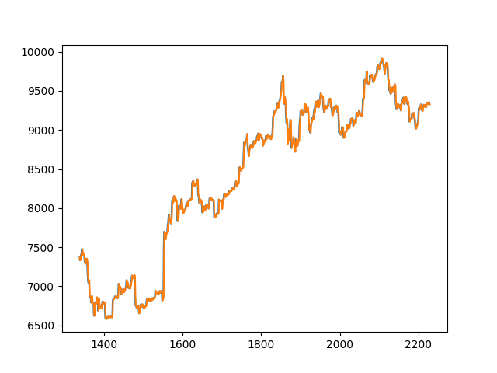
sqrt(mean_squared_error) = 52.81
Now use scaled prediction. Scale → train → predict for scaled data → inverse_scale → calculate errors, plot, etc.
2. past 100 data
# hidden neurons and sqrt(mean_squared_error)

127.90749725918424
60
104.46397017500011
110
95.57550569409257
160
86.9022520053305
210
81.9130448601701
260
77.27227380592812
310
71.93206448111172
360
80.34413446383036
410
77.9333946072431
460
74.47972773351877
510
80.63062115917795
560
78.07839863587107

Now 2 hidden layers. Layer 1 – 300 layer 2- variable
10
90.00260497933027
60
88.15006188591951
110
85.90031697804537
160
84.10937980706314
210
91.2191163698162
260
79.56506468420326
310
80.39577424454714
360
84.20830337112457
410
78.6812825096465
460
82.4500604406582
510
81.10517943337035
560
82.22563150809464
600
83.88604763704144
650
81.2350544922154
700
82.98856946426372
750
80.09746764841509
800
76.9966941183877
850
83.05626026638876
900
77.81469161294433
950
80.82993864534765
1000
78.57273306624816
1050
78.77542373204606
1100
79.4939979893417
1150
80.65705293635014

Worse than last today = tomorrow prediction

3. Use 50 past data

variable is # neurons in the 1st hidden layer

115.87215993149694
60
78.67936402167925
110
67.73974394125172
160
68.11249446467367
210
63.96179700916158
260
63.26095156485205
310
61.8750260018707
360
61.46258942825564
410
60.81514844692079
460
60.61944672010866
510
60.45080722995421
560
59.046963361265426
610
59.40896621328871
660
58.97981208719772
710
58.84325617320855
760
58.82585290617725
810
59.02748610817012
860
58.12607763781264
910
58.02528109421385
960
60.55017776822992
1010
58.81644345065007
1060
58.55624932167615
1110
58.030941570618815
1160
57.84077146519292

Not so good

4. 25 past data

102.58513093399576
60
63.13931452526412
110
59.17678665748528
160
55.424202125007255
210
55.34173800559689
260
54.89736964340453
310
54.81021263569902
360
54.447219795422
410
54.18648405089237
460
54.02950364242586
510
53.88004464167835
560
53.61334909153143
610
53.46016589475943
660
53.76255917531413
710
53.66067657021394
760
53.72147409311426
810
53.84296259576112
860
53.69847551240318
910
53.95208579555367
960
53.568483212491294
1010
53.58757223655378
1060
53.89678654707928
1110
53.58266096616468
1160
53.53173366422356

Similar to today = tomorrow

5. 15 past data
113.5205545638252
51
57.74062846901294
101
56.09724198642539
151
53.998309023863236
201
53.78574575655938
251
53.23564032265412
301
52.987739572202535
351
53.202080537048154
401
53.07383786557403
451
53.1124940888306
501
53.18695492997972
551
53.14566531767358
601
53.01414685891694
651
53.22123414845803
701
53.35656548954888
751
53.136936366214435
801
53.31948658803271
851
53.54396364616261
901
53.28111460964328
951
53.43589568650194
1001
53.359343042422644
1051
53.51207758006619
1101
53.4695634321406
1151
53.311834334590245

still a little worse

6. past 10 data
little better than today = tomorrow
76.71112709019154
51
55.09453838072112
101
53.82563913605916
151
52.787415640603776
201
52.62092070127419
251
52.396982272836375
301
52.39318697590951
351
52.469341415769314
401
52.78968135569989
451
52.747737829029035
501
52.62328951769183
551
52.85668726226735
601
52.82370627250941
651
52.672990954981515
701
52.589250015987844
751
52.764230570022
801
52.75331660974007
851
52.72085545589541
901
52.65654514575826
951
52.89965252664996
1001
52.84938251673527
1051
52.991534498230784
1101
52.871309335574125
1151
52.92037567058778

7. past 6 data
95.59940854702971
51
51.68004400979246
101
51.595621148595825
151
51.85235132903346
201
51.9454052677459
251
51.94504664490209
301
52.05706066160411
351
52.055070986580894
401
52.139003198757756
451
52.218229271192044
501
52.19471193553762
551
52.1776998909932
601
52.144182237629586
651
52.22277192176629
701
52.290713450669834
751
52.2494392155795
801
52.335203565877784
851
52.29367471715028
901
52.29798719151412
951
52.274606715893334
1001
52.307346494017395
1051
52.29118812980492
1101
52.33144874533986
1151
52.310460840301495
a little better

8.past 5 data
83.28461022764581
51
52.360284365501535
101
51.706491929036126
151
52.06961285389176
201
51.97667903272267
251
52.09929188602976
301
52.18540935804273
351
52.21167067971621
401
52.187042380339776
451
52.348812771774604
501
52.24054732618409
551
52.170872337107255
601
52.2061450683815
651
52.21313675552598
701
52.29516448906643
751
52.29989975645503
801
52.2736923091445
851
52.27862221054246
901
52.26779073053965
951
52.28299967384162
1001
52.271953252481644
1051
52.30506618568906
1101
52.28203247241133
1151
52.351733678782
little better

Now add second layer and change # neurons
No use. Keep layer 1 = 100 and tune other parameters
Tuned model :

hidden layers = 1 neurons = 200
learning rate = 0.00001
others default
sqrt(mean_squared_error) = around 51.5

little better than today = tomorrow

Predict with linear regression
past data - sqrt(square_mean_error)
100 – 53.42
50 – 52.59
25 – 52.38
10 – 52.14
9 – 52.36
8 – 51.84
7 – 51.76
6 – 52.33
5 – 52.01
4 – 51.80
3 – 53.38
2 – 66.81

Take past 7 hours data to predict ??

LSTM
past 7 data
epochs = 1500, neurons = 3, batch_size = 1 always
error = 63.32

epochs = 300, neurons = 1
error = 73.48654410995418

300,2
error = 53.23172206056109

300,3
58.40

300,4
56.44942515578164
dropout = 0.1, recurrent_dropout = 0.0
54.47057683065034

300,5
64.30

……..
……..

300,20
64.64795552137883

600,4
79.73774705858575

150,4
55.180939097708055

75,4
58.77

20,4
53.2811431569351
dropout = 0.5 recurrent_dropout = 0.5
56.77
0.1,0
53.084752590328605
0.2,0
53.59731962648303
0.5,0
56.019769124834895
0.7,0
60.413435195616515
0.1,0.1
53.118084832492535

10,4
55.23050124345544

5,4
59.1733032301742

