**Finding Testers**

As there multiple ways to solve this assignment, I chose a more involved solution to which I will explain during the demonstration.

My solution was to build a working REST application (less a UI). I used a MySQL database with Spring Boot/Java that exposes a REST web service to call for the tester information.

Dev Tools Needed:

* Java 8
* Spring Tools Suite 4 (4.12.0.RELEASE)
* MySQL Database (8.0.28)
* Postman

Directions

**NOTE**: I realized you may not be able to run this since I did build a web application that includes a database. I’m more than happy to demo it.

Install MySQL.

Create a new schema, APPLAUSE.

Using a Database IDE, run the “DB_Script.sql” file.

* The schema Tables will be created first with any Foreign Key alterations followed by the Data insertions.

Download/save the zip.

Unpack the zip file.

Import the application into STS4 (Spring Tool Suite/Eclipse).

From the menu toolbar, “Clean” the project and be sure “Build Automatically” is selected.

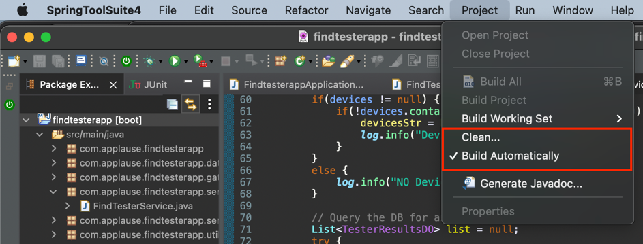

Upon successful clean/build, right-click and select “Run as” and choose “Spring Boot App”.

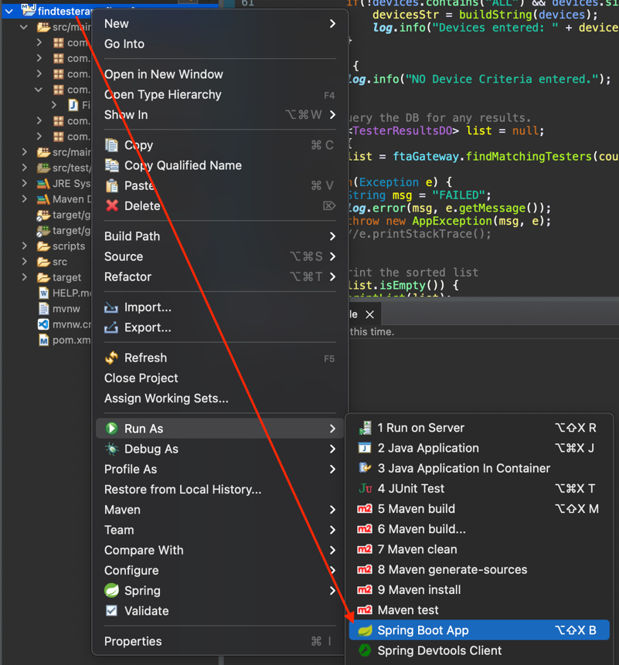

Open Postman.

Create a “GET” REST call to use specified criteria to find Testers that are a match.

The base URL with no criteria is:

<http://localhost:8080/rest/find-testers/find-matching-testers>

Paste this portion of the URL in the textbox between the “GET” dropdown and the “Send” button.

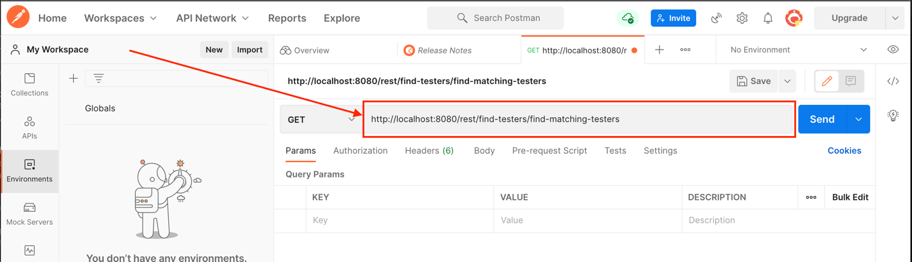

Create criteria for a parameter of “countries” and a parameter of “devices” by doing the following:

* Click in the “Key” textbox and type “countries”. Tab to “Values” and combinations of US, GB, and JP.
* For example (comma separated)
  + US, GB
* Click in the “Key” textbox and type “devices”. Tab to “Values” and combinations of the list of devices.
* For example (comma separated)
  + Nexus 4, iPhone 4, Galaxy S3

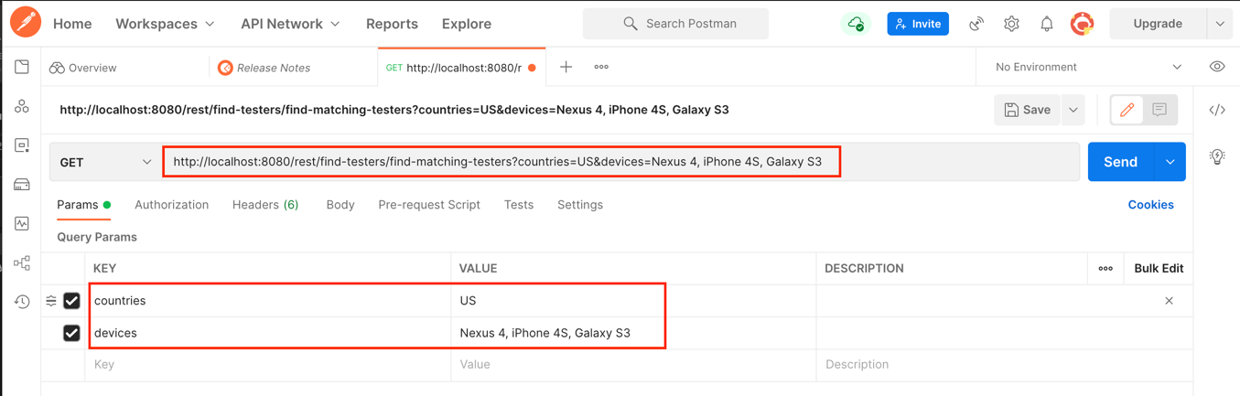

Click “Send” to make the REST call.

http://localhost:8080/rest/find-testers/find-matching-testers?countries=US&devices=Nexus 4, iPhone 4S, Galaxy S3

A successful call will return a message to Postman.

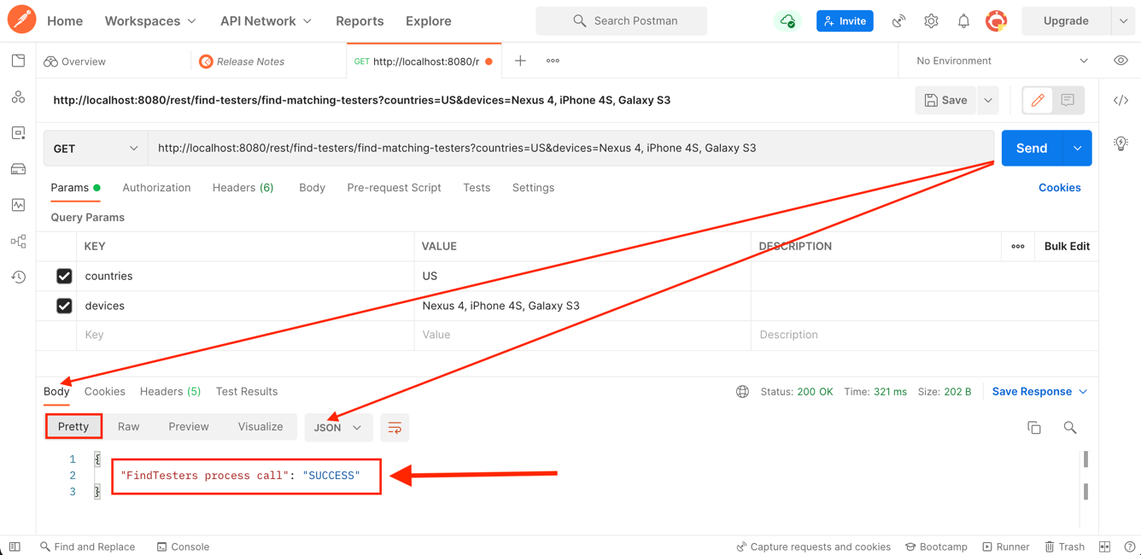

Criteria Case #1

Countries – US, GB

Devices – Nexus 4, iPhone 4S, Galaxy S3

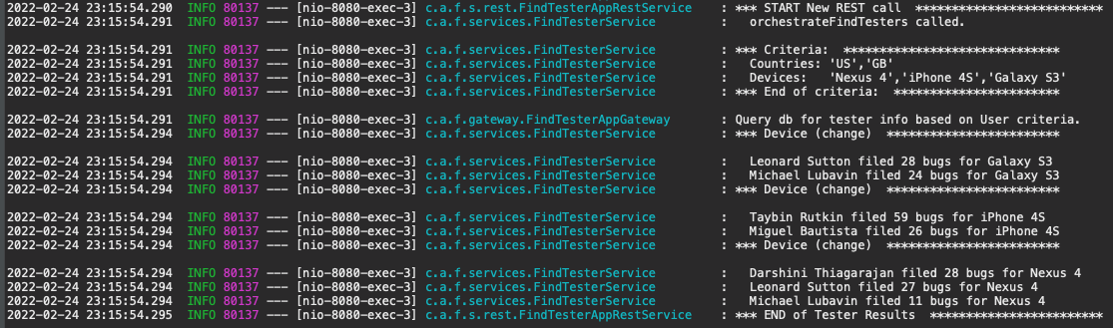

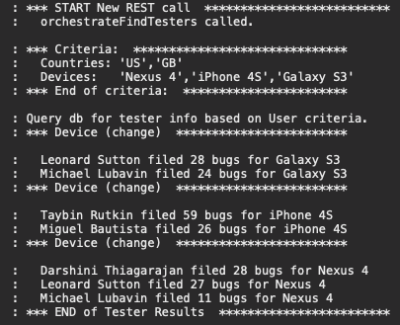

Criteria Case #2

Countries – GB, JP

Devices – Droid Razor, HTC One

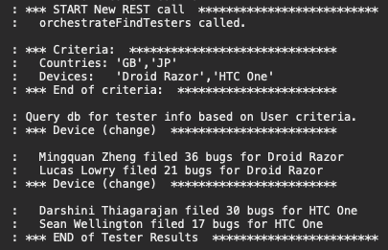

Criteria Case #3

Countries – ALL

Devices – iPhone 5, Galaxy S4

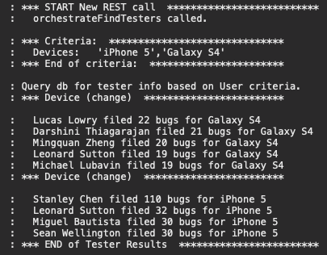

Criteria Case #4

Countries – kkr&3 (error on purpose)

Devices – iPhone 3, Droid DNA

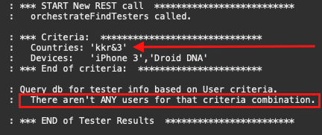

Criteria Case #5

Countries – ALL

Devices – ALL

