Lab2

**DDL**

1-4.

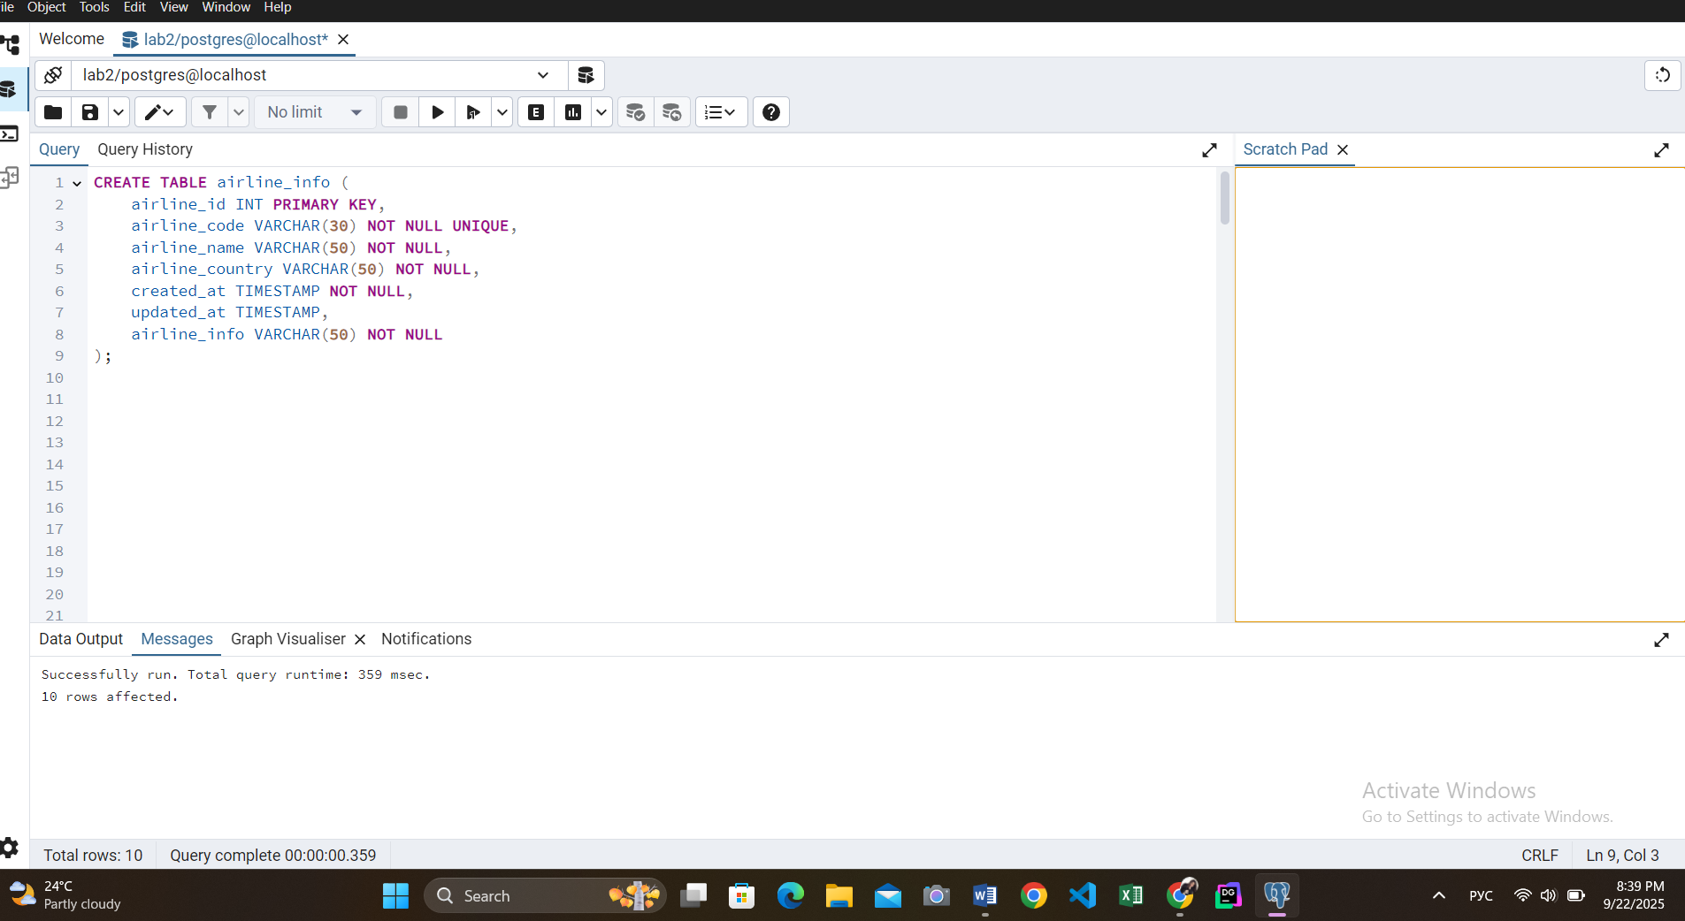

CREATE TABLE airline_info (

airline_id INT PRIMARY KEY,

airline_code VARCHAR(30) NOT NULL UNIQUE,

airline_name VARCHAR(50) NOT NULL,

airline_country VARCHAR(50) NOT NULL,

created_at TIMESTAMP NOT NULL,

updated_at TIMESTAMP,

airline_info VARCHAR(50) NOT NULL

);

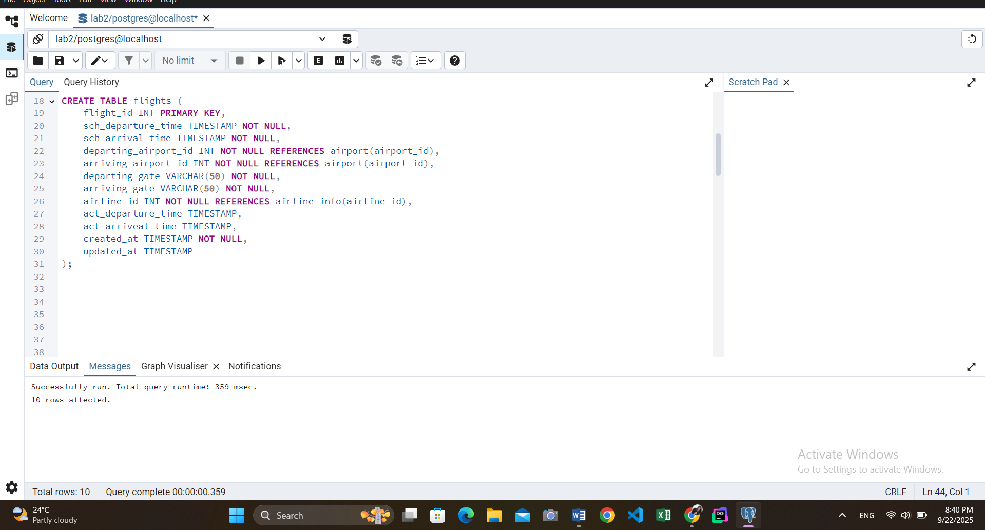

CREATE TABLE flights (

flight_id INT PRIMARY KEY,

sch_departure_time TIMESTAMP NOT NULL,

sch_arrival_time TIMESTAMP NOT NULL,

departing_airport_id INT NOT NULL REFERENCES airport(airport_id),

arriving_airport_id INT NOT NULL REFERENCES airport(airport_id),

departing_gate VARCHAR(50) NOT NULL,

arriving_gate VARCHAR(50) NOT NULL,

airline_id INT NOT NULL REFERENCES airline_info(airline_id),

act_departure_time TIMESTAMP,

act_arriveal_time TIMESTAMP,

created_at TIMESTAMP NOT NULL,

updated_at TIMESTAMP

);

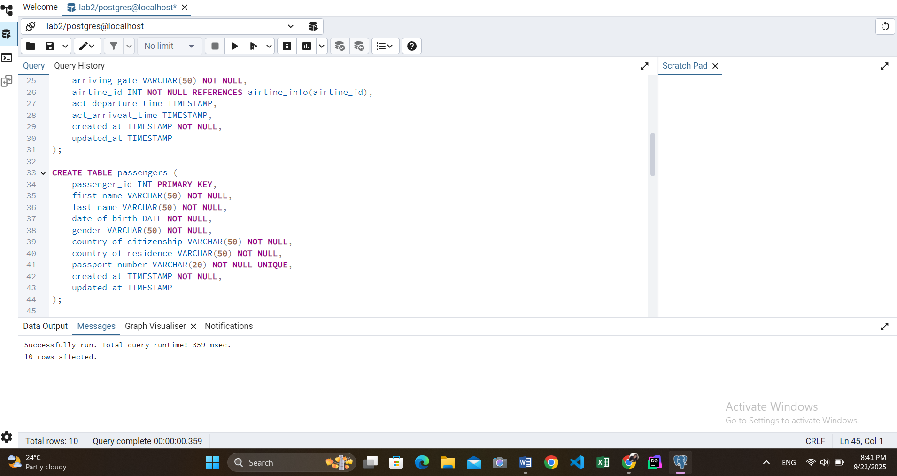

CREATE TABLE passengers (

passenger_id INT PRIMARY KEY,

first_name VARCHAR(50) NOT NULL,

last_name VARCHAR(50) NOT NULL,

date_of_birth DATE NOT NULL,

gender VARCHAR(50) NOT NULL,

country_of_citizenship VARCHAR(50) NOT NULL,

country_of_residence VARCHAR(50) NOT NULL,

passport_number VARCHAR(20) NOT NULL UNIQUE,

created_at TIMESTAMP NOT NULL,

updated_at TIMESTAMP

);

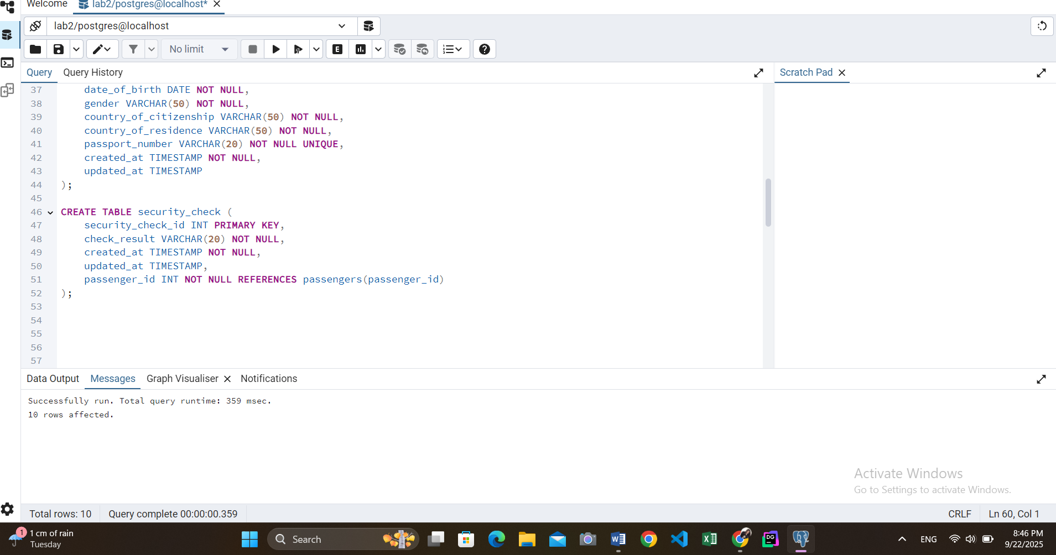CREATE TABLE security_check (

security_check_id INT PRIMARY KEY,

check_result VARCHAR(20) NOT NULL,

created_at TIMESTAMP NOT NULL,

updated_at TIMESTAMP,

passenger_id INT NOT NULL REFERENCES passengers(passenger_id)

);

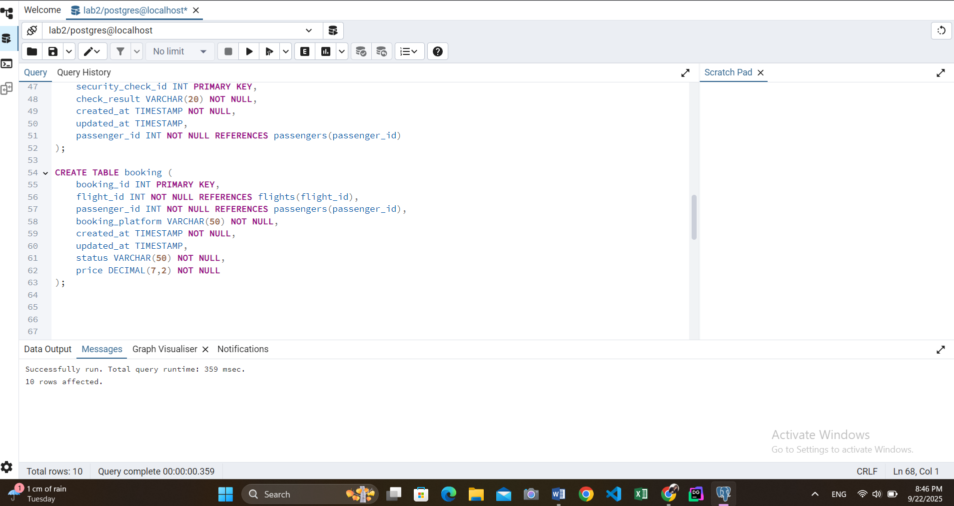

CREATE TABLE booking (

booking_id INT PRIMARY KEY,

flight_id INT NOT NULL REFERENCES flights(flight_id),

passenger_id INT NOT NULL REFERENCES passengers(passenger_id),

booking_platform VARCHAR(50) NOT NULL,

created_at TIMESTAMP NOT NULL,

updated_at TIMESTAMP,

status VARCHAR(50) NOT NULL,

price DECIMAL(7,2) NOT NULL

);

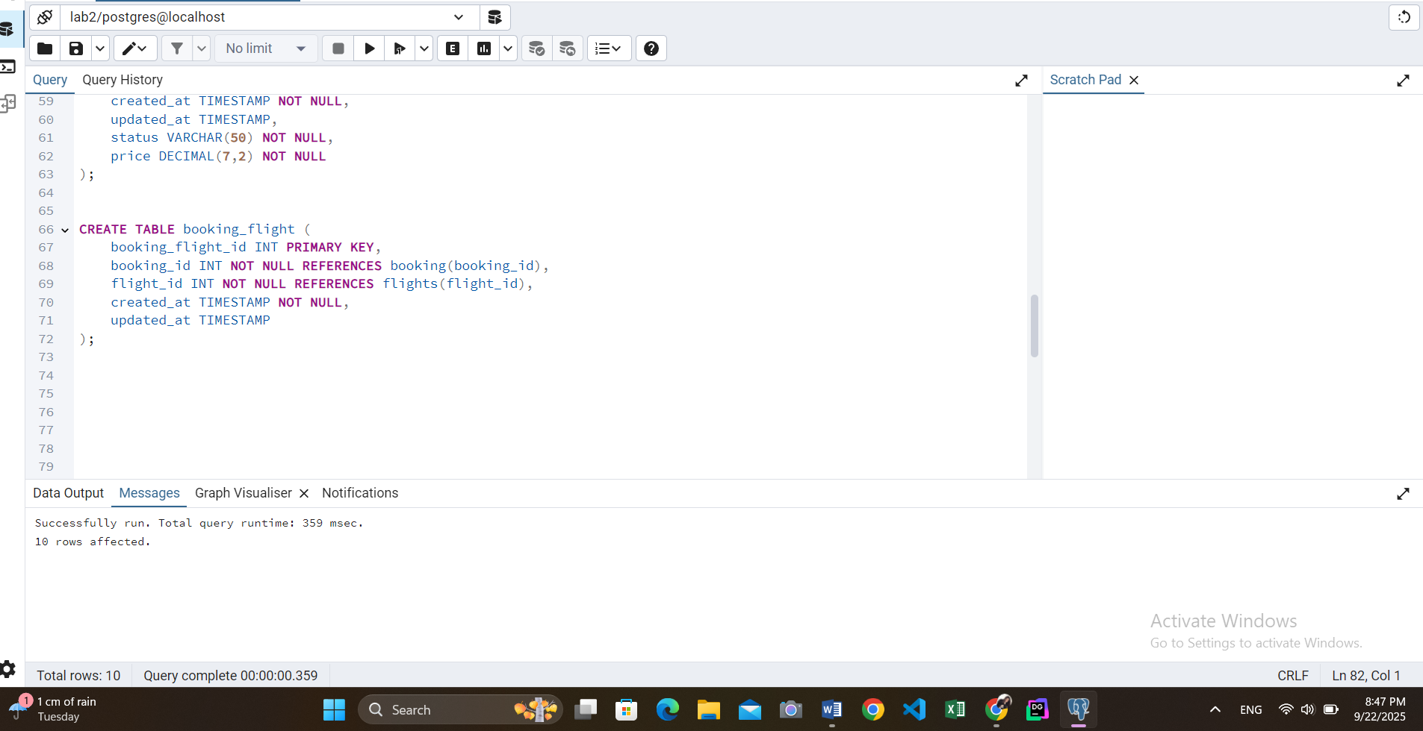

CREATE TABLE booking_flight (

booking_flight_id INT PRIMARY KEY,

booking_id INT NOT NULL REFERENCES booking(booking_id),

flight_id INT NOT NULL REFERENCES flights(flight_id),

created_at TIMESTAMP NOT NULL,

updated_at TIMESTAMP

);

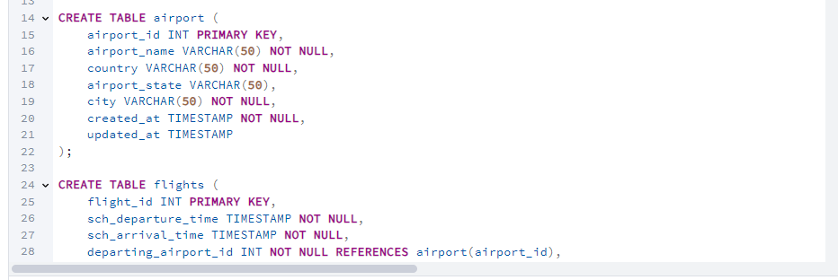

CREATE TABLE airport (

airport_id INT PRIMARY KEY,

airport_name VARCHAR(50) NOT NULL,

country VARCHAR(50) NOT NULL,

airport_state VARCHAR(50),

city VARCHAR(50) NOT NULL,

created_at TIMESTAMP NOT NULL,

updated_at TIMESTAMP

);

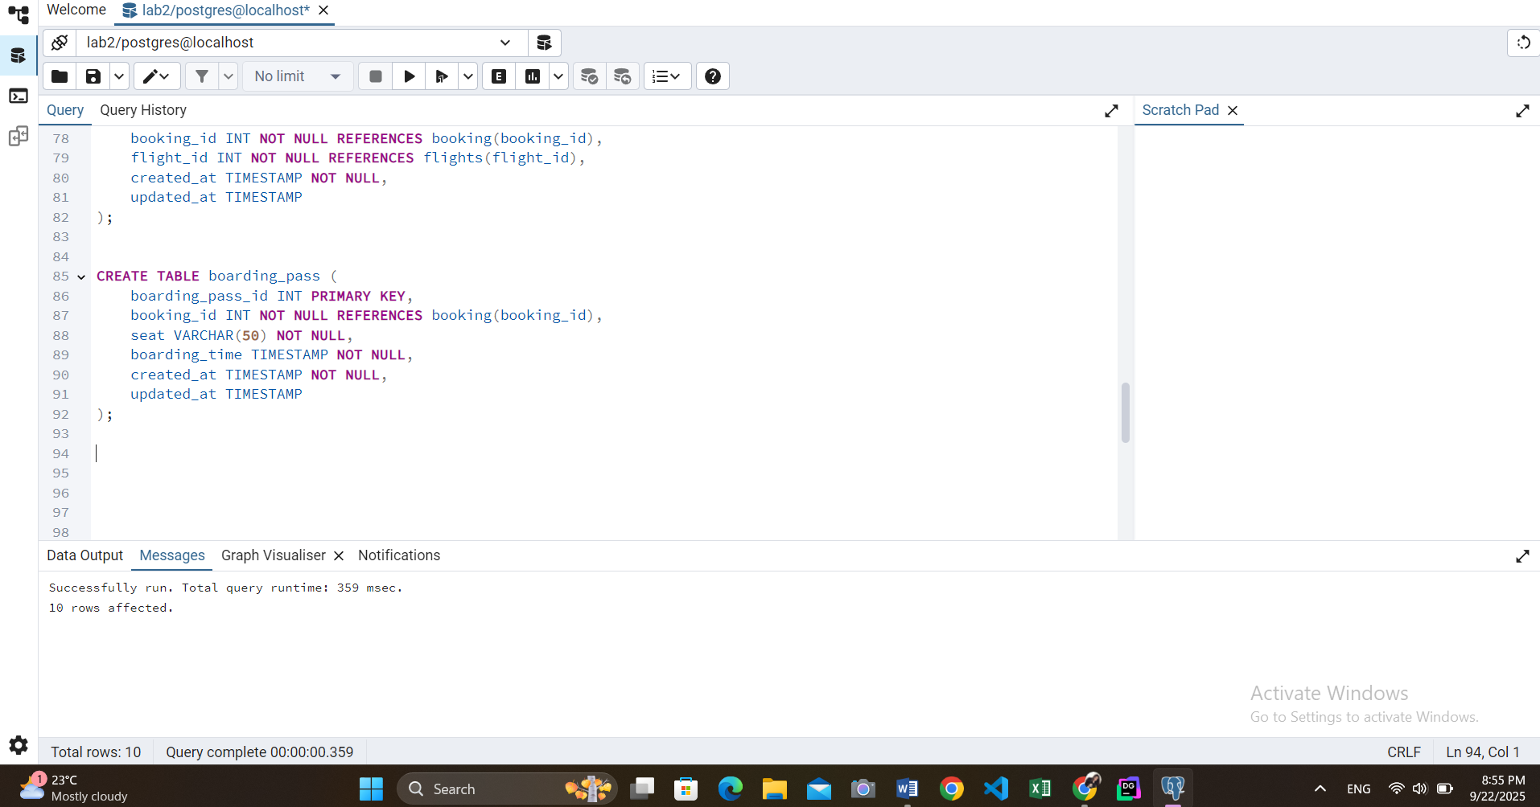

CREATE TABLE boarding_pass (

boarding_pass_id INT PRIMARY KEY,

booking_id INT NOT NULL REFERENCES booking(booking_id),

seat VARCHAR(50) NOT NULL,

boarding_time TIMESTAMP NOT NULL,

created_at TIMESTAMP NOT NULL,

updated_at TIMESTAMP

);

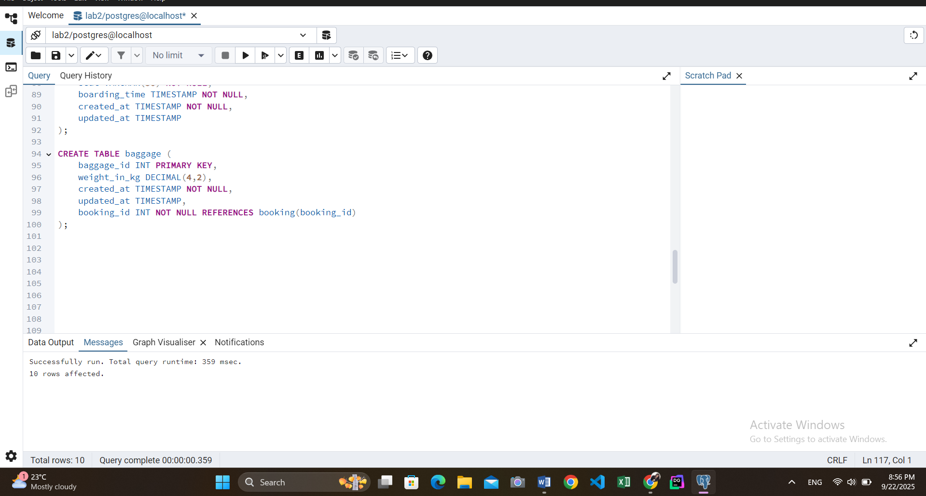

CREATE TABLE baggage (

baggage_id INT PRIMARY KEY,

weight_in_kg DECIMAL(4,2),

created_at TIMESTAMP NOT NULL,

updated_at TIMESTAMP,

booking_id INT NOT NULL REFERENCES booking(booking_id)

);

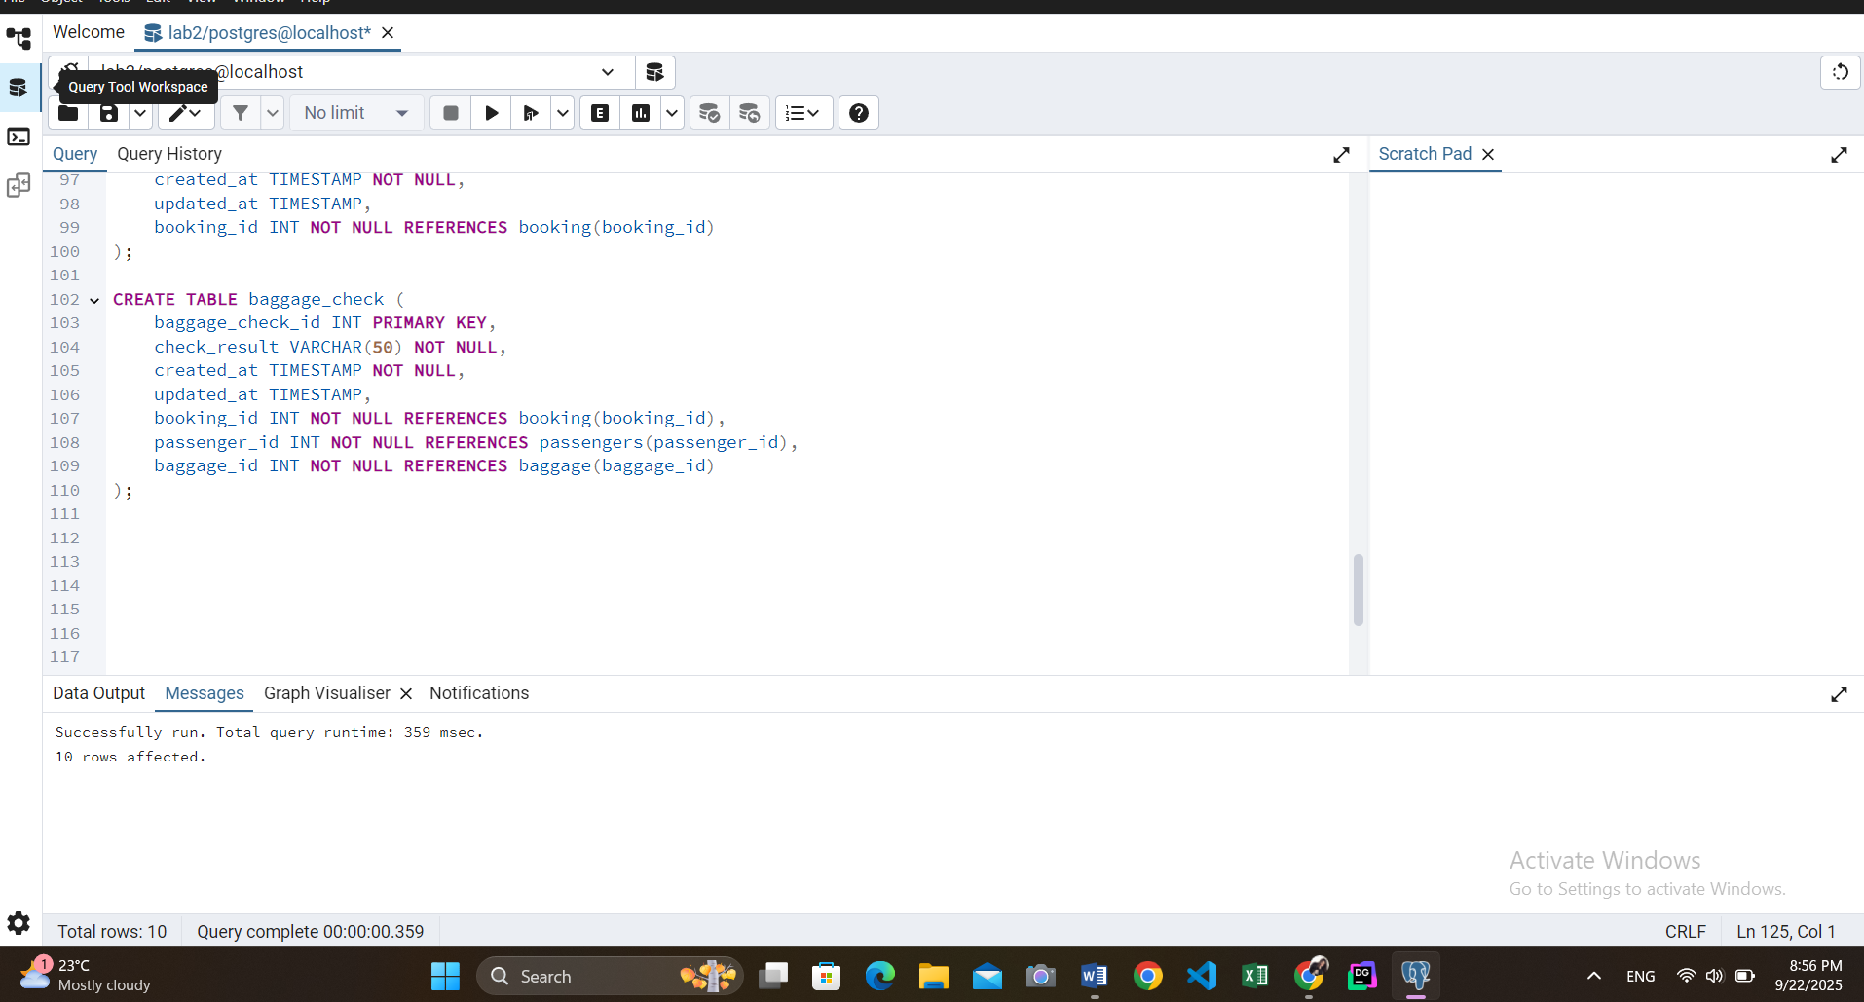

CREATE TABLE baggage_check (

baggage_check_id INT PRIMARY KEY,

check_result VARCHAR(50) NOT NULL,

created_at TIMESTAMP NOT NULL,

updated_at TIMESTAMP,

booking_id INT NOT NULL REFERENCES booking(booking_id),

passenger_id INT NOT NULL REFERENCES passengers(passenger_id),

baggage_id INT NOT NULL REFERENCES baggage(baggage_id)

);

*Also, there is another way of defining FOREIGN KEY: ex:

ALTER TABLE security_check ADD CONSTRAINT fk_passenger FOREIGN KEY (passenger_id) REFERENCES passengers(passenger_id);

5-8.

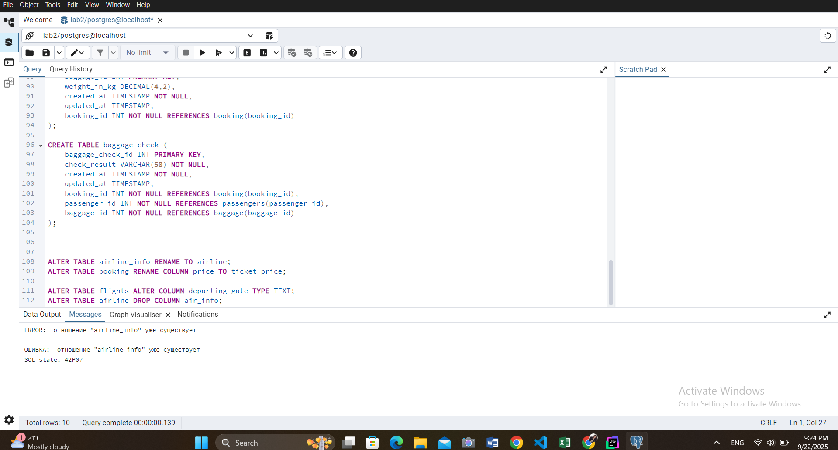

ALTER TABLE airline_info RENAME TO airline;

ALTER TABLE booking RENAME COLUMN price TO ticket_price;

ALTER TABLE flights ALTER COLUMN departing_gate TYPE TEXT;

ALTER TABLE airline DROP COLUMN air_info;

9.

Doing it by second method:

***Airport with Flights by departing_airport_id:***

ALTER TABLE flights ADD CONSTRAINT fk_flights_departing_airport FOREIGN KEY (departing_airport_id) REFERENCES airport(airport_id);

***Airport with Flights by arriving_airport_id:***

ALTER TABLE flights ADD CONSTRAINT fk_flights_arriving_airport FOREIGN KEY (arriving_airport_id) REFERENCES airport(airport_id);

***Airline with Flights by airline_id:***

ALTER TABLE flights ADD CONSTRAINT fk_flights_airline FOREIGN KEY (airline_id) REFERENCES airline(airline_id);

***Passengers with Secuitiry_check, Booking, Baggage_check by passenger_id:***

ALTER TABLE security_check ADD CONSTRAINT fk_security_check_passenger FOREIGN KEY (passenger_id) REFERENCES passengers(passenger_id);

ALTER TABLE booking ADD CONSTRAINT fk_booking_passenger FOREIGN KEY (passenger_id) REFERENCES passengers(passenger_id);

ALTER TABLE baggage_check ADD CONSTRAINT fk_baggage_check_passenger FOREIGN KEY (passenger_id) REFERENCES passengers(passenger_id);

***Flights with Booking_flight by flight_id:***

ALTER TABLE booking ADD CONSTRAINT fk_booking_flight FOREIGN KEY (flight_id) REFERENCES flights(flight_id);

***Booking with Baggage_check, Baggage, Boarding_pass, Booking_flight by booking_id:***

ALTER TABLE booking_flight ADD CONSTRAINT fk_booking_flight_booking FOREIGN KEY (booking_id) REFERENCES booking(booking_id);

ALTER TABLE boarding_pass ADD CONSTRAINT fk_boarding_pass_booking FOREIGN KEY (booking_id) REFERENCES booking(booking_id);

ALTER TABLE baggage ADD CONSTRAINT fk_baggage_booking FOREIGN KEY (booking_id) REFERENCES booking(booking_id);

ALTER TABLE baggage_check ADD CONSTRAINT fk_baggage_check_booking FOREIGN KEY (booking_id) REFERENCES booking(booking_id);

**DML**

1

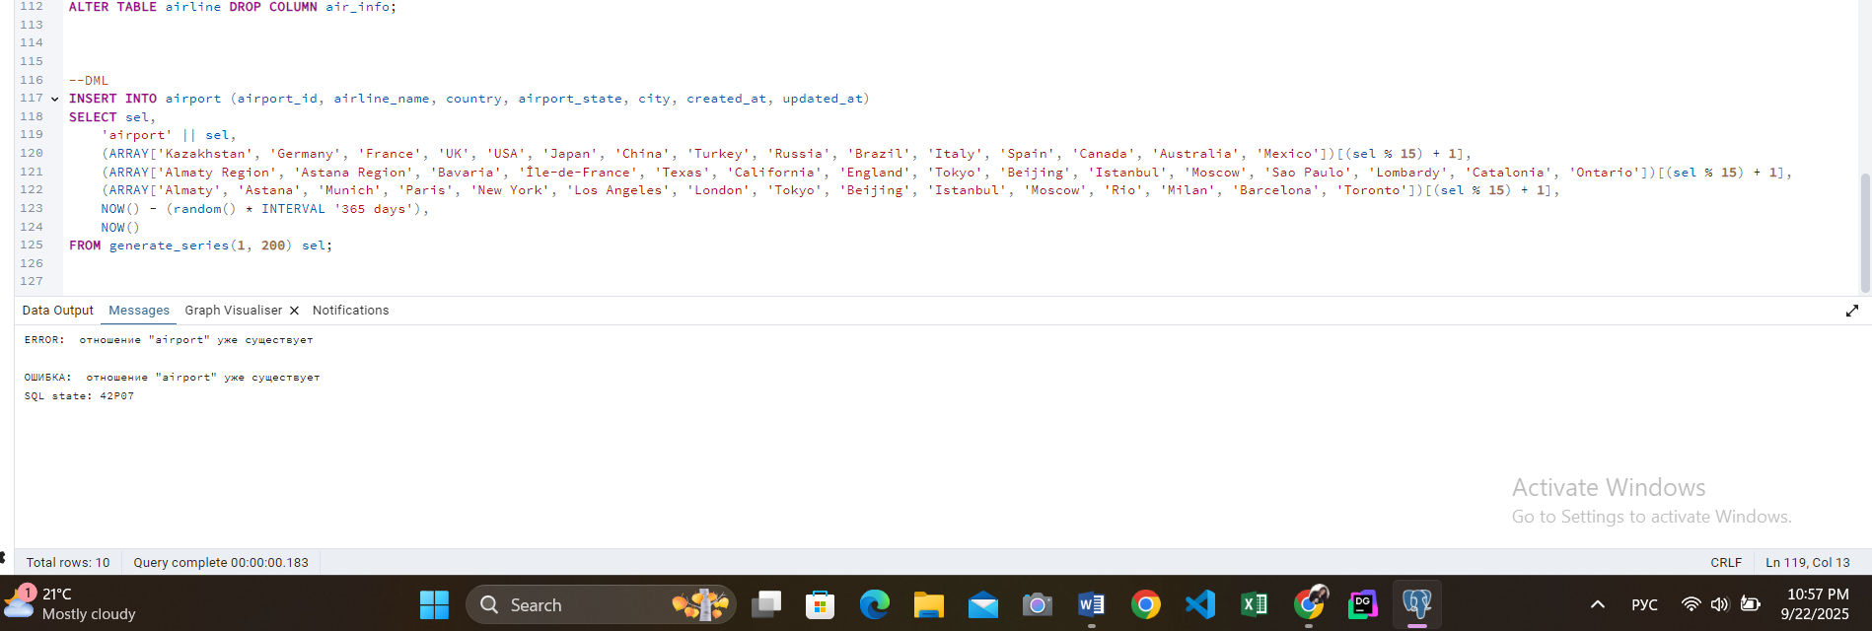

INSERT INTO airport (airport_id, airport_name, country, airport_state, city, created_at, updated_at)

SELECT sel,

'airport' || sel,

(ARRAY['Kazakhstan', 'Germany', 'France', 'UK', 'USA', 'Japan', 'China', 'Turkey', 'Russia', 'Brazil', 'Italy', 'Spain', 'Canada', 'Australia', 'Mexico'])[(sel % 15) + 1],

(ARRAY['Almaty Region', 'Astana Region', 'Bavaria', 'Île-de-France', 'Texas', 'California', 'England', 'Tokyo', 'Beijing', 'Istanbul', 'Moscow', 'Sao Paulo', 'Lombardy', 'Catalonia', 'Ontario'])[(sel % 15) + 1],

(ARRAY['Almaty', 'Astana', 'Munich', 'Paris', 'New York', 'Los Angeles', 'London', 'Tokyo', 'Beijing', 'Istanbul', 'Moscow', 'Rio', 'Milan', 'Barcelona', 'Toronto'])[(sel % 15) + 1],

NOW() - (random() * INTERVAL '365 days'),

NOW()

FROM generate_series(1, 200) sel;

2

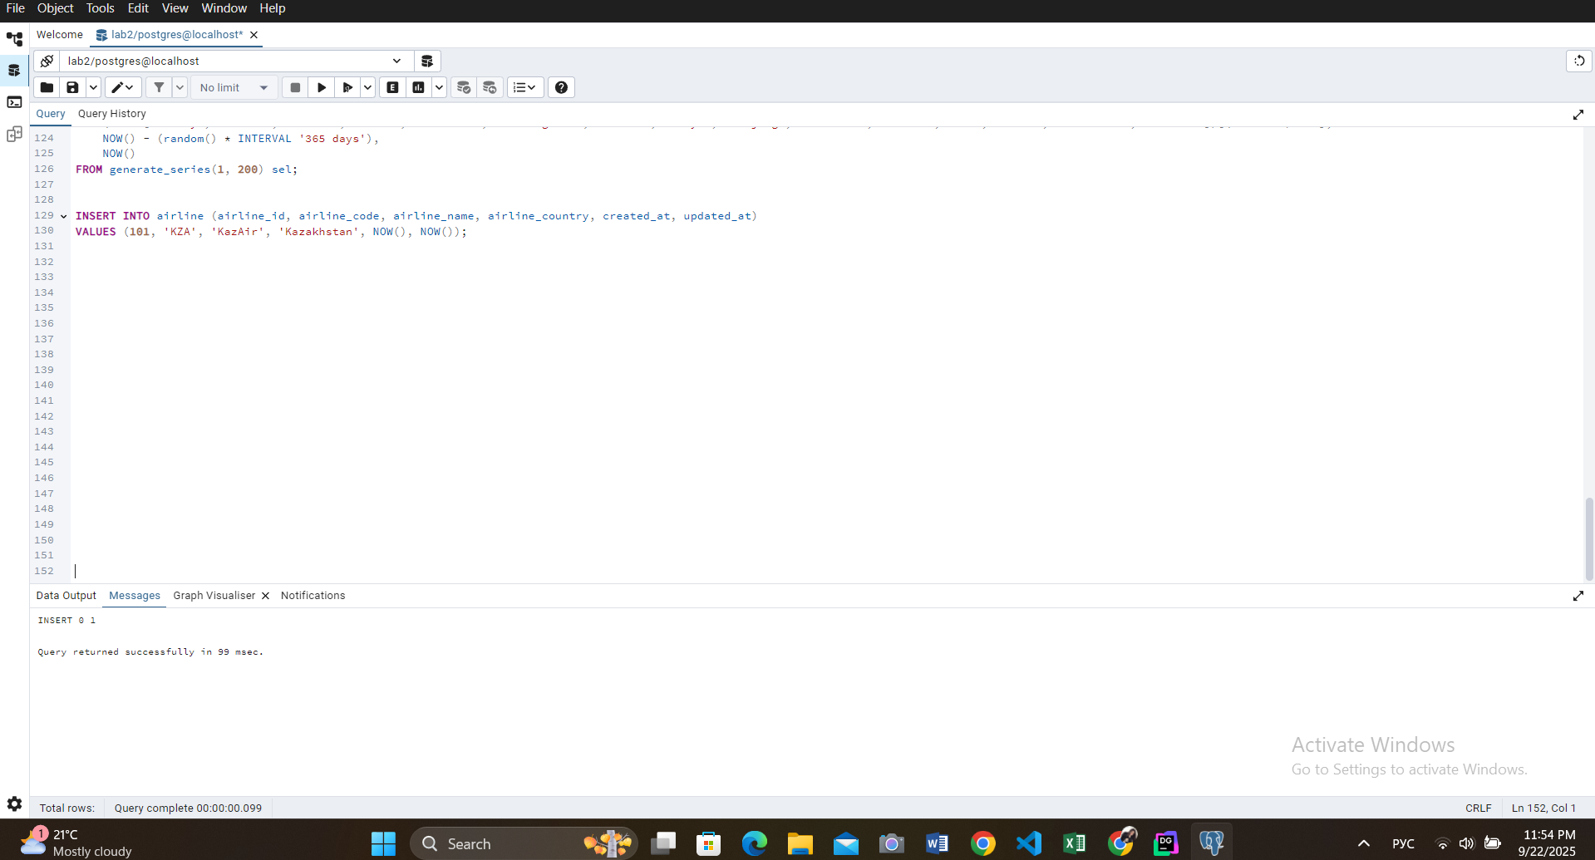

INSERT INTO airline (airline_id, airline_code, airline_name, airline_country, created_at, updated_at)

VALUES (101, 'KZA', 'KazAir', 'Kazakhstan', NOW(), NOW());

3

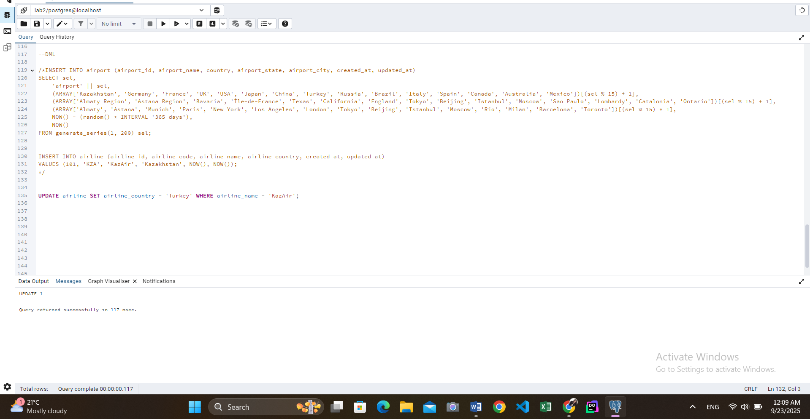

UPDATE airline SET airline_country = 'Turkey' WHERE airline_name = 'KazAir';

4

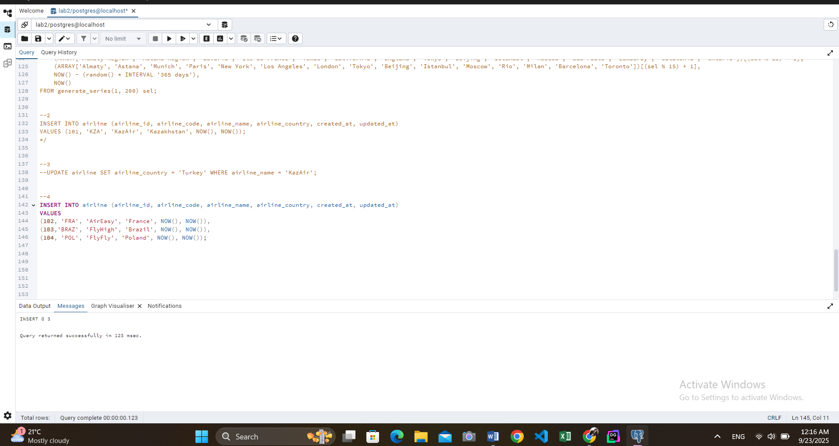

INSERT INTO airline (airline_id, airline_code, airline_name, airline_country, created_at, updated_at)

VALUES

(102, 'FRA', 'AirEasy', 'France', NOW(), NOW()),

(103,'BRAZ', 'FlyHigh', 'Brazil', NOW(), NOW()),

(104, 'POL', 'FlyFly', 'Poland', NOW(), NOW());

5

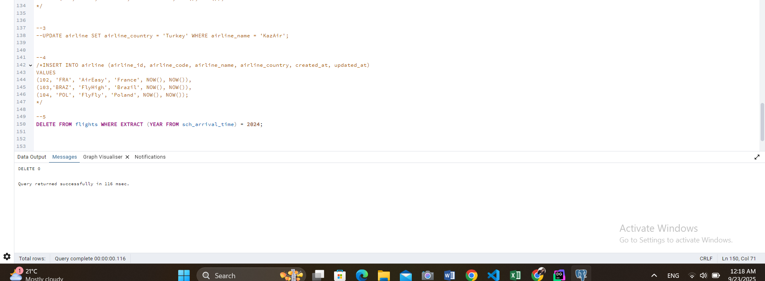

DELETE FROM flights WHERE EXTRACT (YEAR FROM sch_arrival_time) = 2024;

6

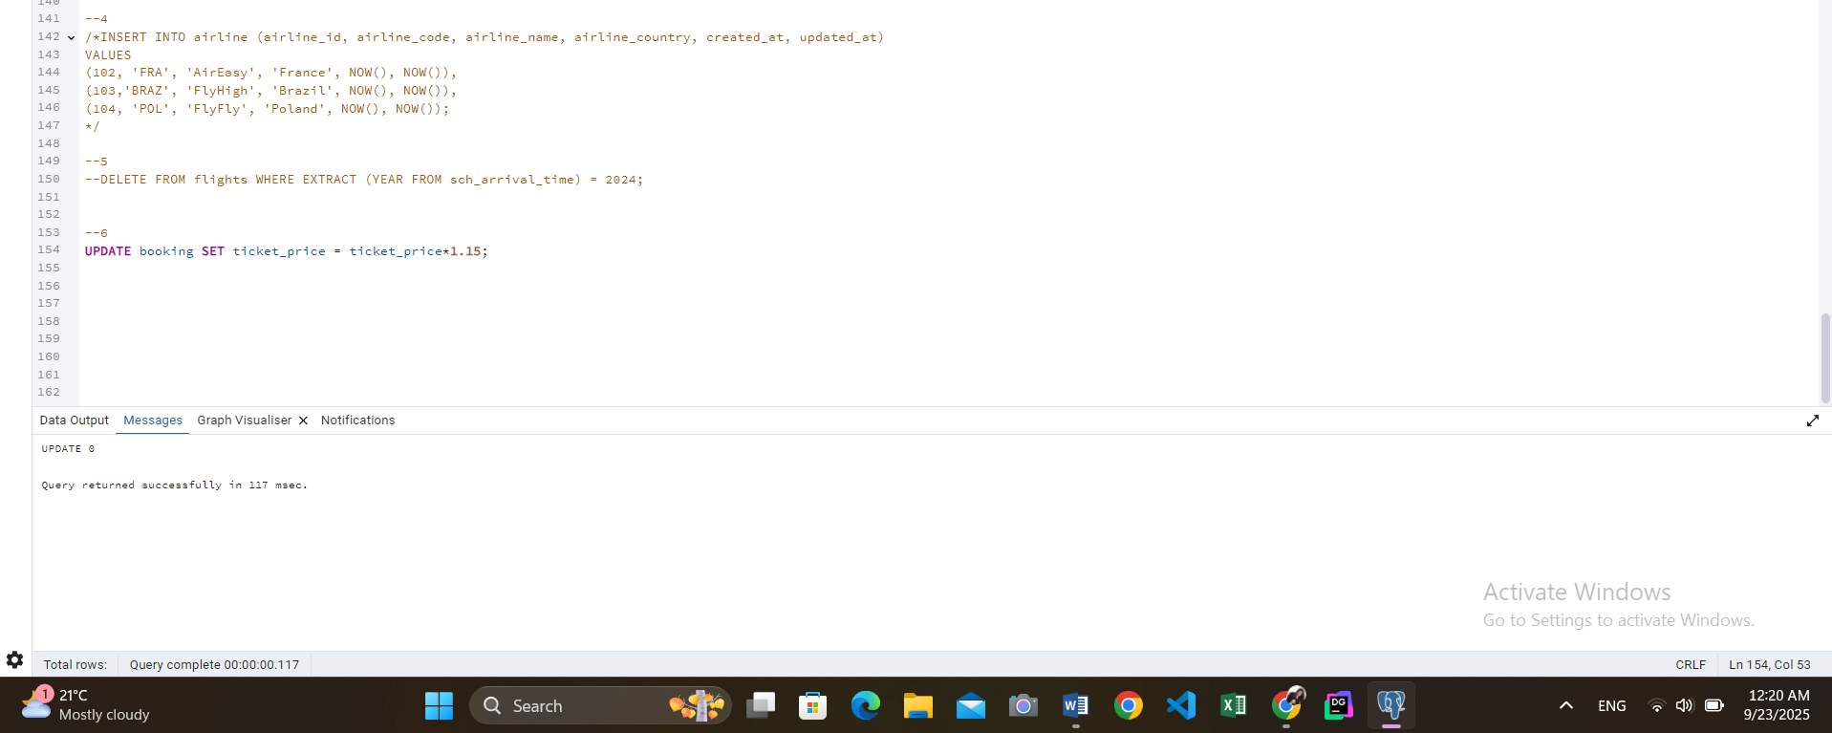

UPDATE booking SET ticket_price = ticket_price*1.15;

7

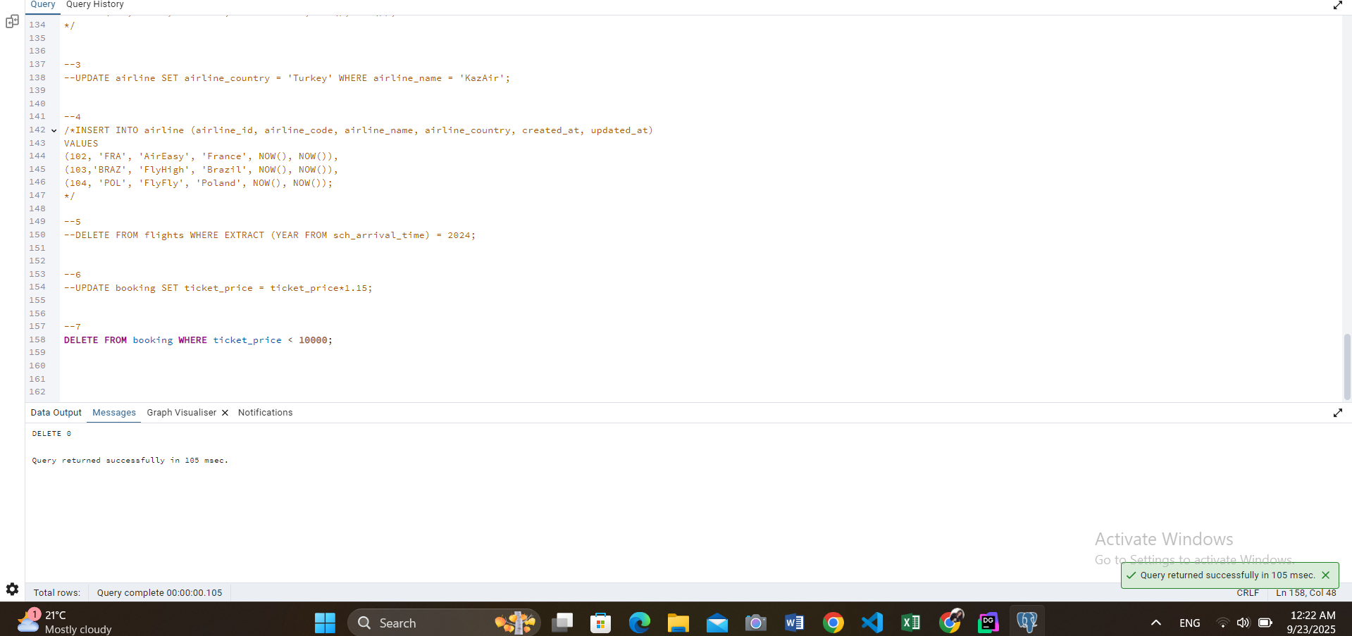

DELETE FROM booking WHERE ticket_price < 10000;