Forget me not - UI

Main Menu

* Continue
  + Level option
* New game
* Options
  + Sound control
  + keybinds
* Credits
* Exit the game/Quit

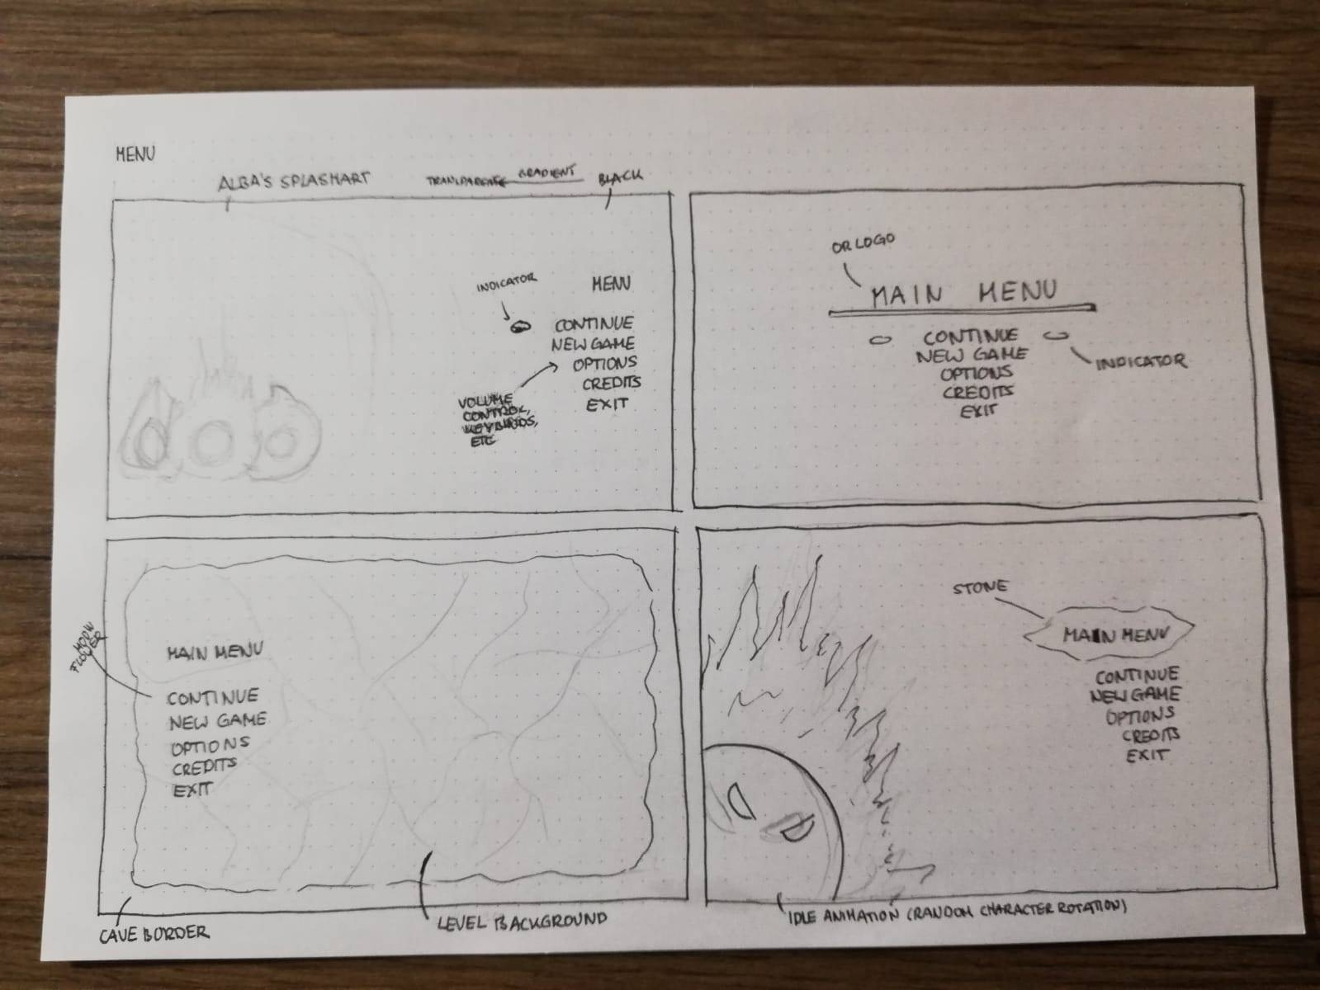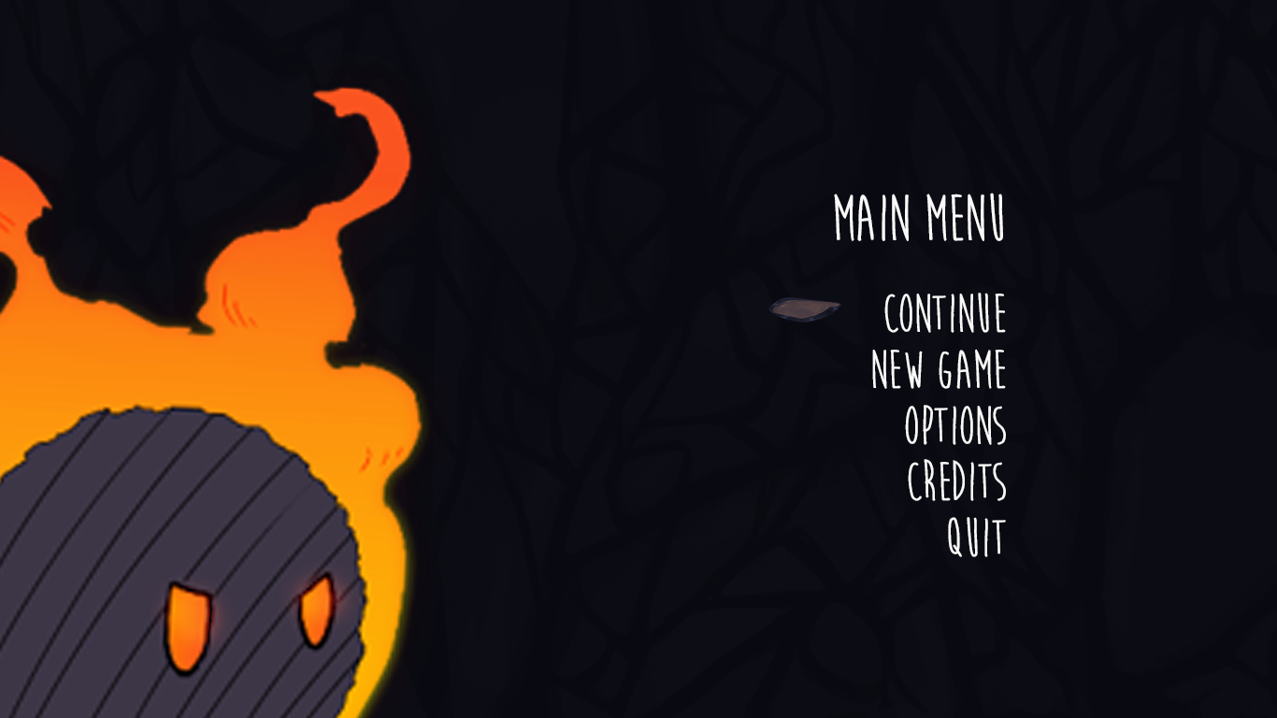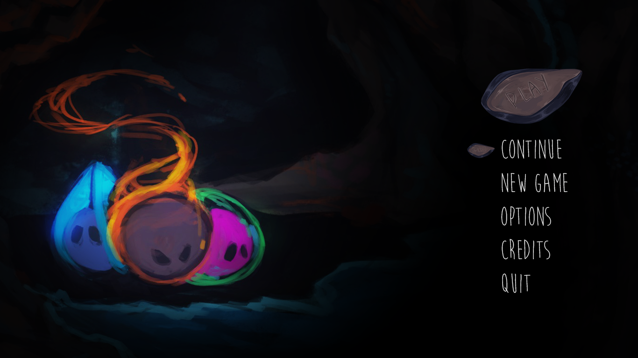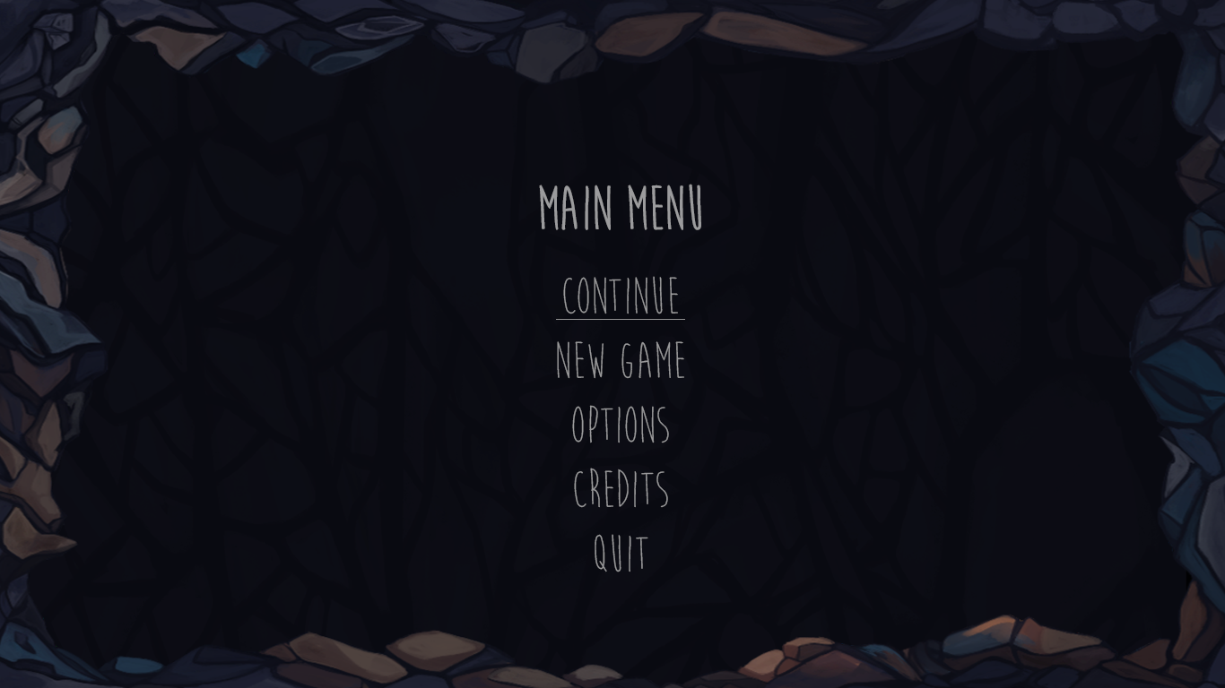

In-game Menu

Hierarchy Option 1

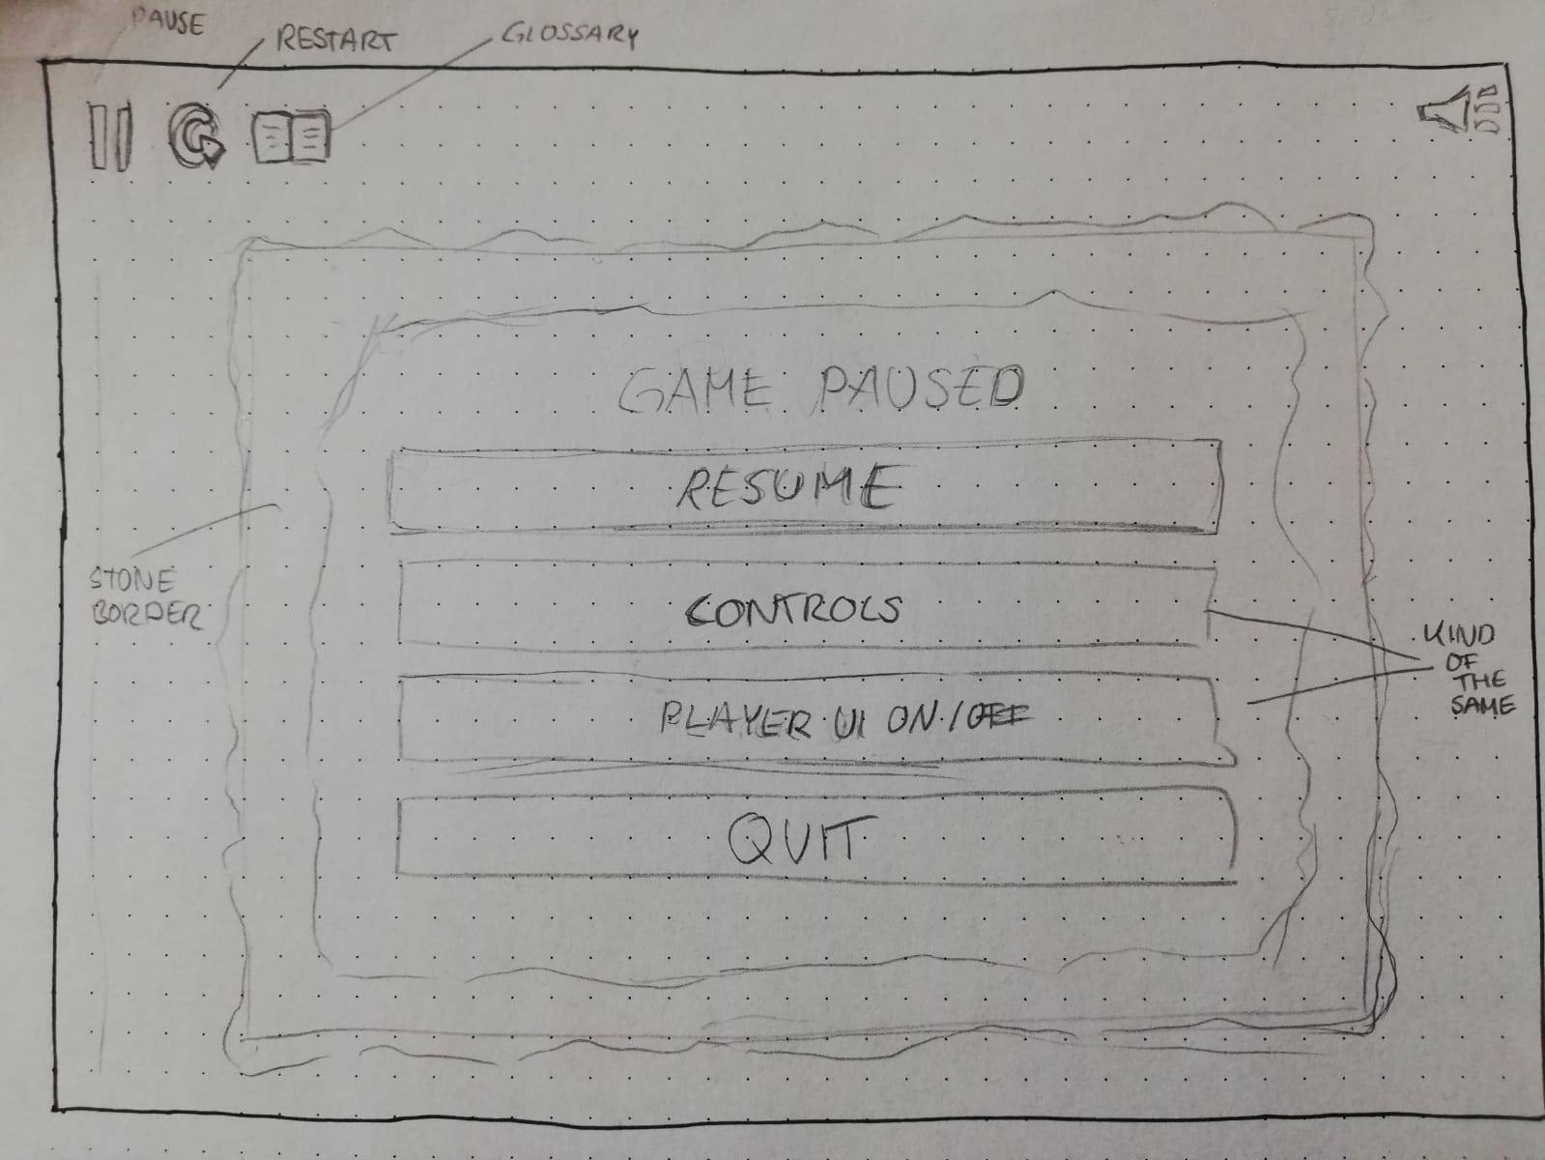

Different buttons for easy access to restart and to get to the glossary.

* restart (there should probably be a keybind for that as well)
* glossary (probably not that important, so it could be included in the pause menu)
* mute buttons (music, effects) (I personally prefer sound control options, but this also depends on you)
* pause button:
  + Resume
  + controls
  + player ui on/off (see discussion about the player UI)
  + back to main menu/Exit

Hierarchy option 2

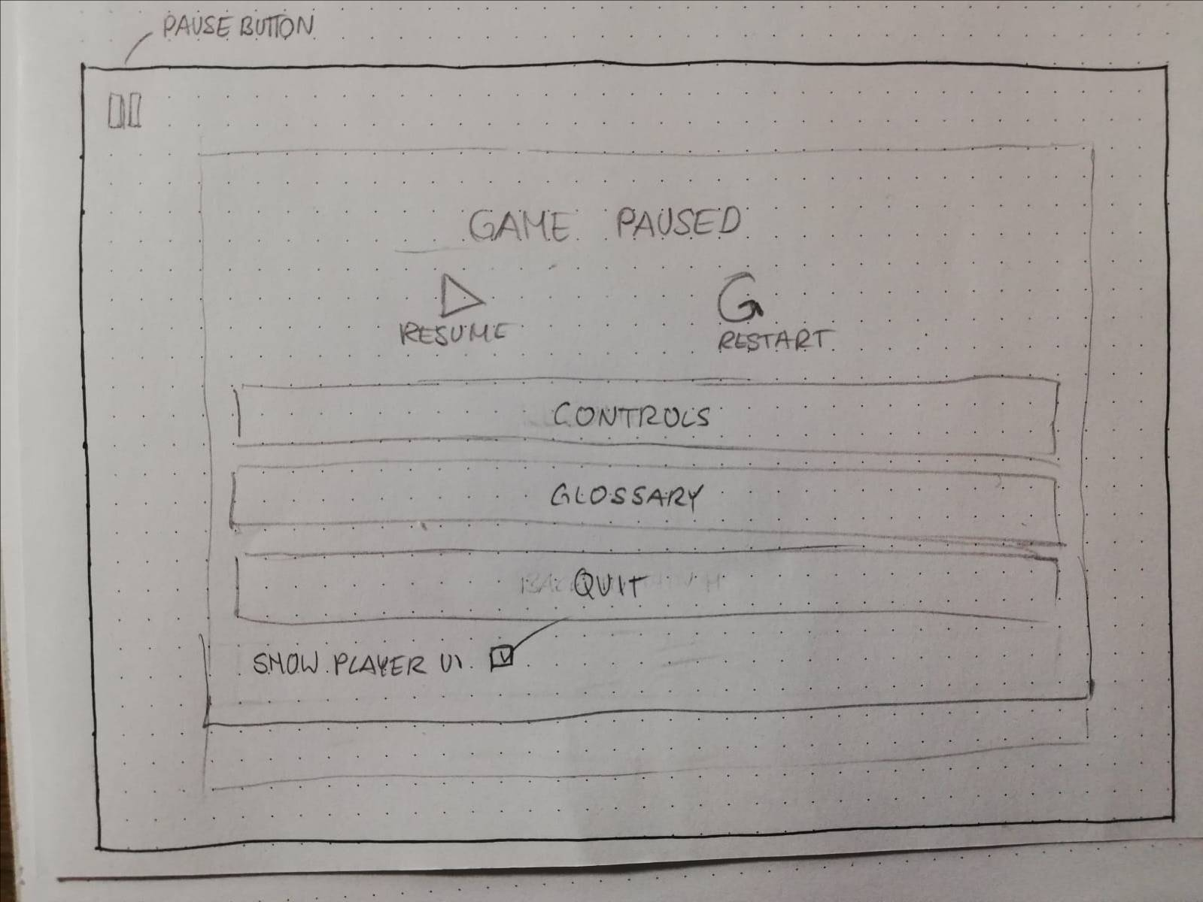

The pause button is the only icon on the screen during the levels/ press esc to get to the pause menu (pause button is not needed).

* pause
  + resume
  + restart
  + glossary
  + controls
    - keybinds
    - sound control
  + back to main menu/exit