

**Fuel Your Passion, Energize Your Day**

**Only at APH Coffee**

| **PREPARED BY:** | | |
| --- | --- | --- |
| **NO.** | **NAME** | **ID** |
| 1 | HAZMI SHAFIQ BIN HAMIRUDDIN | BSW01084686 |
| 2 | PUTERI AINA BINTI NOES | BSW01084927 |
| 3 | ALLYSHA IMAN BINTI FAIZAL RIZA | BSW01085194 |

**Table of Contents**

1. Cover Page
2. Table of Contents
3. Introduction

3.1 Purpose

3.2 Location

3.3 Overview

1. Target Audience

4.1 Demographics

4.2 Cultural & Local Influences

4.3 Psychographics

1. Menu Development and Sourcing

5.1 Signature Beverages

5.2 Catering to Dietary Preferences

5.3 Customization

5.4 Pricing Strategy

1. Marketing Strategy

6.1 Using Social Medias

6.2 Promotions

6.3 Events

6.4 Product Collaborations

6.5 Sustainability Practices

1. Conclusion

7.1 Summary of Benefits

7.2 Call to Action:

**3.0 INTRODUCTION**

#### **3.1 Purpose**

* **Quality and Creativity** : The core purpose of APH Coffee is to provide an exceptional coffee experience, showcasing premium coffee blends and unique signature drinks that stand out in both flavor and presentation.
* **Community Building**: Beyond coffee, APH Coffee aims to be a hub for connection, fostering meaningful relationships and creating a sense of belonging for every visitor.
* **Sustainability and Responsibility**: We are committed to eco-friendly practices, using biodegradable packaging, ethically sourced coffee beans, and offering incentives for reusable cups, ensuring that our operations contribute positively to the environment.

#### **3.2 Location**

* **Prime Positioning**: APH Coffee is strategically located in a bustling and vibrant area, chosen to attract a diverse customer base ranging from professionals and students to families and casual visitors.
* **Modern and Inviting Atmosphere**: The interiors are thoughtfully designed to combine warmth and sophistication, offering a cozy and aesthetic space where customers can relax, work, or socialize.

#### **3.3 Overview**

* **Coffee Enthusiasts**: Those seeking high-quality brews and innovative beverages.
* **Professionals and Students**: Individuals looking for a productive and inviting space to work or study.
* **Eco-Conscious and Health-Conscious Customers**: Guests who value sustainability and dietary-friendly menu options.

### **"Identifying and Understanding the Target Audience for a Coffee Shop"**

This main topic encapsulates the various factors involved in identifying the specific customer base a coffee shop should cater to. It covers aspect as shown below :

### **4.1. Demographics**

**Demographics** refer to the statistical details about a population, such as age, gender, income, occupation, and location. For a coffee shop, understanding demographics helps to identify the types of customers who are most likely to visit.

* **Age**: The age of customers can determine the kind of products and services offered. Younger people may prefer trendy drinks, while older customers might prefer traditional options.
* **Gender**: Gender influences preferences for certain drinks or store environments.
* **Income**: Customers' income levels help decide the pricing and type of coffee offerings—premium or affordable.
* **Occupation**: Coffee shops near offices or universities may attract working professionals or students.
* **Location**: The area where the coffee shop is located affects the type of customers it attracts, such as urban workers or suburban families.

### **4.2 Cultural & Local Influences**

* **"Local Influences and Cultural "** refer to the impact that regional customs, traditions, and community preferences have on the products and ambiance of a coffee shop. These influences can shape the types of beverages offered, the style of the café, and the overall customer experience, ensuring it aligns with the cultural norms and tastes of the local population.

### 

### 

### 

### 

### **4.3 Psychographics**

### Psychographics refer to the attitudes, interests, and values of customers, helping businesses understand what motivates their choices.

* **Lifestyle & Values:**
  + Health-conscious consumers: Many coffee shops offer a variety of options like low-fat milk, dairy-free alternatives (almond, oat, soy milk), and low-sugar options to cater to those interested in maintaining a healthy lifestyle.
  + Eco-conscious individuals: Coffee shops that emphasize sustainable sourcing, organic products, or ethical business practices often attract customers who value environmental and social responsibility.
* **Social Needs:**
  + Coffee shops provide a sense of community, serving as gathering spots for socialization, meetings, or just a quiet place to relax.
  + Many coffee shops are designed to encourage networking or group collaboration, making them appealing to young professionals, students, and business people who need a flexible work or social space.

**5.0 MENU DEVELOPMENT**

**5.1** **Signature Beverages**

Develop a few unique drinks exclusive to APH Coffee that showcase creativity and uniqueness, like a house blend, a flavored latte, or a seasonal special.

Menus :

**APH Sunrise Latte**: A vibrant latte with hints of orange zest and honey, symbolizing a fresh start to the day. It can be served hot or iced.

**Golden Espresso Bliss**: A turmeric-infused latte blended with a shot of bold espresso, offering health benefits and a creamy texture.

**Lavender Mocha Dream**: A luxurious mocha with a subtle lavender syrup, creating a relaxing and aromatic coffee experience.

**5.2 Catering to Dietary Preferences**

Offer milk alternatives like almond, oat, soy, and coconut milk. Include sugar-free and vegan-friendly options to attract a broader audience.

Details :

**Milk Alternatives**: Offer a variety of non-dairy milk options such as almond, oat, soy, coconut, and cashew milk.

**Vegan Pastries**: Include items like vegan muffins, cookies, and croissants made without eggs, dairy, or animal products.

**Vegan-Friendly Beverages**: Use plant-based syrups and toppings. Highlight drinks like vegan hot chocolate made with dark chocolate and non-dairy milk.

**5.3 Customization**

Allow customers to customize their drinks, including sweetness levels, add-ons like syrups or whipped cream, and the type of milk or coffee intensity.

**Sweetness Levels**:

i) Allow customers to choose how sweet they want their drinks (e.g., no sugar, half sugar, or extra sugar).

ii) Provide natural sweeteners like honey, agave, or maple syrup.

Iii) Offer sugar-free syrups for health-conscious customers.

**Flavor Syrups**:

i) Provide a wide range of syrups (e.g., vanilla, caramel, hazelnut, mocha, lavender, pumpkin spice).

ii) Offer seasonal or unique house-made syrups to add an exclusive touch.

**Caffeine Strength**:

i) Allow customers to customize their caffeine intake by choosing single, double, or triple espresso shots.

ii) Offer decaffeinated options for those who prefer less caffeine.

**5.4 Pricing Strategy**

Research competitors’ prices and set a menu that balances affordability and perceived value. Include premium options for customers willing to spend more.

Details :

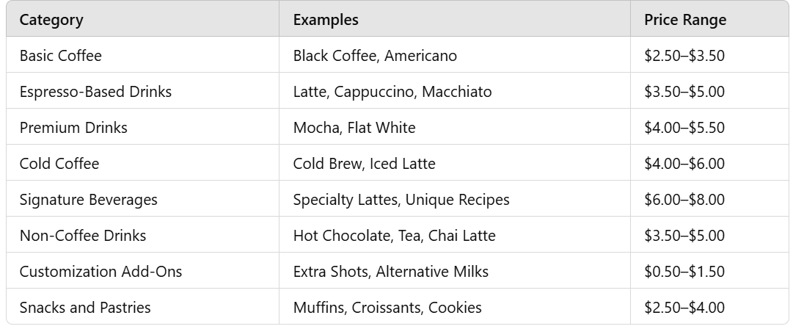

**6.0 MARKETING STRATEGY**

6.1 Using Social Medias

* Instagram and Facebook campaigns showcasing the ambiance and drinks.
* Create high quality contents.

6.2 Promotions

* Loyalty programs and student discounts.
* Send personalized offers on customers' birthdays, such as a free item or a percentage off.

6.3 Events

* Hosting live music or poetry nights to attract more customers.
* Hosting or sponsoring charity events can build goodwill, engage with the community, and promote your brand’s social responsibility.

6.4 Product Collaborations

* Create unique products or experiences in collaboration with other local businesses
* Partner with local businesses like bookstores, bakeries, or gyms to cross-promote services

6.5 Sustainability Practices

* Eco-Friendly Packaging such as use reusable packaging and promote this eco-conscious effort as part of your brand’s commitment to sustainability
* Emphasize that your coffee is helping local farmers to showcase your support for sustainable practices

**7.0 CONCLUSION**

7.1 Summary of Benefits:

* Opening a coffee shop with friends offers a unique opportunity to combine shared passion, creativity, and entrepreneurship.
* Success requires careful planning, clear roles, collaboration, and hard work.
* Overcoming challenges in a competitive market is possible with dedication and strategic decision-making.

7.2 Call to Action:

* Create memorable experiences by interacting with your customers
* Regularly seek customer feedback to improve your offerings and service