**EXPERIMENT NO. 7**

**Aim:** XML DTD

**Theory:**

**Introduction to DTD**

A Document Type Definition (DTD) defines the legal building blocks of an XML document. It defines the document structure with a list of legal elements and attributes.

A DTD can be declared inline inside an XML document, or as an external reference.

1. **Internal XML DTD**

If the DTD is declared inside the XML file, it should be wrapped in a DOCTYPE definition with the following syntax:

< !DOCTYPE root-element [element-declarations]>

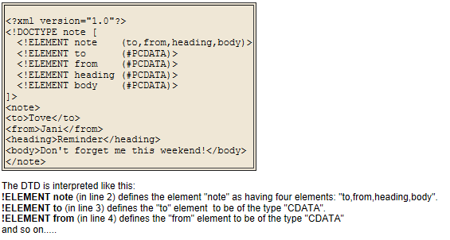

1. **External XML DTD**

If the DTD is declared in an external file, it should be wrapped in a DOCTYPE definition with the following syntax:

**< !DOCTYPE root-element SYSTEM "filename">**

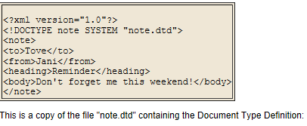

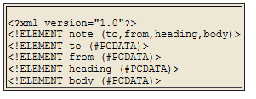

**Why use a DTD?**

XML provides an application independent way of sharing data. With a DTD, independent groups of people can agree to use a common DTD for interchanging data. Your application can use a standard DTD to verify that data that you receive from the outside world is valid. You can also use a DTD to verify your own data.

**PCDATA is text that WILL be parsed by a parser**. **The text will be examined by the parser for entities and markup**.

**CDATA is text that will NOT be parsed by a parser**. Tags inside the text will NOT be treated as markup and entities will not be expanded.

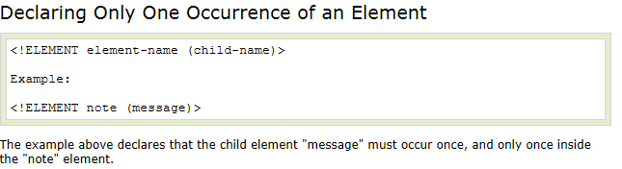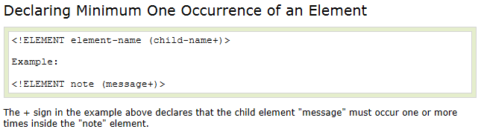

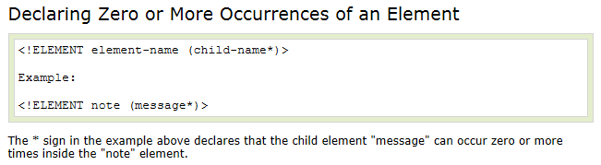

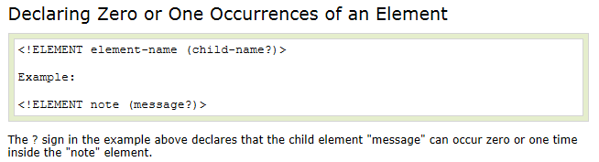

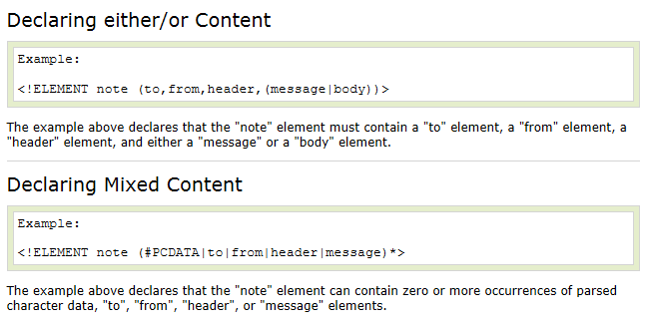

DTD – Attributes

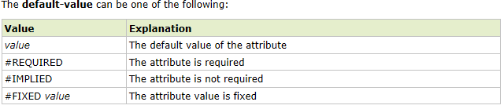

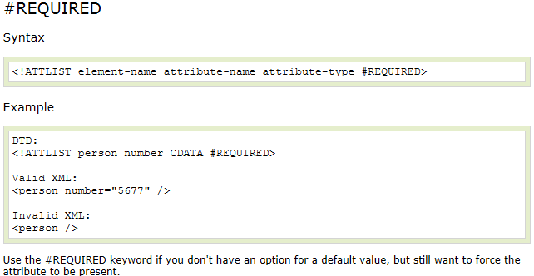

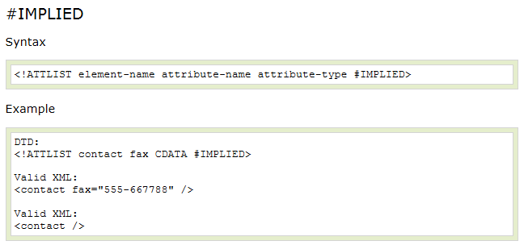

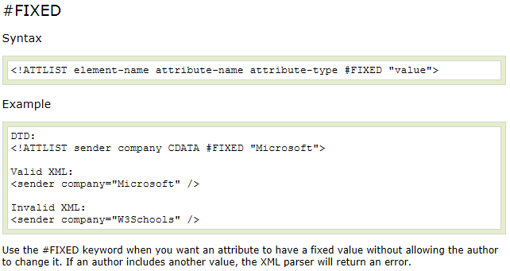

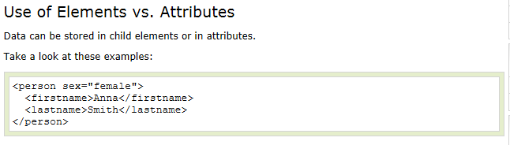

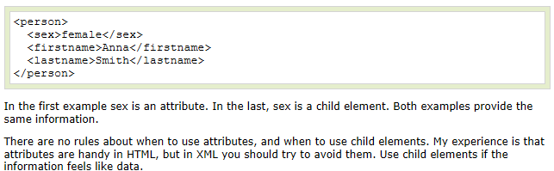

**Implementation:**

1. **Internal DTD**

**Sample.xml File:**

<?xml version="1.0"?>

<!DOCTYPE employeetab[

<!ELEMENT employeetab (employee*)>

<!ELEMENT employee (ename,eadd,ephno,salary)>

<!ATTLIST employee eid CDATA #REQUIRED>

<!ELEMENT ename (fname,lname)>

<!ELEMENT fname (#PCDATA)>

<!ELEMENT lname (#PCDATA)>

<!ELEMENT eadd (street,city,pinno)>

<!ELEMENT street (#PCDATA)>

<!ELEMENT city (#PCDATA)>

<!ELEMENT pinno (#PCDATA)>

<!ELEMENT ephno (#PCDATA)>

<!ELEMENT salary (#PCDATA)>]>

<employeetab>

<employee eid="001">

<ename>

<fname>Salman</fname>

<lname>Hamdare</lname>

</ename>

<eadd>

<street>M.G Road</street>

<city>Pune</city>

<pinno>400102</pinno>

</eadd>

<ephno>9561858496</ephno>

<salary>70000</salary>

</employee>

<employee eid="002">

<ename>

<fname>Safa</fname>

<lname>Hamdare</lname>

</ename>

<eadd>

<street>M.G Road</street>

<city>Pune</city>

<pinno>400102</pinno>

</eadd>

<ephno>9819737130</ephno>

<salary>20000</salary>

</employee>

</employeetab>

1. **External DTD**

**Sample.dtd file:**

<?xml version="1.0"?>

<!ELEMENT employeetab(employee)>

<!ELEMENT employee(ename, eadd, ephno, salary)>

<!ATTLIST employee eid CDATA #REQUIRED>

<!ELEMENT ename(fname,lname)>

<!ELEMENT fname(#PCDATA)>

<!ELEMENT lname(#PCDATA)>

<!ELEMENT eadd(street,city,pinno)>

<!ELEMENT street(#PCDATA)>

<!ELEMENT city(#PCDATA)>

<!ELEMENT pinno(#PCDATA)>

<!ELEMENT ephno(#PCDATA)>

<!ELEMENT salary(#PCDATA)>

**Sample.xml File:**

<?xml version="1.0"?>

<!DOCTYPE employeetab SYSTEM "sample.dtd">

<employeetab>

<employee eid="001">

<ename>

<fname>Salman</fname>

<lname>Hamdare</lname>

</ename>

<eadd>

<street>M.G Road</street>

<city>Pune</city>

<pinno>400102</pinno>

</eadd>

<ephno>9819737130</ephno>

<salary>20000</salary>

</employee>

</employeetab>