**EXPERIMENT NO: 8**

**Aim:** XML Schema and XML Query

**Theory:** XML Schema and Query

**Implementation:**

1. Create an XML Schema (exp8.xsd) and an XML Document (exp8.xml) that has a reference to this XML schema

**--------------------------exp8.xml file---------------------------**

<?xml version="1.0"?>

<note

xmlns:xsi="XMLSchema-instance"

xsi:schemaLocation="exp8.xsd">

<to>Tove</to>

<from>Jani</from>

<heading>Reminder</heading>

<body>Don't forget me this weekend!</body>

</note>

**--------------------------exp8.xsd file---------------------------**

<?xml version="1.0"?>  
<xs:schema xmlns:xs="XMLSchema"  
elementFormDefault="qualified">  
  
<xs:element name="note">  
<xs:complexType>  
<xs:sequence>  
<xs:element name="to" type="xs:string"/>  
<xs:element name="from" type="xs:string"/>  
<xs:element name="heading" type="xs:string"/>  
<xs:element name="body" type="xs:string"/>  
</xs:sequence>  
</xs:complexType>  
</xs:element>  
< /xs:schema>

1. Generating XML from Ordinary tables of Oracle

**SQL to XML**

|  |
| --- |
| Generating XML from "Ordinary" Tables |
| Oracle provides a function, XMLElement that transforms data into XML format. |

1. Insert Xml document to Oracle db

XMLTYPE has built-in functions to allow us to manipulate the data values being placed into the column defined as SYS.XMLTYPE. Data may be inserted into the table using the sys.xmltype.createxml procedure like this:

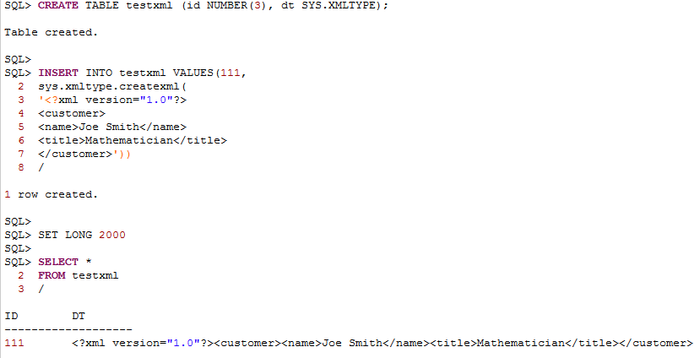

1. Use Text () function to get text value from xml string

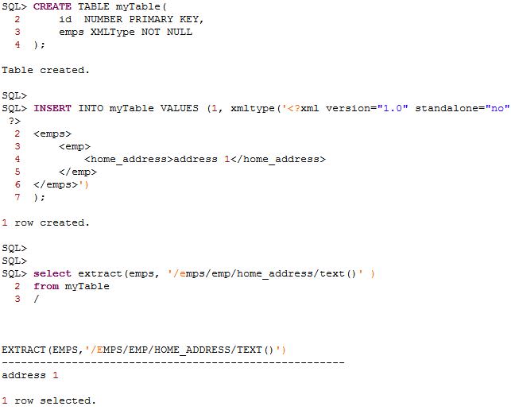

1. XML Element

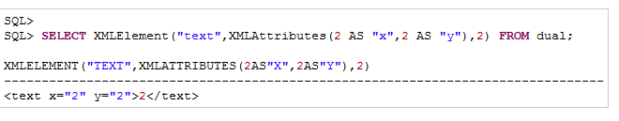

1. Use Extract function to return resultsUsing xpath

