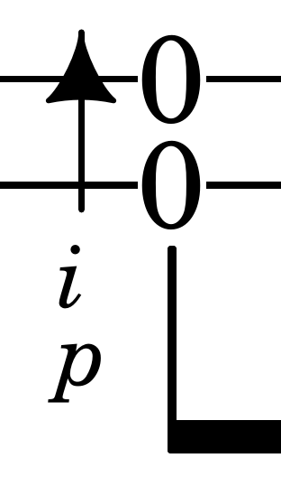

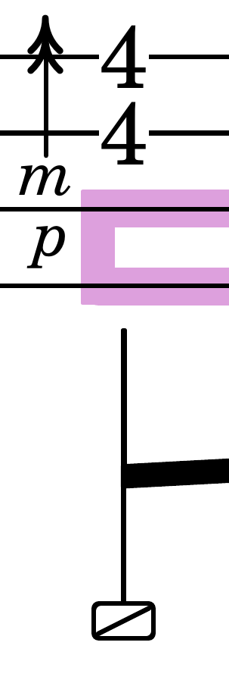
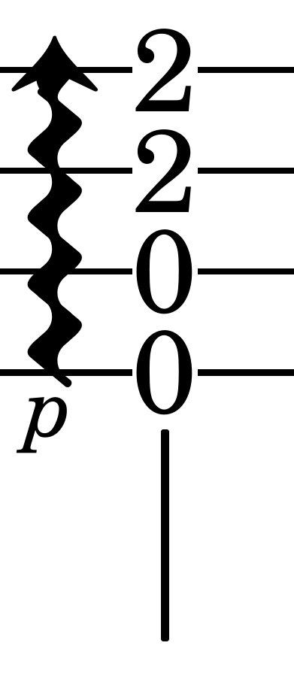
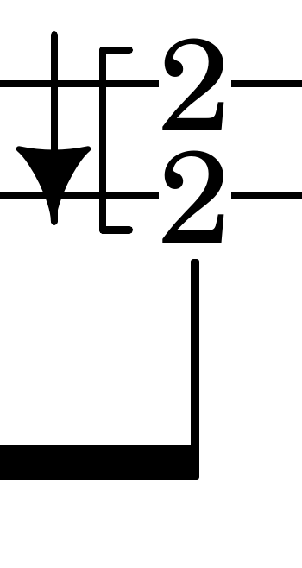
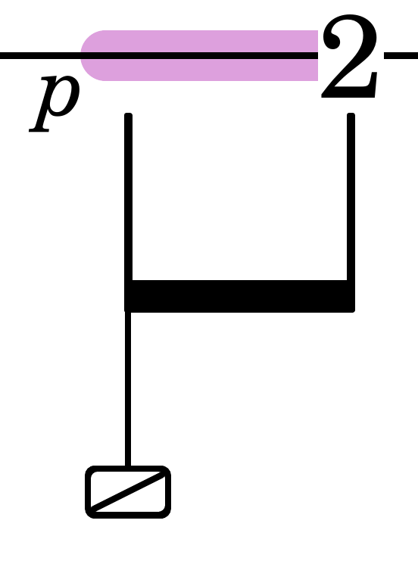


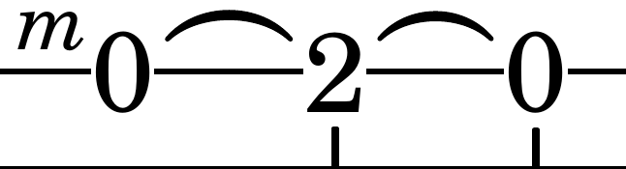
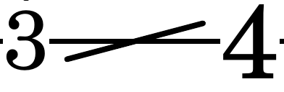
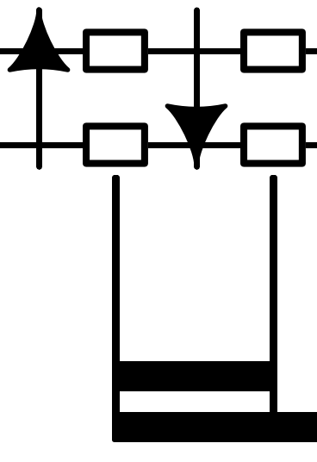
Strum: An upward arrow is executed toward the floor; a downward arrow is executed toward the ceiling. An arrow with a straight stem represents a quick strum. When more than one finger is indicated, the top finger is strumming the strings while the bottom finger is supporting that finger and not actually touching the strings.
– An arrow with a wavy stem indicates a slow strum. In all cases, this slow strum borrows time from the previous beat in order to allow the top note of the strum to land on the beat indicated. If more than one finger is indicated the performer is to produce distinctive strum with each finger unless otherwise indicated.
– A double-headed arrow indicates a flick. The flick is a percussive strum. It is generally accompanied by string damping and a snare.

Partial Barre: A partial barre is indicated with a bracket indicating the frets that are being barred. This maneuver is executed with a hyper-extended or collapsed first joint of the indicated finger.

String Damping: String damping is an important technique in fingerstyle guitar. One places or plants the indicated fingers on the strings indicated for the duration indicated thus stopping those strings from producing sound. String damping can be combined with a certain amount of pressure and release upon the string to produce a snare effect. String damping is indicated with a solid gray line.

Percussion: A box at the end of an extended stem indicates a snare effect which is produced by quickly applying and releasing pressure on the string or strings indicated in order to make the string(s) hit the frets.
– A filled-box indicates a thud upon the face of the guitar. This sound emulates a bass drum and is usually played with the heal of the plucking hand.

Slurs: Ascending and descending slurs (hammer-on and pull-off respectively) are indicated with a curved line. One plucks the first note but not the subsequent notes.

Slides: Slides are indicated with a diagonal line. The first note is plucked and the subsequent notes are not plucked unless otherwise indicated.

Ticks: A tick is a a percussive sound produced by the damping of the strings with the hand that frets the strings while the strings are plucked. A tick is indicated with a box.

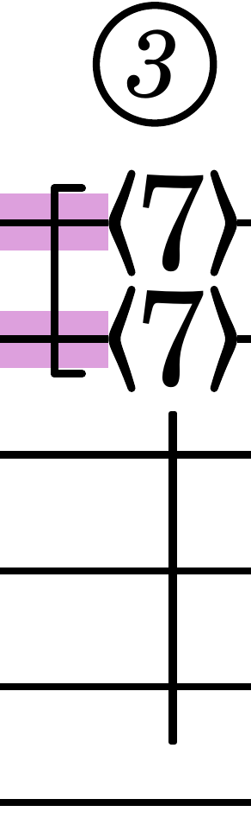
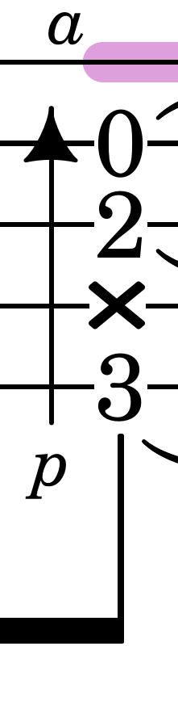

Natural Harmonics: :The fret number that is indicated in between two angled brackets is the harmonic node to be played.

Muted String: A string that is plucked but does not produce a sound is indicated with an 'x' on the string to be muted.

Other Methods Employed: This transcription is operating within the Stropes Tradition of fingerstyle guitar typesetting. Examples can be seen and purchased at <www.stropes.com>.
– This is a relatively new format for the typesetting of fingerstyle guitar notation. It may take a while to get used to the exactitude of the methods employed, it may seem overwhelming at first, but with time, acclimation to the methods employed in the Stropes Tradition will prove to be worth it.
– Non-standard tuning, percussion, and string damping are three reasons for the development of a distinctive fingerstyle guitar notation. Guitar tablature needs this development.
– An 8vb grand staff is employed as the tuning of this composition required the extra staff.

