Performance Notes for “Capone”

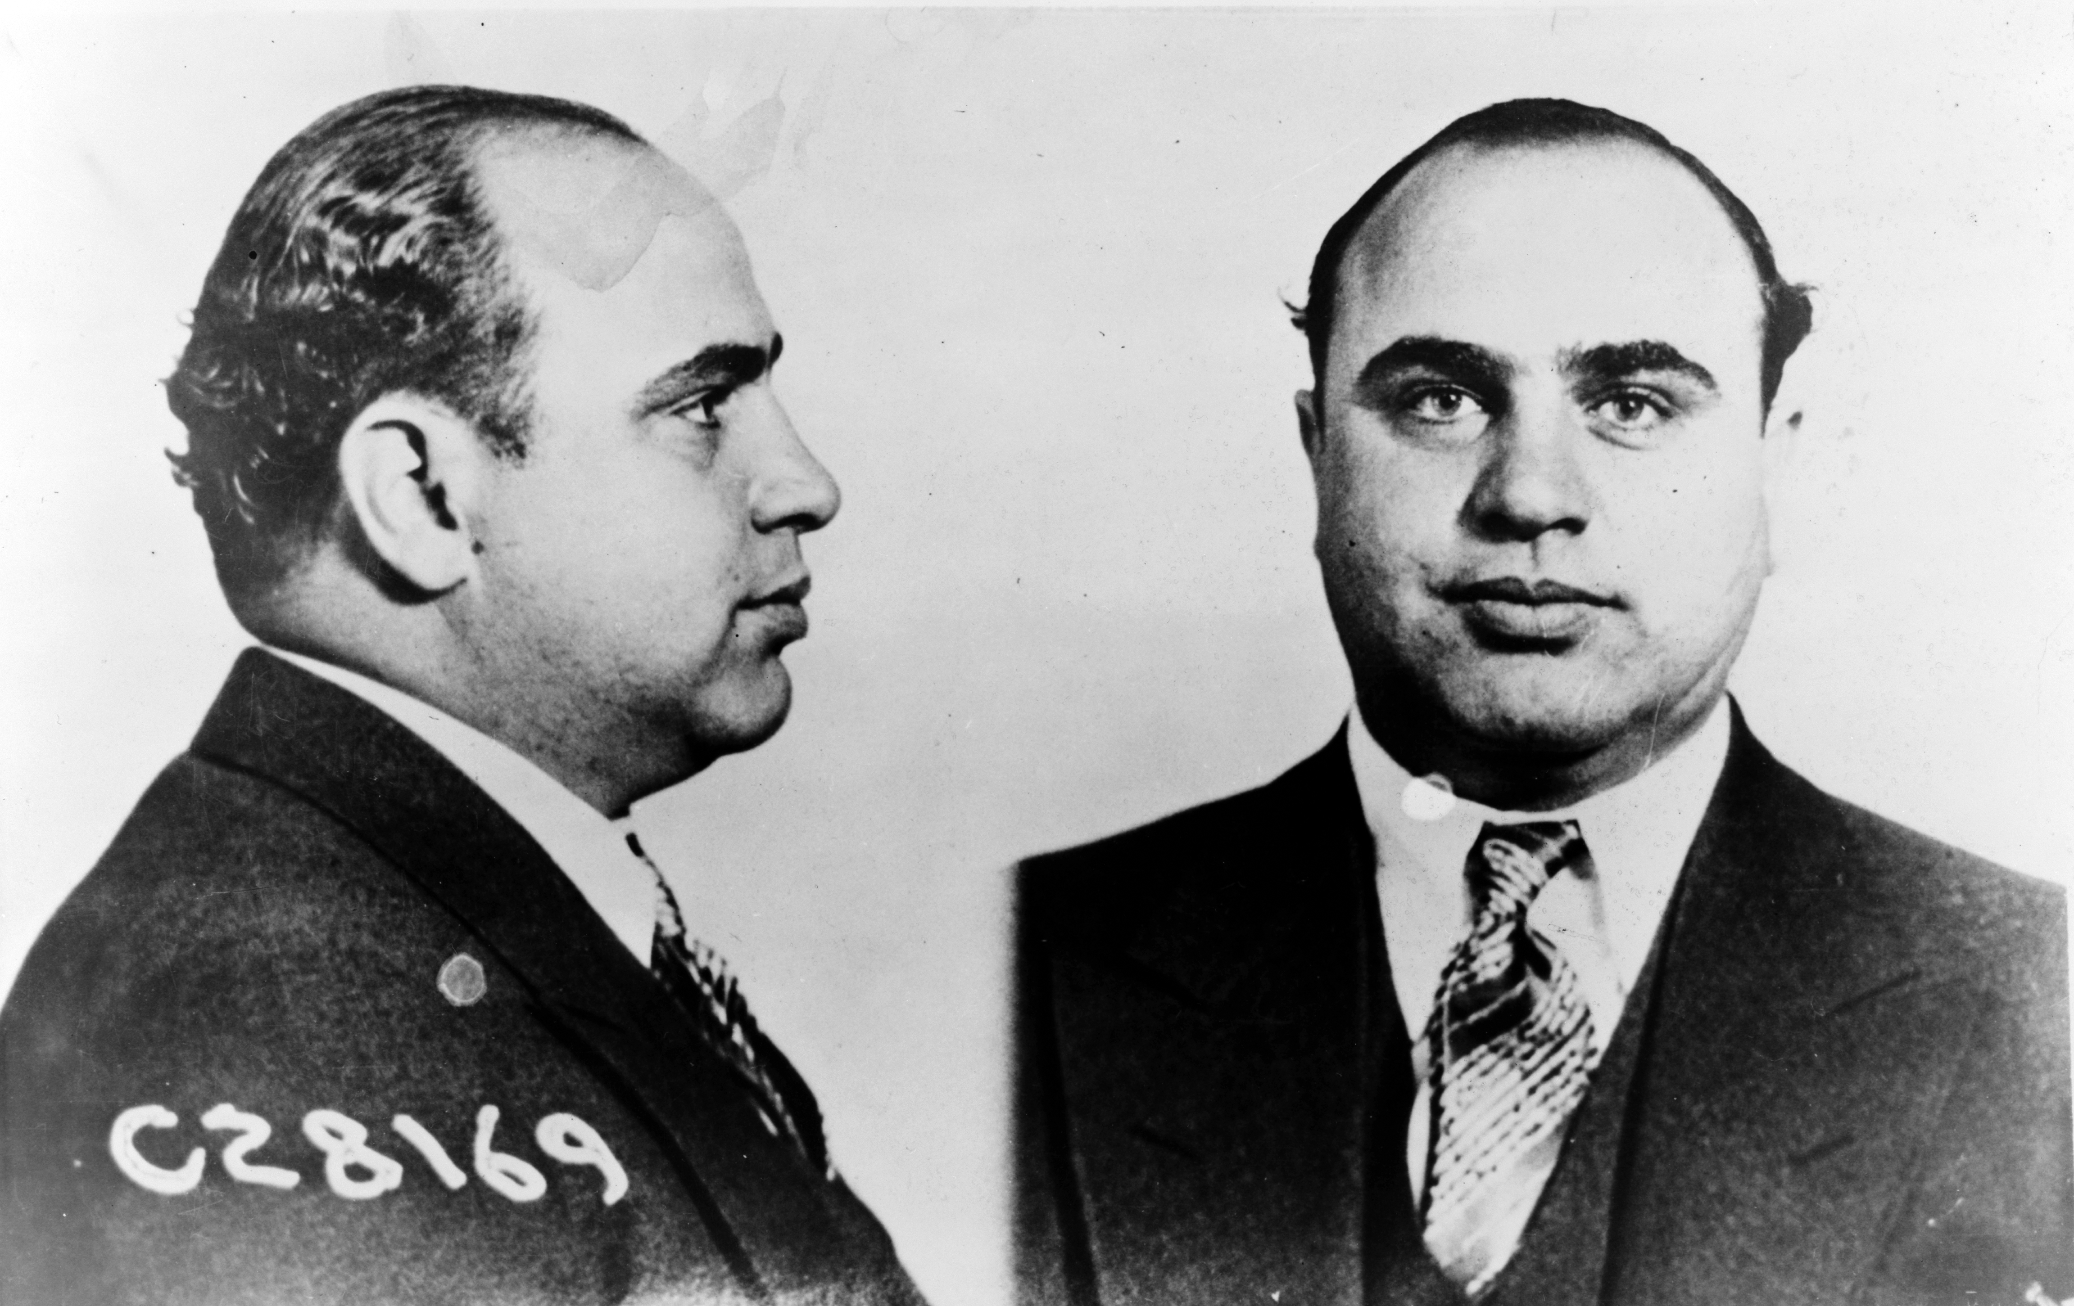
In this transcription, great care has been taken to the notation of pitch duration in the standard notation. This has led to several areas where it may be difficult to read the voice that is playing the pitch. The composer has indicated that , except for several instances, the soprano/top voice and the bass/bottom voice duration should be watched closely.

“Capone” should sound like the end of prohibition and the shuffling of newspaper across concrete streets, curbs, and sidewalks.

note 1
The third fret of the sixth string is fretted through an extension of the left hand. The fourth finger maintains the eleventh fret while the thumb extends along the fret board to the third fret.

note 2
The A ♭ on the fourth string is silenced on the 'and' of the fourth beat by the third lifting lightly off of the string. This effect is performed quickly so as to spend little time between the string sounding and the dampening of the string with the third finger.

note 3
The staccato on the 'and' of the third beat of this measure, and all measures through 98, is produced through the right hand middle finger dampening the string quickly after the string is plucked.

