baipishu

marshall ma

7/10/2020

##Stage I: Filtering 1. 时间低于10分钟。  
2. PSS: 所有题目得分一致。  
3. PHQ第10题和前9题逻辑不一致。  
4. 没有使用心理咨询等服务却选了满意度（没有选“不适用”）。

summary(check$qc_idx)

## Min. 1st Qu. Median Mean 3rd Qu. Max.   
## 0.0000 0.0000 0.0000 0.1336 0.0000 5.0000

which(check$qc_idx > 0)

## [1] 3 125 134 159 270 373 374 375 376 379 381 387 388 431 503  
## [16] 613 619 626 637 779 803 804 829 853 907 912 966 976 1032 1077  
## [31] 1126 1182 1201

##Stage II: Overview | demo | MH exp | PWB | x | x Latent| x | x Spec | x | x MH exp| x |

#extra transformation  
data_vis_pwb <- data_vis %>%  
 gather(PWB, PWB_val, PSS_sum:QLES_sum)  
  
data_vis_lt <- data_vis %>%  
 gather(Latent, Lt_val, c(ERQ_reap:MEMS, SSSI_avg))  
#-------------------------------  
  
#part 1.1 finance and tuition  
  
  
#120 307  
ggplot(data_vis, aes(x = tui_sum)) +   
 geom_bar(stat="count", position = "dodge") + coord_flip() + ggtitle("Plot1.1.1 Count of Subjects in 5 Tuition Conditions")

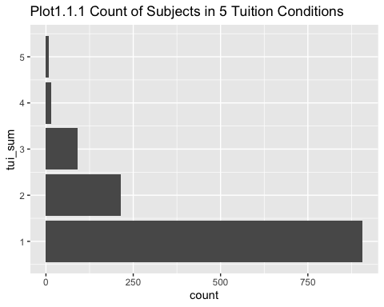

ggplot(data_vis, aes(x=factor(1), fill=as.factor(tui_sum))) +  
 geom_bar(width = 1) +  
 coord_polar("y") +  
 theme_minimal() +   
 scale_fill_grey() + ggtitle("Plot1.1.2 Count of Subjects in 5 Tuition Conditions")

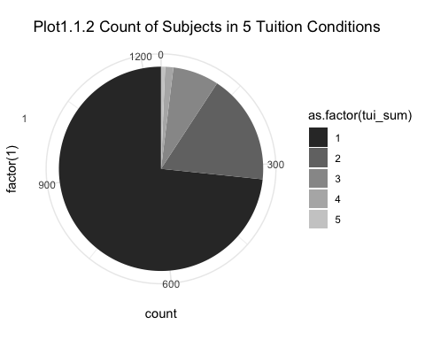

#part 1.2 basic demo  
  
ggplot(data_vis, aes(x = gender_grp)) +   
 geom_bar(stat="count", position = "dodge") + coord_flip() + ggtitle("Plot1.2.1 Count of Subjects in Gender Groups")

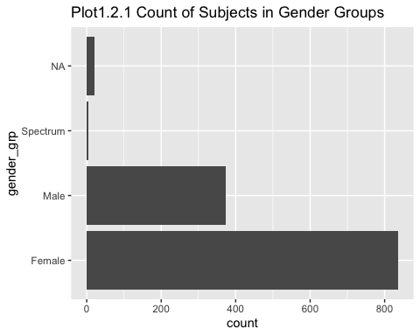

data_summary <- function(data, varname, groupnames){  
 require(plyr)  
 summary_func <- function(x, col){  
 c(mean = mean(x[[col]], na.rm=TRUE),  
 sd = sd(x[[col]], na.rm=TRUE),  
 se = sqrt(var(x[[col]], na.rm=TRUE) / length(x[[col]])))  
 } #need to check se correctness  
 data_sum<-ddply(data, groupnames, .fun=summary_func,  
 varname)  
 data_sum <- rename(data_sum, c("mean" = varname))  
 return(data_sum)  
}  
  
  
#Error Bar  
data_vis_pwb_sum <- data_summary(data_vis_pwb, varname="PWB_val", groupnames=c("PWB", "ICE"))  
  
ggplot(data_vis_pwb_sum, aes(y = PWB_val, x = PWB, fill = ICE)) +   
 geom_bar(stat="summary", position = "dodge", fun = mean) +   
 scale_fill_brewer(palette="YlOrBr") +  
 geom_errorbar(aes(ymin = PWB_val - se, ymax = PWB_val + se), width = .1, alpha = 0.5, position = position_dodge(.9)) +   
 ggtitle("Plot2.1.1 PWB x ICE groups")

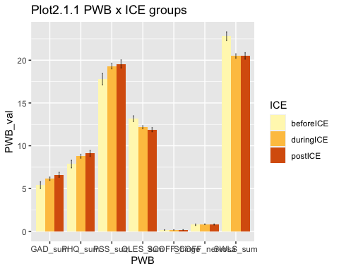

data_vis_short <- data_vis %>% select(PSS_sum, PHQ_sum, GAD_sum, SCOFF_nervosa, SWLS_sum, QLES_sum, GSE_sum, MEMS_3, SSSI_avg)  
  
#scaled plot  
(plot1 <- pairs.panels(data_vis_short,  
 method = "pearson", # correlation method  
 hist.col = "#00AFBB",  
 density = TRUE, # show density plots  
 ellipses = TRUE # show correlation ellipses  
 ))

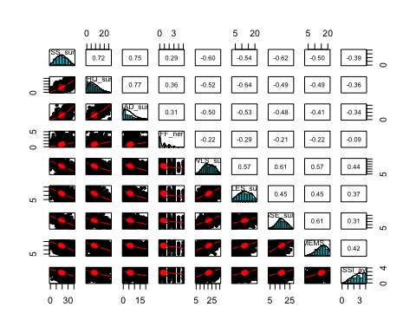

## NULL

corr <- cor(data_vis_short)  
(plot2 <- ggcorrplot(corr, method = "circle", type = "lower"))

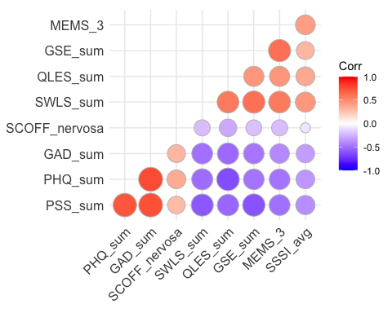

#gather and spread   
  
(plot3 <- ggplot(data_vis_pwb, aes(x = PWB, y = PWB_val, fill = gpa_grp)) + geom_bar(position = "dodge", stat = "summary", fun = mean) + scale_fill_brewer(palette="Greys"))

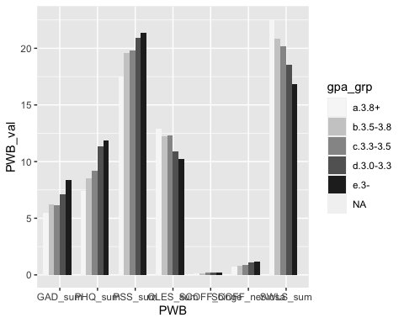

(plot4 <- ggplot(data_vis_lt, aes(x = Latent, y = Lt_val, fill = gpa_grp)) + geom_bar(stat="summary", position = "dodge", fun = mean) + scale_fill_brewer(palette="Set3"))

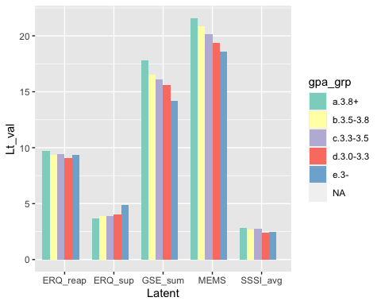

#ICE  
ggplot(data_vis, aes(y = PSS_sum, x = time_day, color = ICE)) +   
 geom_count() +   
 scale_size_area(max_size = 3)

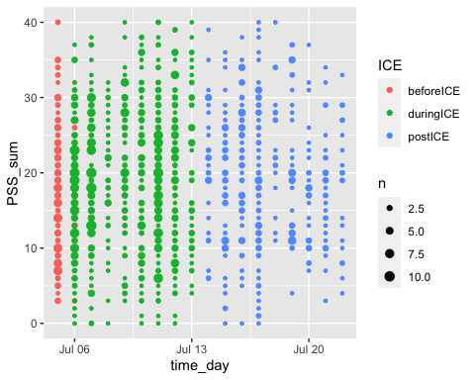

table_test <- tableby(ICE ~ PHQ_sum + GAD_sum + PSS_sum + SWLS_sum + QLES_sum + SCOFF_nervosa, data = data_vis)  
summary(table_test, title = "test", text = TRUE)

##   
## Table: test  
##   
## | | beforeICE (N=163) | duringICE (N=724) | postICE (N=348) | Total (N=1235) | p value|  
## |:-------------|:-----------------:|:-----------------:|:---------------:|:--------------:|-------:|  
## |PHQ_sum | | | | | 0.105|  
## |- Mean (SD) | 7.865 (5.710) | 8.782 (6.213) | 9.109 (6.366) | 8.753 (6.199) | |  
## |- Range | 0.000 - 26.000 | 0.000 - 27.000 | 0.000 - 27.000 | 0.000 - 27.000 | |  
## |GAD_sum | | | | | 0.058|  
## |- Mean (SD) | 5.405 (5.080) | 6.159 (5.308) | 6.612 (5.524) | 6.187 (5.349) | |  
## |- Range | 0.000 - 21.000 | 0.000 - 21.000 | 0.000 - 21.000 | 0.000 - 21.000 | |  
## |PSS_sum | | | | | 0.088|  
## |- Mean (SD) | 17.785 (8.604) | 19.319 (8.863) | 19.563 (8.935) | 19.185 (8.860) | |  
## |- Range | 3.000 - 40.000 | 0.000 - 40.000 | 0.000 - 40.000 | 0.000 - 40.000 | |  
## |SWLS_sum | | | | | < 0.001|  
## |- Mean (SD) | 22.804 (6.518) | 20.488 (6.859) | 20.503 (7.057) | 20.798 (6.910) | |  
## |- Range | 5.000 - 35.000 | 5.000 - 35.000 | 5.000 - 35.000 | 5.000 - 35.000 | |  
## |QLES_sum | | | | | 0.014|  
## |- Mean (SD) | 13.172 (4.327) | 12.174 (4.802) | 11.888 (4.634) | 12.225 (4.707) | |  
## |- Range | 3.000 - 21.000 | 3.000 - 21.000 | 3.000 - 21.000 | 3.000 - 21.000 | |  
## |SCOFF_nervosa | | | | | 0.827|  
## |- Mean (SD) | 0.773 (1.118) | 0.830 (1.140) | 0.807 (1.049) | 0.816 (1.112) | |  
## |- Range | 0.000 - 5.000 | 0.000 - 5.000 | 0.000 - 5.000 | 0.000 - 5.000 | |

table_0000 <- tableby(Service ~ age_grp + gender_grp + degree_grp + religion_grp + gpa_grp + gpa_change_grp, data = data_vis)  
summary(table_0000, title = "demo By Service", text = TRUE)

##   
## Table: demo By Service  
##   
## | | 1 (N=375) | 2 (N=860) | Total (N=1235) | p value|  
## |:--------------|:-----------:|:-----------:|:--------------:|-------:|  
## |age_grp | | | | 0.012|  
## |- 25+ | 85 (22.7%) | 143 (16.6%) | 228 (18.5%) | |  
## |- below25 | 290 (77.3%) | 717 (83.4%) | 1007 (81.5%) | |  
## |gender_grp | | | | < 0.001|  
## |- N-Miss | 9 | 12 | 21 | |  
## |- Female | 286 (78.1%) | 550 (64.9%) | 836 (68.9%) | |  
## |- Male | 77 (21.0%) | 296 (34.9%) | 373 (30.7%) | |  
## |- Spectrum | 3 (0.8%) | 2 (0.2%) | 5 (0.4%) | |  
## |degree_grp | | | | 0.027|  
## |- MBA | 3 (0.8%) | 12 (1.4%) | 15 (1.2%) | |  
## |- 博士 | 45 (12.0%) | 94 (10.9%) | 139 (11.3%) | |  
## |- 本科 | 225 (60.0%) | 581 (67.6%) | 806 (65.3%) | |  
## |- 硕士 | 102 (27.2%) | 173 (20.1%) | 275 (22.3%) | |  
## |religion_grp | | | | 0.230|  
## |- N-Miss | 28 | 50 | 78 | |  
## |- 教 | 50 (14.4%) | 96 (11.9%) | 146 (12.6%) | |  
## |- 无宗教信仰 | 297 (85.6%) | 714 (88.1%) | 1011 (87.4%) | |  
## |gpa_grp | | | | 0.747|  
## |- N-Miss | 24 | 58 | 82 | |  
## |- a.3.8+ | 130 (37.0%) | 309 (38.5%) | 439 (38.1%) | |  
## |- b.3.5-3.8 | 119 (33.9%) | 256 (31.9%) | 375 (32.5%) | |  
## |- c.3.3-3.5 | 47 (13.4%) | 109 (13.6%) | 156 (13.5%) | |  
## |- d.3.0-3.3 | 35 (10.0%) | 93 (11.6%) | 128 (11.1%) | |  
## |- e.3- | 20 (5.7%) | 35 (4.4%) | 55 (4.8%) | |  
## |gpa_change_grp | | | | 0.251|  
## |- a明显变好 | 78 (20.8%) | 166 (19.3%) | 244 (19.8%) | |  
## |- b变好 | 105 (28.0%) | 258 (30.0%) | 363 (29.4%) | |  
## |- c不变 | 134 (35.7%) | 334 (38.8%) | 468 (37.9%) | |  
## |- d变差 | 46 (12.3%) | 88 (10.2%) | 134 (10.9%) | |  
## |- e明显变差 | 12 (3.2%) | 14 (1.6%) | 26 (2.1%) | |

table_y2 <- tableby(GAD_sum ~ age_grp + gender_grp + degree_grp + religion_grp + gpa_grp + gpa_change_grp, data = data_vis)  
summary(table_y2, title = "demo By Service", text = TRUE)

##   
## Table: demo By Service  
##   
## | | 0 (N=144) | 1 (N=118) | 2 (N=121) | 3 (N=93) | 4 (N=95) | 5 (N=94) | 6 (N=72) | 7 (N=112) | 8 (N=48) | 9 (N=53) | 10 (N=43) | 11 (N=38) | 12 (N=28) | 13 (N=29) | 14 (N=38) | 15 (N=14) | 16 (N=17) | 17 (N=16) | 18 (N=15) | 19 (N=11) | 20 (N=7) | 21 (N=29) | Total (N=1235) | p value|  
## |:--------------|:-----------:|:-----------:|:-----------:|:----------:|:----------:|:----------:|:----------:|:----------:|:----------:|:----------:|:----------:|:----------:|:----------:|:----------:|:----------:|:-----------:|:----------:|:----------:|:----------:|:-----------:|:----------:|:----------:|:--------------:|-------:|  
## |age_grp | | | | | | | | | | | | | | | | | | | | | | | | 0.618|  
## |- 25+ | 28 (19.4%) | 18 (15.3%) | 25 (20.7%) | 13 (14.0%) | 21 (22.1%) | 17 (18.1%) | 14 (19.4%) | 16 (14.3%) | 11 (22.9%) | 7 (13.2%) | 5 (11.6%) | 8 (21.1%) | 7 (25.0%) | 5 (17.2%) | 13 (34.2%) | 2 (14.3%) | 5 (29.4%) | 3 (18.8%) | 1 (6.7%) | 3 (27.3%) | 1 (14.3%) | 5 (17.2%) | 228 (18.5%) | |  
## |- below25 | 116 (80.6%) | 100 (84.7%) | 96 (79.3%) | 80 (86.0%) | 74 (77.9%) | 77 (81.9%) | 58 (80.6%) | 96 (85.7%) | 37 (77.1%) | 46 (86.8%) | 38 (88.4%) | 30 (78.9%) | 21 (75.0%) | 24 (82.8%) | 25 (65.8%) | 12 (85.7%) | 12 (70.6%) | 13 (81.2%) | 14 (93.3%) | 8 (72.7%) | 6 (85.7%) | 24 (82.8%) | 1007 (81.5%) | |  
## |gender_grp | | | | | | | | | | | | | | | | | | | | | | | | 0.412|  
## |- N-Miss | 1 | 1 | 0 | 2 | 1 | 4 | 1 | 2 | 3 | 0 | 3 | 0 | 0 | 0 | 1 | 1 | 0 | 0 | 1 | 0 | 0 | 0 | 21 | |  
## |- Female | 89 (62.2%) | 82 (70.1%) | 76 (62.8%) | 70 (76.9%) | 66 (70.2%) | 57 (63.3%) | 48 (67.6%) | 82 (74.5%) | 34 (75.6%) | 40 (75.5%) | 27 (67.5%) | 31 (81.6%) | 18 (64.3%) | 19 (65.5%) | 22 (59.5%) | 8 (61.5%) | 11 (64.7%) | 11 (68.8%) | 9 (64.3%) | 11 (100.0%) | 6 (85.7%) | 19 (65.5%) | 836 (68.9%) | |  
## |- Male | 53 (37.1%) | 35 (29.9%) | 45 (37.2%) | 20 (22.0%) | 27 (28.7%) | 32 (35.6%) | 23 (32.4%) | 28 (25.5%) | 11 (24.4%) | 13 (24.5%) | 13 (32.5%) | 7 (18.4%) | 10 (35.7%) | 10 (34.5%) | 15 (40.5%) | 5 (38.5%) | 5 (29.4%) | 5 (31.2%) | 5 (35.7%) | 0 (0.0%) | 1 (14.3%) | 10 (34.5%) | 373 (30.7%) | |  
## |- Spectrum | 1 (0.7%) | 0 (0.0%) | 0 (0.0%) | 1 (1.1%) | 1 (1.1%) | 1 (1.1%) | 0 (0.0%) | 0 (0.0%) | 0 (0.0%) | 0 (0.0%) | 0 (0.0%) | 0 (0.0%) | 0 (0.0%) | 0 (0.0%) | 0 (0.0%) | 0 (0.0%) | 1 (5.9%) | 0 (0.0%) | 0 (0.0%) | 0 (0.0%) | 0 (0.0%) | 0 (0.0%) | 5 (0.4%) | |  
## |degree_grp | | | | | | | | | | | | | | | | | | | | | | | | 0.876|  
## |- MBA | 3 (2.1%) | 2 (1.7%) | 0 (0.0%) | 1 (1.1%) | 1 (1.1%) | 1 (1.1%) | 1 (1.4%) | 1 (0.9%) | 1 (2.1%) | 2 (3.8%) | 0 (0.0%) | 0 (0.0%) | 0 (0.0%) | 0 (0.0%) | 1 (2.6%) | 0 (0.0%) | 1 (5.9%) | 0 (0.0%) | 0 (0.0%) | 0 (0.0%) | 0 (0.0%) | 0 (0.0%) | 15 (1.2%) | |  
## |- 博士 | 20 (13.9%) | 16 (13.6%) | 14 (11.6%) | 10 (10.8%) | 11 (11.6%) | 13 (13.8%) | 3 (4.2%) | 11 (9.8%) | 9 (18.8%) | 6 (11.3%) | 3 (7.0%) | 5 (13.2%) | 1 (3.6%) | 2 (6.9%) | 8 (21.1%) | 1 (7.1%) | 2 (11.8%) | 2 (12.5%) | 0 (0.0%) | 0 (0.0%) | 0 (0.0%) | 2 (6.9%) | 139 (11.3%) | |  
## |- 本科 | 91 (63.2%) | 70 (59.3%) | 76 (62.8%) | 62 (66.7%) | 65 (68.4%) | 61 (64.9%) | 51 (70.8%) | 73 (65.2%) | 24 (50.0%) | 35 (66.0%) | 33 (76.7%) | 25 (65.8%) | 18 (64.3%) | 22 (75.9%) | 22 (57.9%) | 9 (64.3%) | 9 (52.9%) | 12 (75.0%) | 14 (93.3%) | 8 (72.7%) | 7 (100.0%) | 19 (65.5%) | 806 (65.3%) | |  
## |- 硕士 | 30 (20.8%) | 30 (25.4%) | 31 (25.6%) | 20 (21.5%) | 18 (18.9%) | 19 (20.2%) | 17 (23.6%) | 27 (24.1%) | 14 (29.2%) | 10 (18.9%) | 7 (16.3%) | 8 (21.1%) | 9 (32.1%) | 5 (17.2%) | 7 (18.4%) | 4 (28.6%) | 5 (29.4%) | 2 (12.5%) | 1 (6.7%) | 3 (27.3%) | 0 (0.0%) | 8 (27.6%) | 275 (22.3%) | |  
## |religion_grp | | | | | | | | | | | | | | | | | | | | | | | | 0.971|  
## |- N-Miss | 9 | 12 | 4 | 7 | 6 | 1 | 5 | 9 | 2 | 1 | 4 | 2 | 3 | 0 | 2 | 2 | 2 | 3 | 0 | 1 | 1 | 2 | 78 | |  
## |- 教 | 20 (14.8%) | 12 (11.3%) | 13 (11.1%) | 13 (15.1%) | 13 (14.6%) | 10 (10.8%) | 8 (11.9%) | 13 (12.6%) | 5 (10.9%) | 7 (13.5%) | 3 (7.7%) | 5 (13.9%) | 3 (12.0%) | 3 (10.3%) | 6 (16.7%) | 0 (0.0%) | 2 (13.3%) | 1 (7.7%) | 3 (20.0%) | 0 (0.0%) | 2 (33.3%) | 4 (14.8%) | 146 (12.6%) | |  
## |- 无宗教信仰 | 115 (85.2%) | 94 (88.7%) | 104 (88.9%) | 73 (84.9%) | 76 (85.4%) | 83 (89.2%) | 59 (88.1%) | 90 (87.4%) | 41 (89.1%) | 45 (86.5%) | 36 (92.3%) | 31 (86.1%) | 22 (88.0%) | 26 (89.7%) | 30 (83.3%) | 12 (100.0%) | 13 (86.7%) | 12 (92.3%) | 12 (80.0%) | 10 (100.0%) | 4 (66.7%) | 23 (85.2%) | 1011 (87.4%) | |  
## |gpa_grp | | | | | | | | | | | | | | | | | | | | | | | | < 0.001|  
## |- N-Miss | 9 | 6 | 8 | 7 | 7 | 5 | 7 | 3 | 2 | 1 | 5 | 2 | 4 | 1 | 3 | 1 | 1 | 0 | 3 | 1 | 1 | 5 | 82 | |  
## |- a.3.8+ | 55 (40.7%) | 52 (46.4%) | 51 (45.1%) | 39 (45.3%) | 37 (42.0%) | 32 (36.0%) | 26 (40.0%) | 39 (35.8%) | 14 (30.4%) | 16 (30.8%) | 10 (26.3%) | 8 (22.2%) | 9 (37.5%) | 9 (32.1%) | 11 (31.4%) | 5 (38.5%) | 6 (37.5%) | 2 (12.5%) | 5 (41.7%) | 4 (40.0%) | 0 (0.0%) | 9 (37.5%) | 439 (38.1%) | |  
## |- b.3.5-3.8 | 46 (34.1%) | 36 (32.1%) | 30 (26.5%) | 27 (31.4%) | 23 (26.1%) | 33 (37.1%) | 18 (27.7%) | 34 (31.2%) | 18 (39.1%) | 22 (42.3%) | 21 (55.3%) | 11 (30.6%) | 5 (20.8%) | 10 (35.7%) | 12 (34.3%) | 6 (46.2%) | 6 (37.5%) | 4 (25.0%) | 3 (25.0%) | 2 (20.0%) | 1 (16.7%) | 7 (29.2%) | 375 (32.5%) | |  
## |- c.3.3-3.5 | 18 (13.3%) | 13 (11.6%) | 18 (15.9%) | 12 (14.0%) | 10 (11.4%) | 13 (14.6%) | 10 (15.4%) | 19 (17.4%) | 5 (10.9%) | 5 (9.6%) | 2 (5.3%) | 5 (13.9%) | 4 (16.7%) | 4 (14.3%) | 1 (2.9%) | 1 (7.7%) | 3 (18.8%) | 6 (37.5%) | 0 (0.0%) | 2 (20.0%) | 2 (33.3%) | 3 (12.5%) | 156 (13.5%) | |  
## |- d.3.0-3.3 | 11 (8.1%) | 5 (4.5%) | 10 (8.8%) | 6 (7.0%) | 14 (15.9%) | 9 (10.1%) | 8 (12.3%) | 12 (11.0%) | 8 (17.4%) | 6 (11.5%) | 5 (13.2%) | 11 (30.6%) | 4 (16.7%) | 3 (10.7%) | 7 (20.0%) | 1 (7.7%) | 0 (0.0%) | 4 (25.0%) | 0 (0.0%) | 1 (10.0%) | 1 (16.7%) | 2 (8.3%) | 128 (11.1%) | |  
## |- e.3- | 5 (3.7%) | 6 (5.4%) | 4 (3.5%) | 2 (2.3%) | 4 (4.5%) | 2 (2.2%) | 3 (4.6%) | 5 (4.6%) | 1 (2.2%) | 3 (5.8%) | 0 (0.0%) | 1 (2.8%) | 2 (8.3%) | 2 (7.1%) | 4 (11.4%) | 0 (0.0%) | 1 (6.2%) | 0 (0.0%) | 4 (33.3%) | 1 (10.0%) | 2 (33.3%) | 3 (12.5%) | 55 (4.8%) | |  
## |gpa_change_grp | | | | | | | | | | | | | | | | | | | | | | | | < 0.001|  
## |- a明显变好 | 34 (23.6%) | 25 (21.2%) | 17 (14.0%) | 15 (16.1%) | 19 (20.0%) | 21 (22.3%) | 15 (20.8%) | 14 (12.5%) | 10 (20.8%) | 18 (34.0%) | 6 (14.0%) | 6 (15.8%) | 4 (14.3%) | 6 (20.7%) | 7 (18.4%) | 4 (28.6%) | 4 (23.5%) | 3 (18.8%) | 4 (26.7%) | 5 (45.5%) | 1 (14.3%) | 6 (20.7%) | 244 (19.8%) | |  
## |- b变好 | 37 (25.7%) | 34 (28.8%) | 36 (29.8%) | 38 (40.9%) | 23 (24.2%) | 23 (24.5%) | 21 (29.2%) | 38 (33.9%) | 14 (29.2%) | 20 (37.7%) | 13 (30.2%) | 14 (36.8%) | 11 (39.3%) | 8 (27.6%) | 13 (34.2%) | 1 (7.1%) | 4 (23.5%) | 6 (37.5%) | 1 (6.7%) | 1 (9.1%) | 3 (42.9%) | 4 (13.8%) | 363 (29.4%) | |  
## |- c不变 | 64 (44.4%) | 48 (40.7%) | 49 (40.5%) | 31 (33.3%) | 40 (42.1%) | 35 (37.2%) | 32 (44.4%) | 54 (48.2%) | 12 (25.0%) | 13 (24.5%) | 19 (44.2%) | 8 (21.1%) | 9 (32.1%) | 10 (34.5%) | 10 (26.3%) | 7 (50.0%) | 4 (23.5%) | 3 (18.8%) | 7 (46.7%) | 2 (18.2%) | 1 (14.3%) | 10 (34.5%) | 468 (37.9%) | |  
## |- d变差 | 8 (5.6%) | 9 (7.6%) | 17 (14.0%) | 9 (9.7%) | 11 (11.6%) | 13 (13.8%) | 4 (5.6%) | 5 (4.5%) | 9 (18.8%) | 1 (1.9%) | 5 (11.6%) | 8 (21.1%) | 2 (7.1%) | 5 (17.2%) | 7 (18.4%) | 1 (7.1%) | 5 (29.4%) | 3 (18.8%) | 2 (13.3%) | 2 (18.2%) | 1 (14.3%) | 7 (24.1%) | 134 (10.9%) | |  
## |- e明显变差 | 1 (0.7%) | 2 (1.7%) | 2 (1.7%) | 0 (0.0%) | 2 (2.1%) | 2 (2.1%) | 0 (0.0%) | 1 (0.9%) | 3 (6.2%) | 1 (1.9%) | 0 (0.0%) | 2 (5.3%) | 2 (7.1%) | 0 (0.0%) | 1 (2.6%) | 1 (7.1%) | 0 (0.0%) | 1 (6.2%) | 1 (6.7%) | 1 (9.1%) | 1 (14.3%) | 2 (6.9%) | 26 (2.1%) | |