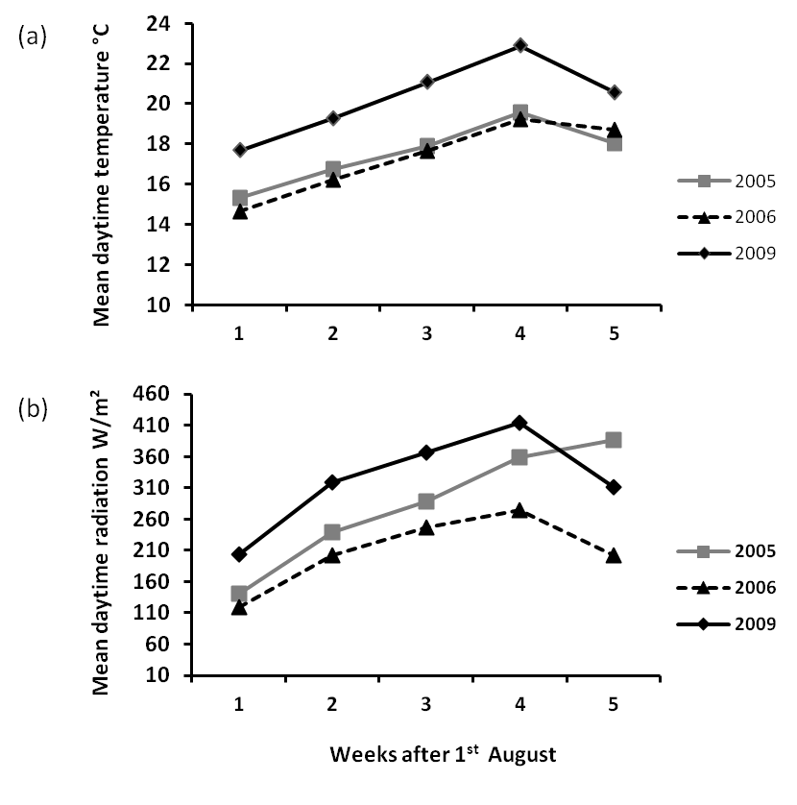

Supplemental Figure S1. Climatic conditions prior to fruit harvest. A) Mean weekly daytime air temperature (°C) and B) mean radiation (W/m²) (b) for a period of 5 weeks starting on the 1st August and prior to the start of harvest period over years.

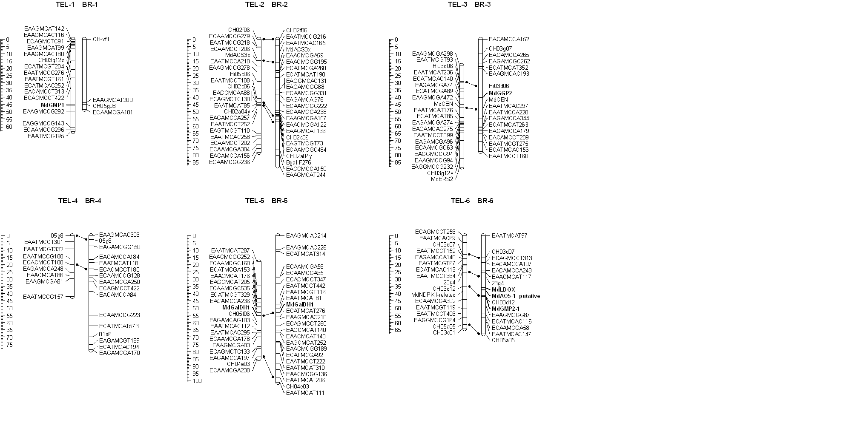
Supplemental Figure S2A. Genetic linkage maps of ‘Telamon’ (TEL) and ‘Braeburn’ (BR) used for QTL analysis. Candidate genes in bold type were mapped in this study.

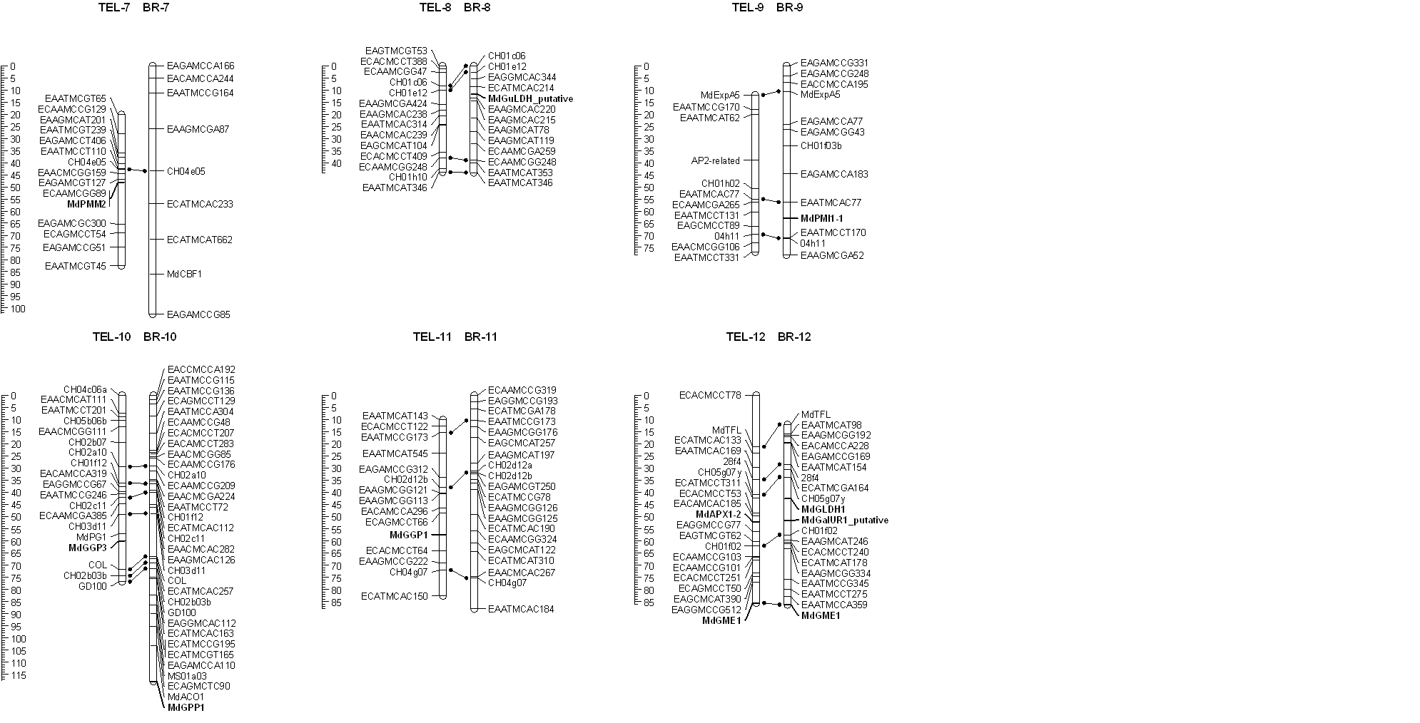

Supplemental Figure S2B: Genetic linkage maps of ‘Telamon’ (TEL) and ‘Braeburn’ (BR) used for QTL analysis. Candidate genes in bold type were mapped in this study.
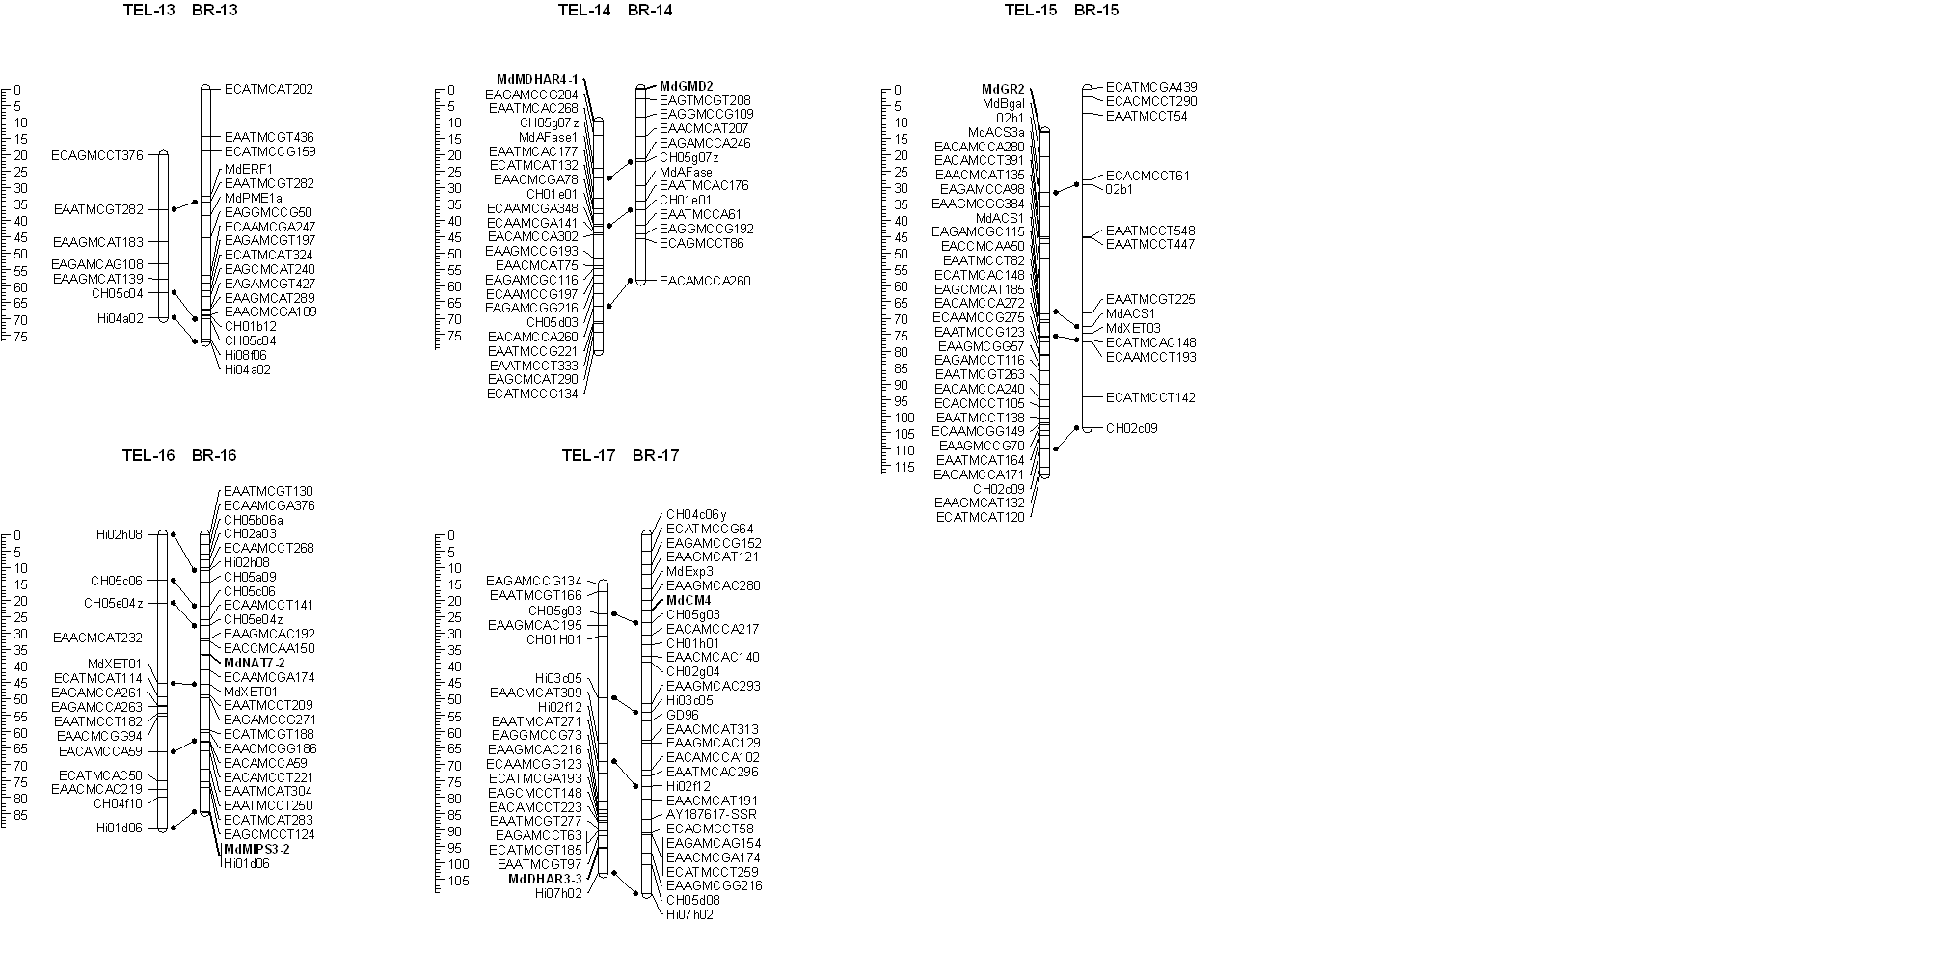
Supplemental Figure S2C: Genetic linkage maps of ‘Telamon’ (TEL) and ‘Braeburn’ (BR) used for QTL analysis. Candidate genes that have been mapped in this study are in bold type.

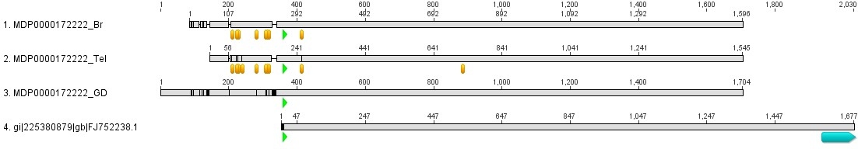

Supplemental Figure S3: Alignment of the MDP0000172222 (MdGGP1) consensus coding sequence (CDS) from apple cultivars ‘Braeburn’ (Br), ‘Telamon’ (Tel) and ‘Golden Delicious’ (GD) with the full length EST sequence from ‘Royal Gala’ (gi|225380879). Orange bars represent the position of SNPs relative to the ‘Golden Delicious’ reference CDS. Small green arrows indicate corrected translation start. Blue arrow indicates PolyA tail. The translation products of the corrected CDS are identical.

Supplemental Figure S4: Alignment of the MDP0000172222 (MdGGP1) consensus coding sequence (CDS) from apple cultivars ‘Braeburn’ (Br), and ‘Telamon’ (Tel) and the full length EST sequence from ‘Royal Gala’ (gi|225380879) to the gDNA scaffold MDC003775.57. Yellow arrows indicate predicted exons of the reference CDS. Orange bars represent the position of SNPs relative to the ‘Golden Delicious’ reference sequence. Small green arrows indicate corrected translation start. The translation products of the corrected CDS are identical. Comparison of the alignments of the consensus CDS sequences and de novo contigs from ‘Telamon’ and ‘Braeburn’ against the gDNA contig used for genome assembly indicated that the start codon of the MdGGP1 reference sequence has been incorrectly predicted. This is because of ambiguous nucleotides and a 23 bp insertion in the reference sequence at position 327 bp, leading to a frame shift. As a result, a TGA stop codon that is present in the 5’ UTR of all ‘Telamon’ and ‘Braeburn’ sequences is missed and the correct ATG is actually located 361 bp further downstream from the predicted start codon. Alignments with available EST sequences from NCBI, and comparisons with other plant GGP peptide sequences within PLAZA v 2.5 (Van Bel et al., 2012), support these conclusions. As a result, the corrected MDP0000172222 CDS length is only 1344 instead of 1704 bp, and the translation product is 448 amino acids long instead of 568. This revised gene structure also agrees much more closely with the sequence of its paralogue, MdGGP2 (MDP0000288088, Figure S3) on LG3, which has a CDS length of 1347 bp, and a translation product of 449 amino acids.

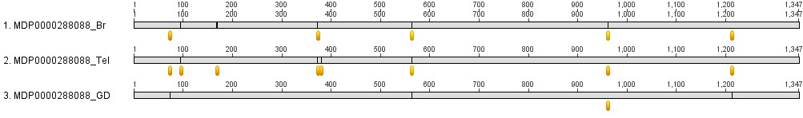

Supplemental Figure S5: Alignment of the MDP0000288088 (MdGGP2) consensus coding sequence (CDS) from ‘Braeburn’ (Br), ‘Telamon’ (Tel) and ‘Golden Delicious’ (GD). Orange bars represent the position of SNPs relative to the ‘Golden Delicious’ reference CDS. Read mapping, and alignment of de novo contigs from ‘Telamon’ and ‘Braeburn’ against the relevant gDNA assembly contig support the predicted reference gene annotation

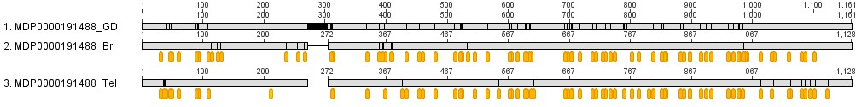

Supplemental Figure S6: Alignment of the MDP0000191488 (MdGGP3) consensus coding sequence (CDS) from ‘Braeburn’ (Br), ‘Telamon’ (Tel) and ‘Golden Delicious’ (GD). Orange bars represent the position of SNPs relative to the ‘Golden Delicious’ reference CDS. Alignment of the MdGGP3 consensus read mapping sequences from ‘Telamon’ and ‘Braeburn’ as well as of de novo contigs generally supported the predicted reference gene annotation.

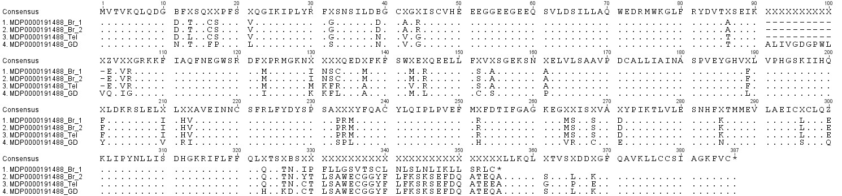

Supplemental Figure S7: Alignment of the MDP0000191488 (MdGGP3) consensus peptide sequences (translation products) from ‘Braeburn’ (Br), ‘Telamon’ (Tel) and ‘Golden Delicious’ (GD). ‘MDP0000191488_Br_1’ and ‘MDP0000191488_Br_2’ represent two possible alternate ‘Braeburn’ translation products arising from a single nucleotide deletion that leads to a frameshift, a premature stop codon and an N-terminal truncated peptide.

Supplemental Table S1: Correlations between fruit antioxidant metabolite concentrations. Pearson’s correlation coefficients for fruit L-ascorbic acid (AsA), dehydroasccorbic acid (DHA), total ascorbic acid (AsA + DHA), glutathione (GSH), glutathione disulphide (GSSG), total glutathione (GSH + GSSG) concentrations and total antioxidant activity (TAA) of flesh (FL) and skin (SK) tissues, as well as fruit fresh weight (FW) in the F1 progeny measured in 2005, 2006 and 2009. *P<0.05, **P<0.01, ***P<0.001, ****P<0.0001, n.s. not significant. For 2005, n=136; 2006, n=140; 2009, n=163.
Supplemental Table S2: Correlations between fruit antioxidant metabolite concentrations over the three years of measurements. Pearson’s correlation coefficients for fruit L-ascorbic acid (AsA), dehydroascorbic acid (DHA), total ascorbic acid (AsA + DHA), % DHA, glutathione (GSH), glutathione disulphide (GSSG), total glutathione (GSH + GSSG), %GSSG and total antioxidant activity (TAA) of flesh (FL) and skin (SK) tissues in the F1 progeny measured in 2005, 2006 and 2009. *P<0.05, **P<0.01, ***P<0.001, ****P<0.0001, n.s. not significant. Measurements of GSH were only carried out in 2006 and 2009, ‘-‘ indicates not determined. For 2005, n=136; 2006, n=140; 2009, n=163.

Trait | 2005 vs 2006 |  | 2005 vs 2009 |  | 2006 vs 2009
AsA FL | 0.53 | **** | 0.59 | **** | 0.49 | ****
DHA FL | n.s. |  | n.s. |  | n.s.
Total AsA FL | 0.46 | **** | 0.51 | **** | 0.49 | ****
%DHA FL | 0.33 | ** | n.s. |  | 0.23 | *
AA SK | 0.66 | **** | 0.37 | *** | 0.47 | ****
DHA SK | n.s. |  | n.s. |  | n.s.
Total AsA SK | 0.62 | **** | 0.25 | * | 0.52 | ****
%DHA SK | n.s. |  | n.s. |  | n.s.
GSH FL | - |  | - |  | n.s.
GSSG FL | - |  | - |  | n.s.
Total GSH FL | - |  | - |  | n.s.
%GSSG FL | - |  | - |  | n.s.
GSH SK | - |  | - |  | 0.20 | *
GSSG SK | - |  | - |  | 0.21 | *
Total GSH SK | - |  | - |  | n.s.
%GSSG SK | - |  | - |  | n.s.

Supplemental Table S3: Overview of population mean values and distribution for foliar L-ascorbic acid (AsA), dehydroascorbate (DHA), total ascorbic acid (totAsA), glutathione (GSH), oxidized GSH (GSSG) and total GSH (totGSH) concentrations. All measurements expressed in μmol gFW⁻¹. Apple leaves from 180 individual of progeny of the ‘Telamon’ x ‘Braeburn’ mapping population were collected in 2009. Each trait value represents the mean of the results from the analysis of 10 randomly chosen mature leaves per genotype ± standard deviations (SD).

Trait | Mean (± SD) | Lowest | Highest | Distribution
AsA | 30.84 (± 3.97) | 19.75 | 42.91 | normal
DHA | 2.271 (± 0.85) | 0.638 | 5.295 | normal
TotAsA | 33.24 (± 4.03) | 23.52 | 44.81 | normal
GSH | 0.651 (± 0.14) | 0.327 | 1.023 | normal
GSSG | 0.091 (± 0.09) | 0.002 | 0.442 | not normal
TotGSH | 0.741 (± 0.15) | 0.365 | 1.132 | normal

Supplemental Table S4: Correlations between glutathione traits in foliar and in fruit flesh and skin tissues. Pearson’s correlation coefficients between fruit glutathione (GSH), glutathione disulphide (GSSG), and total glutathione (GSH + GSSG) concentrations and % GSSG of leaf and flesh (FL) or skin (SK) tissues, in the F1 progeny measured in 2009. *P<0.05, **P<0.01, ***P<0.001, ****P<0.0001, n.s. not significant.
 | GSH Leaf | GSSG Leaf | total GSH Leaf | % GSSG Leaf
GSH FL | 0.22* | n.s. | n.s. | n.s.
GSSG FL | 0.21* | n.s. | n.s. | n.s.
total GSH FL | n.s. | n.s. | n.s. | n.s.
% GSSG FL | 0.20* | n.s. | n.s. | n.s.
GSH SK | n.s. | 0.22* | n.s. | 0.28**
GSSG SK | n.s. | n.s. | n.s. | n.s.
total GSH SK | 0.20* | n.s. | n.s. | 0.20*
% GSSG SK | n.s. | n.s. | n.s. | 0.19*

Supplemental Table S5: Correlations between fruit L-ascorbic acid (AsA) concentrations and physiological traits. Pearson’s correlation coefficients between L-ascorbic acid (AsA), dehydroascorbic acid (DHA), and total ascorbic acid (AsA + DHA) concentrations of flesh (FL) and skin (SK), and fruit flesh browning (Br; Br_colour and Br_time), % dry weight (DW), flesh firmness and soluble solids (°Brix) in the F1 progeny measured in 2006 and 2009. Only significant correlations are shown (*P<0.05, **P<0.01, ***P<0.001, ****P<0.0001, n.s. not significant). For 2006, n=140; 2009, n=163.

Traits | Year | AsA FL |  | DHA FL |  | total AsA FL |  | %DHA FL |  | AsA SK |  | DHA SK |  | total AsA SK |  | %DHA SK
Br_colour | 2006 | n.s. |  | n.s. |  | n.s. |  | n.s. |  | n.s. |  | n.s. |  | n.s. |  | n.s.
 | 2009 | n.s. |  | 0.17 | * | n.s. |  | 0.25 | ** | n.s. |  | n.s. |  | n.s. |  | n.s.
Br_time | 2006 | n.s. |  | -0.24 | ** | n.s. |  | -0.22 | ** | n.s. |  | n.s. |  | n.s. |  | n.s.
 | 2009 | n.s. |  | n.s. |  | n.s. |  | n.s. |  | n.s. |  | -0.19 | * | -0.18 | * | n.s.
%DW_FL | 2006 | - |  | - |  | - |  | - |  | - |  | - |  | - |  | -
 | 2009 | 0.41 | **** | n.s. |  | 0.40 | **** | -0.17 | * | 0.18 | * | n.s. |  | 0.17 | * | n.s.
%DW_SK | 2006 | - |  | - |  | - |  | - |  | - |  | - |  | - |  | -
 | 2009 | 0.43 | **** | n.s. |  | 0.41 | **** | -0.23 | ** | 0.30 | *** | n.s. |  | 0.30 | *** | n.s.
Firmness | 2006 | - |  | - |  | - |  | - |  | - |  | - |  | - |  | -
 | 2009 | 0.42 | **** | n.s. |  | 0.43 | **** | n.s. |  | n.s. |  | n.s. |  | n.s. |  | n.s.
°Brix | 2006 | - |  | - |  | - |  | - |  | - |  | - |  | - |  | -
 | 2009 | 0.21 | ** | n.s. |  | 0.18 | * | -0.19 | * | 0.26 | ** | n.s. |  | 0.24 | ** | -0.19 | *

Supplemental Table S6: QTL mapping for fruit antioxidant concentrations. Overview of QTL identified for apple fruit L-ascorbic acid (AsA), total AsA (totAsA), dehydroascorbate (DHA), glutathione (GSH), total GSH (totGSH), oxidized GSH (GSSG) and total antioxidant activity (TAA) in flesh (FL) and skin (SK) tissues in the ‘Telamon’ x ‘Braeburn’ mapping population. Borderline-significant QTL (3.0<LOD<3.5) are indicated with an asterisk (*). For QTL identified using the Kruskal-Wallis nonparametric mapping functions, we used significance levels of ***P=0.01, ****P=0.005, *****P=0.001, ******P=0.0005 and *******P=0.0001. Gene-specific markers are indicated in italics.

Parent | ‘Telamon’ |  |  |  |  |  |  | ‘Braeburn’
Trait | LG | Year | LOD | Marker | Position (cM) | % variation |  | LG | Year | LOD | Marker | Position (cM) | % variation
AsA FL | 3 | 2005 | - | - | - | -
 |  | 2006 | 4.13 | EAATMCAT236 | 15.7 | 12.4
 |  | 2009 | - | - | - | -
 | 6 | 2005 | 4.79 | CH03d12 | 35.1 | 10.2 |  | 6 | 2005 | 3.67 | MdAO5-1 | 37.5 | 9.7
 |  | 2006 | - | - | - | - |  |  | 2006 | - | - | - | -
 |  | 2009 | - | - | - | - |  |  | 2009 | - | - | - | -
 | 10 | 2005 | 7.03 | MdGGP3 | 60.1 | 16.4 |  | 10 | 2005 | 7.80 | CH03d11 | 48.7 | 23.4
 |  | 2006 | - | - | - | - |  |  | 2006 | - | - | - | -
 |  | 2009 | 6.25 | EAATMCCG246 | 40.7 | 13.3 |  |  | 2009 | 4.50 | CH03d11 | 48.7 | 10.2
 | 11 | 2005 | 4.02 | CH04g07 | 62.0 | 7.6 |  | 11 | 2005 | 3.90 | CH04g07 | 75.3 | 14.2
 |  | 2006 | 3.50 | CH04g07 | 62.0 | 10.5 |  |  | 2006 | 4.60 | EAGCMCAT122 | 60.9 | 21.6
 |  | 2009 | 8.50 | MdGGP1 | 47.3 | 27.5 |  |  | 2009 | 5.62 | ECATMCAC190 | 49.0 | 22.0
 | 16 | 2005 | - | - | - | - |  | 16 | 2005 | - | - | - | -
 |  | 2006 | 3.61 | EAACMCGG94 | 55.2 | 11.0 |  |  | 2006 | 4.57 | ECAAMCGA174 | 41.2 | 12.9
 |  | 2009 | - | - | - | - |  |  | 2009 | - | - | - | -
 | 17 | 2005 | 3.30 | MdDHAR3-3* | 80.5 | 8.4
 |  | 2006 | - | - | - | -
 |  | 2009 | - | - | - | -
TotAsA FL | 3 | 2005 | - | - | - | -
 |  | 2006 | 5.20 | EAATMCAT236 | 15.7 | 18.6
 |  | 2009 | - | - | - | -
 | 6 | 2005 | 3.16 | EAATMCGT119* | 50.7 | 8.4 |  | 6 | 2005 | 3.21 | EACAMCCA107* | 18.7 | 8.6
 |  | 2006 | - | - | - | - |  |  | 2006 | - | - | - | -
 |  | 2009 | - | - | - | - |  |  | 2009 | - | - | - | -
 | 10 | 2005 | 5.68 | CH03d11 | 49.0 | 15.0 |  | 10 | 2005 | 5.98 | CH03d11 | 48.7 | 18.1
 |  | 2006 | - | - | - | - |  |  | 2006 | - | - | - | -
 |  | 2009 | 4.50 | CH03d11 | 49.0 | 9.6 |  |  | 2009 | 4.54 | EAGAMCCA110 | 86.5 | 12.8
 | 11 | 2005 | - | - | - | - |  | 11 | 2005 | - | - | - | -
 |  | 2006 | 4.23 | MdGGP1 | 47.3 | 17.5 |  |  | 2006 | 5.72 | EAGCMCAT122 | 60.9 | 24.9
 |  | 2009 | 5.80 | MdGGP1 | 47.3 | 18.4 |  |  | 2009 | 4.08 | ECATMCAC190 | 49.0 | 12.5
 | 16 | 2005 | - | - | - | - |  | 16 | 2005 | - | - | - | -
 |  | 2006 | 5.26 | EAACMCGG94 | 55.2 | 18.6 |  |  | 2006 | 5.03 | ECAAMCGA174 | 41.2 | 11.9
 |  | 2009 | - | - | - | - |  |  | 2009 | 3.27 | EAGAMCCG271* | 49.8 | 9.0
DHA FL | 11 | 2005 | - | - | - | - |  | 11 | 2005 | - | - | - | -
 |  | 2006 | 3.17 | MdGGP1* | 47.3 | 12.6 |  |  | 2006 | 4.66 | EAGCMCAT122 | 60.9 | 30.0
 |  | 2009 | - | - | - | - |  |  | 2009 | - | - | - | -
 | 16 | 2005 | - | - | - | - |  | 16 | 2005 | - | - | - | -
 |  | 2006 | 4.71 | EAATMCCT182 | 54.3 | 15.3 |  |  | 2006 | 4.60 | MdXET01 | 45.6 | 12.0
 |  | 2009 | - | - | - | - |  |  | 2009 | - | - | - | -
 | 17 | 2005 | **** | EAAGMCAC216 | 28.7 | - |  | 17 | 2005 | - | - | - | -
 |  | 2006 | - | - | - | - |  |  | 2006 | - | - | - | -
 |  | 2009 | **** | EAAGMCAC216 | 28.7 | - |  |  | 2009 | *** | EACAMCCA102* | 71.6 | -
AsA SK | 9 | 2005 | 3.51 | EAATMCCT331 | 64.8 | 11.9 |  | 9 | 2005 | 3.00 | EAAGMCGA52* | 78.1 | 12.1
 |  | 2006 | - | - | - | - |  |  | 2006 | - | - | - | -
 |  | 2009 | 4.36 | AP2-related | 27.9 | 16.7 |  |  | 2009 | 3.93 | CH01f03b | 33.0 | 14.2
 | 16 | 2005 | - | - | - | - |  | 11 | 2005 | - | - | - | -
 |  | 2006 | - | - | - | - |  |  | 2006 | - | - | - | -
 |  | 2009 | 3.62 | CH05e04z | 20.8 | 8.6 |  |  | 2009 | 3.63 | ECATMCAC190 | 49.0 | 10.8
 | 17 | 2005 | - | - | - | -
 |  | 2006 | - | - | - | -
 |  | 2009 | 4.00 | ECATMCGA193 | 70.8 | 15.7
TotAsA SK | 2 | 2005 | 4.22 | MdACS3x | 14.9 | 11.0 |  | 2 | 2005 | 3.00 | EAATMCCG216* | 4.23 | 10.7
 |  | 2006 | - | - | - | - |  |  | 2006 | - | - | - | -
 |  | 2009 | - | - | - | - |  |  | 2009 | - | - | - | -
 | 9 | 2005 | - | - | - | - |  | 9 | 2005 | - | - | - | -
 |  | 2006 | - | - | - | - |  |  | 2006 | - | - | - | -
 |  | 2009 | 3.97 | CH01h02 | 38.6 | 12.5 |  |  | 2009 | 3.50 | CH01f03b | 33.0 | 13.0
 | 10 | 2005 | 5.46 | MdGGP3 | 60.1 | 17.3 |  | 11 | 2005 | - | - | - | -
 |  | 2006 | - | - | - | - |  |  | 2006 | - | - | - | -
 |  | 2009 | - | - | - | - |  |  | 2009 | 3.63 | ECATMCAC190 | 49.0 | 14.0
 | 16 | 2005 | 3.14 | CH05e04z* | 20.8 | 9.4 |  | 16 | 2005 | - | - | - | -
 |  | 2006 | - | - | - | - |  |  | 2006 | 3.37 | ECAAMCGA174* | 41.2 | 11.6
 |  | 2009 | 3.16 | CH05c06* | 14.0 | 8.2 |  |  | 2009 | - | - | - | -
DHA SK | 3 | 2005 | - | - | - | - |  | 10 | 2005 | - | - | - | -
 |  | 2006 | **** | ECATMCAT85 | 39.1 | - |  |  | 2006 | - | - | - | -
 |  | 2009 | - | - | - | - |  |  | 2009 | **** | ECATMCAC257 | 67.4 | -
 | 10 | 2005 | - | - | - | - |  | 16 | 2005 | *** | ECATMCAT283* | 75.3 | -
 |  | 2006 | - | - | - | - |  |  | 2006 | - | - | - | -
 |  | 2009 | *** | CH02B03b* | 74.4 | - |  |  | 2009 | - | - | - | -
 |  |  |  |  |  |  |  | 17 | 2005 | **** | CH04c06y | 0.00 | -
 |  |  |  |  |  |  |  |  | 2006 | - | - | - | -
 |  |  |  |  |  |  |  |  | 2009 | - | - | - | -
GSH FL | 5 | 2006 | - | - | - | - |  | 4 | 2006 | **** | ECAAMCCG223 | 54.9 | -
 |  | 2009 | 3.00 | EACAMCCA236* | 35.2 | 9.5 |  |  | 2009 | - | - | - | -
 |  |  |  |  |  |  |  | 17 | 2006 | - | - | - | -
 |  |  |  |  |  |  |  |  | 2009 | 3.39 | EAACMCAT313* | 62.5 | 13.1
TotGSH FL |  |  |  |  |  |  |  | 4 | 2006 | *** | EAATMCAT118* | 18.6 | -
 |  |  |  |  |  |  |  |  | 2009 | - | - | - | -
GSSG FL | 2 | 2006 | 3.07 | EAATMCCT108* | 40.9 | 10.3 |  | 2 | 2006 | 3.37 | EAATMCAC165* | 8.82 | 11.9
 |  | 2009 | - | - | - | - |  |  | 2009 | - | - | - | -
 | 10 | 2006 | - | - | - | -
 |  | 2009 | ****** | EACAMCCA319 | 37.6 | -
 | 16 | 2006 | - | - | - | - |  | 16 | 2006 | - | - | - | -
 |  | 2009 | ****** | MdXET01 | 45.3 | - |  |  | 2009 | ****** | MdXET01 | 45.6 | -
GSH SK | 3 | 2006 | *** | EAATMCAT176* | 36.0 | - |  | 3 | 2006 | *** | CH03g07* | 10.2 | -
 |  | 2009 | - | - | - | - |  |  | 2009 | - | - | - | -
 | 12 | 2006 | *** | ECACMCCT78* | 0.00 | - |  | 4 | 2006 | *** | EAATMCAT118* | 18.6 | -
 |  | 2009 | - | - | - | - |  |  | 2009 | - | - | - | -
 |  |  |  |  |  |  |  | 6 | 2006 | *** | EAACMCAT117* | 25.4 | -
 |  |  |  |  |  |  |  |  | 2009 | - | - | - | -
TotGSH |  |  |  |  |  |  |  | 3 | 2006 | **** | CH03g07 | 10.2 | -
 |  |  |  |  |  |  |  |  | 2009 | - | - | - | -
GSSG SK |  |  |  |  |  |  |  | 4 | 2006 | - | - | - | -
 |  |  |  |  |  |  |  |  | 2009 | **** | 05g8 | 2.63 | -
 | 16 | 2006 | - | - | - | - |  | 16 | 2006 | - | - | - | -
 |  | 2009 | **** | MdXET01 | 45.3 | - |  |  | 2009 | **** | MdXET01 | 45.6 | -
TAA FL | 6 | 2006 | 3.32 | EAATMCCT406* | 53.5 | 10.8 |  | 6 | 2006 | 3.01 | EAAGMCGG87* | 47.8 | 8.6
 | 12 | 2006 | 3.41 | EACAMCAC185* | 49.8 | 12.3 |  | 11 | 2006 | 3.92 | EAGCMCAT122 | 60.9 | 20.6
 |  |  |  |  |  |  |  | 16 | 2006 | 3.73 | ECAAMCGA174 | 41.2 | 11.8

Supplemental Table S7: QTL mapping of fruit physiological traits. Overview of QTLs identified for fresh weight (FW), flesh browning traits (Br; Br_colour and Br_time), firmness and soluble solids (°Brix) in progeny of the ‘TxB ‘mapping population. Borderline-significant QTLs (3.0 < LOD <3.5) are indicated with an asterisk (*). For QTL obtained with Kruskal-Wallis nonparametric mapping functions, significance levels of ***P = 0.01, ****P = 0.005, *****P = 0.001, ******P = 0.0005 and *******P = 0.0001 were used. Gene-specific markers are indicated in italics.

Parent | ‘Telamon’ |  |  |  |  |  |  | ‘Braeburn’
Trait | LG | Year | LOD | Marker | Position (cM) | % variation |  | LG | Year | LOD | Marker | Position (cM) | % variation
FW | 2 | 2005 | - | - | - | - |  | 8 | 2005 | - | - | - | -
 |  | 2006 | 3.93 | MdACS3x | 14.9 | 10.3 |  |  | 2006 | - | - | - | -
 |  | 2009 | - | - | - | - |  |  | 2009 | 4.15 | EAAGMCAC215 | 14.6 | 11.5
 | 8 | 2005 | - | - | - | - |  | 10 | 2005 | 4.70 | CH03d11 | 48.7 | 15.0
 |  | 2006 | - | - | - | - |  |  | 2006 | - | - | - | -
 |  | 2009 | 3.89 | EAGCMCAT104 | 24.5 | 10.8 |  |  | 2009 | - | - | - | -
 | 10 | 2005 | 5.08 | CH03d11 | 49.0 | 15.3 |  | 15 | 2005 | - | - | - | -
 |  | 2006 | - | - | - | - |  |  | 2006 | 5.70 | ECATMCGA439 | 0.00 | 39.7
 |  | 2009 | - | - | - | - |  |  | 2009 | 3.15 | EAATMCCT548* | 45.0 | 11.4
 | 15 | 2005 | - | - | - | - |  | 17 | 2005 | 4.38 | Hi03c05 | 54.1 | 14.5
 |  | 2006 | 5.28 | 02b1 | 18.6 | 14.1 |  |  | 2006 | 4.73 | GD96 | 56.7 | 18.8
 |  | 2009 | - | - | - | - |  |  | 2009 | - | - | - | -
 | 17 | 2005 | 4.53 | Hi03c05 | 34.6 | 13.0
 |  | 2006 | 3.06 | Hi03c05* | 34.6 | 8.2
 |  | 2009 | - | - | - | -
Br_Colour | 17 | 2006 | **** | EAATMCAT271 | 57.5 | - |  | 3 | 2006 | *** | EAATMCAC297* | 55.1 | -
 |  | 2009 | ***** | EAGGMCCG73 | 66.1 | - |  |  | 2009 | - | - | - | -
 |  |  |  |  |  |  |  | 16 | 2006 | *** | EACCMCAA150* | 32.5 | -
 |  |  |  |  |  |  |  |  | 2009 | *** | CH05e04z* | 27.7 | -
Br_Time | 3 | 2006 | **** | EAGAMCGA96 | 40.7 | - |  | 10 | 2006 | - | - | - | -
 |  | 2009 | - | - | - | - |  |  | 2009 | **** | CH02b03b | 69.0 | -
 | 10 | 2006 | - | - | - | -
 |  | 2009 | **** | CH02b03b | 74.4 | -
 | 17 | 2006 | - | - | - | -
 |  | 2009 | **** | EAGGMCCG73 | 66.1 | -
Firmness | 10 | 2009 | ****** | CH02c11 | 42.2 | - |  | 8 | 2009 | **** | EAAGMCAC215 | 14.6 | -
 |  |  |  |  |  |  |  | 10 | 2009 | ****** | CH02c11 | 40.1 | -
°Brix | 10 | 2009 | ******* | CH03d11 | 49.0 |  |  | 10 | 2009 | ******* | CH03d11 | 48.7
 |  |  |  |  |  |  |  | 16 | 2009 | ****** | CH05a09 | 14.6

Supplemetal Table S8: Malus x domestica orthologues of candidate genes of L-ascorbic acid (AsA) metabolism. Apple candidate gene orthologues in the ‘Golden Delicious’ apple genome were identified on the basis of similarities to Arabidopsis reference sequences and multi-species phylogenetic analyses. Gene identifications, description and position (kb) on the linkage groups (LG) of the apple physical map are also displayed. Names were attributed based on their similarity to functionally characterised Arabidopsis orthologues.

Gene | Reference sequence | Reference gene description | Malus name | Malus gene prediction | LG | Position (kb)
L-galactose
Phosphomannose isomerase | At3g02570 | AtPMI1 | MdPMI1-1 | MDP0000271872 | 9 | 28,079
 |  |  | MdPMI1-2 | MDP0000442168 | 17 | 20,138
 |  |  | MdPMI1-3 | MDP0000448667 | 13 | 2,288
 |  |  | MdPMI1-4 | MDP0000516216 | 13 | 2,292
Phosphomannosemutase | At2g45790 | AtPMM | MdPMM1 | MDP0000164473 | 1 | 8,763
 |  |  | MdPMM2 | MDP0000164320 | 7 | 15,480
 |  |  | MdPMM3 | MDP0000930064 | 7 | 15,461
GDP-mannose pyrophosphorylase | At2g39770 | AtGMP or VTC1 | MGMP1 | MDP0000394192 | 1 | 18,324
 |  |  | MGMP2 | MDP0000203812 | 1 | 18,304
ADP-glucose pyrophosphorylase (putative GMP) | At1g74910 |  | MdGMP2-1 | MDP0000323050 | 6 | 20,271
 |  |  | MdGMP2-2 | MDP0000323049 | 6 | 20,220
 |  |  | MdGMP2-3 | MDP0000257196 | 0 | unmapped
 |  |  | MdGMP2-4 | MDP0000861711 | 0 | unmapped
 |  |  | MdGMP2-5 | MDP0000259742 | 17 | 2,779
 |  |  | MdGMP2-6 | MDP0000195095 | 17 | 2,783
 |  |  | MdGMP2-7 | MDP0000290712 | 10 | 10,027
GDP-mannose-3,5-epimerase | At5g28840 | AtGME | MdGME1 | MDP0000951479 | 12 | 30,186
 |  |  | MdGME2 | MDP0000194772 | 4 | 21,323
 |  |  | MdGME3 | MDP0000296691 | 4 | 21,338
GDP-L-galactose phosphorylase | At4g26850 | AtGGP or VTC2 | MdGGP1 | MDP0000172222 | 11 | 22,752
 |  |  | MdGGP2 | MDP0000288088 | 3 | 23,505
 |  |  | MdGGP3 | MDP0000191488 | 10 | 25,348
L-galactose-1-P-phosphatase | At3g02870 | AtGPP or VTC4 | MdGPP1 | MDP0000161522 | 10 | 32,593
 |  |  | MdGPP2 | MDP0000217405 | 10 | 32,597
 |  |  | MdGPP3 | MDP0000217438 | 5 | 0.475
L-galactose dehydrogenase | At4g33670 | AtGalDH | MdGalDH1 | MDP0000257872 | 5 | 22,437
 |  |  | MdGalDH2 | MDP0000612011 | 8 | 7,522
L-galactonolactone dehydrogenase | At3g47930 | AtGLDH | MdGLDH1 | MDP0000303103 | 12 | 10,361
 |  |  | MdGLDH2 | MDP0000146721 | 12 | 10,370
 |  |  | MdGLDH3 | MDP0000172541 | 12 | 10,377
 |  |  | MdGLDH4 | MDP0000304239 | 12 | 10,379
 |  |  | MdGLDH5 | MDP0000168778 | 14 | 13,192
Galacturonate
Putative D-galacturonic acid reductase | At2g37790 | AtAKR | put MdGalUR1 | MDP0000309417 | 12 | 20,164
 | AAT76306 | FaAKR | put MdGalUR2-1 | MDP0000135496 | 16 | 7,731
 |  |  | put MdGalUR2-2 | MDP0000857724 | 16 | 7,652
 |  |  | put MdGalUR2-3 | MDP0000067565 | 13 | 0.773
Glucuronate
Putative L-gulonolactone dehydrogenase (D-arabinono-1,4-lactone oxidase) | At5g11540 |  | put MdGuLDH1 | MDP0000296859 | 8 | 14,712
 |  |  | put MdGuLDH2 | MDP0000374700 | 0 | unmapped
 |  |  | put MdGuLDH3 | MDP0000269942 | 1 | 10,787
 |  |  | put MdGuLDH4 | MDP0000234975 | 1 | 10,782
 |  |  | put MdGuLDH5 | MDP0000911607 | 15 | 3,559
 |  |  | put MdGuLDH6 | MDP0000167886 | 7 | 18,393
Ascorbate recycling
Ascorbate peroxidase | At1g07890 | AtAPX1 | MdAPX1-1 | MDP0000199034 | 11 | 10,340
 |  |  | MdAPX1-2 | MDP0000241173 | 3 | 9,372
 | At3g09640 | AtAPX2 | MdAPX2-1 | MDP0000210077 | 12 | 17,634
 |  |  | MdAPX2-2 | MDP0000192572 | 12 | 4,886
 | At4g35000 | AtAPX3 | MdAPX3-1 | MDP0000151342 | 8 | 9,016
 |  |  | MdAPX3-2 | MDP0000169497 | 15 | 17,918
 |  |  | MdAPX3-3 | MDP0000021998 | 2 | 34,162
 | At4g32320 | AtAPX6 | MdAPX6 | MDP0000943804 | 15 | 5,957
 | At1g77490 | AtTAPX | MdTAPX | MDP0000918790 | 15 | 31,255
Monodehydroascorbate reductase | At3g52880 | AtMDHAR1 | MdMDHAR1-1 | MDP0000267350 | 14 | 1,266
 |  |  | MdMDHAR1-2 | MDP0000261821 | 0 | unmapped
 | At3g09940 | AtMDHAR3 | MdMDHAR3-1 | MDP0000140206 | 3 | 26,369
 |  |  | MdMDHAR3-2 | MDP0000157871 | 4 | 19,849
 | At3g27820 | AtMDHAR4 | MdMDHAR4-1 | MDP0000152184 | 9 | 1,760
 |  |  | MdMDHAR4-2 | MDP0000320539 | 17 | 2,313
Dehydroascorbate reductase | At1g19570 | AtDHAR1 | MdDHAR1-1 | MDP0000311865 | 1 | 15,766
 |  |  | MdDHAR1-2 | MDP0000236168 | 1 | 15,754
 | At5g16710 | AtDHAR3 | MdDHAR3-1 | MDP0000240690 | 9 | 29,343
 |  |  | MdDHAR3-2 | MDP0000175246 | 17 | 22,639
 |  |  | MdDHAR3-3 | MDP0000156763 | 17 | 22,647
 |  |  | MdDHAR3-4 | MDP0000530903 | 9 | 29,332
Glutathione reductase | At3g24170 | AtGR1 | MdGR1 | MDP0000300208 | 9 | 15,818
 | At3g54660 | AtGR2 | MdGR2 | MDP0000202123 | 15 | 3,089
Chorismate mutase/Ascorbate peroxidase | At3g29200 | AtCM/APX | MdCM1 | MDP0000196554 | 9 | 3,613
 |  |  | MdCM2 | MDP0000560179 | 16 | 2,699
 |  |  | MdCM3 | MDP0000240474 | 13 | 4,124
 |  |  | MdCM4 | MDP0000179859 | 17 | 3,888
Ascorbate degradation
Ascorbate oxidase activity | At5g21105 | AtAO | MdAO1 | MDP0000125288 | 11 | 16,569
 |  |  | MdAO2 | MDP0000131142 | 10 | 19,284
 | At4g22010 | AtSKS4 | put MdAO3-1 | MDP0000221906 | 10 | 31,918
 |  |  | put MdAO3-2 | MDP0000214159 | 5 | 1,195
 | At1g76160 | AtSKS5 | put MdAO4-1 | MDP0000459304 | 8 | 0.473
 |  |  | put MdAO4-2 | MDP0000610961 | 9 | 21,332
 |  |  | put MdAO4-3 | MDP0000150489 | 17 | 8,013
 | At3g13390 | AtSKS11 | put MdAO5-1 | MDP0000261927 | 6 | 13,843
 |  |  | put MdAO5-2 | MDP0000436303 | 12 | 0.292
 | At4g37160 | AtSKS15 | put MdAO6 | MDP0000246398 | 2 | 15,048
 | At5g66920 | AtSKS17 | put MdAO7 | MDP0000522743 | 15 | 21,721
Ascorbate transport
Nucleobase Ascorbate Transporter | At1g60030 | AtNAT7 | MdNAT7-1 | MDP0000218729 | 13 | 5,640
 |  |  | MdNAT7-2 | MDP0000320308 | 16 | 4,018
 | At2g27810 | AtNAT12 | MdNAT12-1 | MDP0000314057 | 11 | 12,993
 |  |  | MdNAT12-2 | MDP0000253540 | 15 | 26,583
Fucose synthesis
GDP-mannose 4,6-dehydratase | At5g66280 | AtGMD2 | MdGMD1 | MDP0000303268 | 5 | 20,901
 |  |  | MdGMD2 | MDP0000386723 | 14 | 3,320
 |  |  | MdGMD3 | MDP0000615109 | 14 | 3,330
myo-inositol metabolism
myo-inositol-1-phosphate synthase | At5g10170 | AtMIPS3 | MdMIPS3-1 | MDP0000698835 | 6 | 6,184
 |  |  | MdMIPS3-2 | MDP0000207103 | 16 | 5,629
 |  |  | MdMIPS3-3 | MDP0000459576 | 16 | 5,650
myo-inositol oxidase | At1g14520 | AtMIOX1 | MdMIOX1-1 | MDP0000287757 | 15 | 14,163
 |  |  | MdMIOX1-2 | MDP0000163301 | 2 | 5,587
 |  |  | MdMIOX1-3 | MDP0000285285 | 15 | 14,135
Anthocyanin biosynthesis
Leucocyanidin oxygenase | At4g22880 | AtLDOX | MdLDOX1 | MDP0000240641 | 6 | 13,776
 |  |  | MdLDOX2 | MDP0000360447 | 6 | 13,780
 |  |  | MdLDOX3 | MDP0000240643 | 6 | 13,783
 |  |  | MdLDOX4 | MDP0000788934 | 6 | 13,800
Glutathione metabolism
Glutathione synthase | At5g27380 | AtGS2 | MdGS2-1 | MDP0000196450 | 12 | 29,009
 |  |  | MdGS2-2 | MDP0000188669 | 4 | 20,295

Supplemental Table S9: List of selected candidate gene orthologues of L-ascorbic acid metabolism mapped on the ‘Telamon’ x ‘Braeburn’ genetic linkage maps. SNP-based markers for each candidate gene were developed using RNA-Seq data, and mapped using the high-resolution melting technique. Details of the gene ID, the forward and reverse primers, the length of the PCR product, the segregation type, and the position (cM) on the linkage group (LG) are shown.

Malus gene name | Reference sequence | Malus gene prediction | Forward primer | Reverse primer | PCR product (bp) | Segregation type in “TxB” population | Map | LG | Position (cM)
MdPMI1-1 | At3g02570 | MDP0000271872 | GCACGATTAAATAGGGATGTAGAGA | GATAAGTGTACGGCCCAACG | 119 | aa x ab | BR | 9 | 63,003
MdPMM2 | At2g45790 | MDP0000164320 | CGGAGTGGGATGCTTAATGT | CCATTTTTGGGCGTATGTTC | 106 | ab x aa | TEL | 7 | 28,044
MdGMP1 | At2g39770 | MDP0000394192 | CCTGGATTCGTTGAGGAAGA | CAACATCCGGTCCAATCAG | 122 | ab x aa | TEL | 1 | 45,428
put MdGMP2-1 | At1g74910 | MDP0000323050 | TGTTCCCTCTTCAACCTCCA | GAAAACCCAGATCCCCAGAG | 150 | aa x ab | BR | 6 | 41,751
MdGME1 | At5g28840 | MDP0000951479 | GGTTCCAATGTAATAGGACTTAGCA | TCAAGTGCTCATTATGTGACAGC | 144 | ef x eg | TEL/BR | 12 | 85.644/74.236
MdGGP1 | At4g26850 | MDP0000172222 | AGTGCACCCATTGATGTTGA | AAGAAGCTTTCCCGGTCAAT | 134 | ab x aa | TEL | 11 | 47,269
MdGGP2 |  | MDP0000288088 | GCCAGCAAAGATGGTGAAGT | GCAATCGCTCAAGAATGTGA | 139 | aa x ab | BR | 3 | 40,538
MdGGP3 |  | MDP0000191488 | ATGGTTGTGTTGGAGGCATT | GACCTTTCCACATTCGATCTTC | 120 | ab x aa | TEL | 10 | 60,051
MdGPP1 | At3g02870 | MDP0000161522 | GGCGAACAAGGAATAACGAA | CAAATCCCACAACCAAACCT | 134 | aa x ab | BR | 10 | 117,865
MdGalDH1 | At4g33670 | MDP0000257872 | GACGCTATGCTGACGGTTTT | CCCAATGGAAGTCCTGTGAT | 200 | ab x cd | TEL/BR | 5 | 37.211/53.395
MdGLDH1 | At3g47930 | MDP0000303103 | GATTCGGCCGGTTGGGTCGG | CCCAGCCTGCACTCTCACCC | 133 | aa x ab | BR | 12 | 30,471
put MdGalUR1 | At2g37790 | MDP0000309417 | CACTTTCGCTTAGATGCATGA | TGCCTTTGGTACATCTTCTGG | 153 | aa x ab | BR | 12 | 39,471
put MdGuLDH | At5g11540 | MDP0000296859 | GCGACACTTAACCGAACACA | TGAACTCGCACACATTCTCC | 146 | aa x ab | BR | 8 | 11,562
MdMIPS3-2 | At4g39800 | MDP0000207103 | GAAGAGCAAGGTGGACAAGG | TCGTTTAGCCCCACAATCAC | 81 | aa x ab | BR | 16 | 84,363
MdMDHAR1-1 | At3g52880 | MDP0000267350 | AGGAGCTGATGCCAAAAACA | CAATCACAGCCTTCCCATTC | 101 | ab x aa | TEL | 14 | 0.000
MdDHAR3-3 | At5g16710 | MDP0000156763ª | GCATCTCCCTTATGACCTGAA | AATCCGCAACCCACTTCTC | 119 | ab x aa | TEL | 17 | 80,449
MdGR2 | At3g24170 | MDP0000202123 | AGGGATTTGCAGTTGCTGTG | ACAAACTCTTCTGCGGCTGT | 154 | ab x aa | TEL | 15 | 0.000
MdAPX2 | At3g09640 | MDP0000210077 | TCCGAACCTAGAGCACCAAC | CAAGAACCACCACCAGAAGG | 136 | ab x aa | TEL | 12 | 52,210
MdCM4 | At3g29200 | MDP0000179859 | TGAGAACGATAAGATGGGTAGGA | TCCAAGACTGGTTAAAGAAGGA | 105 | aa x ab | BR | 17 | 23,235
put MdAO5-1 | At1g55560 | MDP0000261927 | TGGATGGATACTCCTTCTTTGC | CACTCCGTCCAGAAGGTTGT | 89 | aa x ab | BR | 6 | 37,507
MdNAT7-2 | At5g62890 | MDP0000320308 | CAAAATCAAGACCACGCTCA | CTTCAGCAGCCGTATGTTCC | 82 | aa x ab | BR | 16 | 36,506
MdGMD2 | At5g66280 | MDP0000386723 | TACGACGTCTACGGCCTGAT | GGGGTCGATGTAGATGTGGT | 75 | aa x ab | BR | 14 | 0.000
MdLDOX | At4g22880 | MDP0000240641 | GAGCTTGCACTTGGTGTTGA | GATGGAATTTGGAACGCACT | 132 | aa x ab | BR | 6 | 36,170

Supplemental Table S10: Activities of the clones of Malus sylvestris (GB CN915822) and Malus x domestica (CN939721) with 100% identity to MdGGP1 or MdGGP2, respectively, at the transcript level when expressed in Escherichia coli. Results represent mean values of n replications (± standard deviations).

GeneBank | Locus | Activity (nmol/sec/mg protein) | n
CN915822 | GGP1 | 0.14 (+/- 0.03) | 5
CN939721 | GGP2 | 0.99 (+/- 0.02) | 3

Supplemental Table S11: Polymorphisms present in ‘Braeburn’ and ‘Telamon’ MDP0000172222 (MdGGP1) consensus coding sequence (CDS), and read coverage per allele. Read coverage determined from RNA-Seq data following read mapping to the reference CDS. SNPs in bold were used for the development of HRM markers. Homozygous SNPs contain reads for only one of the two possible variants.

 |  |  |  |  |  | ‘Braeburn’ |  | ‘Telamon’
Location in MdGGP1 | SNP position in reference CDS | SNP | Reference nucleotide | Reference Amino Acid | Amino Acid Change | Reads Allele 1 | Reads Allele 2 | Reads Allele 1 | Reads Allele 2
5'UTR | 211 | A:G | A | - |  | 33 | 13 | 40 | 68
5'UTR | 224 | C:G | C | - |  | 38 | 26 | 50 | 34
5'UTR | 229 | C:G | C | - |  | 37 | 31 | 30 | 42
5'UTR | 240 | A:A | T | - |  | - | - | 42 | 18
5'UTR | 282 | T:C | C | - |  | 26 | 17 | 0 | 62
5'UTR | 309 | G:C | C | - |  | 18 | 14 | 26 | 0
5'UTR | 312 | C:T | C | - |  | 18 | 14 | 0 | 38
5'UTR | 318 | C:A | G | - |  | 17 | 9 | 26 | 0
CDS | 414 | C:T | T | D | - | 154 | 137 | 130 | 90
CDS | 885 | T:C | T | N | - | - | - | 14 | 8
* "-" indicates no SNP detected

Supplemental Table S12: Polymorphisms present in ‘Braeburn’ and ‘Telamon’ MDP0000288088 (MdGGP2) consensus coding sequence (CDS), and read coverage per allele. Read coverage determined from RNA-Seq data following read mapping to the reference CDS. SNPs in bold were used for the development of HRM markers. Homozygous SNPs contain reads for only one of the two possible variants. Non-synonymous SNPs at reference positions 161 and 171 are part of the same codon.

 |  |  |  |  |  | Braeburn |  | Telamon
Location in MdGGP2 | SNP position in reference CDS | SNP | Reference nucleotide | Reference Amino Acid | Amino Acid Change | Reads Allele 1 | Reads Allele 2 | Reads Allele 1 | Reads Allele 2
CDS | 74 | T:G | G | G | V | 45 | 0 | 12 | 8
CDS | 96 | T:C | Y | C | - | 66 | 0 | 18 | 10
CDS | 169 | G:A | A | M | V | 59 | 0 | 18 | 6
CDS | 171 | G:A | G | M | V | 0 | 56 | - | -
CDS | 373 | A:C | M | R | - | 22 | 0 | 16 | 14
CDS | 381 | A:G | A | T | - | - | - | 14 | 14
CDS | 564 | C:T | R | P | - | 0 | 17 | 20 | 0
CDS | 962 | C:G | S | S | C | 149 | 0 | 130 | 0
CDS | 1212 | A:G | A | S | - | 0 | 130 | 104 | 62
* "-" indicates no SNP detected

