E-COMMERCE CUSTOMER SEGMENTATION AND SALES ANALYSIS USING PYTHON

ABSTRACT
E-commerce platforms generate a large amount of customer and transaction data every day. Analysing this data can help businesses understand customer purchasing behaviour, identify valuable customers, detect customers who may stop purchasing, and improve marketing strategies.
This project, E-Commerce Customer Segmentation and Sales Analysis Using Python, focuses on analysing an e-commerce transaction dataset and dividing customers into meaningful groups based on their purchasing behaviour. The project uses Python libraries such as Pandas, NumPy, Plotly, Scikit-learn, and IPyWidgets.
A synthetic dataset containing 10,000 transaction records and customer IDs ranging from 1001 to 2000 is generated using Python. The dataset contains information such as customer ID, product, product category, country, quantity, unit price, purchase date, revenue, and gender.
The project performs data cleaning, feature extraction, business KPI analysis, product and category analysis, country-wise analysis, customer purchase frequency analysis, and RFM analysis. RFM stands for Recency, Frequency, and Monetary value. Based on RFM scores, customers are classified into segments such as Champions, Loyal Customers, Potential Loyalists, At Risk, High Value At Risk, Lost Customers, and Regular Customers.
K-Means clustering is also applied to the RFM data to identify customer groups based on similarities in their purchasing behaviour. Interactive analysis components are created using IPyWidgets to allow users to explore product, country, and customer-segment information.
The project demonstrates how data analysis, customer segmentation, visualization, and machine learning can be combined to obtain useful business insights from e-commerce transaction data.

1. INTRODUCTION
The growth of e-commerce has resulted in the generation of large amounts of customer transaction data. Every purchase provides information about customer behaviour, products, spending patterns, purchasing frequency, and other business-related activities.
Simply storing transaction data is not enough. Businesses need to analyse this information to understand their customers and make better decisions. Customer segmentation is one useful technique that divides customers into groups based on similar characteristics or purchasing behaviour.
This project uses Python to analyse an e-commerce transaction dataset and perform customer segmentation. The project first generates and prepares the dataset, followed by data cleaning and exploratory analysis. Different business metrics are calculated to understand sales performance.
RFM analysis is then used to measure three important customer characteristics:
- Recency – how recently a customer made a purchase.
- Frequency – how frequently a customer made purchases.
- Monetary – how much money a customer spent.
Based on these values, customers are assigned different segments. K-Means clustering is additionally applied to the RFM features to discover customer groups using an unsupervised machine-learning technique.
The project also provides visualizations such as bar charts, line charts, pie charts, histograms, scatter plots, and 3D plots. These visualizations make the analysis easier to understand and help identify patterns in customer behaviour.

2. PROBLEM STATEMENT
E-commerce businesses generate large volumes of transaction data, making it difficult to manually understand customer behaviour.
Without proper analysis, businesses may face difficulties in:
- Identifying their most valuable customers.
- Understanding customer purchasing patterns.
- Finding customers who are at risk of becoming inactive.
- Comparing product and category performance.
- Analysing revenue across different countries.
- Understanding customer purchase frequency.
- Grouping customers according to their behaviour.
- Using transaction data effectively for business decisions.
Therefore, there is a need for a data analysis system that can process transaction data, generate meaningful business insights, segment customers, and visually represent the results.

3. OBJECTIVES
The main objectives of the project are:
- To generate and analyse a synthetic e-commerce transaction dataset.
- To clean and prepare transaction data for analysis.
- To calculate important business KPIs.
- To analyse monthly revenue trends.
- To analyse product-wise and category-wise performance.
- To analyse revenue generated from different countries.
- To identify top customers based on revenue.
- To analyse customer purchase frequency.
- To perform RFM analysis.
- To classify customers into meaningful customer segments.
- To apply K-Means clustering to customer RFM data.
- To visualize customer behaviour using interactive charts.
- To identify high-value and at-risk customers.
- To provide a simple interactive environment for exploring the data.

4. SCOPE OF THE PROJECT
The project focuses on analysing e-commerce transaction data and identifying patterns in customer behaviour.
The scope includes:
- Transaction data generation.
- Data cleaning and preprocessing.
- Revenue calculation.
- Customer and transaction analysis.
- Product analysis.
- Category analysis.
- Country-wise analysis.
- Customer frequency analysis.
- RFM analysis.
- Customer segmentation.
- K-Means clustering.
- Data visualization.
- Interactive data exploration.
The project can be extended in the future by using real-world datasets, predictive models, recommendation systems, customer churn prediction, and deployment as a web-based application.
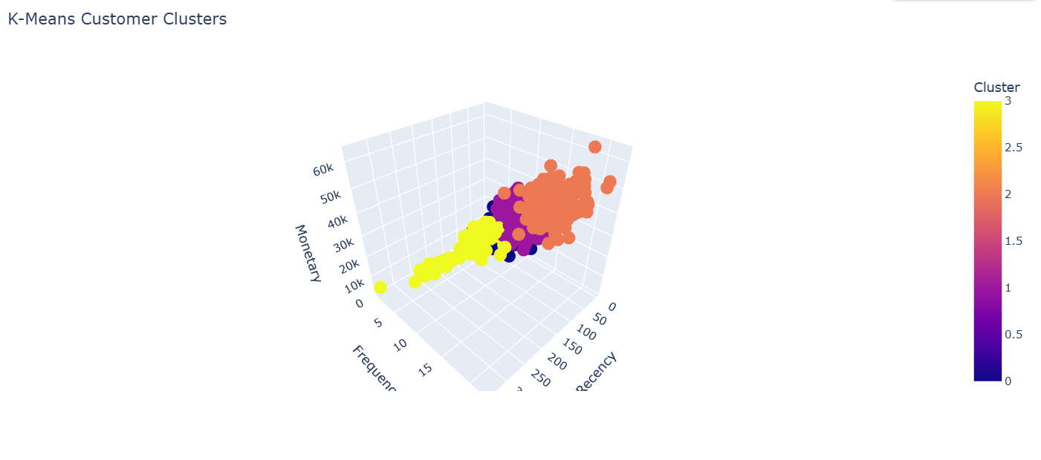

5. EXISTING SYSTEM
In a basic e-commerce environment, transaction data may be stored without detailed customer segmentation or behavioural analysis.
Traditional analysis may involve manually checking:
- Sales records.
- Customer purchases.
- Product performance.
- Revenue reports.
- Customer activity.
Such methods can become time-consuming when the amount of data increases.
The existing approach may therefore have limitations such as:
- Limited customer segmentation.
- Difficult manual analysis.
- Less visual representation.
- Difficulty identifying at-risk customers.
- Limited use of machine-learning techniques.
- Difficulty comparing multiple business dimensions.

6. PROPOSED SYSTEM
The proposed system uses Python-based data analysis and machine-learning techniques to analyse e-commerce transaction data.
The system generates a synthetic transaction dataset and processes it through several stages.
The major stages are:
Dataset Generation → Data Cleaning → Feature Engineering → Business Analysis → RFM Analysis → Customer Segmentation → K-Means Clustering → Visualization → Interactive Analysis
The system provides both rule-based customer segmentation using RFM scores and machine-learning-based clustering using K-Means.
This allows customer behaviour to be analysed from multiple perspectives.

7. TECHNOLOGIES USED

7.1 Python
Python is the primary programming language used in the project. It is used for dataset generation, data processing, calculations, visualization, and machine learning.

7.2 Pandas
Pandas is used for:
- Creating DataFrames.
- Cleaning data.
- Grouping records.
- Calculating business metrics.
- Performing RFM analysis.
- Manipulating transaction data.

7.3 NumPy
NumPy is used for numerical operations and generating synthetic data such as:
- Customer IDs.
- Products.
- Quantities.
- Prices.
- Countries.
- Gender values.

7.4 Plotly
Plotly is used to create interactive visualizations including:
- Line charts.
- Bar charts.
- Pie charts.
- Histograms.
- 2D scatter plots.
- 3D scatter plots.

7.5 Scikit-learn
Scikit-learn is used for machine-learning operations.
The project uses:
- StandardScaler for feature standardization.
- KMeans for customer clustering.

7.6 IPyWidgets
IPyWidgets is used to create interactive dropdown controls for exploring product, country, and customer-segment information.

7.7 Jupyter Notebook
The project is designed to run in a Python notebook environment where the analysis, output tables, charts, and interactive components can be displayed.

8. SYSTEM REQUIREMENTS

8.1 Hardware Requirements
- Processor: Intel Core i3 or above
- RAM: Minimum 4 GB
- Storage: Minimum 1 GB free space
- Keyboard and mouse
- Display monitor

8.2 Software Requirements
- Operating System: Windows/Linux/macOS
- Python 3.x
- Jupyter Notebook or compatible notebook environment
- Pandas
- NumPy
- Plotly
- Scikit-learn
- IPyWidgets

9. SYSTEM MODULES
The project can be divided into the following modules:

Module 1: Dataset Generation
Generates a synthetic e-commerce dataset containing transaction and customer information.

Module 2: Data Cleaning
Checks missing values and duplicate records and removes invalid or duplicate data.

Module 3: Feature Engineering
Creates additional date-related features such as year, month, month name, day, and weekday.

Module 4: Business KPI Analysis
Calculates revenue, number of customers, number of transactions, units sold, and average transaction value.

Module 5: Sales Analysis
Analyses revenue based on month, product, category, and country.

Module 6: Customer Analysis
Identifies top customers and analyses purchase frequency.

Module 7: RFM Analysis
Calculates Recency, Frequency, and Monetary values for each customer.

Module 8: Customer Segmentation
Assigns customers to predefined behavioural segments using RFM scores.

Module 9: K-Means Clustering
Uses machine learning to group customers according to similarities in RFM characteristics.

Module 10: Interactive Analysis
Provides dropdown-based exploration of products, countries, and customer segments.

10. DATASET OVERVIEW
The project uses a synthetically generated e-commerce dataset.
The dataset contains:
- 10,000 transaction records
- Customer IDs ranging from 1001 to 2000
- 10 products
- 4 product categories
- 6 countries
- Quantity values between 1 and 5
- Unit prices between 20 and 1500
- Purchase dates covering the year 2025
The products included are:
- Laptop
- Smartphone
- Headphones
- Smartwatch
- Tablet
- Keyboard
- Mouse
- Monitor
- Camera
- Speaker
The product categories include:
- Electronics
- Accessories
- Wearables
- Audio
The countries included are:
- India
- USA
- UK
- Germany
- Canada
- Australia
The dataset is generated using NumPy random functions with a fixed random seed of 42 so that the generated data can be reproduced.
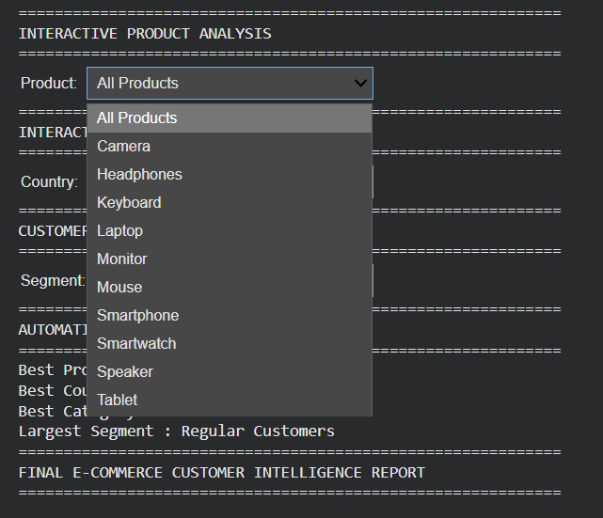

11. DATA ATTRIBUTES
The major attributes in the dataset are:
Attribute | Description
Customer_ID | Unique identifier representing a customer
Product | Product purchased
Category | Category of the purchased product
Country | Customer transaction country
Quantity | Number of units purchased
UnitPrice | Price of one unit
PurchaseDate | Date of purchase
Revenue | Total revenue from the transaction
Gender | Assigned customer gender
Additional date-related attributes are created during feature engineering:
- Year
- Month
- MonthName
- Day
- Weekday

12. DATA GENERATION
The dataset is generated using Python and NumPy.
A total of 10,000 transaction records are created. Customer IDs are randomly selected from the range 1001 to 2000.
Products are randomly selected from the predefined product list. Quantity is randomly generated between 1 and 5, while unit prices are generated between 20 and 1500.
Purchase dates are generated across the year 2025.
Revenue is calculated using:
Revenue = Quantity × Unit Price
Gender information is assigned to customers using randomly generated values.
The dataset is therefore suitable for demonstrating data analysis and customer segmentation techniques without using private or real customer information.

13. DATA PREPROCESSING
Data preprocessing is performed before analysis.

13.1 Missing Value Checking
The isnull() function is used to identify missing values in the dataset.

13.2 Duplicate Checking
The duplicated() function is used to identify duplicate transaction records.

13.3 Duplicate Removal
Duplicate records are removed using:
drop_duplicates()

13.4 Invalid Value Removal
Transactions with zero or negative quantity or unit price are removed.

13.5 Date Conversion
The purchase date is converted into the appropriate datetime format.

13.6 Revenue Recalculation
Revenue is recalculated after cleaning to ensure consistency.

14. FEATURE ENGINEERING
Additional features are extracted from the purchase date.
The project creates:
- Year – year of the transaction.
- Month – numerical month.
- MonthName – name of the month.
- Day – day of the month.
- Weekday – day of the week.
These features make it easier to analyse sales trends over time.

15. BUSINESS KPI ANALYSIS
The project calculates several important business performance indicators.

Total Revenue
Represents the total amount generated from all transactions.

Total Customers
Represents the number of unique customer IDs in the dataset.

Total Transactions
Represents the total number of transaction records.

Total Units Sold
Represents the total quantity of products sold.

Average Transaction Value
Represents the average revenue generated per transaction.
These KPIs provide a basic overview of the overall business performance.

16. SALES ANALYSIS

16.1 Monthly Revenue Analysis
Monthly revenue is calculated by grouping transactions according to month.
A line chart is used to display the monthly revenue trend.
This helps identify changes in sales performance throughout the year.

16.2 Product Revenue Analysis
Revenue is grouped by product to identify products generating higher revenue.
A bar chart is used to represent product-wise revenue.

16.3 Product Quantity Analysis
The total quantity sold for each product is calculated.
This helps distinguish products that are frequently purchased from products that generate higher revenue because of higher prices.

16.4 Category Analysis
Revenue is grouped according to product category.
A pie chart is used to show the contribution of different categories to total revenue.

16.5 Country Analysis
Revenue is grouped by country to compare geographical sales performance.
A bar chart is used to represent country-wise revenue.

17. CUSTOMER ANALYSIS
Customer revenue is calculated by grouping transaction records using Customer_ID.
The customers are sorted according to total revenue, allowing the project to identify the top 10 customers.
The project also calculates customer purchase frequency by counting the number of transactions associated with each customer.
A histogram is used to visualize the distribution of customer purchase frequency.

18. RFM ANALYSIS
RFM analysis is one of the main components of the project.
RFM stands for:

Recency
Recency measures how recently a customer made a purchase.
A lower recency value means the customer purchased more recently.

Frequency
Frequency measures how many transactions a customer made.
A higher frequency indicates that the customer purchases more often.

Monetary
Monetary measures the total amount spent by a customer.
A higher monetary value indicates greater customer spending.
The three measures are calculated for every customer using transaction data.
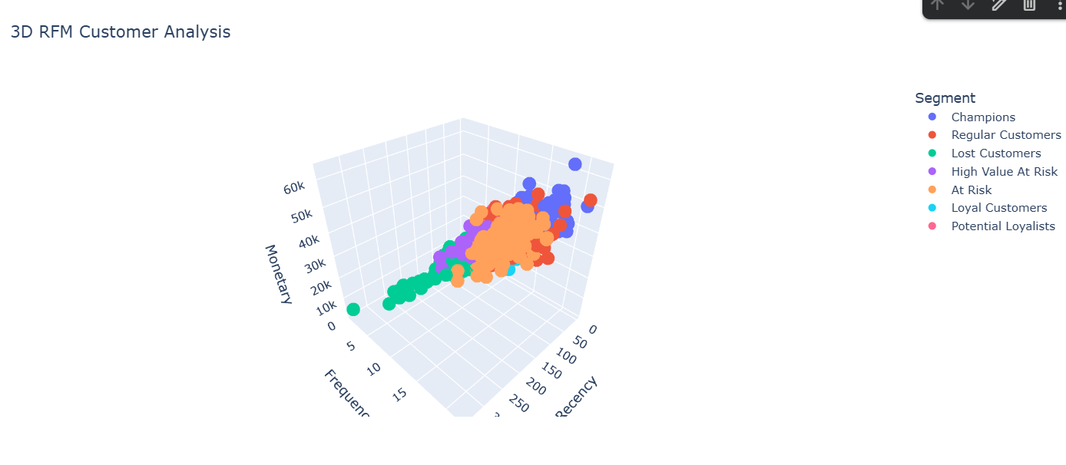

19. RFM SCORING
After calculating RFM values, each customer receives an RFM score.
The customers are divided into five groups for each RFM component.
For Recency:
- Lower recency receives a higher score.
- A score of 5 represents better recent activity.
For Frequency:
- Higher frequency receives a higher score.
For Monetary:
- Higher monetary value receives a higher score.
The three scores are combined to create an overall RFM score.
For example, an RFM score such as 555 represents a customer with high scores in Recency, Frequency, and Monetary value.

20. CUSTOMER SEGMENTATION
Customers are assigned to different segments based on their RFM scores.

Champions
Customers with high Recency, Frequency, and Monetary scores.
These customers are highly active and valuable.

Loyal Customers
Customers with high recent activity and relatively high purchase frequency.

Potential Loyalists
Customers who have recently purchased and show good monetary behaviour but may have lower frequency.

At Risk
Customers with low recent activity but relatively good purchase frequency.
These customers may require attention to encourage future purchases.

High Value At Risk
Customers who have low recent activity but have relatively high monetary value.

Lost Customers
Customers with low recent activity and low purchase frequency.

Regular Customers
Customers who do not fall into the other defined segments.
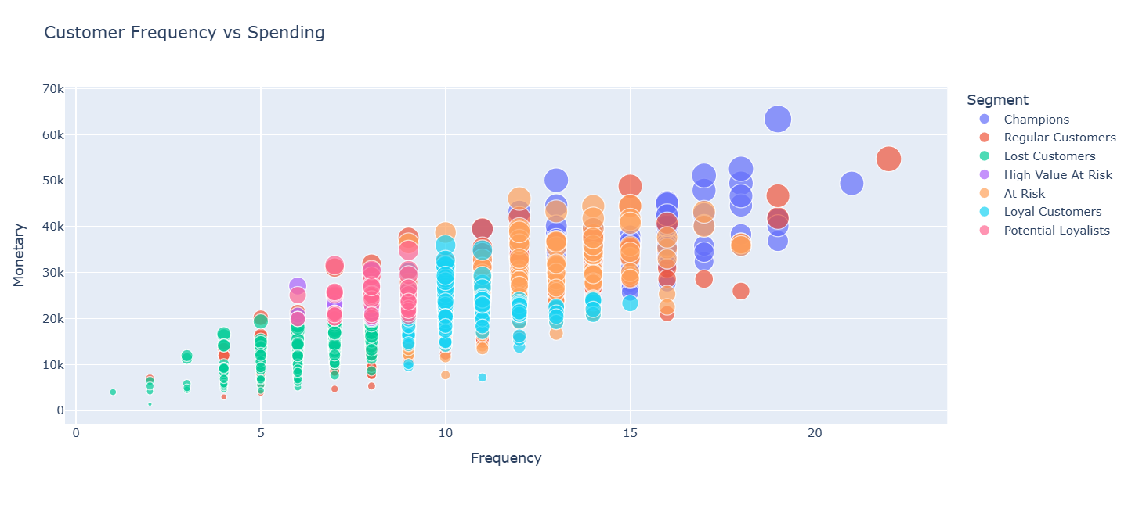

21. CUSTOMER SEGMENT DISTRIBUTION
The number of customers belonging to each segment is calculated using value_counts().
A pie chart is then created to display the distribution of customer segments.
This provides a visual understanding of how the customer base is divided across different behavioural groups.

22. CUSTOMER BEHAVIOUR VISUALIZATION
A scatter plot is created using:
- Frequency on the X-axis.
- Monetary value on the Y-axis.
- Monetary value as point size.
- Customer segment as colour.
This visualization helps identify relationships between purchase frequency and customer spending.
A 3D scatter plot is also used with:
- Recency
- Frequency
- Monetary value
This allows customer behaviour to be viewed from three dimensions.

23. K-MEANS CUSTOMER SEGMENTATION
K-Means clustering is used as a machine-learning technique to group customers based on their RFM characteristics.
The features selected are:
- Recency
- Frequency
- Monetary
Before applying K-Means, the features are standardized using StandardScaler.
This is important because the three variables may have different numerical ranges.
The K-Means algorithm is configured with:
- Number of clusters: 4
- Random state: 42
- Number of initializations: 10
The model assigns each customer to one of four clusters.
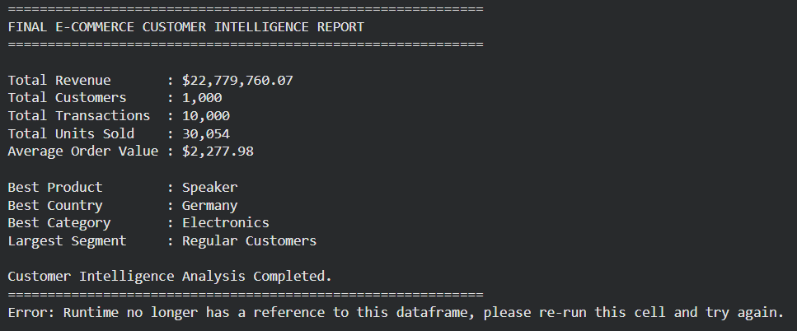

24. K-MEANS CLUSTER SUMMARY
After clustering, the project calculates the average:
- Recency
- Frequency
- Monetary value
for each cluster.
It also counts the number of customers in each cluster.
This summary helps compare the characteristics of the four machine-learning-generated customer groups.
Unlike the RFM rule-based segmentation, K-Means does not use predefined segment names. It groups customers based on similarities in their numerical RFM characteristics.
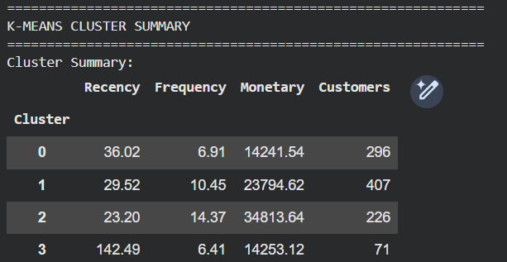

25. K-MEANS VISUALIZATION
A 3D scatter plot is used to visualize the K-Means clusters.
The three axes represent:
- Recency
- Frequency
- Monetary
Each cluster is represented separately in the visualization.
Customer ID, RFM segment, and other information can also be displayed when interacting with the visualization.

26. AT-RISK CUSTOMER IDENTIFICATION
The project filters customers whose RFM segment is At Risk.
For these customers, the system displays:
- Customer ID
- Recency
- Frequency
- Monetary value
- RFM score
The customers are sorted by Monetary value, allowing higher-value at-risk customers to be identified first.
This can help businesses prioritize customers who may be valuable but have not purchased recently.

27. CHAMPION CUSTOMER IDENTIFICATION
The project also filters customers classified as Champions.
Their:
- Customer ID
- Recency
- Frequency
- Monetary value
- RFM score
are displayed.
Champion customers represent highly valuable and active customers according to the project's RFM rules.

28. INTERACTIVE PRODUCT ANALYSIS
An interactive product dropdown is created using IPyWidgets.
Users can select:
- All Products
- Individual products
When a product is selected, the system calculates:
- Revenue
- Units sold
- Number of transactions
It also generates a monthly revenue chart for the selected product.
This allows users to explore individual product performance without manually filtering the dataset.

29. INTERACTIVE COUNTRY ANALYSIS
An interactive country dropdown is used to explore country-wise performance.
Users can select:
- All Countries
- Individual countries
For the selected country, the system calculates:
- Revenue
- Number of customers
- Number of transactions
Category performance is also visualized for the selected country.

30. INTERACTIVE CUSTOMER SEGMENT EXPLORER
An interactive customer-segment dropdown is included to allow users to explore specific customer groups.
The user can select a segment such as:
- Champions
- Loyal Customers
- Potential Loyalists
- At Risk
- High Value At Risk
- Lost Customers
- Regular Customers
The selected segment can then be analysed based on its customer and RFM characteristics.

31. SYSTEM METHODOLOGY
The overall methodology followed by the project is:

Step 1: Dataset Generation
Generate 10,000 synthetic e-commerce transaction records.

Step 2: Data Cleaning
Check missing values, duplicate records, invalid quantities, and invalid prices.

Step 3: Feature Engineering
Extract useful date-related features from purchase dates.

Step 4: KPI Analysis
Calculate revenue, customers, transactions, units sold, and average transaction value.

Step 5: Exploratory Data Analysis
Analyse monthly, product, category, country, and customer-level performance.

Step 6: RFM Analysis
Calculate Recency, Frequency, and Monetary values for each customer.

Step 7: RFM Scoring
Assign scores from 1 to 5 to each RFM component.

Step 8: Customer Segmentation
Classify customers according to predefined RFM rules.

Step 9: K-Means Clustering
Standardize RFM features and group customers into four clusters.

Step 10: Visualization
Generate interactive charts and 3D visualizations.

Step 11: Interactive Exploration
Allow users to filter and explore products, countries, and customer segments.

32. RESULTS AND OBSERVATIONS
The project produces several types of analytical results.
The system can determine:
- Overall revenue generated.
- Number of customers.
- Number of transactions.
- Number of units sold.
- Average transaction value.
- Monthly revenue patterns.
- Product-wise revenue.
- Product-wise quantity sold.
- Category contribution.
- Country-wise revenue.
- Top customers.
- Customer purchase frequency.
- RFM values and scores.
- Customer segment distribution.
- K-Means customer clusters.
- At-risk customers.
- Champion customers.
The visualizations make these results easier to interpret and provide a clear view of customer and sales behaviour.
The exact numerical outputs depend on the generated dataset and should be inserted into the final report from the notebook output rather than manually inventing values.

33. ADVANTAGES
- Automated Data Analysis
Large numbers of transaction records can be analysed efficiently.
- Customer Segmentation
Customers can be divided into meaningful behavioural groups.
- Identification of Valuable Customers
Champion and high-value customers can be identified.
- Identification of At-Risk Customers
Customers showing reduced recent activity can be identified.
- Multiple Analytical Views
The system analyses products, categories, countries, and customers.
- Visual Representation
Charts make complex information easier to understand.
- Machine Learning Integration
K-Means clustering provides an additional method of customer grouping.
- Interactive Analysis
Dropdown controls allow users to explore selected products and countries.
- Reproducible Dataset
The fixed random seed allows the synthetic dataset generation process to be reproduced.

34. LIMITATIONS
- The dataset is synthetic and does not represent real customer behaviour.
- The generated customer information is randomized.
- K-Means uses a predefined number of four clusters.
- The project does not currently include predictive customer churn modelling.
- The system is primarily designed for notebook-based analysis.
- The project does not include a production database.
- The analysis is based mainly on historical transaction information.
- Customer segmentation rules are predefined and may not represent every real-world business requirement.

35. FUTURE ENHANCEMENTS
The project can be enhanced in several ways.

Real Dataset Integration
The system can be connected to real e-commerce transaction data.

Web Application
The project can be converted into a web application using frameworks such as Django or Flask.

Database Integration
A database such as MySQL or MongoDB can be used to store transaction and customer information.

Customer Churn Prediction
Machine-learning models can be added to predict whether a customer is likely to stop purchasing.

Recommendation System
A product recommendation system can be developed based on customer purchase history.

Automated Reports
The system can generate automated business reports and dashboards.

Advanced Machine Learning
Other clustering algorithms can be compared with K-Means to determine which method provides better customer grouping.

Real-Time Analysis
The system could be extended to analyse new transactions as they are generated.

36. CONCLUSION
The E-Commerce Customer Segmentation and Sales Analysis Using Python project demonstrates how data analysis and machine-learning techniques can be used to understand e-commerce customer behaviour.
The project begins by generating a synthetic e-commerce transaction dataset and performing data cleaning and preprocessing. Business KPIs are then calculated to provide an overview of sales performance.
Product, category, country, and customer-level analysis provides different views of the transaction data. RFM analysis is used to evaluate customers according to their recency, frequency, and monetary value. Based on these scores, customers are divided into meaningful segments such as Champions, Loyal Customers, Potential Loyalists, At Risk, High Value At Risk, Lost Customers, and Regular Customers.
K-Means clustering is additionally applied to the RFM features to identify customer groups using an unsupervised machine-learning technique. Interactive visualizations allow the data to be explored from different perspectives.
Overall, the project demonstrates the practical use of Python for data preprocessing, exploratory data analysis, customer segmentation, visualization, and machine learning. It provides a foundation that can later be extended into a full web-based e-commerce analytics system using real-world data.

- Python Documentation
- Pandas Documentation
- NumPy Documentation
- Plotly Documentation
- Scikit-learn Documentation
- IPyWidgets Documentation
- Jupyter Notebook Documentation

The appendix may contain:
- Complete Python source code.
- Dataset sample.
- Output screenshots.
- KPI output.
- Monthly revenue chart.
- Product revenue chart.
- Category analysis chart.
- Country analysis chart.
- RFM segment distribution.
- RFM 3D visualization.
- K-Means cluster visualization.
- Interactive product analysis.
- Interactive country analysis.
- Interactive customer segment analysis.

