|  |  |  |
| --- | --- | --- |
|  | | |
| Refute Questions  Submitted to: Dr. P. Savaridassan Mayank Anand RA2411030010067 819 / U1 BTech CSE Cybersecurity | | |
|  |  |  |

C Language

# Problem Statement

Implement a menu-driven program for selecting preferred units. Demonstrate that switch works with integer choices but fails with string input.

## Solution Code

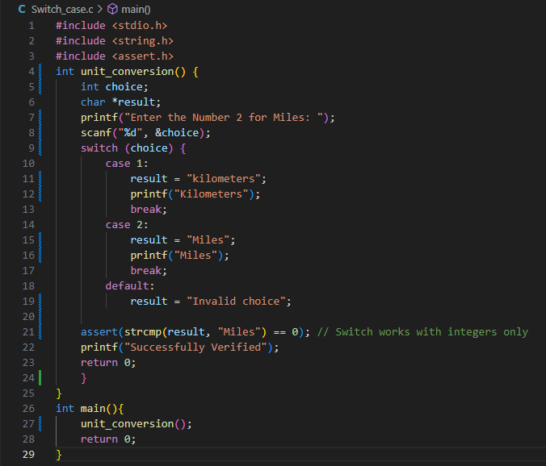

## Execution

## Test Case 1: Successful Execution



Test Case 2: If Assertion was wrong



Explanation Of Failure

The failure occurs if switch is used with a string literal (e.g., "Km"). This results in a compile-time error since strings are pointers, not integral constants. The limitation lies in the switch statement’s inability to handle non-integer types.

# Problem Statement

Use a global variable to count the number of users logged into a system. Validate that the variable is initialized to zero by default.

## Solution Code

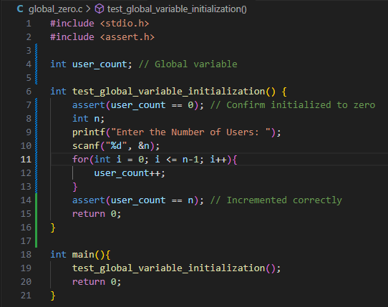

## Execution

## Test Case 1: Successful Execution



Test Case 2: If Assertion was wrong



Explanation Of Failure

If the test fails, here it indicates the global variable was initialized with a non-zero value. This could happen if the variable is explicitly assigned a value or if uninitialized memory is accessed due to compiler-specific behavior or incorrect testing setup.