|  |  |  |
| --- | --- | --- |
|  | | |
| Refute Questions  Submitted to: Dr. P. Savaridassan Mayank Anand RA2411030010067 819 / U1 BTech CSE Cybersecurity | | |
|  |  |  |

Python

# Problem Statement

Write a function to calculate the area of a rectangle, and verify that the intermediate calculation variables (e.g., length, width) are not accessible outside the function.

## Solution Code

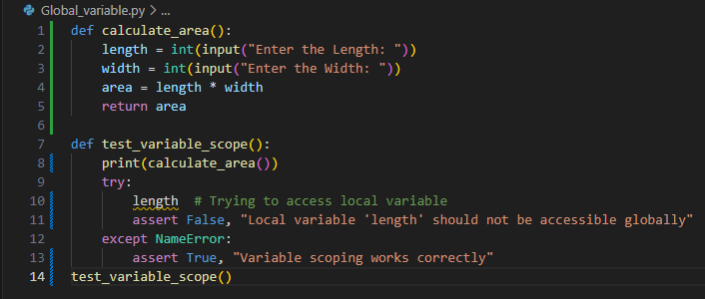

## Execution

## Test Case 1: Successful Execution



Test Case 2: If Assertion was wrong

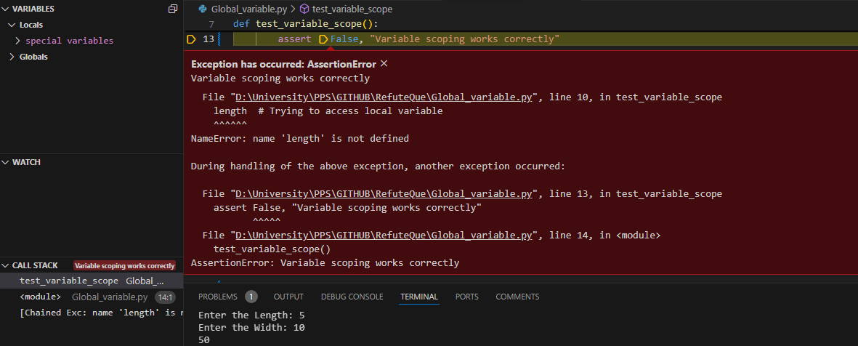

Explanation Of Failure

The test fails if the variable declared inside the function (length) is accessible globally. This indicates a scoping violation, as local variables should remain private to their function. The logic error occurs if a variable is unintentionally made global (e.g., using global length) or declared outside the function.

# Problem Statement

Write a program to update a password. Verify that the original password string remains unchanged after "modifying" it.

## Solution Code

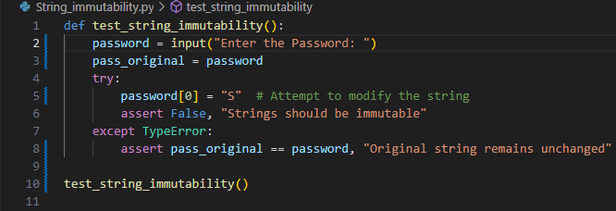

## Execution

## Test Case 1: Successful Execution



Test Case 2: If Assertion was wrong

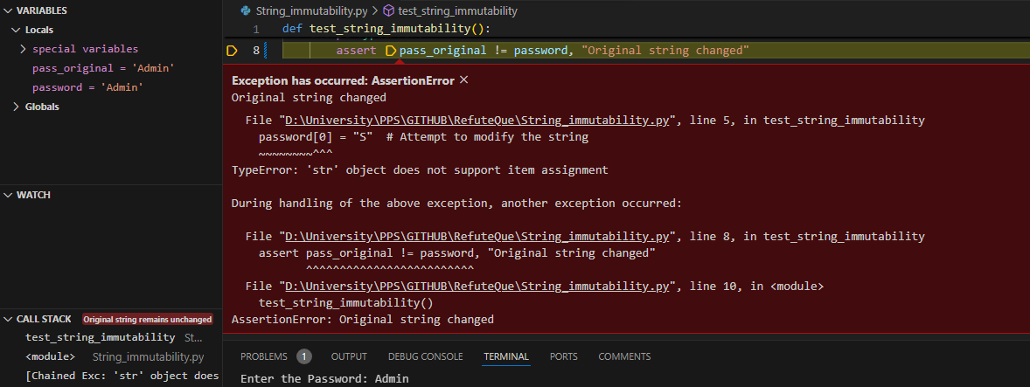

Explanation Of Failure

If the test fails, it means the string was modified in place, which contradicts Python's immutability guarantee. This could happen only if you're working with a different object type that mimics strings but is mutable, like bytearray. The limitation lies in mistaking string-like objects for immutable strings.