**Data Preprocessing**

1. Data Augmentation

We use a keras Sequential model with two layers: flip horizontal and vertical and rotation with 20 degrees to generate augmented images for training.

2. Normalization

We normalize the image dataset through rescaling it by /255, caching and shuffling.

**Method Explore**

**CNN – U-Net**

Followed the U-Net structure below, we build its model and compile with Adam optimization rules and learning rate 0.0001 for training. In each run of the training process, we batch 10 images from the training dataset and 100 data points in fit function.

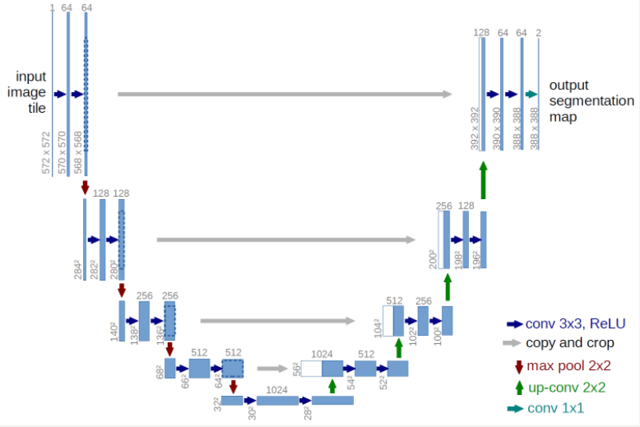

Figure U-Net

The training accuracy for each epoch is around 0.59. Comparing with training using logistic regression, the U-Net structure improves the performance a lot.

We also modify the U-Net structure by adding batchnormalization layers before every conv 3x3 ReLu layers.

**Resnet101 and DeepLab**

**Next Step**

We will future look into the resnet structure.