Univariate normal distribution with mean of an standard deviation of 1

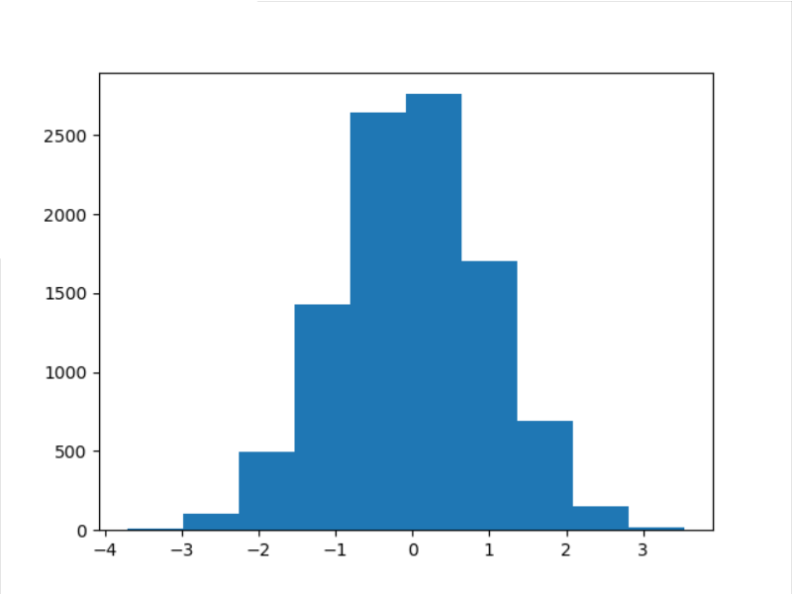

Histogram of samples generated by a categorical distribution with probabilities [0.1, 0.1, 0.3, 0.3, 0.2]

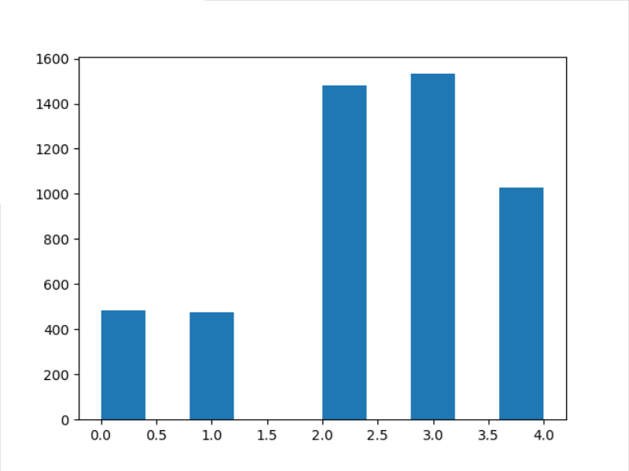

Scatter plot of the samples for a 2-D Gaussian with mean at [1, 1] and a covariance matrix [[1, 0.5], [0,5], 1]

