Part 2:

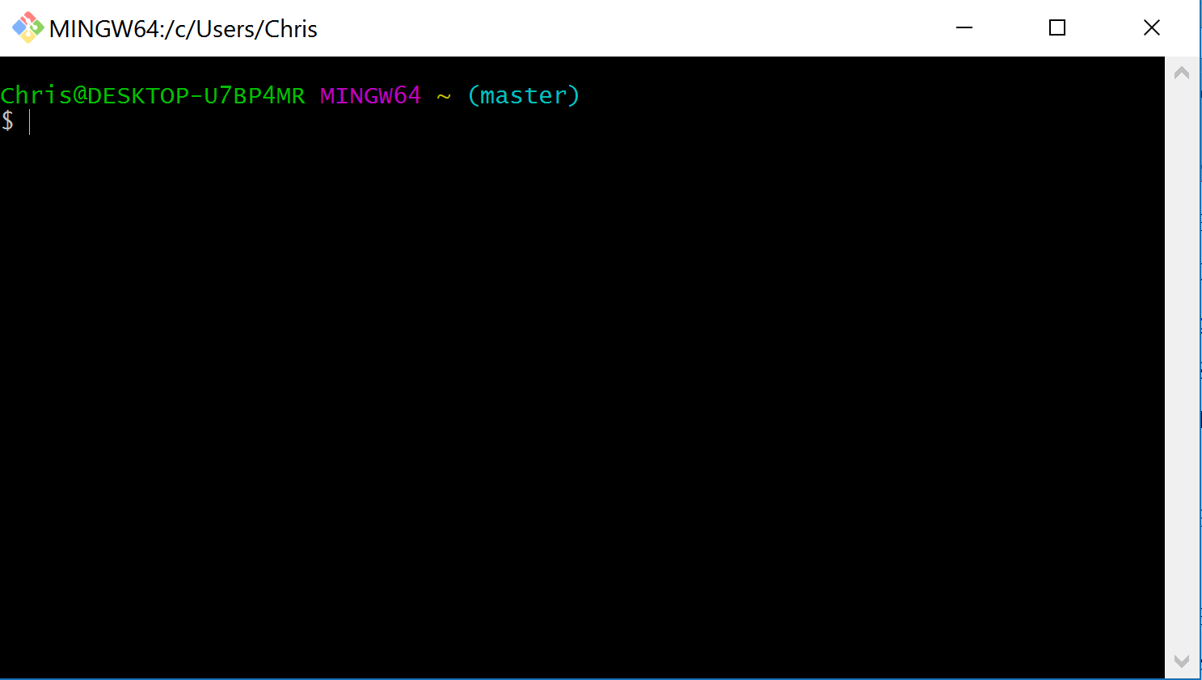

Part 3: Github is a version based control repository, used for uploading code. It was created by Tom Preson-Werner, Chris Wanstrath, and PJ Hyett. It was developed to allow coders to open source code, and collaborate amongst each-other. There are 7 (popular) similar platforms to Github. Bitbucket, SourceForge, GitLab, Klin, Codeplane, Codeplex, and Beanstalk. These platfomrs allow people to work on the same code, at the same time, and obtain open-source code from other users.

Part 4: 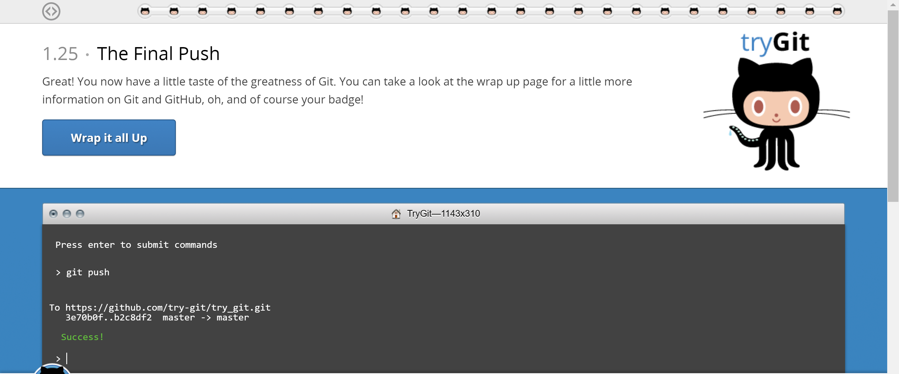

Part 5:

Repository – A hidden directory where Git operates.

Commit – Run commit command to store staged changes. (Git commit –m).

Push – Push command sends committed changes to repository, usually hosted on github.

Branch – A copy of a repository which allows for separate commits. Then the branch is merged back into the main master branch (main copy).

Fork – A personal copy of another user’s repository. Forks allow you to make changes to a project without effecting the original.

Merge – Merging takes changes from one branch, and applies them to another branch.

Clone – A copy of the repository that lives on your computer, instead of the website’s server.

Pull – fetching changes, and merging them.

Pull Request – Proposed changes to a repository submitted by a user, which can be either accepted or rejected by a repo’s collaborators.