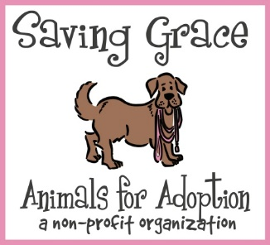**Saving Grace** works with many rural shelters throughout North Carolina where dogs have received little to no prior veterinary care. This results in a high population of heartworm positive dogs. Most cases are treated successfully, and the dogs do very well. However, the treatment is not without risk. These risks and the possibility of complications may result in additional costs and tests needed with your personal veterinarian. Treatment for Heartworm Disease for dogs in our care is not optional, but we do offer treatment options for adopters. As a shelter, we have limited resources and can provide very basic and effective treatment through our veterinarians. Dogs going through treatment will be considered “fostered” so that SG can legally provide the Heartworm Injections. Complications are rare but do happen. There is no wrong choice and we encourage you to choose what works best for you as the adopter. Saving Grace does not provide reimbursement for veterinary care provided outside of our organization. If you would like to work with your veterinarian, or need emergency care outside the hours Saving Grace is open, you will be responsible for costs incurred.

Dog Name: ________________________________ Date: ____________ Initial: ____________

**Option 1: My Heart is with Saving Grace**

Saving Grace offers the most basic Heartworm protocol to our shelter dogs in order to be able to offer treatment to many animals. Our partner veterinarians come onsite as available and administer treatments to dogs who are due for injections. Multiple dogs are treated together to maximize the use of the costly drugs and their veterinarian’s time. As a result, there is not flexibility for treatment days or times. We do our best to coordinate drop off and pickup times with as much notice as possible. Depending on where your dog is in the treatment process, it may result in multiple return visits to Saving Grace and the dogs must be present at assigned times. During the Foster to Adopt period Saving Grace provides a 30-day Doxycycline regimen. Dogs undergoing Heartworm treatment through Saving Grace should still receive the recommended initial wellness exam and be established with a personal veterinarian which includes Heartworm and Flea/Tick preventatives. The veterinarians that assist Saving Grace with this program are not available to provide follow-up care or assistance following treatments.

An adopter that would like to go a step further than the most basic treatment for Heartworms is welcome to consult their personal veterinarian to explore procedures, treatments, and other services or purchases related to treatment. Additional services are the responsibility and at the personal cost of the foster/adopter with your veterinarian/clinic. Saving Grace will then be able to work alongside the personal veterinarian’s treatment plan while providing the injections (which is the costliest portion of the treatment).

Initial:

**Option 2: We got this**

This plan is for the adopter who has a relationship with an established veterinarian and would like the option to work with them at their cost. With this plan, you agree to provide all necessary care needed at your cost and schedule appointments at your convenience with the veterinarian of your choice. The veterinarian will most likely recommend bloodwork and radiographs prior to treatment. The cost for care leading up to treatment and including Heartworm treatment is usually between $800-$1200 depending on the veterinarian, the hospital, and the plan you choose.

Initial:

October 2022