Capstone: Real Estate Marketplace

- To run the tests:
Truffle v5.5.16 (core: 5.5.16)
Ganache v^7.1.0
Solidity v0.5.16 (solc-js)
Web3.js v1.5.3
Navigate into eth-contracts folder and run following commands:
- ganache-cli –a 50
- truffle compile
- truffle migrate --reset
- truffle test
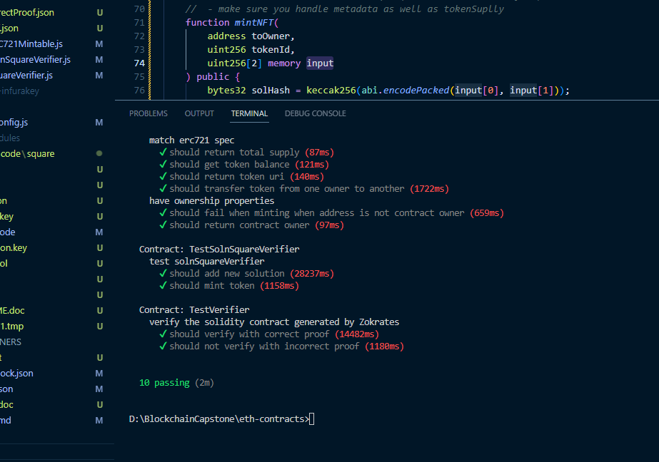

- Contract addresses on rinkeby test network:
https://rinkeby.etherscan.io/address/0xa93e4c9f2445dfa1fc82761a95a88da79bda0145

- OpenSea transferred token:
https://testnets.opensea.io/assets/rinkeby/0xa93e4c9f2445dfa1fc82761a95a88da79bda0145/1
https://testnets.opensea.io/assets/rinkeby/0xa93e4c9f2445dfa1fc82761a95a88da79bda0145/2
https://testnets.opensea.io/assets/rinkeby/0xa93e4c9f2445dfa1fc82761a95a88da79bda0145/4
https://testnets.opensea.io/assets/rinkeby/0xa93e4c9f2445dfa1fc82761a95a88da79bda0145/5
https://testnets.opensea.io/assets/rinkeby/0xa93e4c9f2445dfa1fc82761a95a88da79bda0145/6

- Deployment on Rinkeby Test Network:

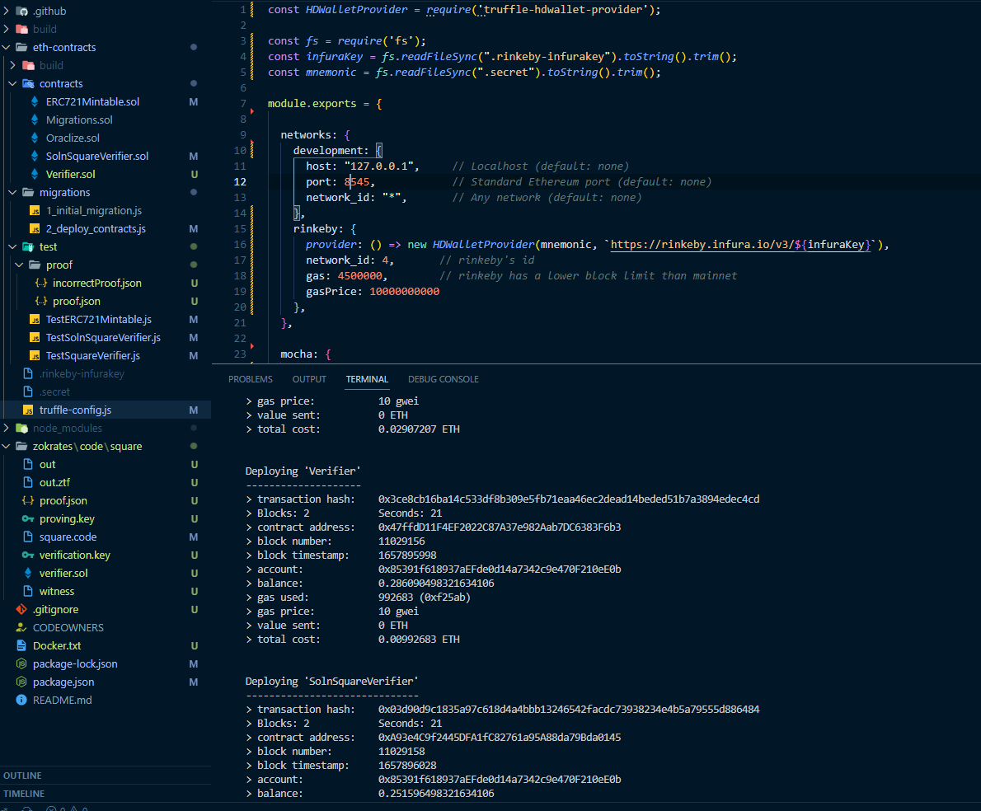

Deploying 'CustomERC721Token'
-----------------------------
> transaction hash: 0x26a70cdbe2bde0d1460c9fe220613d6260c78608d663ebeac54d9551f1e6f279
> Blocks: 1 Seconds: 5
> contract address: 0x8014e96492a5d11D1BAF6507A7A15E3634A017d2
> block number: 11029154
> block timestamp: 1657895968
> account: 0x85391f618937aEFde0d14a7342c9e470F210eE0b
> balance: 0.296017328321634106
> gas used: 2907207 (0x2c5c47)
> gas price: 10 gwei
> value sent: 0 ETH
> total cost: 0.02907207 ETH

Deploying 'Verifier'
--------------------
> transaction hash: 0x3ce8cb16ba14c533df8b309e5fb71eaa46ec2dead14beded51b7a3894edec4cd
> Blocks: 2 Seconds: 21
> contract address: 0x47ffdD11F4EF2022C87A37e982Aab7DC6383F6b3
> block number: 11029156
> block timestamp: 1657895998
> account: 0x85391f618937aEFde0d14a7342c9e470F210eE0b
> balance: 0.286090498321634106
> gas used: 992683 (0xf25ab)
> gas price: 10 gwei
> value sent: 0 ETH
> total cost: 0.00992683 ETH

Deploying 'SolnSquareVerifier'
------------------------------
> transaction hash: 0x03d90d9c1835a97c618d4a4bbb13246542facdc73938234e4b5a79555d886484
> Blocks: 2 Seconds: 21
> contract address: 0xA93e4C9f2445DFA1fC82761a95A88da79Bda0145
> block number: 11029158
> block timestamp: 1657896028
> account: 0x85391f618937aEFde0d14a7342c9e470F210eE0b
> balance: 0.251596498321634106
> gas used: 3449400 (0x34a238)
> gas price: 10 gwei
> value sent: 0 ETH
> total cost: 0.034494 ETH

> Saving migration to chain.
> Saving artifacts
-------------------------------------
> Total cost: 0.0734929 ETH

Summary
=======
> Total deployments: 4
> Final cost: 0.07575827 ETH

- Contract ABI
[
{
"inputs": [
{
"internalType": "address",
"name": "verifierAddress",
"type": "address"
},
{
"internalType": "string",
"name": "name",
"type": "string"
},
{
"internalType": "string",
"name": "symbol",
"type": "string"
}
],
"payable": false,
"stateMutability": "nonpayable",
"type": "constructor"
},
{
"anonymous": false,
"inputs": [
{
"indexed": true,
"internalType": "address",
"name": "owner",
"type": "address"
},
{
"indexed": true,
"internalType": "address",
"name": "approved",
"type": "address"
},
{
"indexed": true,
"internalType": "uint256",
"name": "tokenId",
"type": "uint256"
}
],
"name": "Approval",
"type": "event"
},
{
"anonymous": false,
"inputs": [
{
"indexed": true,
"internalType": "address",
"name": "owner",
"type": "address"
},
{
"indexed": true,
"internalType": "address",
"name": "operator",
"type": "address"
},
{
"indexed": false,
"internalType": "bool",
"name": "approved",
"type": "bool"
}
],
"name": "ApprovalForAll",
"type": "event"
},
{
"anonymous": false,
"inputs": [
{
"indexed": false,
"internalType": "address",
"name": "previousOwner",
"type": "address"
},
{
"indexed": false,
"internalType": "address",
"name": "newOwner",
"type": "address"
}
],
"name": "OwnershipTransferred",
"type": "event"
},
{
"anonymous": false,
"inputs": [
{
"indexed": false,
"internalType": "address",
"name": "triggerer",
"type": "address"
}
],
"name": "Paused",
"type": "event"
},
{
"anonymous": false,
"inputs": [
{
"indexed": false,
"internalType": "uint256",
"name": "solutionIndex",
"type": "uint256"
},
{
"indexed": false,
"internalType": "address",
"name": "tokenOwner",
"type": "address"
}
],
"name": "SolutionAdded",
"type": "event"
},
{
"anonymous": false,
"inputs": [
{
"indexed": true,
"internalType": "address",
"name": "from",
"type": "address"
},
{
"indexed": true,
"internalType": "address",
"name": "to",
"type": "address"
},
{
"indexed": true,
"internalType": "uint256",
"name": "tokenId",
"type": "uint256"
}
],
"name": "Transfer",
"type": "event"
},
{
"anonymous": false,
"inputs": [
{
"indexed": false,
"internalType": "address",
"name": "triggerer",
"type": "address"
}
],
"name": "Unpaused",
"type": "event"
},
{
"constant": false,
"inputs": [
{
"internalType": "bytes32",
"name": "_myid",
"type": "bytes32"
},
{
"internalType": "string",
"name": "_result",
"type": "string"
}
],
"name": "__callback",
"outputs": [],
"payable": false,
"stateMutability": "nonpayable",
"type": "function"
},
{
"constant": false,
"inputs": [
{
"internalType": "bytes32",
"name": "_myid",
"type": "bytes32"
},
{
"internalType": "string",
"name": "_result",
"type": "string"
},
{
"internalType": "bytes",
"name": "_proof",
"type": "bytes"
}
],
"name": "__callback",
"outputs": [],
"payable": false,
"stateMutability": "nonpayable",
"type": "function"
},
{
"constant": false,
"inputs": [
{
"internalType": "address",
"name": "to",
"type": "address"
},
{
"internalType": "uint256",
"name": "tokenId",
"type": "uint256"
}
],
"name": "approve",
"outputs": [],
"payable": false,
"stateMutability": "nonpayable",
"type": "function"
},
{
"constant": true,
"inputs": [
{
"internalType": "address",
"name": "owner",
"type": "address"
}
],
"name": "balanceOf",
"outputs": [
{
"internalType": "uint256",
"name": "",
"type": "uint256"
}
],
"payable": false,
"stateMutability": "view",
"type": "function"
},
{
"constant": true,
"inputs": [],
"name": "baseTokenURI",
"outputs": [
{
"internalType": "string",
"name": "",
"type": "string"
}
],
"payable": false,
"stateMutability": "view",
"type": "function"
},
{
"constant": true,
"inputs": [
{
"internalType": "uint256",
"name": "tokenId",
"type": "uint256"
}
],
"name": "getApproved",
"outputs": [
{
"internalType": "address",
"name": "",
"type": "address"
}
],
"payable": false,
"stateMutability": "view",
"type": "function"
},
{
"constant": true,
"inputs": [],
"name": "getOwner",
"outputs": [
{
"internalType": "address",
"name": "",
"type": "address"
}
],
"payable": false,
"stateMutability": "view",
"type": "function"
},
{
"constant": true,
"inputs": [
{
"internalType": "address",
"name": "owner",
"type": "address"
},
{
"internalType": "address",
"name": "operator",
"type": "address"
}
],
"name": "isApprovedForAll",
"outputs": [
{
"internalType": "bool",
"name": "",
"type": "bool"
}
],
"payable": false,
"stateMutability": "view",
"type": "function"
},
{
"constant": false,
"inputs": [
{
"internalType": "address",
"name": "to",
"type": "address"
},
{
"internalType": "uint256",
"name": "tokenId",
"type": "uint256"
}
],
"name": "mint",
"outputs": [
{
"internalType": "bool",
"name": "",
"type": "bool"
}
],
"payable": false,
"stateMutability": "nonpayable",
"type": "function"
},
{
"constant": true,
"inputs": [],
"name": "name",
"outputs": [
{
"internalType": "string",
"name": "",
"type": "string"
}
],
"payable": false,
"stateMutability": "view",
"type": "function"
},
{
"constant": true,
"inputs": [
{
"internalType": "uint256",
"name": "tokenId",
"type": "uint256"
}
],
"name": "ownerOf",
"outputs": [
{
"internalType": "address",
"name": "",
"type": "address"
}
],
"payable": false,
"stateMutability": "view",
"type": "function"
},
{
"constant": false,
"inputs": [
{
"internalType": "address",
"name": "from",
"type": "address"
},
{
"internalType": "address",
"name": "to",
"type": "address"
},
{
"internalType": "uint256",
"name": "tokenId",
"type": "uint256"
}
],
"name": "safeTransferFrom",
"outputs": [],
"payable": false,
"stateMutability": "nonpayable",
"type": "function"
},
{
"constant": false,
"inputs": [
{
"internalType": "address",
"name": "from",
"type": "address"
},
{
"internalType": "address",
"name": "to",
"type": "address"
},
{
"internalType": "uint256",
"name": "tokenId",
"type": "uint256"
},
{
"internalType": "bytes",
"name": "_data",
"type": "bytes"
}
],
"name": "safeTransferFrom",
"outputs": [],
"payable": false,
"stateMutability": "nonpayable",
"type": "function"
},
{
"constant": false,
"inputs": [
{
"internalType": "address",
"name": "to",
"type": "address"
},
{
"internalType": "bool",
"name": "approved",
"type": "bool"
}
],
"name": "setApprovalForAll",
"outputs": [],
"payable": false,
"stateMutability": "nonpayable",
"type": "function"
},
{
"constant": false,
"inputs": [
{
"internalType": "bool",
"name": "state",
"type": "bool"
}
],
"name": "setPaused",
"outputs": [],
"payable": false,
"stateMutability": "nonpayable",
"type": "function"
},
{
"constant": true,
"inputs": [
{
"internalType": "bytes4",
"name": "interfaceId",
"type": "bytes4"
}
],
"name": "supportsInterface",
"outputs": [
{
"internalType": "bool",
"name": "",
"type": "bool"
}
],
"payable": false,
"stateMutability": "view",
"type": "function"
},
{
"constant": true,
"inputs": [],
"name": "symbol",
"outputs": [
{
"internalType": "string",
"name": "",
"type": "string"
}
],
"payable": false,
"stateMutability": "view",
"type": "function"
},
{
"constant": true,
"inputs": [
{
"internalType": "uint256",
"name": "index",
"type": "uint256"
}
],
"name": "tokenByIndex",
"outputs": [
{
"internalType": "uint256",
"name": "",
"type": "uint256"
}
],
"payable": false,
"stateMutability": "view",
"type": "function"
},
{
"constant": true,
"inputs": [
{
"internalType": "address",
"name": "owner",
"type": "address"
},
{
"internalType": "uint256",
"name": "index",
"type": "uint256"
}
],
"name": "tokenOfOwnerByIndex",
"outputs": [
{
"internalType": "uint256",
"name": "",
"type": "uint256"
}
],
"payable": false,
"stateMutability": "view",
"type": "function"
},
{
"constant": true,
"inputs": [
{
"internalType": "uint256",
"name": "tokenId",
"type": "uint256"
}
],
"name": "tokenURI",
"outputs": [
{
"internalType": "string",
"name": "",
"type": "string"
}
],
"payable": false,
"stateMutability": "view",
"type": "function"
},
{
"constant": true,
"inputs": [],
"name": "totalSupply",
"outputs": [
{
"internalType": "uint256",
"name": "",
"type": "uint256"
}
],
"payable": false,
"stateMutability": "view",
"type": "function"
},
{
"constant": false,
"inputs": [
{
"internalType": "address",
"name": "from",
"type": "address"
},
{
"internalType": "address",
"name": "to",
"type": "address"
},
{
"internalType": "uint256",
"name": "tokenId",
"type": "uint256"
}
],
"name": "transferFrom",
"outputs": [],
"payable": false,
"stateMutability": "nonpayable",
"type": "function"
},
{
"constant": false,
"inputs": [
{
"internalType": "address",
"name": "newOwner",
"type": "address"
}
],
"name": "transferOwnership",
"outputs": [],
"payable": false,
"stateMutability": "nonpayable",
"type": "function"
},
{
"constant": false,
"inputs": [
{
"internalType": "uint256[2]",
"name": "a",
"type": "uint256[2]"
},
{
"internalType": "uint256[2][2]",
"name": "b",
"type": "uint256[2][2]"
},
{
"internalType": "uint256[2]",
"name": "c",
"type": "uint256[2]"
},
{
"internalType": "uint256[2]",
"name": "input",
"type": "uint256[2]"
}
],
"name": "addSolution",
"outputs": [],
"payable": false,
"stateMutability": "nonpayable",
"type": "function"
},
{
"constant": false,
"inputs": [
{
"internalType": "address",
"name": "toOwner",
"type": "address"
},
{
"internalType": "uint256",
"name": "tokenId",
"type": "uint256"
},
{
"internalType": "uint256[2]",
"name": "input",
"type": "uint256[2]"
}
],
"name": "mintNFT",
"outputs": [],
"payable": false,
"stateMutability": "nonpayable",
"type": "function"
}
]

