Ethereum Dapp for Tracking Items through Supply Chain
A DApp supply chain solution backed by the Ethereum platform, built with smart contracts that manage specific user permission controls as well as contracts that track and verify a product’s authenticity.

PROJECT WRITE-UP:
- Libraries used:
Web3: A collection of modules that contain functionality for the ethereum ecosystem.
Truffle: Used for compiling, testing, debugging and deploying smart contracts.
Ethjs-abi: Encoding and decoding from the ethers-wallet module.
- I do not use IPFS in this project.
- The contract address:
https://rinkeby.etherscan.io/address/0x7AbeE0a14134D3E40b2156886465BE0F54a0cbEa
https://rinkeby.etherscan.io/address/0x04b52fD875985B2ed805aBc803034BE93020E0fd
https://rinkeby.etherscan.io/address/0xEFA94828AbA9aAA2a63Ac44D7f972c986dFD3D66
https://rinkeby.etherscan.io/address/0xC44350aEc29704Dd0F7a122761e8dBE73e98e3CB
https://rinkeby.etherscan.io/address/0xC5206653EE9A0A53C4cBCe8945Be5c8619D769b5
https://rinkeby.etherscan.io/address/0x38e381a2FC9675CC9Dc130E76E4Ce8c35798fEa6
- Built With:
Truffle v5.5.16 (core: 5.5.16)
Solidity - 0.5.16 (solc-js)
Node v14.17.3
Web3.js v1.5.3
- Step-by-step instructions:

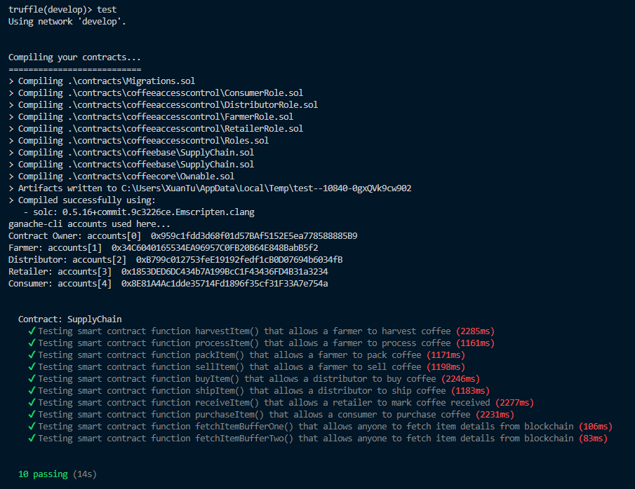
Firstly, I use Truffle to compile contracts and run tests using local network.
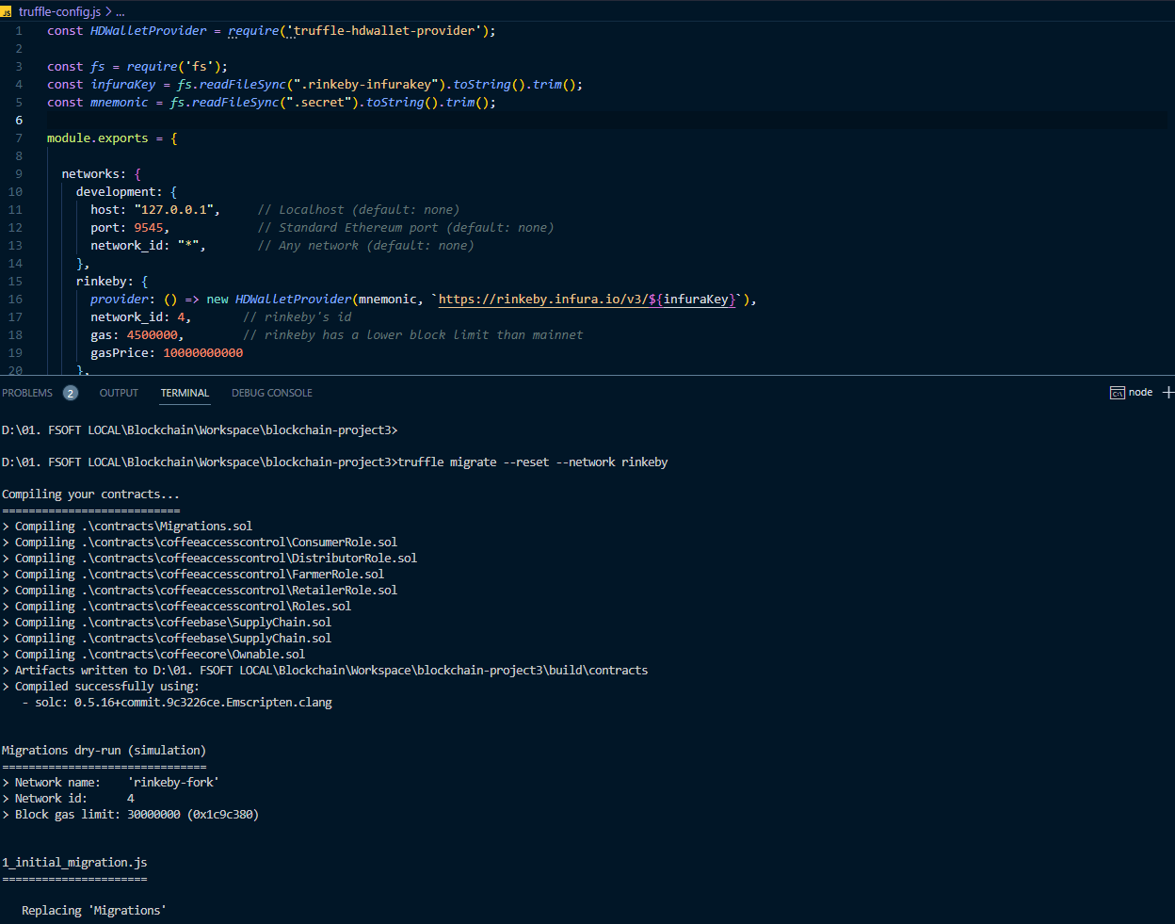Then I edit the truffle-config file to add settings to deploy contracts to the Rinkeby Test Network.

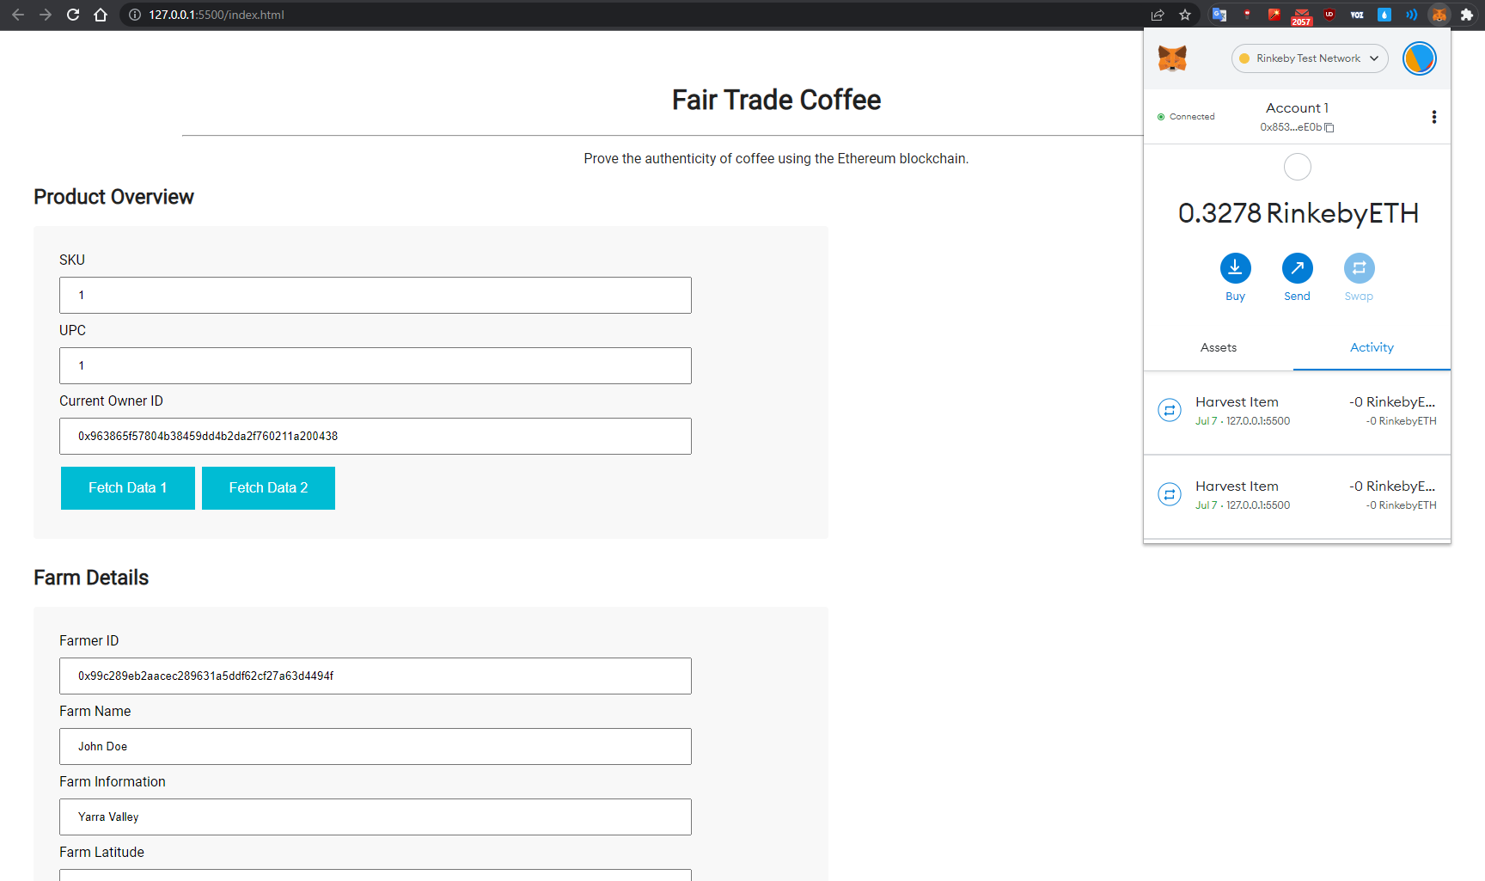
I run the front-end in local environment by Live Server Extension of VS Code, then I can interact with my Dapp by Chrome browser with Metamask installed and configured.

