**Karlheinz Stockhausen**

**MANTRA**

**for 2 pianos and electronics**

**Marco Stroppa, August 2015 (adapted from Serge Lemouton, 2012)**

**stroppa@marcostroppa.eu**

**ELECTRONIC RIDER**

For this version, each pianist uses an iPad which controls the frequencies of the oscillators generated by *pd*.

NB: middle A = A4.

Needed software: *Pd* (on the Macintosh), *TouchOSC* (on both iPads).

**Interfaces (controllers for the pianists)**

Interface piano 1 (three pages):

1. main rotary control, F#3 [54] – G#4 [68]. The yellow line below the rotary control allows for a visual fine tuning of the frequencies, but does not send any control values. The horizontal blue slider at the bottom shows the whole range of the piece, from appx. 3Hz to F#6 [90].
2. red vertical slider for the high register (D4 [62] 🡪 F#6 [90], through A5 [81]).
3. Kurzwellen, start/stop (left) and volume (brown vertical slider).

To move from one page to the other, tap the upper 0.5 cm on the right, centre or left.

Interface piano 2 (three pages):

1. main rotary control, Bb2 (46) – C4 (60). The blue line below the rotary control allows for a visual fine tuning of the frequencies, but does not send any control values. The horizontal red slider at the bottom shows the whole range of the piece, from A2 [45] to A5 [81].
2. red vertical slider for the high register (D4 [62] 🡪 A5 [81]).
3. very low frequencies 5Hz [-8.51] 🡪 7Hz [-2.59]. NB. the start button is not effective!

To move from one page to the other, tap the upper 0.5 cm on the right, centre or left.

**Setup of the Wi-Fi/OSC connection**

**between iPads and Mac (*Pd*)**

**A. INITIALIZATION**

• reset the **network settings** on both iPads:

Settings / General / Reset (all the way below) / Reset Network Settings

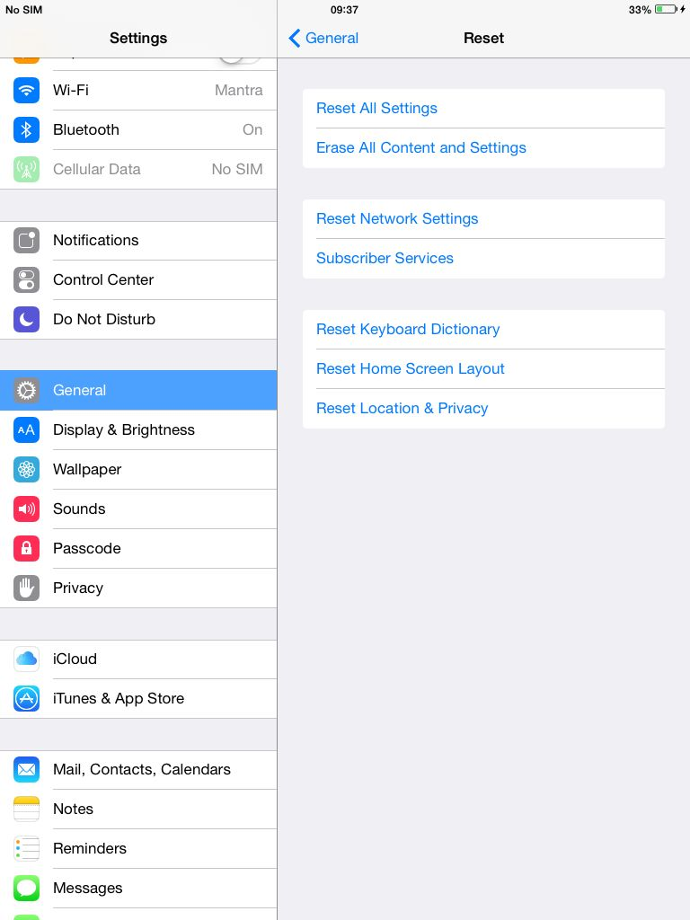

This should clean any problematic settings and reduce synchronization issues.

• find the best **Wi-Fi channel**. To do this (tested on OSX 10.9.5):

1. Turn Wi-Fi On
2. Alt Click on the Wi-Fi icon and choose the last line: Open Wireless Diagnostics

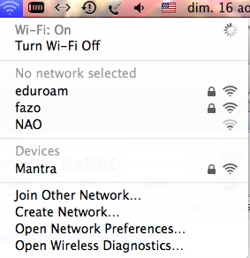

1. Give your password, but DO NOT Continue.
2. Choose Window/Utilities (cmd 2)

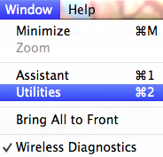

1. Select Wi-Fi Scan and type on Scan Now

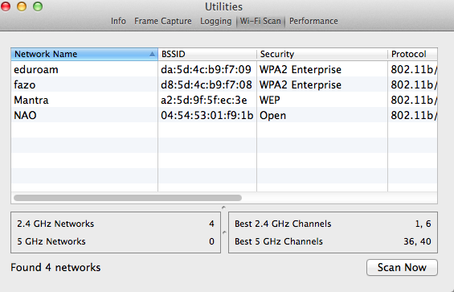

1. Use one of the proposed Best 2.4 GHz Channels when setting up the local network (see below)

**B. ON THE MACINTOSH:**

1. In *Network Preferences / Wi-Fi* type on **Advanced**, then on **TCP/IP**. Configure the Network Manually as below:

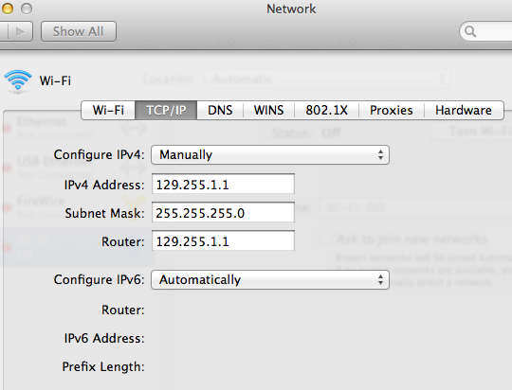

1. Create a local Network:

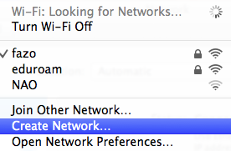

1. Call the network *Mantra*, choose one of the best channels (Channel 6, here), use a 40-bit WEP security, and type a 5-character password (I use “ircam”):

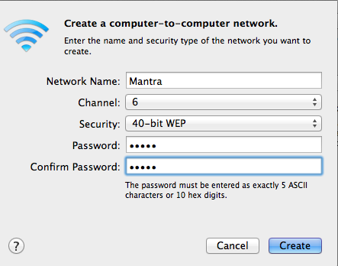

1. Make sure that you have the latest version of *Pd* installed (at this time: *Pd-0.46-6_32*). If not, download the *Pd vanilla* version (that is, the core of Pure Data, mainly written by Miller Puckette, focusing on audio signal and MIDI processing) on <http://msp.ucsd.edu/software.html> (verified on August 16, 2015).
2. Open Audio MIDI Setup and verify that the audio driver and sampling rate are correct. The current version uses 96KHz, but there is also an older version running at 44.1KHz. The usage of a Fireface Audio Interface is strongly recommended.
3. Go in *mantra2015/mantra-*pd and double click on the red patch (at this time: *mantra2015i-96*).
4. On the main page, make sure that the local IP addresses are exactly as below:

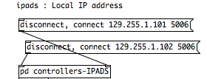

1. Open *pd controllers-IPADS* and make sure that the patch below the two *loadbang*’s looks exactly as below, as well as the *udpreceive*’s contain the numbers 8006 and 9997.

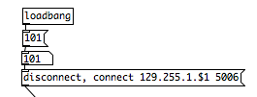 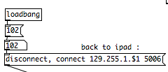

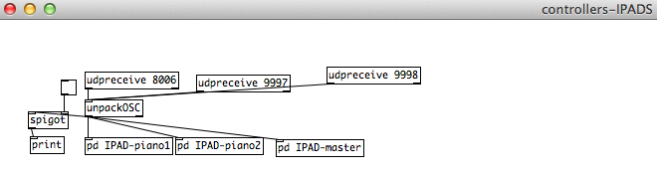

Leave *Pd* on while setting the iPads.

**B. ON THE iPADs:**

**Initialization and installation**

1. If not already done, install *TouchOSC* (available from the Apple Store, current version: 1.9.4) on both iPads.
2. From *iTunes*, copy on both iPads the following files (in *mantra2015 / TouchOSC*) into the Application by dragging them into the appropriate space: **mantra_piano1b.touchosc**, **mantra_piano2b.touchosc**.

**Setting the communication.**

NB: The following information applies to both iPads. When the settings differ, it is shown by a double picture.

1. In *Settings / Wi-Fi* join the Network called *Mantra* (give the password you defined).

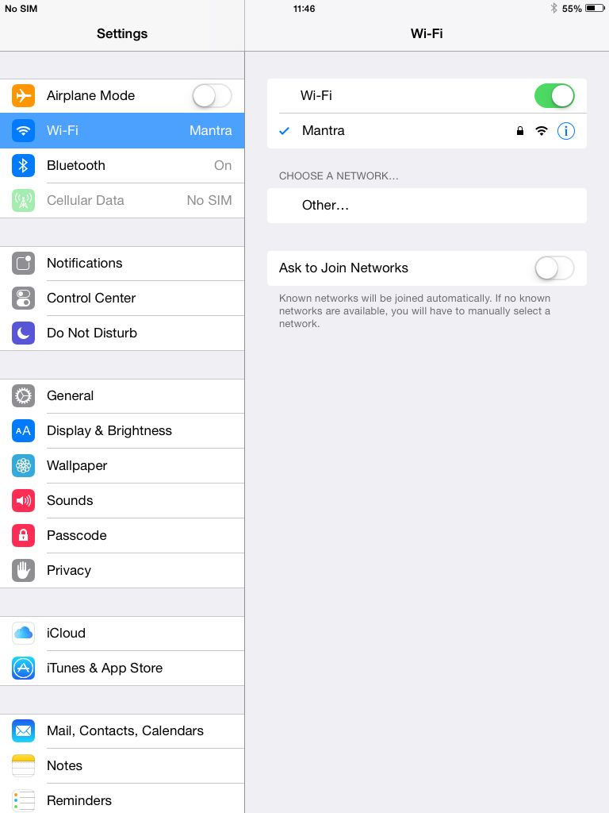

1. Type on **“i”**, choose “*Static*” and give exactly the addresses below:

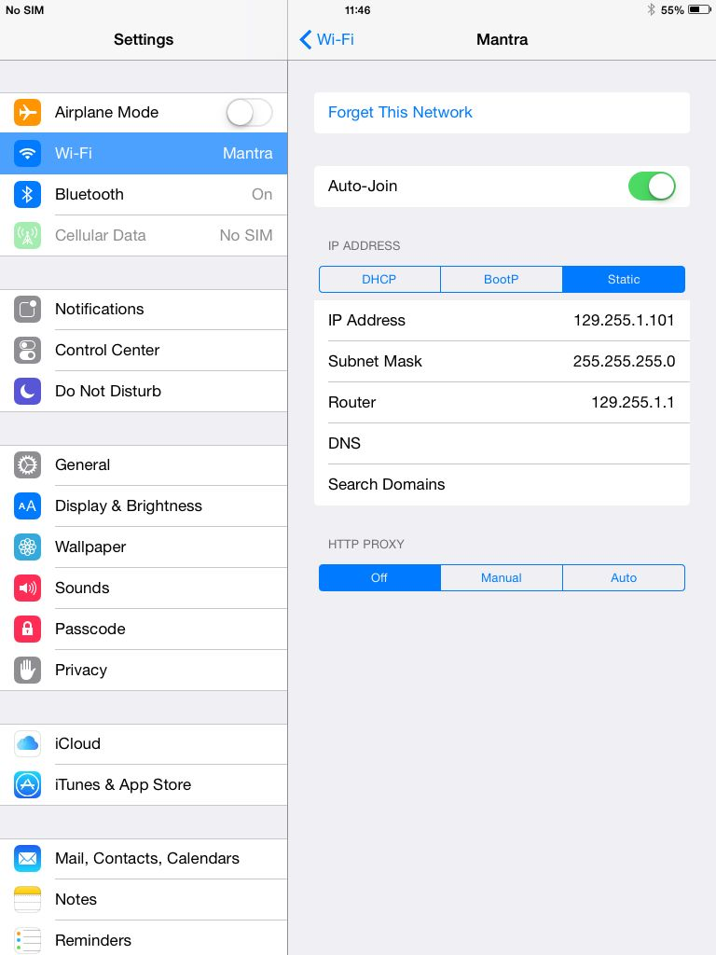 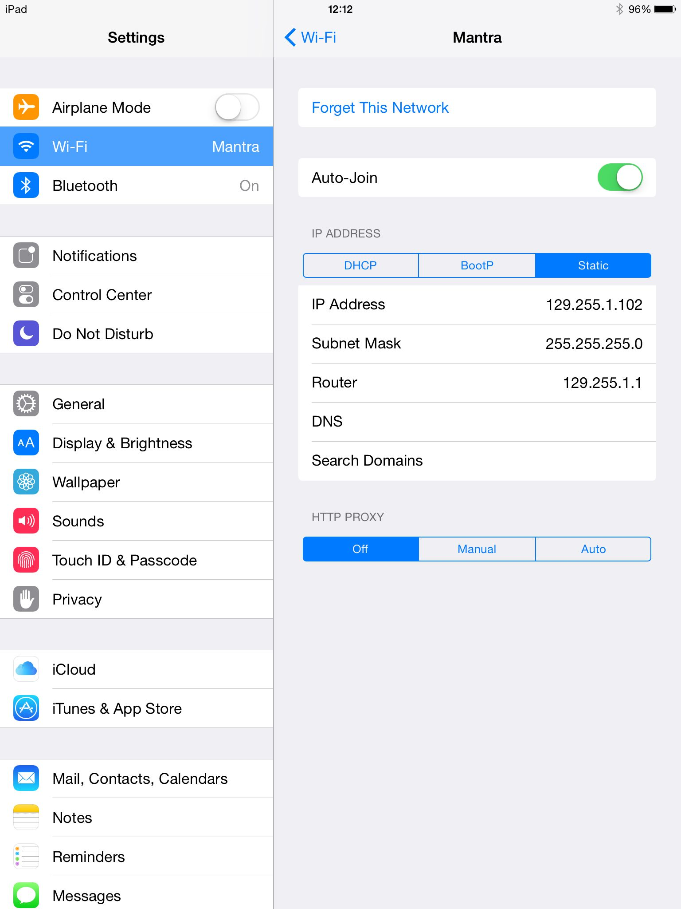

**iPad1** **iPad2**

Leave Auto*-Join* ON, so that the Network will be automatically joined next time the iPad is turned on.

1. Open *TouchOSC* and tap on the name below LAYOUT (here it is already selected):

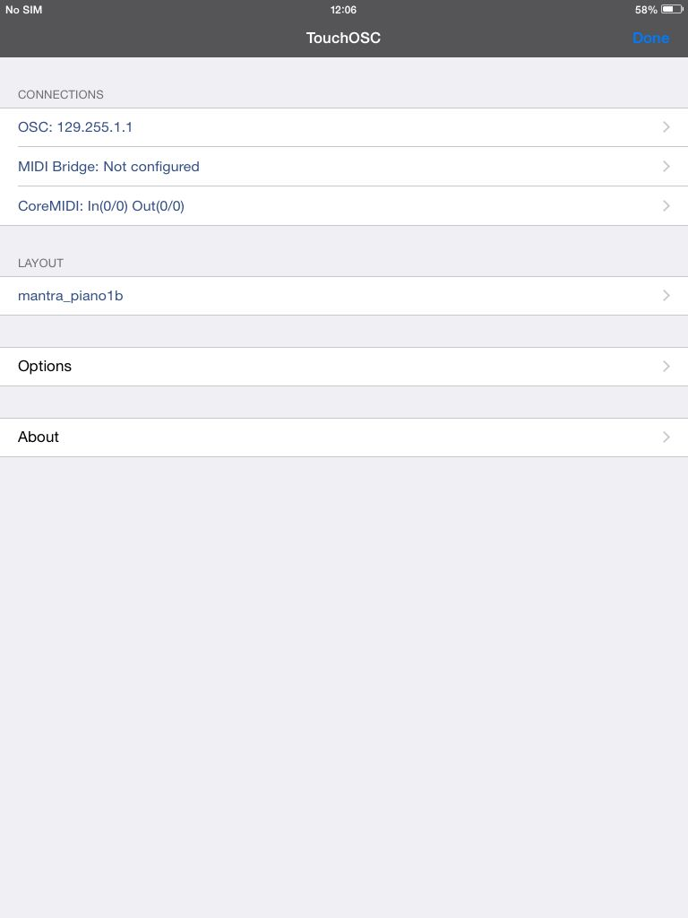

1. Select **mantra_piano1b** and **mantra_piano2b** from the list for the iPad n. 1 and 2.

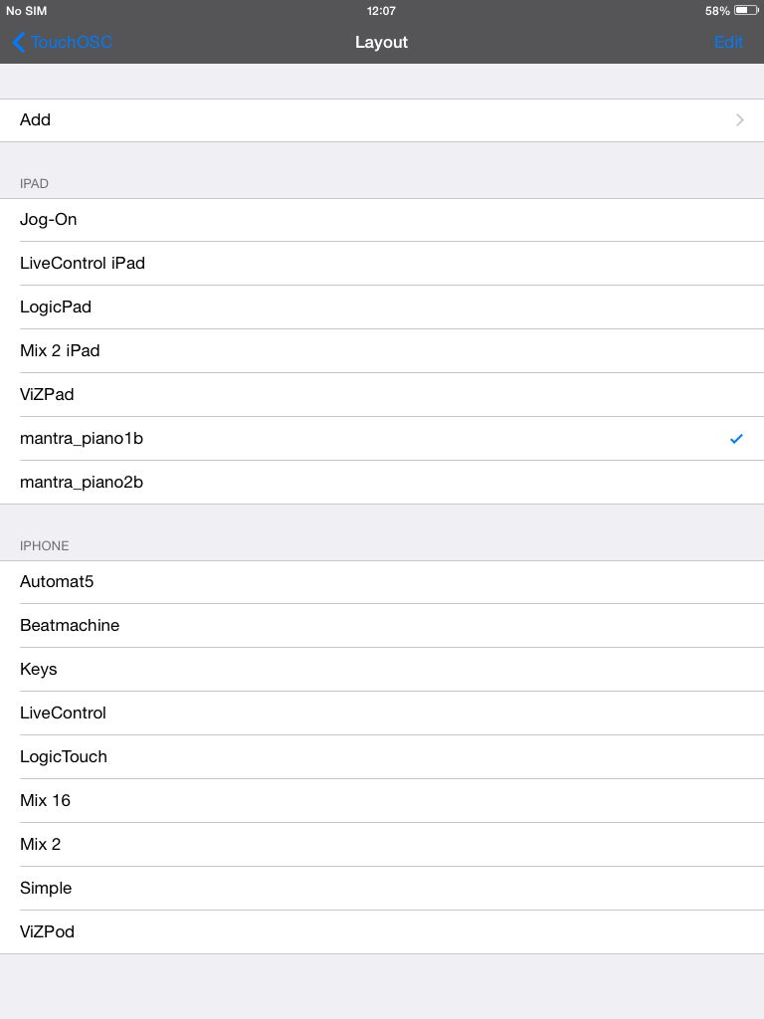 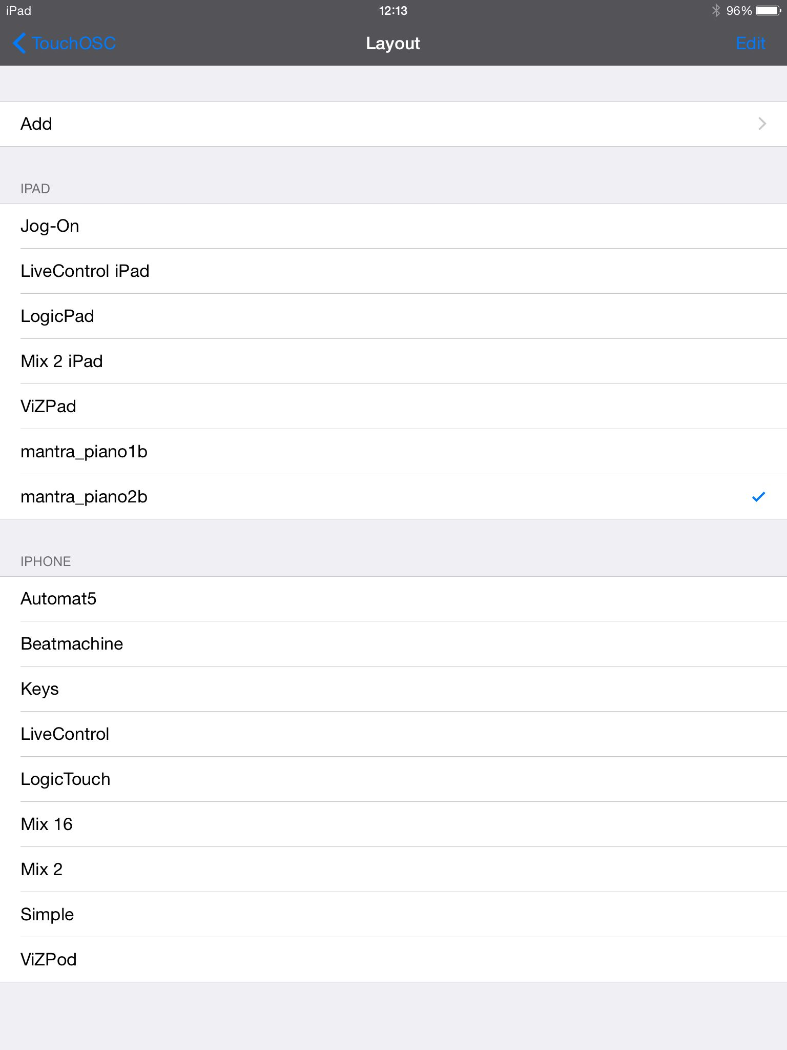

**iPad1** **iPad2**

1. Go back to the previous page and check that the OSC address below CONNECTIONS is: 129.255.1.1 (that is, the address of the local network manually entered on the Macintosch). If it is not the case, a problem occurred or an error was made and the local network should be recreated.
2. Type on OSC and set the in and outgoing ports as below:

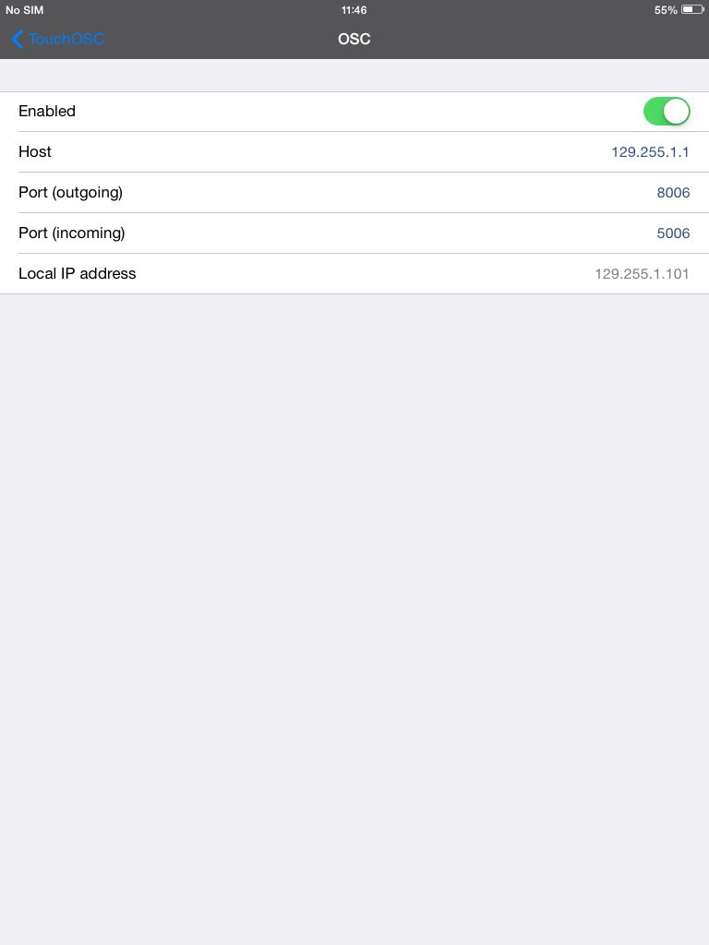 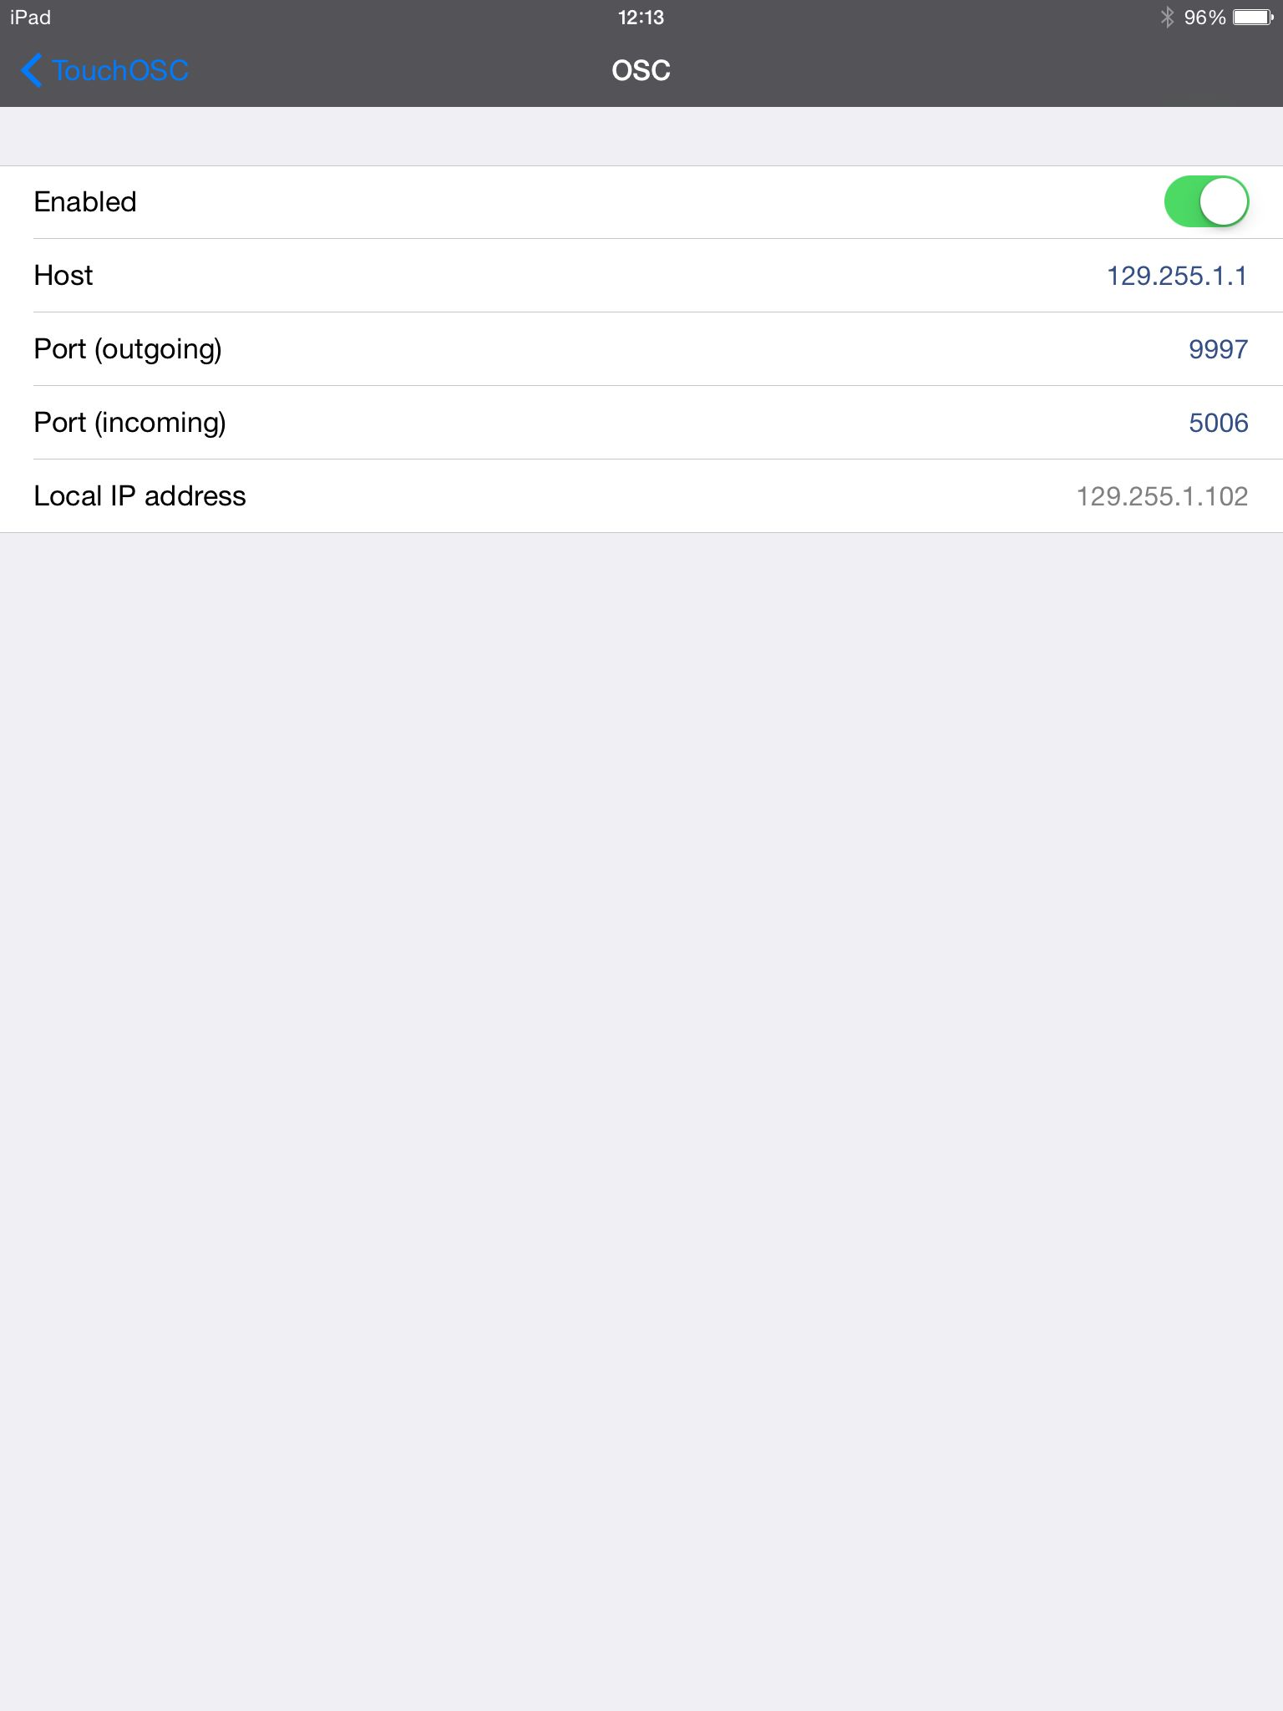

**iPad1** **iPad2**

1. Go back to the main page (page 1 of the controller) on both iPads.

**NB:** If asked, reply “Trust” to the iPad’s question **“Trust This Computer?”**

**C. FINALIZING THE COMMUNICATION**

1. Go back to *Pd* and click on both “disconnect, connect…” boxes to initialize the networks.



In the *Pd* window, the following messages should appear:



1. Move the rotary slider on both iPads. The horizontal sliders below should also move.

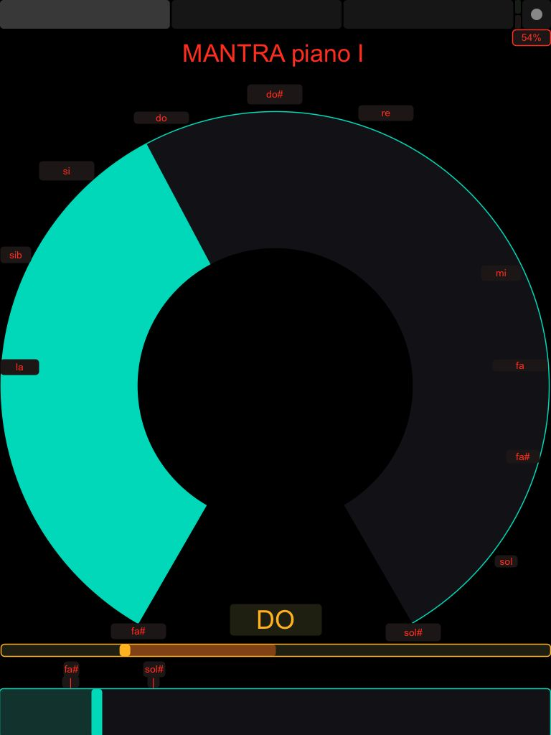 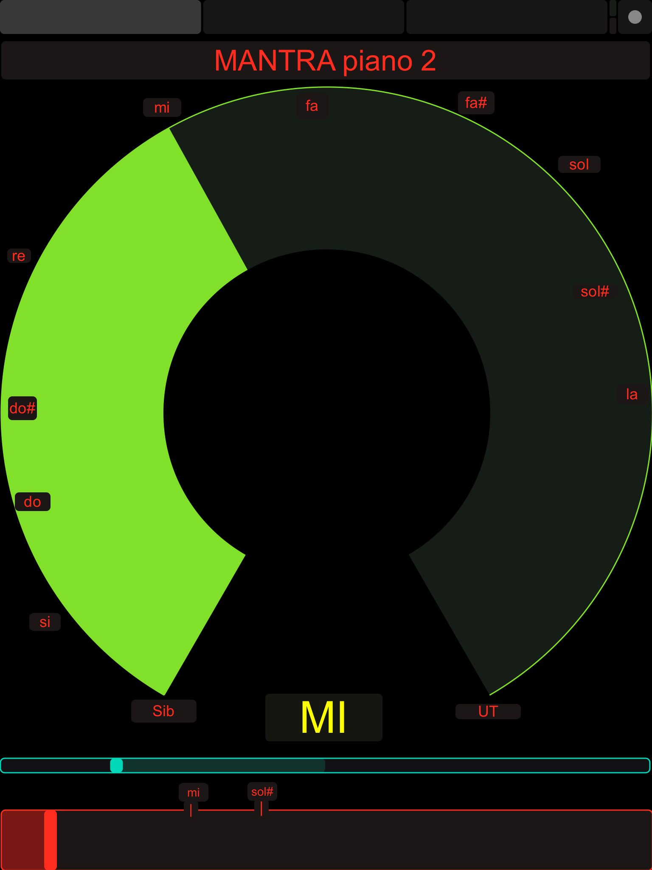

**iPad1** **iPad2**

1. Check, in the main *Pd* patch, that the pitch and ring values also move:

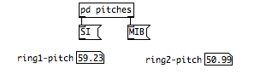

If this is the case, the communication between the iPads and the Macintosh is correctly setup.

**NB:**

If the following message appears in the *Pd* window when moving the sliders:

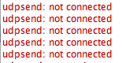

this means that one or both iPads have connection problems. In this case, check that they are correctly turned on (no automatic sleep!), and click again on “disconnect, connect…” in the main window. If the message still appears, restart the patch and/or the iPads.