**Karlheinz Stockhausen**

**MANTRA**

**for 2 pianos and electronics**

**Marco Stroppa, August 2015 (with the help of Serge Lemouton)**

**stroppa@marcostroppa.eu**

**PD USER’s MANUAL**

This text explains how to initialize and setup the patch running Mantra on Pd written by Serge Lemouton in 2013 and adapted for Marco Stroppa with the piano duo Pierre-Laurent Aimard, Tamara Stefanovich.

NB: middle A = A4.

Needed software: *Pd* (on the Macintosh), *TouchOSC* (on both iPads). If not already done, please initialize the communication between iPads and Macintosh as explained in **Communication_Rider.pdf**.

NB: this Users_Manual explains how to run Mantra using a Sampling Rate of 96 KHz and an audio interface digitally connected with an ADAT interface (hence the usage of only odd input channels).

**A. INITIALIZATION**

1. Make sure that the usual audio setup in the Macintosh is correct, that is, that the audio driver (Fireface, for instance) and sampling rate (96000) are correct.
2. Open *Pd* and set the **Media / Audio Settings** as follows:

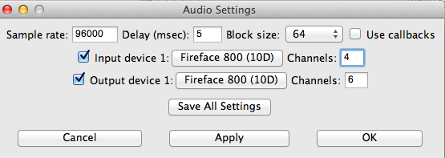

Type **Apply** and **Save All Settings** to memorize them.

**NB:** When any Settings are modified (also MIDI), always go back to this window to save them.

**NB2:** Select a larger amount of channels to have some freedom when routing the input signal (the output signal, usually, is routed in the Audio Interface’s mixer).

1. Open the patch with the red label (at present: mantra2015h-96.pd) and verify the ***adc~***’s that are used.

**Open this bpatcher:** 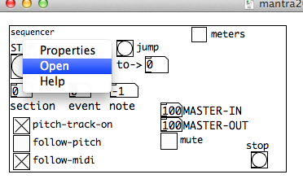

**Open pd pitch.**

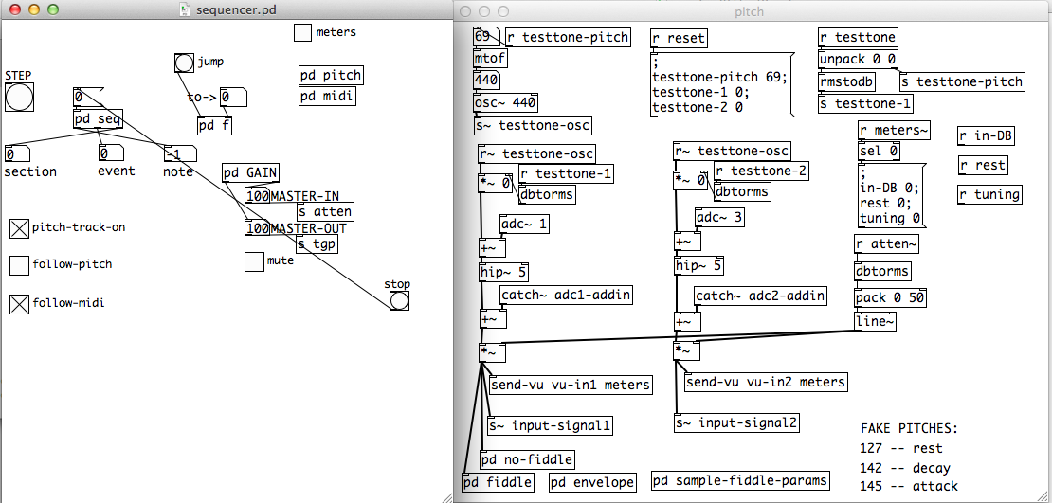

**Change the adc~’s numbers, if needed (here, adc~1 and adc~3 are used)**.

**NB:** the adc’s number cannot be higher than the maximum number of input channels specified in Audio Settings.

1. Verify that the **sampler’s absolute address** corresponds to the location of your hard disk. This is mandatory only when the patch is installed in another computer or moved to another location.

**Open pd importMachFivePresets:**

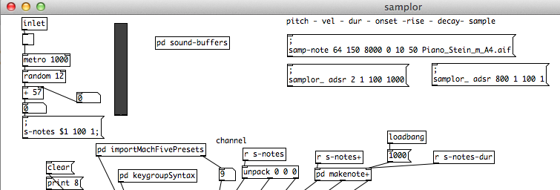

**Write the correct, absolute address in the box on the right.**

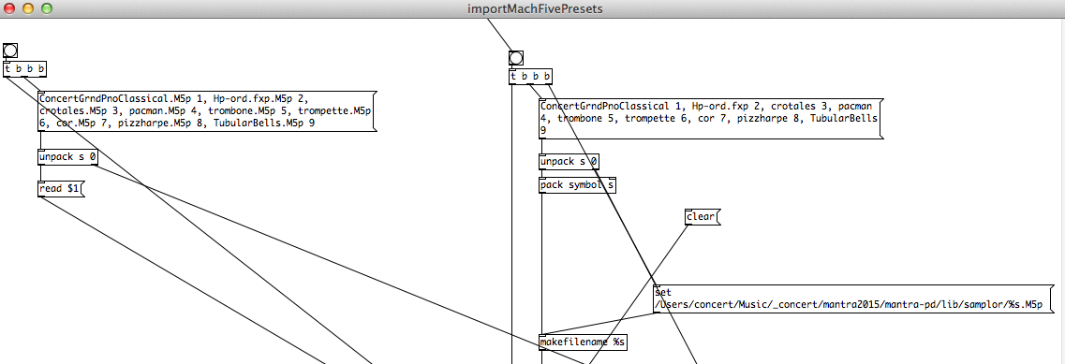

1. Verify also the absolute address of the **test file** in **pd tests**:

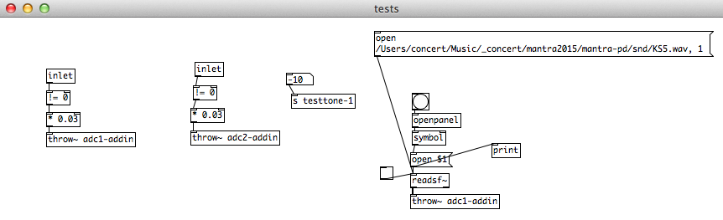

1. Set the **tuning.**

Open the file **mantraqlist.txt** and change the level of the variable “**tuning-set**” [default: 442 Hz].

**B. AUDIO TESTS**

1. Restart the patch, turn DPS ON, click on meters and type on **reset.**
2. Check the sound by clicking on **pd tests**and verify that a sound is heard. The piano 1 comes out from dac~ 1, the piano 2 from dac~ 2 (as seen in the patcher **pd audio-works**).
3. Check that the Kurzwellen file is played (third page of the piano 1’s controller) or manually trigger the file in **pd readsf** (careful, it can be **LOUD**!):

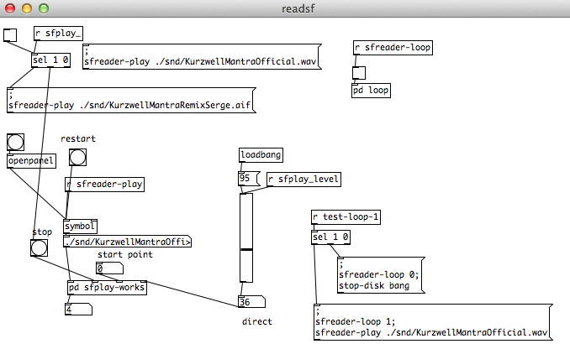

The file currently used is a remix made by Serge Lemouton in 2013. If the official file is preferred, connect the other box near the top, left, at the place of the one currently connected.

**NB:** this file comes out from **dac~ 3**, as seen in the patcher **pd sfplay-works**:

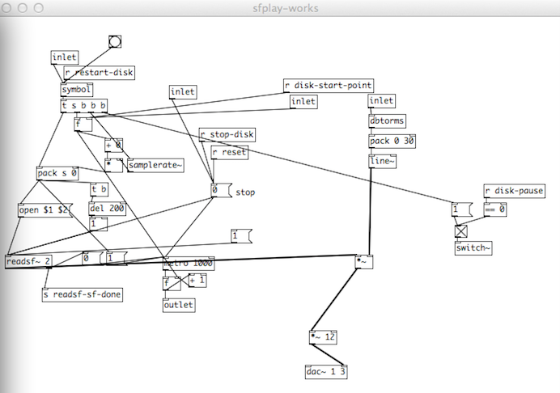

Change it in this patch, if needed.

**C. OTHER PRESETS**

1. To change the values of the Master levels (in/out), open the file **mantraqlist.txt** and change the level of the variables “**master-level**” [OUT, default: 88], and “**atten**” [IN, default: 80].
2. To change the default values of the ring modulators, filters and compressor, this should be done in the message boxes in the patcher **pd reset**.