Lab 4
ECE 60141: MAP Reconstruction with Non-Gaussian Priors
Name: [fill in]
GitHub repository: https://github.com/slenderu/image-processing-labs (code under lab4/)
Random seed: 0 (torch.manual_seed(0) before drawing w); CPU, float64.
Setup: kodim23.pgm on [0, 1], Levin kernel 1 with circular boundaries, σw = 0.02, p = 2.0, q = 1.2, N = 50, ω = 1.0. The same y (unclipped, RMSE to x_true = 0.04754) is used in every run. Crop: rows 168–295, columns 384–511 (0-based; top-left pixel (row 168, col 384)). Edge-profile row: 230.

D1. Potential and influence function
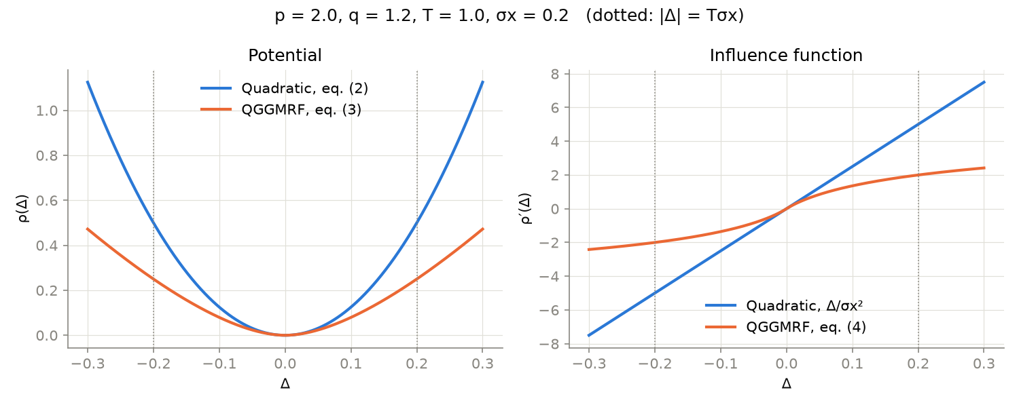
Quadratic potential (2) and QGGMRF (3), and their influence functions; p = 2, q = 1.2, T = 1, σx = 0.2.
For a pixel pair straddling a strong edge, the quadratic prior's influence keeps growing linearly with the difference (7.5 at Δ = 0.3 in the plot), so it pulls the two pixels together hardest exactly at the edge and blurs it. The QGGMRF influence matches the quadratic for |Δ| below Tσx but levels off beyond it (2.4 at Δ = 0.3, growing only like |Δ|^0.2), so the pull across the edge is weak and the data term can keep the jump.

D2. Derivation of equation (15) from equation (14)
[To be derived by hand. Take Δ′ → 0 in (14) with p = 2 and show the step where the powers of Δ′ cancel.]

D3. Surrogate functions
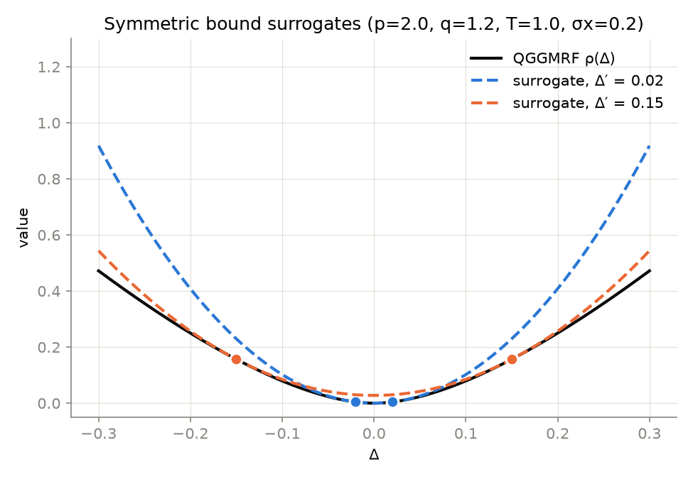
QGGMRF potential with the symmetric bound surrogates at Δ′ = 0.02 and Δ′ = 0.15; dots mark Δ = ±Δ′.
Both surrogates touch the potential exactly at the two marked points Δ = ±Δ′ and lie on or above it everywhere else on [−0.3, 0.3] (numerically, the smallest value of surrogate minus potential on a 60,001-point grid is -8.7e-19 for Δ′ = 0.02 and 0.0e+00 for Δ′ = 0.15, i.e. zero to round-off).

D4. Specification given to the AI assistant
The code was built in one part by Claude Code (model Claude Opus 5.5), from the following prompt (quoted verbatim), together with the assignment page assignment.html, which holds equations (1)–(19), the neighborhood and weights, the function signatures, and the Step 5 pseudocode:
Read assignment.html and implement Lab 4 using the exact equations, function signatures, and experiment settings.
Keep the required functions in lab4.py and put the experiments in run_lab4.py. Import the four allowed functions from lab3.py. Use CPU, float64, seed 0, and no loops over pixels. Handle zero differences safely, keep autograd working, and don’t clip the data or reconstruction.
Check the influence function against autograd and the true gradient against equation (16). Run the baseline monotonicity check before running all six experiments, R1–R6. Use the same noisy image for every run, 50 iterations, and omega=1. Print progress and save each completed run so it doesn’t need to be repeated.
Save all required plots, images, crops, the edge profile, surrogate-weight image, and the cost/RMSE/timing table in results. Use one consistent 128×128 crop containing a strong edge and record its coordinates and the profile row.
Draft short answers for the written parts using the actual results and place them into a word file, including all seven D11 questions. For D4, save this prompt and honestly record any problems found and how they were corrected. Leave D2 for me to derive by hand.
What it got wrong the first time, and how it was found:
- Floor applied in the wrong place. The first lab4.py floored |Δ| at 10⁻⁸ in every factor of rho and rho_prime, not only inside the |Δ/(Tσx)|^(q−p) power. For |Δ| < 10⁻⁸ this made rho_prime return sign(Δ)·10⁻⁸/σx² instead of ≈ Δ/σx², while autograd of the clamped rho returned 0. The influence-function check against autograd caught it: the maximum relative error was 1.0×10⁻⁷ to 8.6×10⁻⁷ instead of round-off. The fix was to floor |Δ| only inside the (q−p) power, so rho(0) = 0 exactly. After the fix the check gives 7.4e-16. This was corrected before any reconstruction was run.
- Edge profile did not show the difference clearly. On the full-length profile at row 230, the R1 and R2 curves look nearly the same at the beak's left edge, even though the crops look different. Rather than choosing a different row to make the difference look larger, the script now reports the steepest adjacent-pixel step across the edge, on row 230 and averaged over rows 200–260, plus the noise level in a flat background patch. D7 also has a zoom panel. The answers below use those numbers.
- Figure layout. In the first D8 figure the second-row titles overlapped the first-row images. Found by looking at the rendered PNG and fixed by adding vertical spacing.
- Environment. Torch printed a CUDA-driver warning during autograd, so the run script hides the GPU (CPU only, as required). Node and LibreOffice are not installed, so this report was written with python-docx.
Checks that passed the first time: autograd true_gradient against equation (16) on the full image (max relative error ≤ 9.7e-16 at x = y for R1 and R2, at x_true, and at a perturbed image); g^tHg of (18) against the second difference of the surrogate Q of (13) (≤ 6.8e-16); ∇Q(x; x) = ∇f(x) (tangency); b̃ of (14) against bρ′(Δ)/(2Δ) of (12) (1.9e-16); finite values at Δ = 0; and a 1.3e-05 relative jump in b̃ at the switch to (15). Convention choice: the D9 weights are computed at the final image x⁽⁵⁰⁾.

D5. True cost against iteration (baseline QGGMRF)
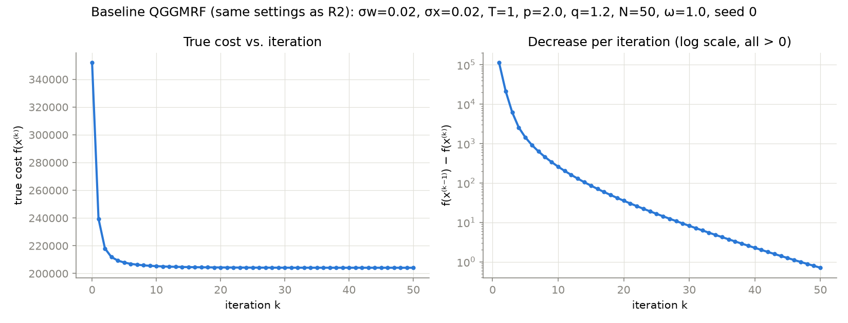
Baseline QGGMRF (σx = 0.020, T = 1; the same settings as R2). Left: true cost f(x⁽ᵏ⁾). Right: decrease per iteration on a log scale.
The true cost decreased at every one of the 50 iterations, from 3.5190e+05 to 2.0415e+05, with 0 increases (the smallest decrease was 0.70, at the last iteration).

D6. Images
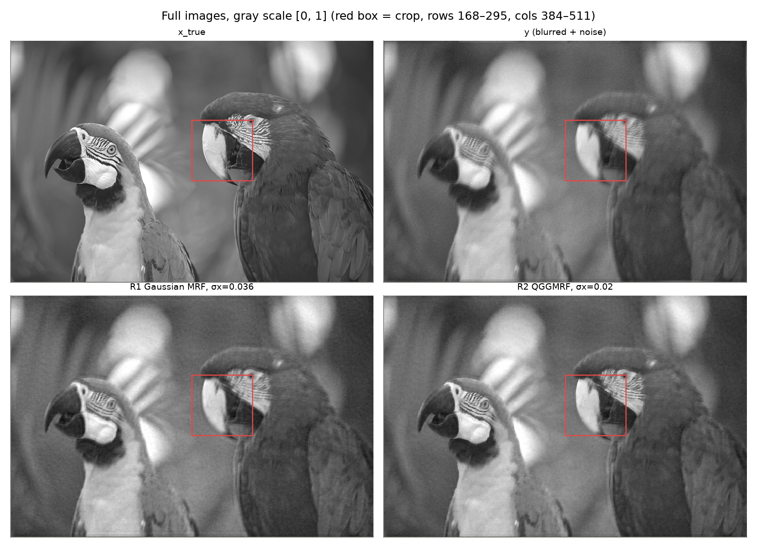
x_true, y, R1 (Gaussian MRF, σx = 0.036), R2 (QGGMRF, σx = 0.020), all on the gray scale [0, 1]. The red box is the crop.
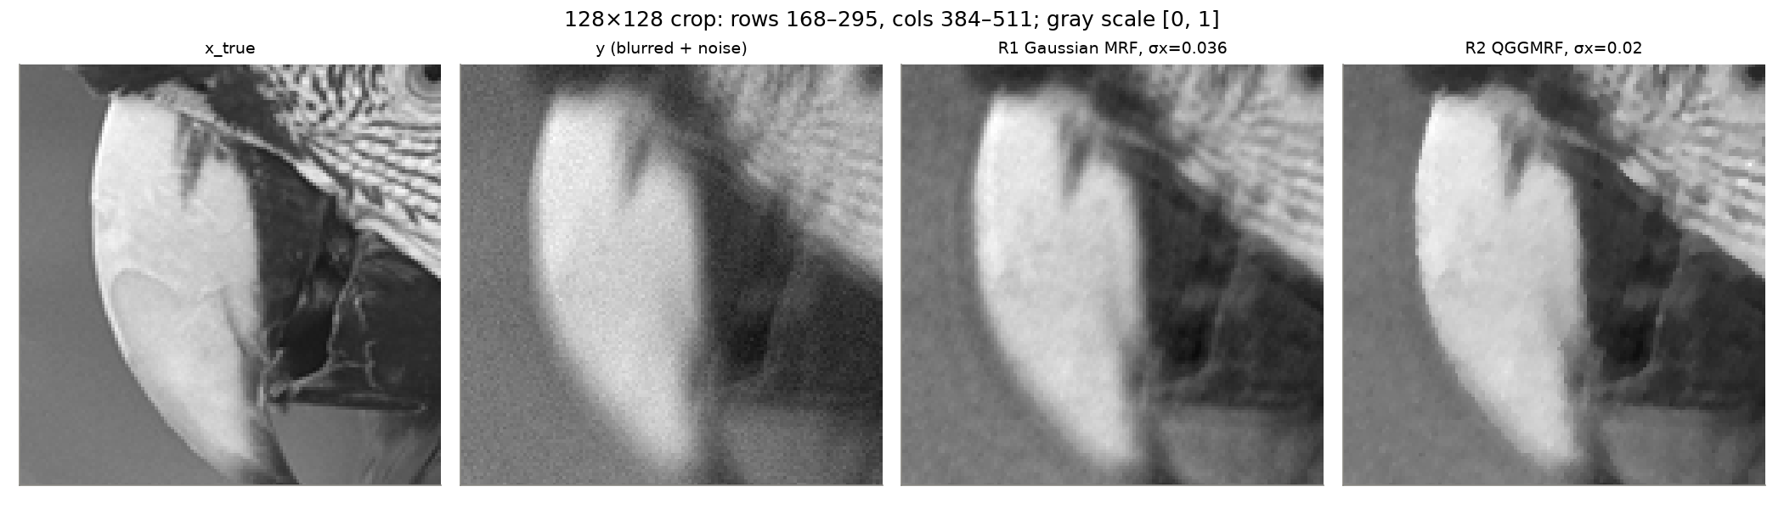
The same four images cropped to rows 168–295, columns 384–511 (0-based; top-left pixel (row 168, col 384)); gray scale [0, 1].
Display only: values outside [0, 1] are shown as black or white. The data and the reconstructions were not clipped.

D7. Edge profile
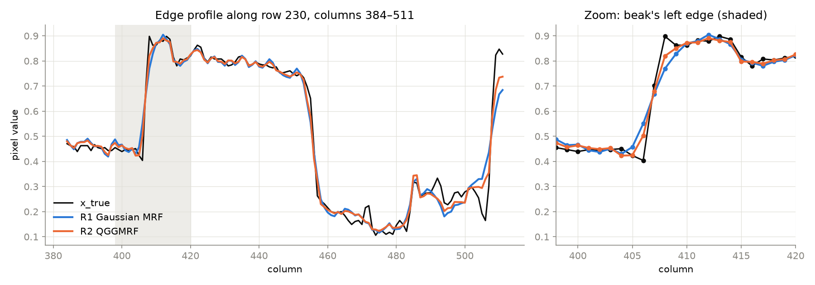
Pixel values along row 230, columns 384–511, for x_true, R1 and R2. The profile crosses gray background → white beak (≈ column 407) → dark mouth (≈ column 456). Right: zoom on the beak's left edge.

D8. σx study
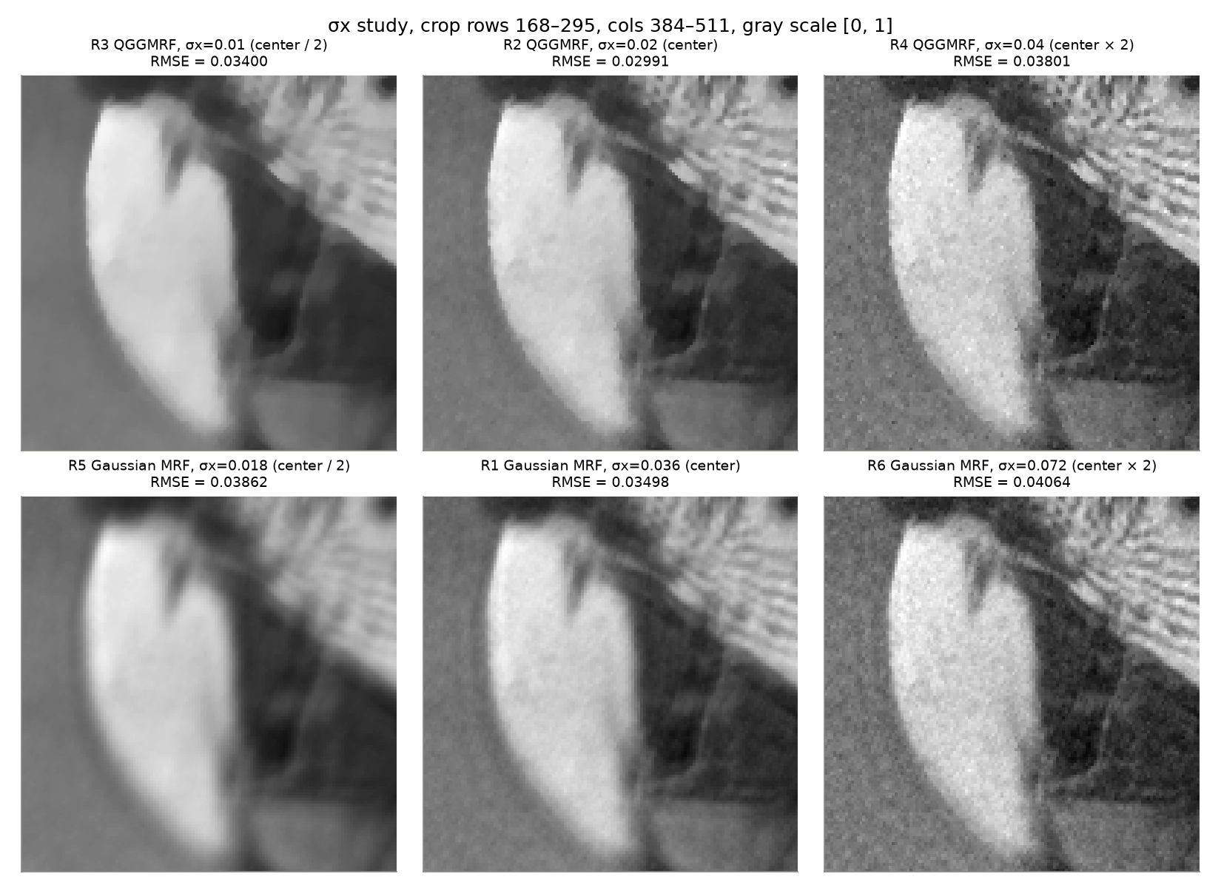
Top: QGGMRF R3, R2, R4 (σx = 0.010, 0.020, 0.040). Bottom: Gaussian MRF R5, R1, R6 (σx = 0.018, 0.036, 0.072). RMSE is over the full image in [0, 1] units.

D9. Summed surrogate weights
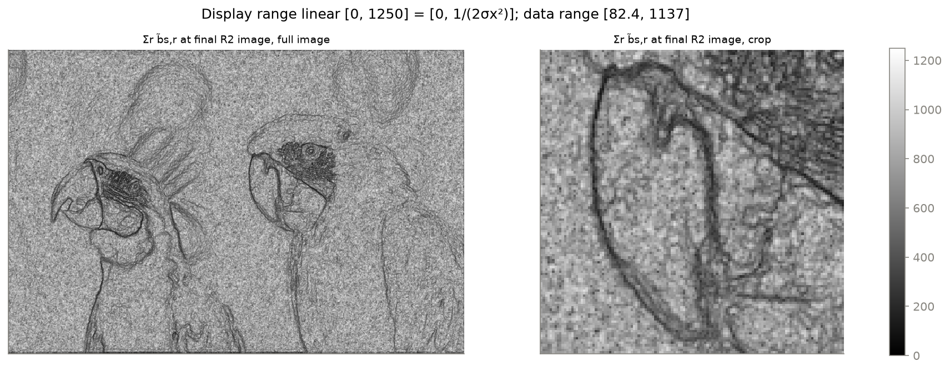
Σr b̃s,r at the final R2 image (full image and crop).
Display range: linear, black = 0 to white = 1250 = 1/(2σx²), which is the value at an interior pixel whose neighbors are all equal (equation (15) summed over the neighborhood, Σ b = 1). The actual data range is [82.4, 1136.9], with interior median 750.

D10. Cost, RMSE and time
Run | Prior | T | σx | Final true cost | RMSE | Wall clock (s)
R1 | Gaussian MRF | 100 | 0.036 | 200,097.0 | 0.03498 | 132.0
R2 | QGGMRF | 1 | 0.020 | 204,148.3 | 0.02991 | 127.9
R3 | QGGMRF | 1 | 0.010 | 248,489.1 | 0.03400 | 117.0
R4 | QGGMRF | 1 | 0.040 | 159,746.7 | 0.03801 | 116.8
R5 | Gaussian MRF | 100 | 0.018 | 253,843.5 | 0.03862 | 117.9
R6 | Gaussian MRF | 100 | 0.072 | 150,423.4 | 0.04064 | 116.5
50 iterations each, ω = 1, CPU float64 on 4 threads. RMSE is against x_true over the full image (y itself: 0.04754). The true cost decreased at every iteration in all six runs. The final costs of runs with different σx or T are not comparable, since they are different cost functions.

D11. Answers to the questions
1. R1 vs. R2 at the edge and in flat regions. R2 has visibly sharper edges: the beak outline, the line between beak and face, and the feather stripes. At the beak's left edge (columns 398–420), the steepest step between neighboring pixels on row 230 is 0.176 for R2 against 0.118 for R1 (x_true: 0.298). Averaged over rows 200–260 it is 0.197 against 0.119. In the D7 zoom, R1 needs about one more pixel to ramp up. Neither recovers the full step, because the reconstruction is limited by the blur. In the flat background R2 is also smoother: the std of a flat patch is 0.0125 for R2 against 0.0152 for R1 (x_true: 0.0097). R2's flat areas have a slightly blotchy, piecewise-flat texture. The D1 influence plot explains the difference: the Gaussian pull grows in proportion to the difference, so the edge pair (Δ ≈ 0.3–0.5) gets the strongest pull toward each other. The QGGMRF pull flattens out beyond |Δ| ≈ Tσx, so the edge pair is only weakly coupled and the deblurring data term can rebuild the jump.
2. Did lower RMSE go with the better-looking image? Mostly. R2 has the lowest full-image RMSE (0.02991) and looks best to me. But RMSE and appearance disagree in places. R3 (RMSE 0.03400) beats R1 (0.03498) even though R3 looks cartoonish and has lost the fine feather texture. On the crop alone, R4 has slightly lower RMSE (0.05058) than R2 (0.05086) even though R4 is clearly grainy. RMSE averages squared error over all pixels, so it does not measure the things the eye weighs most: whether edges are sharp, whether noise looks like structured grain, and whether texture is lost. A few large errors at a blurred edge can cost the same as visible grain spread over a flat region.
3. What σx controls. σx is the scale of neighbor differences the prior expects, so it sets how strong the regularization is (the prior weight goes as 1/σx², and for the QGGMRF it also moves the transition point Tσx). Halving it over-smooths. R5 is the blurriest image (edge step 0.085). R3 keeps edges (0.167) but flattens texture into patches (flat std 0.0063). Doubling it under-regularizes: R4 and R6 are sharp but grainy (flat std 0.0329 and 0.0341), because the deblurring amplifies the noise. Both changes raise RMSE. In the limit σx → 0 the prior dominates and the solution tends toward a constant image. In the limit σx → ∞ the prior vanishes and the result tends to the unregularized least-squares deconvolution, which amplifies noise at frequencies the blur suppresses. For the QGGMRF a large σx also pushes most differences into the quadratic regime, so it behaves like a Gaussian prior, while a small σx puts nearly all differences in the |Δ|^1.2 regime.
4. Why the QGGMRF can use a smaller σx. For the QGGMRF, a smaller σx strengthens the pull on small differences much more than the pull on large ones. Below |Δ| ≈ Tσx the influence is Δ/σx², which grows as σx⁻². Far above it, the influence grows only as σx⁻¹·² and is nearly flat in Δ (∝ |Δ|^0.2). With the center values, at a noise-sized difference Δ = 0.01 the R2 influence is about 13.6 against 7.6 for R1, nearly twice the smoothing pull in flat regions. At an edge-sized difference Δ = 0.3 it is about 49 against 194, one quarter of the pull. The Gaussian prior has one straight line in D1, so any increase in its smoothing hits edges proportionally, and its best σx is a compromise at a larger value.
5. Why p = 2 is required but q is free. The surrogate weight is b̃ ∝ ρ′(Δ′)/Δ′, and at Δ′ = 0 it must be the limit ρ″(0). Pixels with equal neighbors occur everywhere, so this limit must be finite. With p = 2, ρ is quadratic near zero and ρ″(0) = 1/σx² is bounded (equation (15)). With p < 2, ρ″ behaves like |Δ|^(p−2) and goes to infinity. The weights blow up, g^tHg becomes infinite, and α* goes to 0 (or the numbers become inf/NaN), so the algorithm stalls. q only shapes ρ for large differences, where ρ′(Δ)/Δ is finite. Any 1 ≤ q < p keeps ρ convex and ρ′(Δ)/Δ non-increasing in |Δ|, which is what the symmetric bound needs, so q is a free modeling choice about how much large jumps are penalized.
6. Monotonicity in R2. Yes. The true cost decreased at all 50 iterations of R2 (0 increases; the last decrease was 0.70), and the same holds for all six runs. The guarantee rests on the first inequality in (8), f(x⁽ᵏ⁺¹⁾) ≤ q(x⁽ᵏ⁺¹⁾; x⁽ᵏ⁾), which holds because the surrogate lies above the true cost. The second inequality (the step lowers the surrogate, true for any ω in (0, 2)) and the equality at the touching point complete it. If b̃ came out slightly too small, the surrogate would be too flat. It would dip below the true cost away from x′ and also stop being tangent, so (5) fails, α* comes out too large, and the step can overshoot. The guarantee is then lost: the cost might still go down in practice, but nothing prevents an increase.
7. Structure in the Σr b̃s,r image. It is an edge map of the current reconstruction. Flat regions are bright, because ρ′(Δ)/Δ is largest near Δ = 0. Dark lines trace every strong edge: both parrot outlines, the beak contour, the eyes and the black-and-white face stripes, because there |Δ| ≫ Tσx = 0.02 and b̃ ∝ ρ′(Δ)/Δ falls off. The flat regions are speckled rather than uniformly 1250 (interior median 750), because residual noise differences of about 0.01–0.02 are already near Tσx. The one-pixel border is darker because border pixels have fewer valid neighbors. This is the picture of majorization as re-weighting: a Gaussian prior whose couplings have been switched off across the edges of the current image.

