AIML_CropMapper: Installation & Usage
This guide will walk you through setting up an Anaconda environment for AIML_CropMapper, configuring external tools (ESA SNAP & OrfeoToolbox), and running each stage of the processing pipeline.

1. Prerequisites
- Windows 10/11 with administrative privileges.
- Anaconda/Miniconda (Python 3.10+).
- ESA SNAP installed via Windows installer (e.g., default <drive>:\Program Files\esa-snap).
- OrfeoToolbox (OTB) at <drive>:\AIML_CropMapper\3_OBIA_classifier\OTB-6.2.0-Win64.
- Internet access for Sentinel-1 downloads.
Top-level folder: <drive>:\AIML_CropMapper
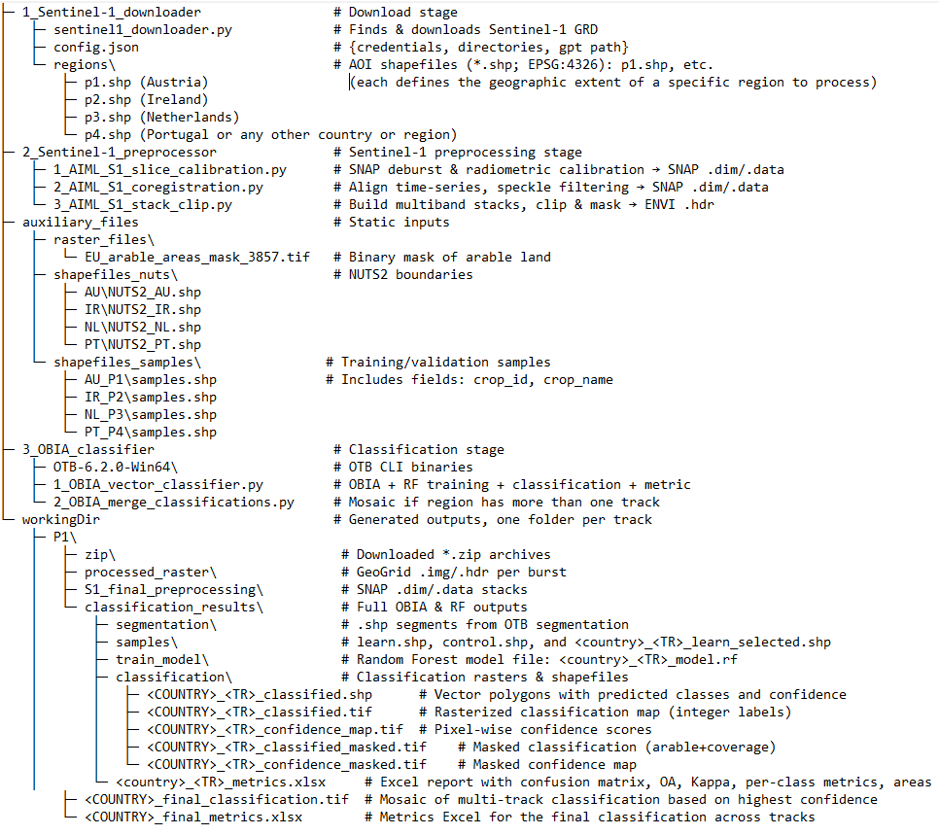

2. Conda Environment & Dependencies
- Create & activate from Anconda command prompt:
conda create -n aiml_cropmapper python=3.10 -y
conda activate aiml_cropmapper
- Install packages:
conda install -c conda-forge numpy pandas geopandas rasterio gdal fiona shapely pyproj scikit-learn openpyxl requests loguru -y

3. Setup external tools on on Windows PATH
- Add SNAP GPT path:
setx PATH "<drive>:\Program Files\esa-snap\bin;%PATH%"
- Add OTB CLI (Orfeo Toolbox Command-Line Interface) path:
setx PATH "<drive>:\AIML_CropMapper\3_OBIA_classifier\OTB-6.2.0-Win64\bin;%PATH%"

4. Setup downloader configuration
In 1_Sentinel-1_downloader/config.json:
{
"creodias_user_mail": "your CDSE email",
"creodias_user_password": "your CDSE password",
"download_directory": "<drive>:\\AIML_CropMapper\\workingDir",
"geometry_directory": "regions",
"gpt_directory": "<drive>:\\Program Files\\esa-snap\\bin\\gpt.exe"
}

– Replace with your own credentials to the Copernicus Data Space Ecosystem
5. Stage 1 – Download Sentinel-1 GRD scenes for given track by command:
conda activate aiml_cropmapper
cd <drive>:
cd: <drive>:\AIML_CropMapper\1_Sentinel-1_downloader
python sentinel1_downloader.py -j config.json -s 2024-10-15 -e 2025-10-17 --track P4
-j: config file
-s/-e: start/end dates
--track: P1–P4
Outputs .zip in workingDir\P4\zip.

6. Stage 2 – Sentinel-1 Preprocessing
This stage processes raw Sentinel-1 .zip products into stacked, clipped, and masked raster data for classification. It comprises three sequential Python scripts. Run these in order.

6.1 Step 1 – Calibration and Slice Assembly
Script: 1_AIML_S1_slice_calibration.py
Location: <drive>:\AIML_CropMapper\2_Sentinel-1_preprocessor

Purpose:
- Calibrate .zip S1 scenes (thermal noise removal, orbit correction, border noise removal, sigma nought calibration)
- Assemble slices (bursts) into a single .dim product per date
- Clip to polygon using predefined geoRegion (hardcoded per track)

Input folders:
- workingDir\<track>\zip\ — contains .zip Sentinel-1 scenes

Output folders:
- workingDir\<track>\calibrated\ — temporary .dim files (removed after slicing)
- workingDir\<track>\slice_assembly\YYYYMMDD_<track>_IW_GRDH_<Sensor>.dim/.data — final calibrated S1 products for a date

Run the command:
cd F:\AIML_CropMapper\2_Sentinel-1_preprocessor
python 1_AIML_S1_slice_calibration.py --track P4
You can also run for multiple tracks:
python 1_AIML_S1_slice_calibration.py -track P1 P2 P3 P4

What it does internally:
- For each .zip scene in zip/, it generates a SNAP XML file dynamically with proper input/output paths.
- Executes gpt with:
gpt -DAuxDataPath=<your SNAP aux path> -q 4 <calibration_graph.xml>
- After all .zip scenes are calibrated, it groups .dim files by acquisition date and performs slice assembly, generating one .dim per day.
- Temporary .xml files and intermediate .dim are deleted to save space.

6.2 Step 2 – Coregistration and Filtering
Script: 2_AIML_S1_coregistration.py
Location: <drive>:\AIML_CropMapper\2_Sentinel-1_preprocessor

Purpose:
- Stack and coregister all .dim products by acquisition date
- Apply multi-temporal speckle filtering (Lee-Sigma)
- Perform terrain correction and final speckle filtering (Median)
- Generate one VH and one VV .dim file with all stacked bands

Input folders:
- workingDir\<track>\slice_assembly\*.dim — from previous step

Output folder:
- workingDir\<track>\S1_final_preprocessing\YYYYMMDD_YYYYMMDD_VH.dim/.data
- workingDir\<track>\S1_final_preprocessing\YYYYMMDD_YYYYMMDD_VV.dim/.data

Run the command:
python 2_AIML_S1_coregistration.py --track P4
You can also run for multiple tracks:
python 2_AIML_S1_coregistration.py --track P1 P3

What it does internally:
- Builds a virtual product list using CreateStack in SNAP for all .dim files (sorted by date)
- Applies:
  - Cross-correlation alignment
  - Warping to correct geometry
  - Multi-temporal speckle filtering
  - Terrain correction using SRTM 3Sec DEM
  - Log conversion (dB) + Median speckle filter
- Outputs two .dim files: one for VH, one for VV, containing multitemporal bands (one per date).
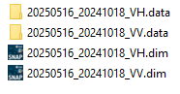

6.3 Step 3 – Stack Bands, Clip to AOI, and Mask
Script: 3_AIML_S1_stack_clip.py
Location: <drive>:\AIML_CropMapper\2_Sentinel-1_preprocessor

Purpose:
- Read VH and VV .img files from .data folders
- Stack bands into a single multiband .img and .hdr
- Clip raster using NUTS2 shapefile (NUTS2_<COUNTRY>.shp)
- Output clipped raster per region

Input folders:
- workingDir\<track>\S1_final_preprocessing\*VH.data\ and *VV.data\
- auxiliary_files\shapefiles_nuts\<COUNTRY>\NUTS2_<COUNTRY>.shp

Output folder:
- workingDir\<track>\processed_raster\COUNTRY_<track>_YYYYMMDD_YYYYMMDD_VH_VV.img/.hdr

Run the command:
python 3_AIML_S1_stack_clip.py --track P4
You can also run for multiple tracks:
python 3_AIML_S1_stack_clip.py --track P1 P2 P3 P4

What it does internally:
- Collects all .img slices from VH and VV .data folders
- Sorts bands by date (from filename) and stacks them in order
- Clips stacked image to regional shapefile:
auxiliary_files\shapefiles_nuts\PT\NUTS2_PT.shp ← for P4/PT
- Output is stored as .img + .hdr with the name format:
PT_P4_20241015_20250508_VH_VV.img
PT_P4_20241015_20250508_VH_VV.hdr
- Intermediate stack is deleted after clipping to save space.

7. Stage 3 – OBIA Classification
Overall goal: segment the SAR stack into objects, train/apply a Random Forest on samples, rasterize and mask the results, then compute metrics and export to excel.

7.1 Run the OBIA pipeline script
cd <drive>:\AIML_CropMapper\3_OBIA_classifier
python 1_OBIA_vector_classifier.py --track P4
- Use --track to list one or more belts (e.g., P1 P2 P3 P4).

In some cases if this error occurs (OSError: could not find or load spatialindex_c-64.dll) this command need to executed:
set SPATIALINDEX_C_LIBRARY=%CONDA_PREFIX%\Library\bin

7.2 Stage Breakdown
- Segmentation
  - input: workingDir/<track>/processed_raster/*_VH_VV_stack.img
  - tool: otbcli_LargeScaleMeanShift
  - output: classification_results/segmentation/<track>_segmentation.shp
- Split samples (70/30)
  - input: auxiliary_files/shapefiles_samples/PT_P4/samples.shp
  - output:
    - classification_results/samples/learn.shp
    - classification_results/samples/control.shp
- Select training polygons
  - input: learn.shp + segmentation.shp
  - output: classification_results/samples/PT_P4_learn_selected.shp
- Train random forest
  - input: *_learn_selected.shp, features meanB*
  - tool: otbcli_TrainVectorClassifier
  - output: classification_results/train_model/PT_P4_model.rf
- Vector classification + confidence
  - input: segmentation.shp, PT_P4_model.rf
  - tool: otbcli_VectorClassifier
  - outputs:
    - classification/PT_P4_classified.shp (with predicted,confidence fields)
- Rasterize classification
  - input: PT_P4_classified.shp
  - tool: otbcli_Rasterization
  - output: classification/PT_P4_classified.tif
- Rasterize Confidence
  - input: PT_P4_classified.shp
  - output: classification/PT_P4_confidence_map.tif
- Cutline extraction
  - input: the classified raster
  - method: GDAL Polygonize in Python
  - output: processed_raster/PT_P4_valid_coverage.shp
- Mask Classification
  - inputs:
    - classification/PT_P4_classified.tif
    - arable mask: auxiliary_files/raster_files/EU_arable_areas_mask_3857.tif
    - cutline shapefile: processed_raster/PT_P4_valid_coverage.shp
  - Output: classification/PT_P4_classified_masked.tif
- Mask Confidence
  - Similar inputs as above
  - Output: classification/PT_P4_confidence_masked.tif
- Metrics & Excel Export
  - Inputs:
    - classification_results/samples/control.shp
    - classification/PT_P4_classified_masked.tif
  - Metrics computed:
    - confusion matrix
    - overall accuracy (OA)
    - kappa index
    - producer’s accuracy (recall) & user’s accuracy (precision) per class
    - F1-score per class
    - Class area in hectares (pixel count × pixel area)
  - Output: classification_results/PT_P4_metrics.xlsx

8. Stage 4 – Merge multi-track classifications
Script: 2_OBIA_merge_classifications.py
Directory: <drive>:\AIML_CropMapper\3_OBIA_classifier
When your AOI spans more than one Sentinel-1 belt (e.g. P1 + P1a), this script builds a single, highest-confidence mosaic and computes final metrics.

8.1 Command
cd <drive>:\AIML_CropMapper\3_OBIA_classifier
python 2_OBIA_merge_classifications.py --track P1
--track P1 will automatically discover and merge P1 and P1a outputs.

8.2 Inputs
- Masked classification rasters
- workingDir\<TR>\classification_results\classification\<COUNTRY>_<TR>_classified_masked.tif
- workingDir\<TR>\classification_results\classification\<COUNTRY>_<TR>_confidence_masked.tif
- Control samples shapefile
  - workingDir\<TR>\classification_results\samples\control.shp

8.3 Workflow
- Discover tracks
  - Scans workingDir for subfolders beginning with the prefix (P1, P1a)
  - Matches them to country codes (TRACK_REGIONS)
- Compute Global Grid
  - Opens the first track’s masked classification to read its projection and geotransform
  - Computes the union of all track extents → determines global cols, rows, and gt_global
- Warp & Stack
  - For each discovered track:
    - applies gdal.Warp to resample both classification and confidence into the global grid, in memory
    - reads the warped arrays into two stacks: class_stack (int labels) and conf_stack (float confidences)
- Select Highest-Confidence Pixel
  - Converts any NaN in conf_stack to -inf so they’re never chosen
  - Computes idx = argmax(conf_stack, axis=0) to find which track has the highest confidence at each pixel
  - Builds final = take_along_axis(class_stack, idx) as the merged classification
  - Sets any pixel where all confidences were nodata back to 0
- Save Final Mosaic
  - Writes classification_results\<COUNTRY>_final_classification.tif with gt_global and the shared projection
  - Sets the no-data value to 0
- Compute Final Metrics
  - Loads samples\control.shp for the first track folder (they’re identical across P1/P1a)
  - For each control point, uses the inverse geotransform to sample final → pairs of true vs. predicted labels
  - Calculates:
    - Confusion matrix
    - Overall Accuracy (OA)
    - Kappa
- Producer’s (recall) and User’s (precision) per class
    - F1-score per class
    - Class area (ha) by counting pixels × pixel area
- Export Final Excel
  - Creates classification_results\<COUNTRY>_final_metrics.xlsx with:
    - Table: Confusion matrix
    - OA & Kappa fields
    - Per-class metrics table (Producer’s, User’s, F1)
    - Areas (ha) per class

8.4 Outputs
- workingDir\P1\classification_results\AU_final_classification.tif
- workingDir\P1\classification_results\AU_final_metrics.xlsx

9 Additional performance settings:
- SNAP (ESA’s Sentinel Application Platform)
  - Install location
Don’t install SNAP on your system drive (usually C:) — put it on a dedicated data or applications drive (e.g. D:\ or E:). This avoids I/O contention with your OS and other installed software.
  - VM Parameters (-Xmx / -Xms)
Under Tools → Options → Performance, set your Java heap size to about 70 % of your total RAM. If you have 64 GB RAM, use -Xmx45000m (≈ 45 GB). You can also set -Xms (initial heap) the same as -Xmx to avoid dynamic resizing pauses.
  - Cache Path
Point SNAP’s on-disk cache to a fast drive (SSD) with plenty of free space. E.g. D:\snap-cache.
  - Cache Size (MB)
Also in Options → Performance, set Cache Size to ~70 % of RAM. For 64 GB that’s around 45 000 MB. A larger cache means fewer disk reads when you revisit tiles or computation intermediates.
  - Tile Size (px)
In the Processing section of the same dialog, choose a tile size that balances per‐tile overhead vs. memory use. 512 px is a common sweet spot: small enough to avoid giant in-memory grids, large enough to amortize per-tile overhead.
  - Number of Threads
Set this to your maximum number of CPU cores (or slightly below, to leave room for OS/jvm threads). If you have a 16-core machine, enter 16.
  - Benchmark Operator
If you run the built-in benchmark (click Compute next to “Benchmark operator”), SNAP will suggest optimal tile sizes and thread counts based on your hardware. Re-run it whenever you change major settings.
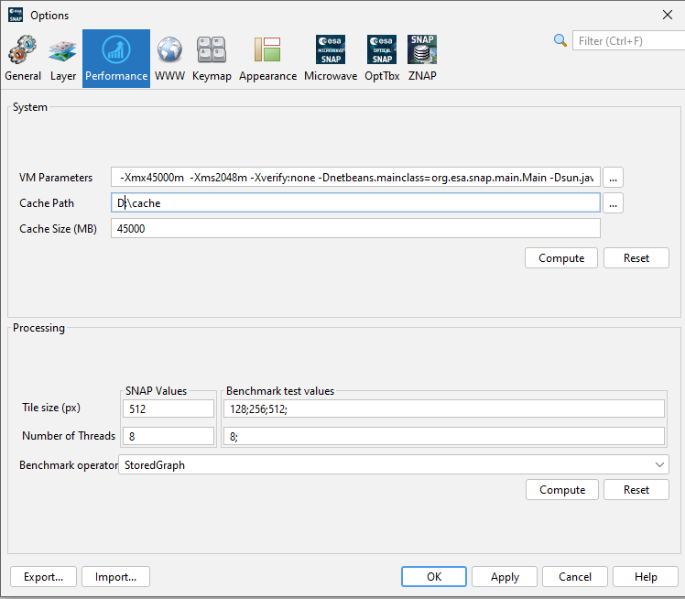

  - Under Tools → Options → Microwave check Use FileCache in readers to conserve memory
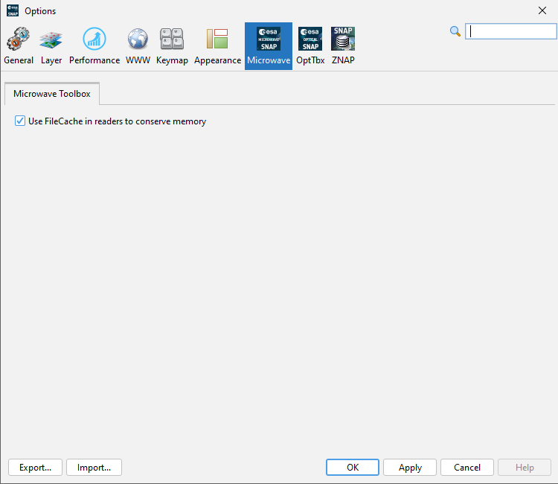

- OrfeoToolbox (OTB) CLI segmentation
In your 1_OBIA_vector_classifier.py you call:
run_cmd(
f"otbcli_LargeScaleMeanShift "
f"-in {ras} "
f"-spatialr 15 "
f"-ranger 6 "
f"-minsize 50 "
f"-tilesizex 8192 "
f"-tilesizey 8192 "
f"-mode vector "
f"-mode.vector.out {seg_shp} "
f"-cleanup false "
f"-ram 100128",
1,
'Image segmentation'
)
  - -spatialr (spatial radius)
Defines the radius (in pixels) of the local window used to compute mean-shift clusters in the spatial domain. Larger values gather information from a wider neighborhood, producing smoother, larger segments—but cost a lot of more time to work per pixel (window grows quadratically). Smaller values yield finer detail but can over-segment noisier areas and run faster.
  - -tilesizex & -tilesizey
Break the input raster into tiles of size X × Y pixels: here 8192×8192. Larger tiles reduce edge-buffer overhead (fewer overlaps between tiles) but consume more RAM per tile. Smaller tiles lighten per-tile memory use but increase the total number of tiles and thus processing overhead (more blocks to schedule, more repeated reads at tile edges).
  - -ram
Specifies how much memory (in MB) OTB may use. Set this to around 70 % of your total RAM (e.g. 45 000 MB on a 64 GB machine) to give plenty of headroom for both OTB and any other concurrent processes.

