SmartHouse User Model and Requirements Analysis
FivePlusOne Devs | CSC 312 Software Engineering Capstone | Step 4
Name | Student number | Email
[Full name 1] | [Student number 1] | [Email address 1]
[Full name 2] | [Student number 2] | [Email address 2]
[Full name 3] | [Student number 3] | [Email address 3]
[Full name 4] | [Student number 4] | [Email address 4]
[Full name 5] | [Student number 5] | [Email address 5]
[Full name 6] | [Student number 6] | [Email address 6]
Prepared 11 October 2026

ABSTRACT
SmartHouse helps prospective homeowners describe a home that fits their plot, household and budget, then explore a personalised concept. This report identifies provisional user profiles, the architectural-consultation mental model, and data, functional and behavioural requirements. The evidence consists of recorded project feedback and a dated review of two public home-design product pages. The analysis prioritises understandable consultation questions, coherent plan and three-dimensional views, explicit affordability assumptions, revision and export tasks, and a compact project workspace. Independent participant research remains a validation activity. The present prototype is frontend-only; authentication, professional approval and production costing are deferred.
1 INTRODUCTION
Early home planning involves more than choosing a drawing. A user must relate the size of the land, the spaces a household needs, the intended appearance and the money available. SmartHouse proposes a guided consultation that produces a confirmed brief and a house concept with matching views and estimated costs [1]. The problem is framed as helping users make understandable early design choices, rather than guaranteeing a construction price or replacing professional approval.
The Step 4 analysis addresses who uses the system, what those users expect the interface to represent, and which data, actions and responses follow from their goals [2]. Implementation details are mentioned only to distinguish the current prototype from the intended platform. Rectangular plots and single-storey homes are the initial supported scope. Complex terrain, detailed engineering, procurement and approved construction drawings are excluded.
2 EVIDENCE AND ELICITATION
2.1 Evidence sources
Three source types inform the analysis. First, the revised proposal defines the product purpose and stakeholders [1]. Second, the project discussion records feedback from a product owner or team representative about personalisation, consultation, visualisation and excessive scrolling [3]. Third, a desk review on 11 October 2026 examines the public product pages of Planner 5D and Floorplanner [4,5]. The review records advertised functionality; it does not establish product usability, price accuracy or successful use by participants.
No independent interview transcripts, survey responses or timed participant observations are analysed here. Accordingly, the profiles and requirements below are hypotheses grounded in this evidence, not demographic findings or measured population preferences. Table 1 records the feedback and its interpretation; evidence identifiers allow requirements to be traced to their basis.
Table 1: Project feedback record and interpretation
ID | Recorded need | Interpretation
E1 | A different house tailored to each user. | Collect household and lifestyle needs, not only plot area and budget.
E2 | Ask questions an architect would ask. | Use a guided consultation and reviewable design brief.
E3 | See the house, not just the floor plan. | Provide consistent exterior and interactive 3D views.
E4 | The project page requires too much scrolling. | Separate brief editing from design exploration; compact controls.
E5 | Build a prototype without backend/authentication. | Support a local demo without sign-in or API dependency.
2.2 Comparative desk review
Planner 5D presents floor-plan creation, furnishing and visual rendering on its public page [4]. The relevant observation is that a plan and a visual appearance are complementary representations. Floorplanner advertises room, wall, door and window editing together with a real-time 3D view [5]. This supports investigating whether users can understand the relationship between layout choices and the visible house. These observations are secondary evidence, not proof that SmartHouse users need every advertised feature.
Table 2: Desk-review record collected 11 October 2026
Source | Observation | Implication
E6 / [4] | Public page links floor plans and visual rendering. | Keep plan and appearance connected.
E7 / [5] | Public page describes openings and real-time 3D. | Inspect doors, windows and rooms in consistent views.
2.3 Interpretation and validation needs
Taken together, E1-E7 suggest that the main value is a comprehensible personal design process: explain needs, confirm them, see the proposed house, understand tradeoffs and revise. This is an interpretation to test. In particular, research must establish which questions users can answer reliably, whether plan dimensions are understood, what costs users assume are included, and whether the revised project navigation reduces effort.
3 USER MODEL
3.1 Provisional user profiles
A first-time homeowner may have little experience reading architectural plans. This user needs familiar room names, units, examples and visible assumptions. The main tasks are to enter site and budget information, describe essential accommodation, inspect an understandable house concept, and recognise when a requirement exceeds the supported scope. Architectural literacy is a design concern, not a measured characteristic of a recruited sample.
A household planner may be deciding for adults, children, visiting relatives or future household changes. This user needs to express bedrooms, bathrooms, privacy, storage and guest accommodation and to distinguish essentials from optional features. A home-working user may require an office and separation from noise. A user with access needs may require step-free movement or other accommodations; those needs must be recorded explicitly and reviewed rather than inferred from age or household type.
A demo manager maintains illustrative catalogue items and rates. In the prototype, this is an interface role available without secured permissions, not a protected administrator account. In the later platform, an administrator would manage published design/pricing data and access. Architects/designers and cost practitioners are secondary stakeholders who may review exported concepts and assumptions; no professional login or approval workflow is assumed for Step 4.
Table 3: Users and tasks
Profile | Tasks and needs
Homeowner | Start/resume project; describe site and budget; confirm a brief; inspect and export concept.
Household planner | Describe occupants, privacy and future needs; prioritise rooms; revise requirements.
Home-working / access needs | Record office/access requirements; identify support limits and review needs.
Demo manager | Maintain illustrative designs/rates locally; understand changes affect demo data.
3.2 Use-case model
Figure 1 models the users and their goals inside the SmartHouse boundary. Validation and generation are system responses within these tasks. Professional review is outside the current application boundary and is therefore not shown as an implemented approval use case. The written cases in Section 6 expand key interactions from the user perspective.
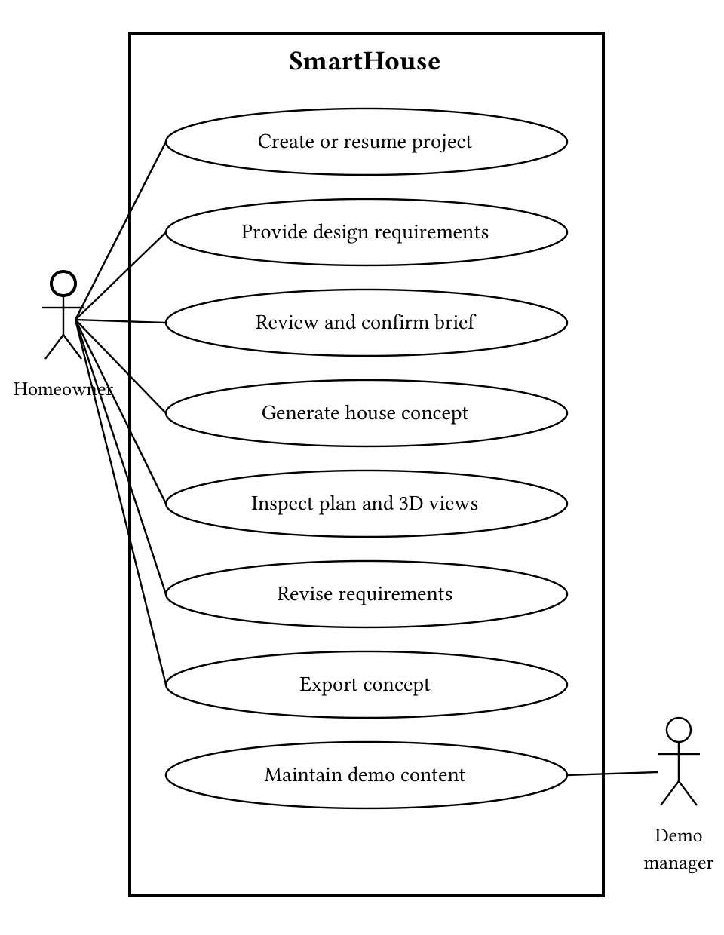
Figure 1: UML use-case view of the homeowner and demo-manager tasks.
Table 4: Use-case catalogue
ID | Goal | Result
UC1 | Create/resume project | Named workspace or restored draft.
UC2 | Provide needs | Saved consultation answers.
UC3 | Confirm brief | Reviewed requirement snapshot.
UC4 | Generate concept | House option with conflict feedback.
UC5 | Inspect views | Understand plan, exterior and 3D.
UC6 | Revise needs | Updated brief and concept.
UC7 | Export concept | SVG plan or JSON summary.
UC8 | Maintain demo content | Updated local catalogue/rates.
4 MENTAL MODEL
4.1 Architectural consultation metaphor
The intended mental model is an architectural consultation followed by reviewing a sketchbook and a model house. A project is the user's client file. The consultation is the conversation about land, family, daily life and money. The brief is the agreed description of the desired home. The concept is a proposal to inspect and revise. This metaphor explains why users answer questions before seeing the house, and why confirming a brief should not be mistaken for approving construction.
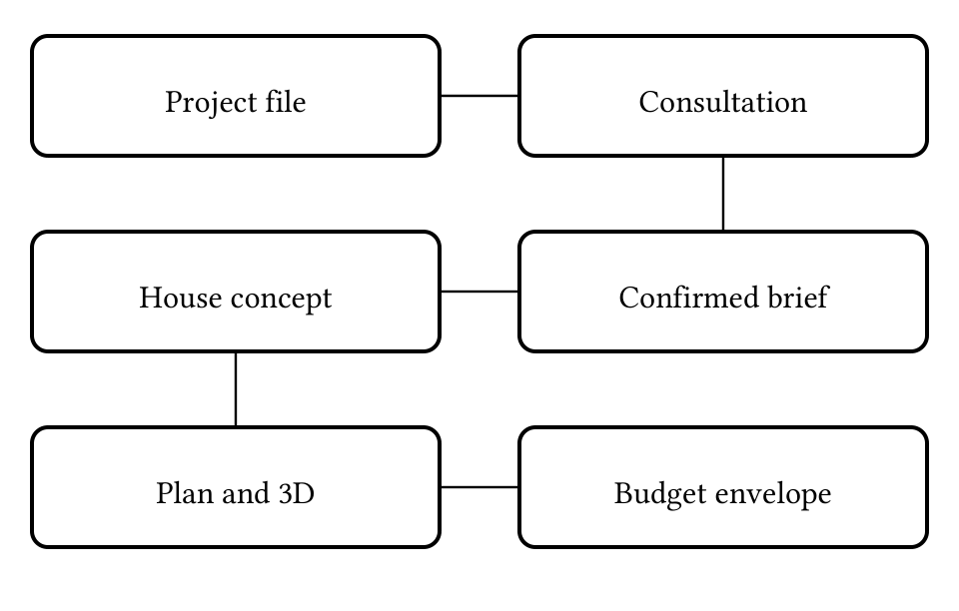
Figure 2: Familiar concepts that organise the user's design journey.
Figure 2 shows how the project file, consultation and confirmed brief lead to a concept. Floor plans and 3D views are different views of the same proposed house. The budget acts as an envelope for design choices; the interface should make the cost effect of revisions visible. A roof-removal control can use the familiar idea of a dollhouse to expose room relationships without asking the user to understand CAD terminology.
Table 5: Interface concepts and familiar meanings
Interface term | Mental image | Expected behaviour
Project | Client folder | Resume the same home discussion.
Brief | Agreed needs | Review/edit before generation.
House concept | Architectural sketch | Explore and request changes.
3D / cutaway | Model house | Rotate, zoom and inspect rooms.
Estimate | Planning budget | See basis, exclusions and tradeoffs.
Version | Sketchbook entry | Retain a confirmed brief after revisions.
4.2 Interaction principles
The interface should place the user in control: allow back navigation, show editable summaries and retain saved progress. Memory load should be reduced through labelled units, conditional questions and preserved answers. Consistency should link room names, counts and dimensions across views. Feedback should distinguish saving, confirmation, generation, conflict and unsupported scope. E4 specifically motivates a separate design workspace and brief editor, instead of presenting a long form above the house.
The perception gap is important: an attractive 3D scene can appear more authoritative than the underlying estimate or layout warrants. Therefore the concept stage, pricing assumptions and matters requiring review must be understandable. In the prototype, browser-local saving is also made explicit so that users do not assume cross-device access.
5 REQUIREMENTS ANALYSIS
5.1 Data model at analysis level
The analysis identifies domain information independently of an implementation technology. Figure 3 relates a project to design briefs, site/budget information, house concepts, spaces/openings and estimates. These are high-level concepts; detailed classes, storage schemas and algorithms belong to the later Design Model. A household description and requirement set inform a brief. A concept expresses rooms and appearance and is presented as a plan or model.
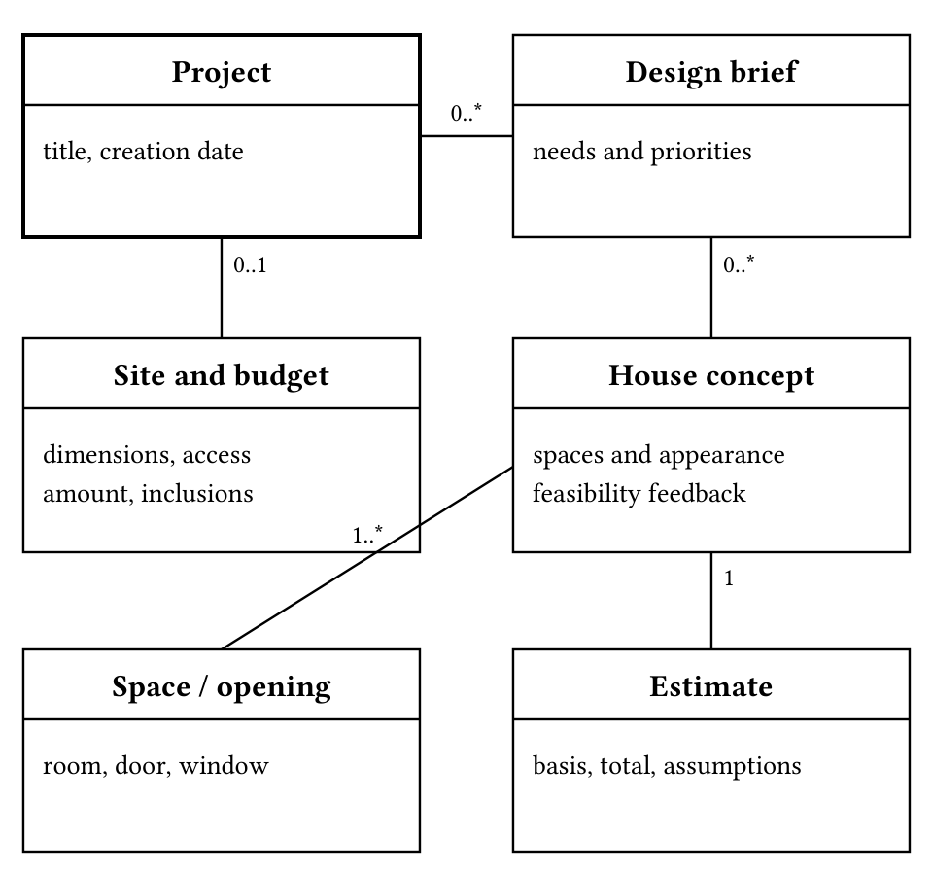
Figure 3: Abstract class relationships for requirements analysis.
The current prototype saves drafts and confirmed briefs locally and derives geometry for viewing. It does not persist production-grade mesh or price snapshots. Figure 3 represents the required domain relationships rather than claiming that every entity already has a database table.
Table 6: Data requirements and constraints
Data | Required information / rules
Site | Width, length, supported shape, road access, location and known terrain; unknown facts remain explicit.
Budget | Positive amount, currency, intended inclusions and finish preference; no implied guaranteed price.
Household / needs | Occupants, room counts, lifestyle, privacy, accessibility, essentials and optional preferences.
Brief / version | Reviewed answers, assumptions, support limits and version identity.
Concept / views | Footprint, room/opening geometry and appearance; shared identity across plan and 3D.
Estimate / export | Calculation basis, rate context, total and exclusions; export identifies the concept/brief.
5.2 Functional requirements
Table 7 uses report-specific identifiers, separate from the broader proposal requirements. Must and Should describe priority; status distinguishes implemented prototype behaviour (I), partial support (P) and later platform work (L). Evidence is drawn from Table 1, Table 2 and the proposal [1]. Technical implementation alone does not validate the user need.
Table 7: Functional requirements and traceability
ID | User-facing requirement | Basis | Priority / status
F01 | Create, name and resume a project. | E2, [1] | Must / I
F02 | Complete guided questions with relevant follow-ups. | E1,E2 | Must / I
F03 | Record household essentials and optional needs. | E1, [1] | Must / P
F04 | Review, edit and confirm the design brief. | E2 | Must / I
F05 | Generate a personalised spatial concept. | E1 | Must / P
F06 | Explain plot or estimated-budget conflicts. | [1] | Must / P
F07 | Keep plan, exterior and 3D geometry consistent. | E3 E6 E7 | Must / I
F08 | Rotate/zoom the house and inspect its interior. | E3,E7 | Must / I
F09 | Show the estimate basis and relevant exclusions. | [1] | Must / P
F10 | Revise needs and retain confirmed brief versions. | E1,E2 | Must / P
F11 | Download a concept/plan for later discussion. | [1] | Must / P
F12 | Maintain illustrative demo designs and rates. | [1] | Should / I
F13 | Protect and synchronise user-owned projects. | [1] | Later / L
Partial status is significant. The generator currently uses one adaptable room pattern; extra features may be recorded without being generated. Plot/budget checks use demo assumptions. Costing uses illustrative area rates rather than verified construction quantities. Brief snapshots are retained but geometry is recomputed. Exports currently provide SVG/JSON rather than a complete professional package. F13 is deliberately outside the login-free prototype scope.
5.3 Nonfunctional requirements
The quality requirements in Table 8 are acceptance proposals, not measured study results. Evaluation must record test conditions, devices and participant tasks before asserting that a quality target has been achieved.
Table 8: Quality requirements and proposed evaluation
ID | Quality requirement | Acceptance evidence
N01 | Understandable consultation and navigation. | Representative users can complete the agreed core tasks and explain their next action.
N02 | Keyboard/touch access and readable content. | Manual checks of labels, focus, contrast, camera buttons and narrow-screen use.
N03 | Consistent visual representations. | Geometry/version checks; no room-count or opening mismatch between views.
N04 | Reliable saving and recovery. | Resume tests, stale-revision rejection and clear storage-failure feedback.
N05 | Responsive interaction and bounded work. | Documented generation/viewer benchmarks; performance targets agreed before evaluation.
N06 | Transparent estimates and limits. | Users can identify demo rates, exclusions and concept-stage status.
N07 | Maintainable system responsibilities. | Separate consultation, geometry, visualisation, cost and persistence contracts.
N08 | Appropriate privacy in each release. | Local-storage disclosure in prototype; access/security tests before account-based release.
5.4 Behaviour and business rules
The main states are new project, editing draft, saved draft, confirmed brief, concept exploration and revised draft. Confirming a revised draft creates a new brief snapshot. Saving is not the same as confirming. An invalid input returns to a correctable field; a stale revision requires reconciling the latest saved draft. A generation conflict remains a conflict and must not silently remove an essential room. A failed 3D view offers a two-dimensional fallback rather than blocking the whole task.
Table 9: Events and required system responses
Event | Required response
Save incomplete draft | Validate supplied values, preserve progress and allow later completion.
Confirm brief | Check required/conditional answers and acknowledgements; explain unsupported scope.
Show concept | Present the matching views, cost basis and any plot/budget conflict.
Edit confirmed needs | Retain the previous brief; show that the existing concept reflects the old confirmation.
Storage/graphics failure | Show an actionable recovery or fallback state; do not report a false success.
Site dimensions and budget must be finite and positive. Room counts must fall within supported limits. Unknown site conditions must remain labelled. Prototype scope is rectangular, single-storey planning; known sloped terrain is not automatically supported. The budget comparison is conditional on demo rates and exclusions. Published building compliance and guaranteed construction affordability are not outcomes of this analysis.
6 WRITTEN USE CASES
6.1 UC3 Confirm the design brief
Goal: agree on the information used to produce the house. Preconditions: a project exists and the user has entered consultation answers. Main flow: (1) the user opens Review brief; (2) checks site, household, budget and style summaries; (3) edits an inaccurate section; (4) acknowledges concept assumptions; (5) confirms. The system checks required and conditional values, saves the brief snapshot and opens the design workspace. Alternate flows: missing answers lead to the relevant questions; unsupported scope is explained while the draft is preserved; a stale revision requires reload/reconciliation. Postcondition: a confirmed brief exists, or the editable draft remains without a false confirmation.
6.2 UC5 Inspect the proposed home
Goal: understand how the house looks and how its spaces connect. Preconditions: a confirmed brief and generated concept exist. Main flow: (1) the user opens Your house; (2) rotates/zooms the interactive model; (3) selects front, overview or above views; (4) removes the roof to inspect rooms; (5) opens the floor plan or exterior views; (6) reads cost and plot feedback. Alternate flow: unavailable 3D graphics provide a static exterior fallback. Postcondition: the user can inspect the same concept in available representations and see unresolved constraints; no claim of professional approval is made.
6.3 UC6 Revise household requirements
Goal: change the concept when needs or priorities change. Preconditions: a project and confirmed brief exist. Main flow: (1) the user opens Edit brief; (2) changes a room count or supported preference; (3) saves the draft; (4) reviews the revised summary; (5) reconfirms; (6) inspects the updated concept and estimated budget effect. Alternate flows: the user can pause after saving, or retain the previous confirmed concept if confirmation fails. Postcondition: a new brief snapshot is retained and the current views reflect it. Exact historical geometry/pricing replay is a later requirement, not a completed prototype capability.
6.4 UC7 Export a concept
Goal: keep information for later discussion. Preconditions: a confirmed concept is displayed. Main flow: (1) the user chooses Download floor plan or Download concept data; (2) the system packages the corresponding SVG or JSON; (3) the user saves the file; (4) uses it in subsequent discussion. Alternate flow: a missing render or failed download must not be reported as a successful export. Postcondition: an available local concept file identifies the brief and assumptions. A PDF concept package and professional drawings are later extensions.
7 SOFTWARE ENGINEERING PRACTICE
The project follows an iterative Scrum-oriented process [1]. Requirements are elicited from available feedback, prioritised, translated into small prototype increments and reviewed again. User-centred design is applied by keeping tasks and mental models visible in requirements, rather than selecting technology first. Modular responsibilities separate the consultation, concept generation, view rendering and persistence, making changes easier to inspect and test.
Methods include use-case modelling, abstract class analysis, a conditional questionnaire, low-fidelity interaction review and executable prototype evaluation. The UML models in Figures 1 and 3 capture goals and domain relationships; Figure 2 explains the interface concept. The user-interface goals are usability, consistency, user control, reduced memory load, and understandable feedback. The project discussion identifies excessive scrolling as a concrete issue to address, not a measured improvement score.
Umbrella activities include requirements traceability, risk tracking, configuration/version control, quality assurance, documentation and review. Git/GitHub retain changes and report versions. The prototype test suite checks local create/save/confirm/reopen tasks, incomplete/stale updates, storage failures, room relationships and selected 3D geometry invariants [7]. Such tests are engineering evidence; they cannot replace interviews, user-task observation or professional design review.
7.1 Research and acceptance plan
A proposed next study should recruit prospective homeowners with varied planning experience, including household and home-working/access needs where participants choose to discuss them. Use short semi-structured interviews and task observation, with consent and anonymised IDs. Ask participants to create a project, complete a brief, interpret a room arrangement, explain an estimate, revise a need and export a concept. Record task completion, errors, questions and observed effort separately from researcher interpretation. Ask an available designer and cost practitioner to review the spatial and pricing assumptions. These activities are proposed, not completed findings.
The editable record below is a placeholder for actual primary evidence. It must be filled from real research before being used to claim interview or observation results. Avoid recording unnecessary personal identifiers or sensitive household information.
Table 10: Primary research record placeholders
Field | To be completed
Date / method | [Date; interview, survey or observation]
Participant | [Anonymised ID and relevant planning experience]
Task / context | [Task, device and circumstances]
Raw observation | [Exact response or observed behaviour]
Interpretation | [Need, uncertainty and alternative explanation]
Traceability | [Related requirement and consent/record reference]
7.2 Risks and scope control
The main risks are an attractive model being mistaken for a build-ready design, inaccurate pricing assumptions, a narrow layout pattern not meeting diverse needs, and complexity expanding beyond the academic timeline. Mitigations are explicit concept status, transparent demo rates, recorded unsupported requirements, representative task evaluation and incremental scope decisions. Accessibility and professional compliance must be assessed rather than inferred from an illustrative model.
8 CONCLUSIONS
SmartHouse should be understood as a guided architectural planning workspace: users describe their needs, confirm a brief, explore a coherent house concept, examine affordability and revise. The user model and mental model lead to traceable data, functional, behavioural and quality requirements. The current prototype demonstrates parts of this workflow without a backend. The remaining analysis priority is independent user and domain-expert validation of consultation questions, concept comprehension, estimate expectations and navigation effort.
REFERENCES
[1] FivePlusOne Devs. 2026. SmartHouse Revised Project Proposal. CSC 312 project document. Repository: docs/SmartHouse_Revised_Project_Proposal.md.
[2] CSC 312 course material. 2026. Step 4 User Model Requirements and Analysis assignment brief. Supplied course instructions; includes Chapter 15 User Interface Design guidance.
[3] SmartHouse project discussion. 2026. Product requirements and prototype feedback, 10-11 October 2026. Recorded project-owner/team-representative messages; not an independent participant study.
[4] Planner 5D. 2026. House Design Software and Home Design in 3D. Retrieved 11 October 2026 from https://planner5d.com/. Public product-page desk review.
[5] Floorplanner. 2026. Online Floor Planner and 3D Room Planner Tool. Retrieved 11 October 2026 from https://floorplanner.com/. Public product-page desk review.
[6] CSC 312 course material. 2026. ACM SigConf format for SE Reports 2026. Supplied Word report-format template.
[7] FivePlusOne Devs. 2026. SmartHouse frontend prototype and test suite. Repository paths: client/src and client/tests/prototype.test.cjs. Baseline inspected 11 October 2026.

