Report on Excel and Word automation

This report will cover how to automate **Excel** and *Word.*

# Excel automation

“Writing code accounts for 90 percent of programming. Debugging code accounts for the other 90 percent.”

* first item in unordered list

1. first item in ordered list

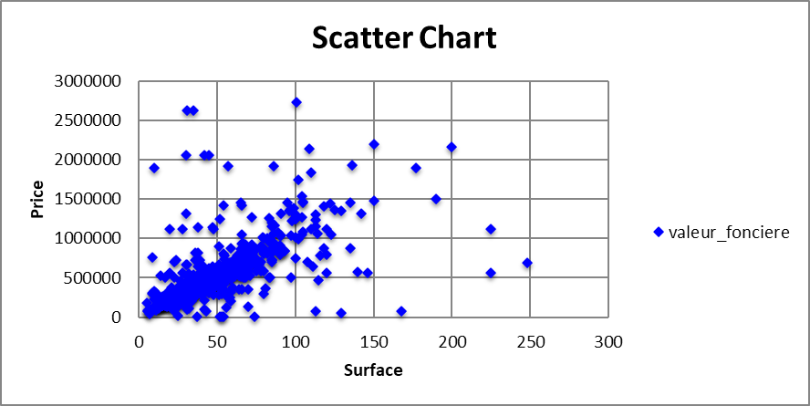

|  |  |  |
| --- | --- | --- |
| index | surface_reelle_bati | valeur_fonciere |
| 0 | 31 | 95000.0 |
| 1 | 43 | 545000.0 |
| 2 | 18 | 220000.0 |
| 3 | 25 | 132500.0 |
| 4 | 75 | 590000.0 |