Queries made from the bobross database:

1. **SET OPERATORS:**
2. Query:

SELECT title, apple_frame  
FROM elementsbyepisode  
UNION ALL  
SELECT title, apple_frame  
FROM copiedtable;

1. Columns: title, apple_frame
2. Expected Row Count: 806
3. Screenshot:

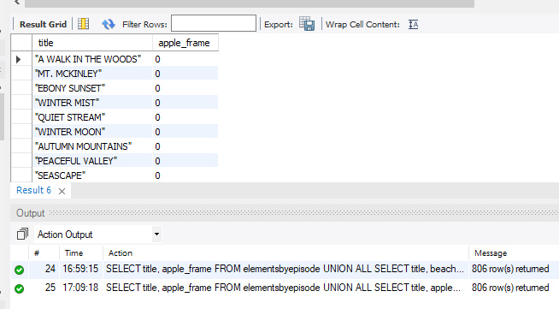

1. Query:

SELECT episode  
FROM elementsbyepisode  
UNION  
SELECT episode  
FROM copiedtable;

1. Columns: episode
2. Expected Row Count: 403
3. Screenshot:

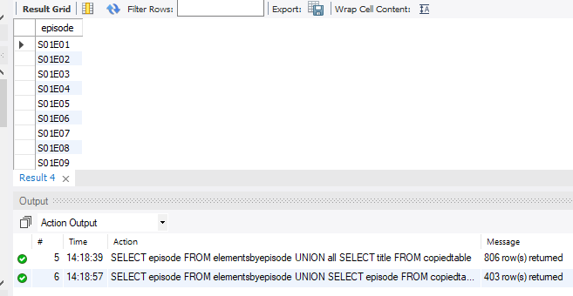

1. **SUBQUERIES:**
2. Query:

SELECT episode, title, boat  
FROM elementsbyepisode  
WHERE boat IN (SELECT boat FROM copiedtable);

1. Columns: episode, title, boat
2. Expected Row Count: 403
3. Screenshot:

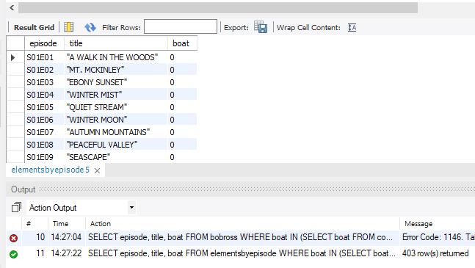

1. Query:

SELECT episode, title, trees  
FROM elementsbyepisode  
WHERE trees IN (SELECT trees FROM copiedtable  
 WHERE trees >= 1);

1. Columns: episode, title, trees
2. Expected Row Count: returned 337
3. Screenshot:

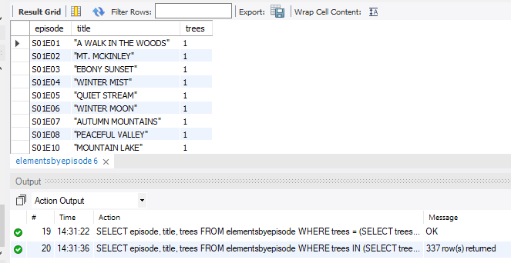

1. **ORDER OF OPERATION OF QUERIES:**
2. Query:

SELECT *  
FROM elementsbyepisode  
WHERE mountains >= 1  
GROUP BY trees  
HAVING count(trees) >= 1  
ORDER BY title;

1. Columns: all
2. Expected Row Count: returned 2
3. Screenshot:

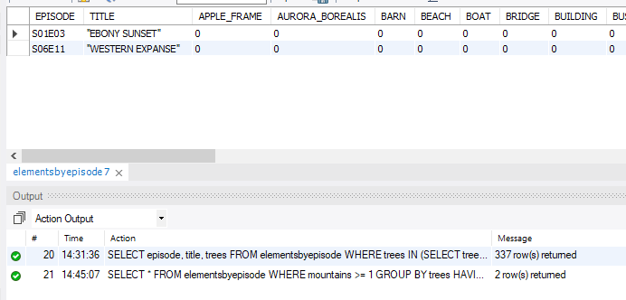

1. Query:

SELECT title, bushes, mountains, trees  
FROM elementsbyepisode  
WHERE trees >= 1  
GROUP BY mountains  
HAVING count(mountains) >= 1  
ORDER BY title;

1. Columns: title, bushes, mountains, trees
2. Expected Row Count: returned 2
3. Screenshot:

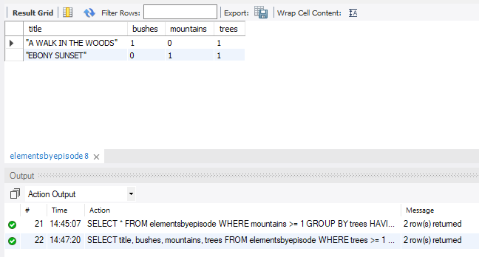

1. **CREATING, ALTERING, AND DROPPING TABLES:**
2. Query:

CREATE TABLE newtable AS  
SELECT title, bushes, mountains, trees  
FROM elementsbyepisode;

1. Columns: title, bushes, mountains, trees
2. Expected Row Count: 403
3. Screenshot:



1. Query:

ALTER TABLE newtable   
DROP COLUMN bushes;

1. Columns: title, mountains, trees
2. Expected Row Count: 403
3. Screenshot:



1. Query:

DROP TABLE copiedtable;

1. Columns: n/a
2. Expected Row Count: n/a
3. Screenshot:

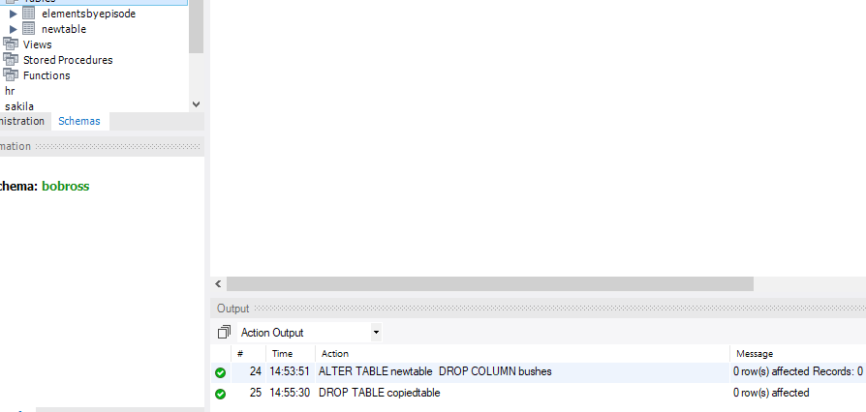

1. **ASSOCIATIONS:**
2. Query:

SELECT new.title, new.mountains, new.trees, epi.bushes, epi.moon FROM newtable new  
JOIN elementsbyepisode epi  
ON new.title = epi.title;

1. Columns: title, mountains, trees, bushes, moon
2. Expected Row Count: returned 407
3. Screenshot:

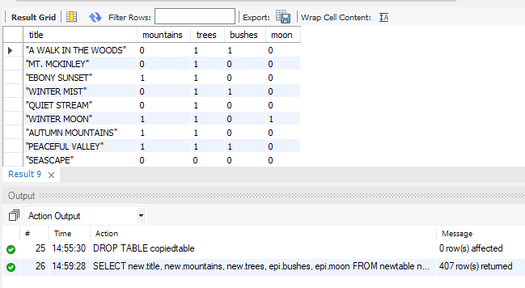

1. Query:

SELECT new.title, new.mountains, new.trees, epi.bushes, epi.moon FROM newtable new  
LEFT JOIN elementsbyepisode epi  
ON new.title = epi.title;

1. Columns: title, mountains, trees, bushes, moon
2. Expected Row Count: returned 407
3. Screenshot:

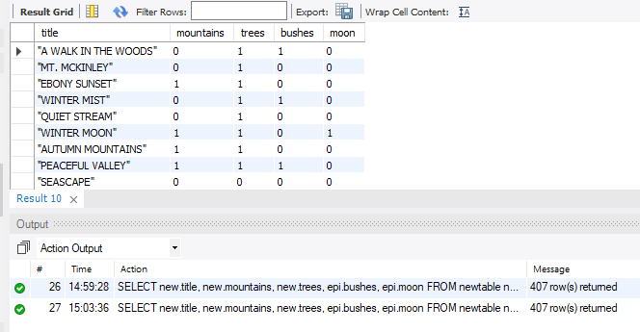

1. **JOINS AND MULTIPLE TABLE JOINS:**
2. Query:

SELECT new.title, new.mountains, new.trees, epi.hills, epi.lakes FROM newtable new  
RIGHT JOIN elementsbyepisode epi  
ON new.title = epi.title;

1. Columns: title, mountains, trees, hills, lakes
2. Expected Row Count: returned 407
3. Screenshot:

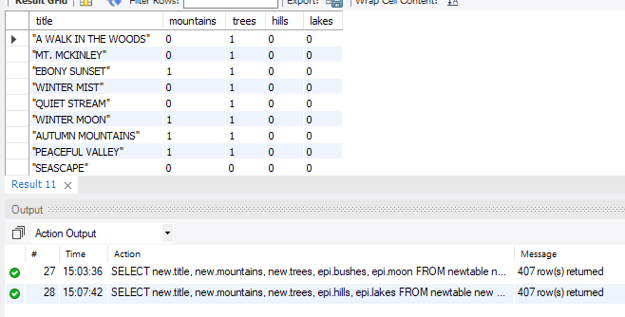

1. Query:

SELECT epi.title, epi.boat, epi.cactus, new.mountains, new.trees, anew.farm, anew.fence  
FROM elementsbyepisode epi  
JOIN newtable new  
ON epi.title = new.title  
JOIN anothernewtable anew  
ON epi.title = anew.title;

1. Columns: title, boat, cactus, mountains, trees, farm, fence
2. Expected Row Count: returned 415
3. Screenshot:

