# Boxplot Visualization Summary:

Boxplots are good ways to visualize and compare compounds among different samples. A boxplot graphically depicts a vector through its five-number summary. The edges of the box represent the lower and upper quartiles while the whiskers represent the minimum and maximum values. The median is displayed as a line within the box. Outliers are represented as symbols outside of the whiskers. More information is available on https://www.nature.com/articles/nmeth.2813.

### Input Summary:

Input Dataset: -> e.csv

Output Datasets and Files: -> Boxplot -> boxplot_plot.zip

**- values:** The boxplot were generated to visualize the value of each compound. Samples were grouped by Male, Female and colored by Lmbrd1, Null.

### Result Summary:

Boxplot for each compound were generated and saved in a zip file.

**- values:** The boxplot were generated to visualize the value of each compound. Samples were grouped by Male, Female and colored by Lmbrd1, Null.

An example boxplot is shown in Figure 1.

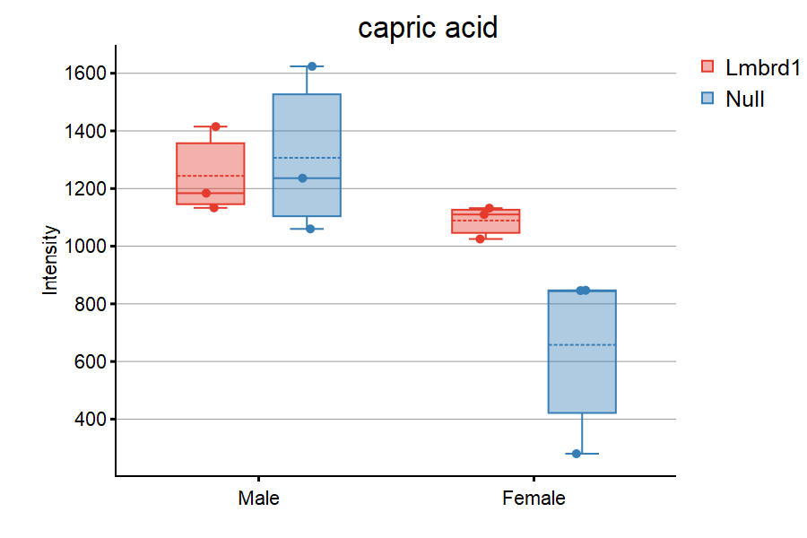

Figure 1: an example of boxplot.