# Fold Change Result Summary

Input Dataset: ->e.csv.

Treatment Group: two_groups.

Fold Change Calculation: **the median of Control MHC devided by the median of MHC**.

Result Summary: out of 148 compounds, there are **80** (0.54%) increased from Control MHC to MHC with fold_change greater than 1, while **68** (0.46%) decreased.. Table 1 and Table 2 show the 10 compounds increased and decreased the most.

| label | fold_changes |
| --- | --- |
| oleic acid | 6.691215 |
| inosine-5'-monophosphate | 3.722697 |
| alpha-ketoglutarate | 2.372703 |
| glycerol-alpha-phosphate | 1.917061 |
| sucrose | 1.679839 |
| 1-monostearin | 1.538717 |
| 4-hydroxybutyric acid | 1.534720 |
| beta-alanine | 1.480670 |
| succinic acid | 1.444290 |
| cysteine-glycine | 1.382883 |

Table 1: most increased compounds (->Student t-test->fold_change.csv)

| label | fold_changes |
| --- | --- |
| fructose-6-phosphate | 0.2555388 |
| glucose-6-phosphate | 0.3303903 |
| hexose-6-phosphate | 0.4169191 |
| noradrenaline | 0.6015969 |
| levoglucosan | 0.6573333 |
| behenic acid | 0.6663206 |
| oxalic acid | 0.6752656 |
| hydroxycarbamate NIST | 0.6824698 |
| aspartic acid | 0.6846738 |
| adenosine | 0.7038632 |

Table 2: most decreased compounds (->Student t-test->fold_change.csv)

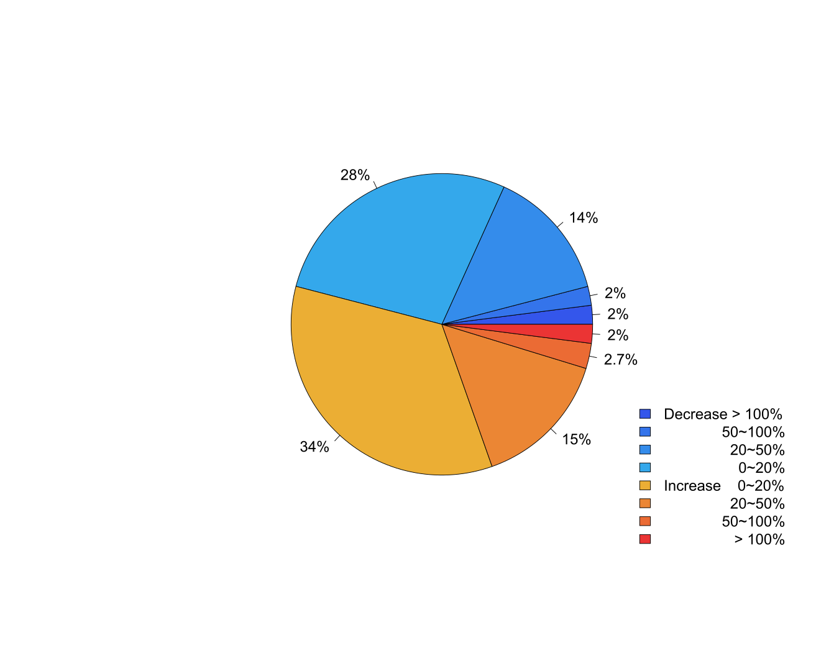

Figure 3: Detailed summary of Fold Changes.

Figure 3 shows a more detailed summary of fold changes, where the percentage of compounds with 0~20%, 20~50% and more than 100% increasing and decreasing are shown.