# Heatmap Plot Visualization Summary

Input Statistics: ->e.csv; .

Scaling Method: standard.

Dendrogram Clustering Method: average.

Dendrogram Distance Method: euclidean.

Sample Order: dendrogram.

Compound Order: dendrogram.

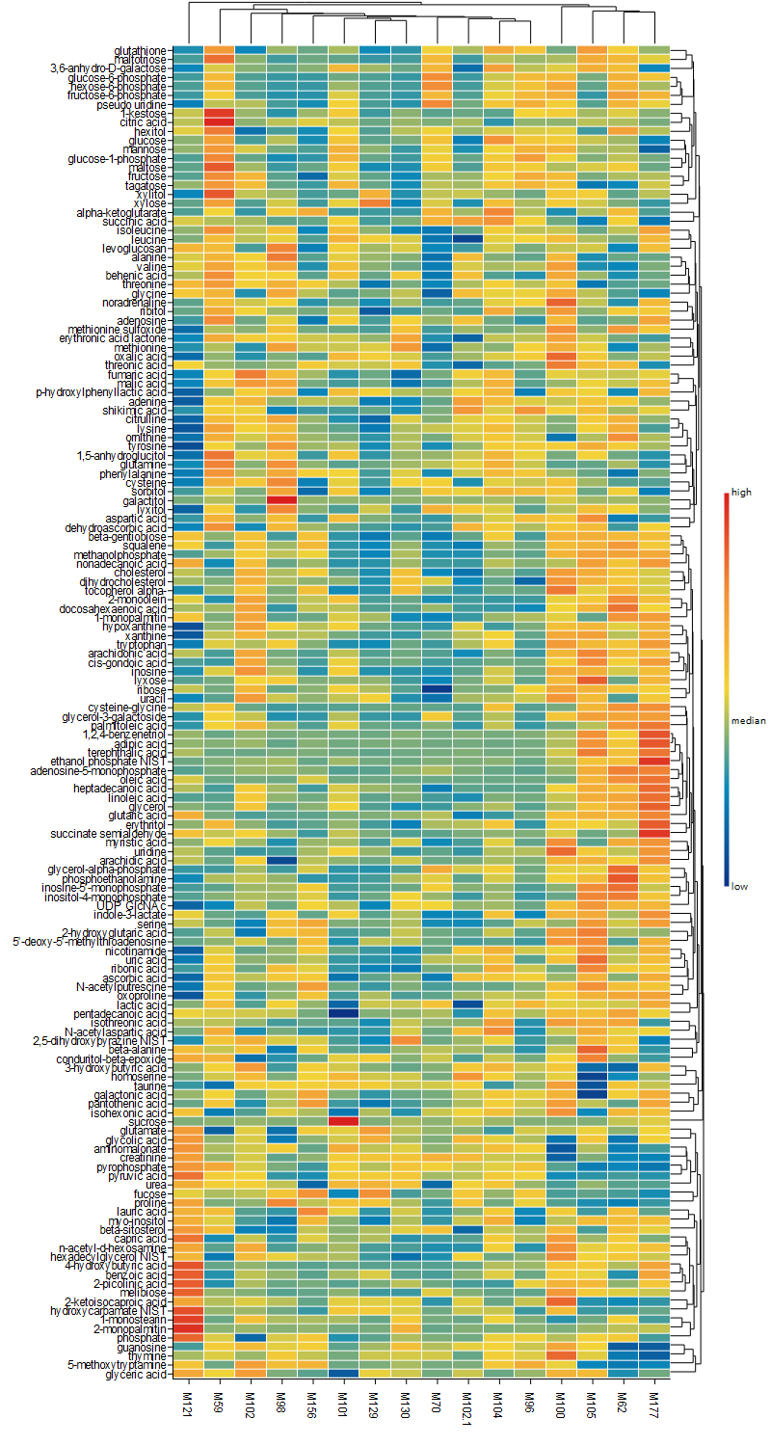

Figure 2: Heatmap Plot (

->Heatmap->heatmap_plot.svg;

.