# Post-hoc Power Analysis Summary

Input Statistics: ->e.csv; .

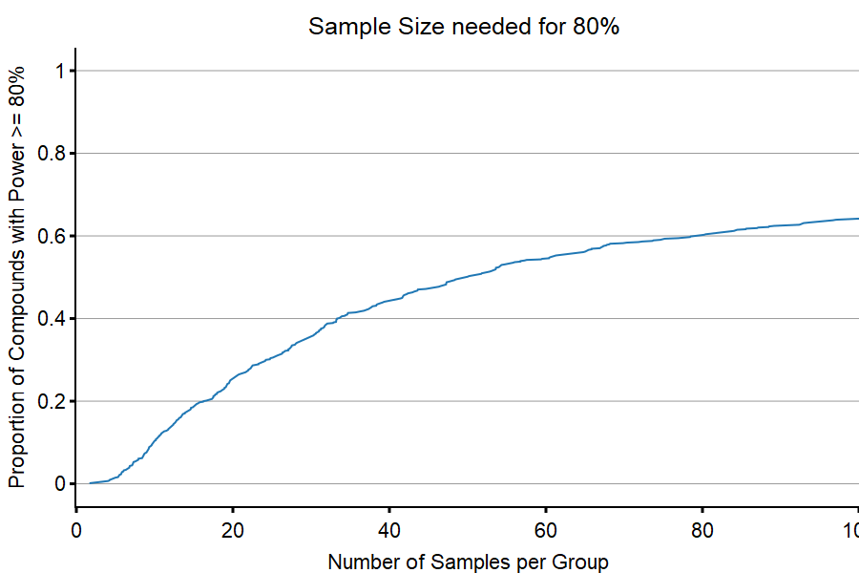

Figure 1: Volcano Plot (

->post-hoc Sample Size Analysis->ssize_plot.svg;

.