semi

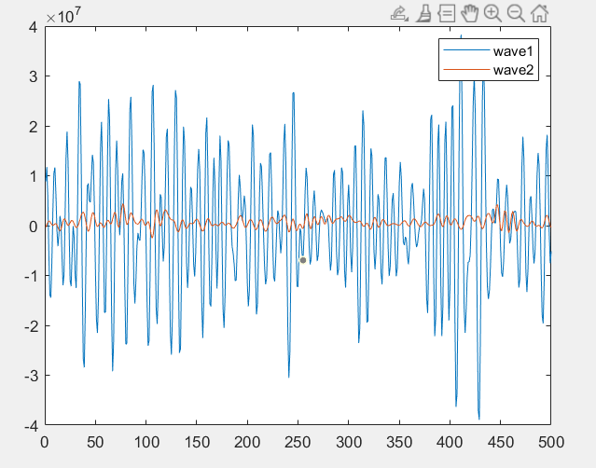

60deg





C++(左) matlab（右）



 

李博c++里的newman近似计算方法（对应matlab中的wave_drift_newman_tug1.m）

 

 

自己写的newman近似方法，pij=(pii+pjj)/2 qij=0;

 

%%%%%%%%%%%%%%%%%%%%%%%%%%%%%%%%%%%%%%%%%%%%%%%%%%%%%%%%%%%%%%%%%%%





Full qtf(matlab)



C++程序的结果



C++ fullqtf(左) newman近似（右）