CROCO_VISU user’s manual

Installation

See https://github.com/slgentil/croco_visu for installation of the conda environment and croco_visu GUI

Setup the wrapper for your simulation

Before running the GUI, you have to change the file croco_wrapper.py to adapt it to your simulation.
- You have to adapt the path and keymap_files
- You have to adapt all the keymap structures to your files.

You can find two examples in the croco_visu directory:
- croco_classic_wrapper.py for the files generated by croco without xios
- croco_xios_wrapper.py for the files generated by croco with xios

How to launch croco_visu
conda activate croco_visu
python croco_gui_xarray.py, la fenêtre suivante s’affiche

!!! Every time you enter text in an input area, you must validate the entry with the Enter key

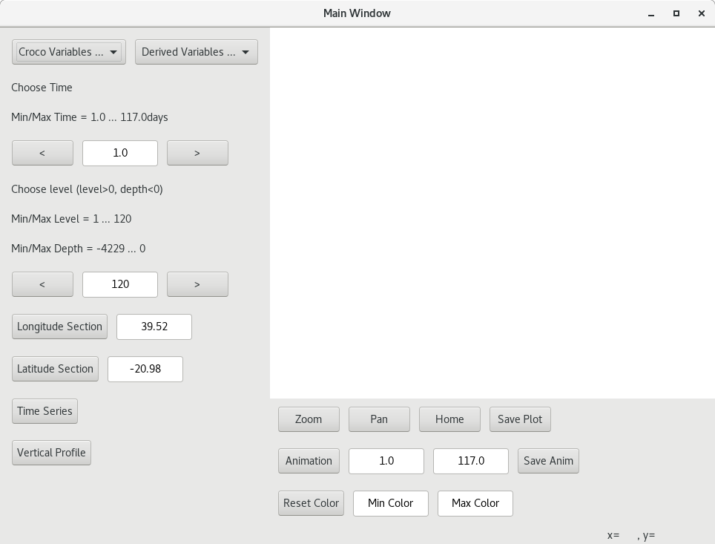

Choose a variable in the Croco Variables… or Derived Variables… list

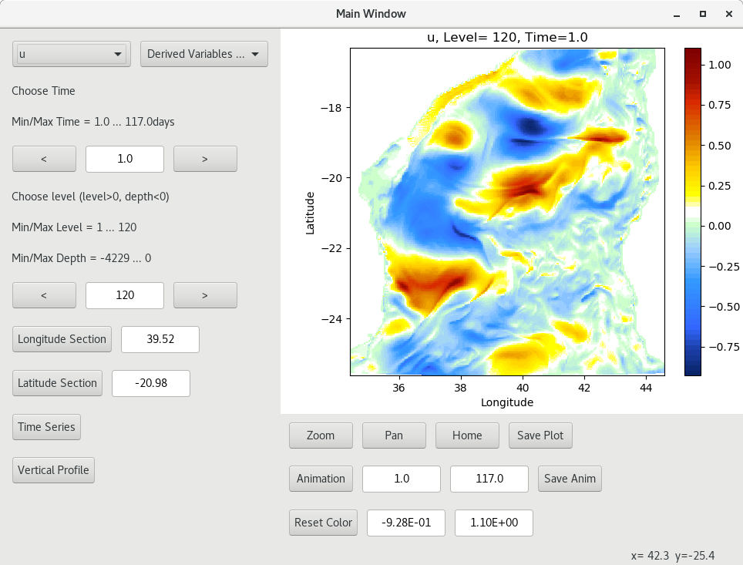

Variable is shown at the surface, min/max time, min/max level and min/max depth are also filled in
You can change time and level with < and > buttons
You can directly enter a time, level (positive) and depth (negative) in the text input.

Select a point on the plot to choose a longitude/latitude (defaults are in the middle of the plot)
You can now click on Longitude Section or Latitude Section button to plot a section

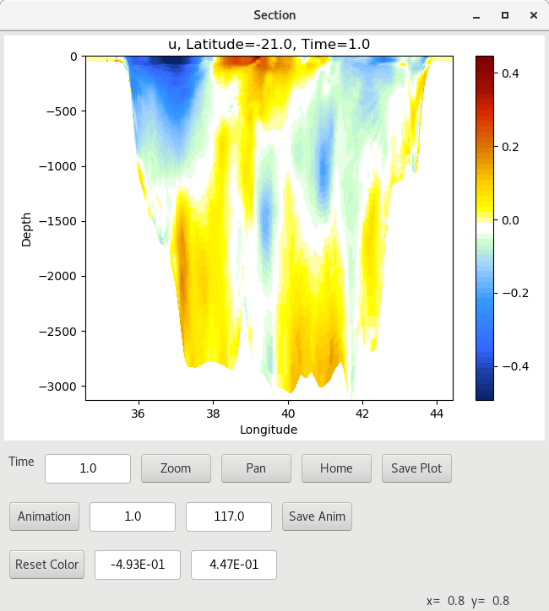

In all the windows, you can:

- click Zoom and select a zoom
- click Pan to translate the plot
- click Home to return to the default section
- click Save Plot to save the plot (a new dialog box will help you to choose the directory and the name)

- change min/max time (Enter to validate!!!) for the animation
- click on Animation to save the animation in a file Figures_xxx/dummy.mp4
- Save Anim to copy Figures_xxx/dummy.mp4 file in Figures_/title_of_the_anim.mp4 file

- change min/max color to change the colormap
- click Reset Color will return to the default colormap

You can see the coordinates of the cursor in the right bottom corner of the window.

In the main window, you can also click on Time Series to plot the current variable at the longitude/latitude and level/depth position in time.

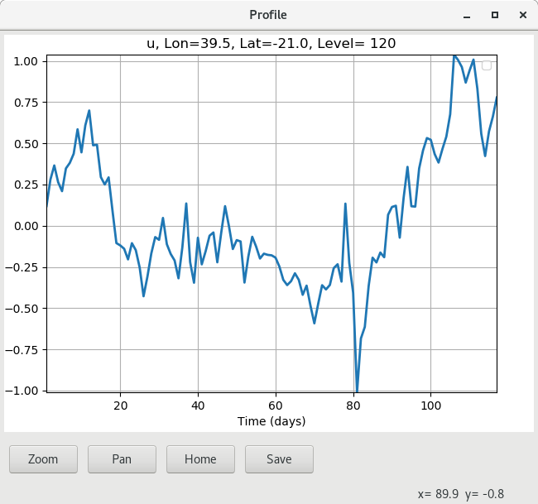

You can click on Vertical Profile to plot the profile of the current variable at the current time and at the latitude/longitude point.

