<http://www.dfrobot.com/index.php?route=product/product&filter_name=KIT0040&product_id=1043#.Uq1axWeA25P>

[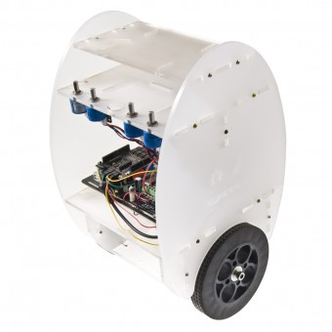](http://www.dfrobot.com/image/cache/data/KIT0040/_DSC0236-600x600.JPG)

[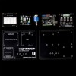](http://www.dfrobot.com/image/cache/data/KIT0040/2-600x600.jpg)[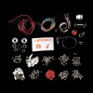](http://www.dfrobot.com/image/cache/data/KIT0040/1-600x600.jpg)[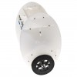](http://www.dfrobot.com/image/cache/data/KIT0040/_DSC0238-600x600.JPG)[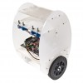](http://www.dfrobot.com/image/cache/data/KIT0040/_DSC0236-600x600.JPG)[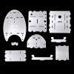](http://www.dfrobot.com/image/cache/data/KIT0040/3-600x600.jpg)[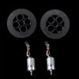](http://www.dfrobot.com/image/cache/data/KIT0040/4-600x600.jpg)

2-Wheel Balancing Robot Kit

Product Code: KIT0040 Brand: [DFRobot](http://www.dfrobot.com/index.php?route=product/manufacturer/product&manufacturer_id=11)

**$399.00**

Reward Points: 300

Qty:

[-](javascript:void(0)) [+](javascript:void(0))

Stock:3 

 Add to Cart

Add to WishList

0 reviews  0 reviews  |  Write a review

[Share on print](http://www.dfrobot.com/) [Share on facebook](http://www.dfrobot.com/) [Share on twitter](http://www.dfrobot.com/) [Share on email](http://www.dfrobot.com/) [More Sharing Services](http://www.dfrobot.com/) [4](http://www.dfrobot.com/)

Related Products

* [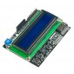](http://www.dfrobot.com/index.php?route=product/product&product_id=51)

[LCD Keypad Shield For Arduino](http://www.dfrobot.com/index.php?route=product/product&product_id=51)

$13.90

* [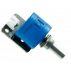](http://www.dfrobot.com/index.php?route=product/product&product_id=86)

[Analog Rotation Sensor V2](http://www.dfrobot.com/index.php?route=product/product&product_id=86)

$5.90

* [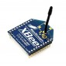](http://www.dfrobot.com/index.php?route=product/product&product_id=184)

[XBee 1mW Wire Antenna](http://www.dfrobot.com/index.php?route=product/product&product_id=184)

$23.50

* [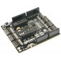](http://www.dfrobot.com/index.php?route=product/product&product_id=788)

[6 DOF IMU Shield](http://www.dfrobot.com/index.php?route=product/product&product_id=788)

$34.50

* [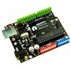](http://www.dfrobot.com/index.php?route=product/product&product_id=838)

[DFRduino UNO R3](http://www.dfrobot.com/index.php?route=product/product&product_id=838)

$22.90

* [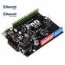](http://www.dfrobot.com/index.php?route=product/product&product_id=1044)

[Bluno - BLE with Arduino Uno](http://www.dfrobot.com/index.php?route=product/product&product_id=1044)

$35.00

[Description](http://www.dfrobot.com/#tab-description) [Reviews (0)](http://www.dfrobot.com/#tab-review) [Tech-Support](http://www.dfrobot.com/#tab-related)

**Introduction**

This 2-Wheel Balancing Robot Kit is based on the opensource 2-wheel balancing algorithm which is transplanted to the Arduino platform. They key comonents of this self-balancing robot are an DFRduino Uno, a 6 DOF IMU shield, 2 12V DC motors, 4 analog rotation sensors and a dual motor driver.  The custom-made acrylic case is easy to assemble, and solid enought for strutting and motion. It's egg-shaped outfit is definitely an eye-catching chic minibot, at the same time allowing extra areas for your own modules and add-ons. Through assembling this 2-Wheel Balancing Robot, the user will not only learn the 2-wheel self-balancing programming with Arduino, but also explore more cool possibilities with other modules on this platform, for example, RC control via Xbee, Blutooth communication via Bluno board.

**How Does It Work**

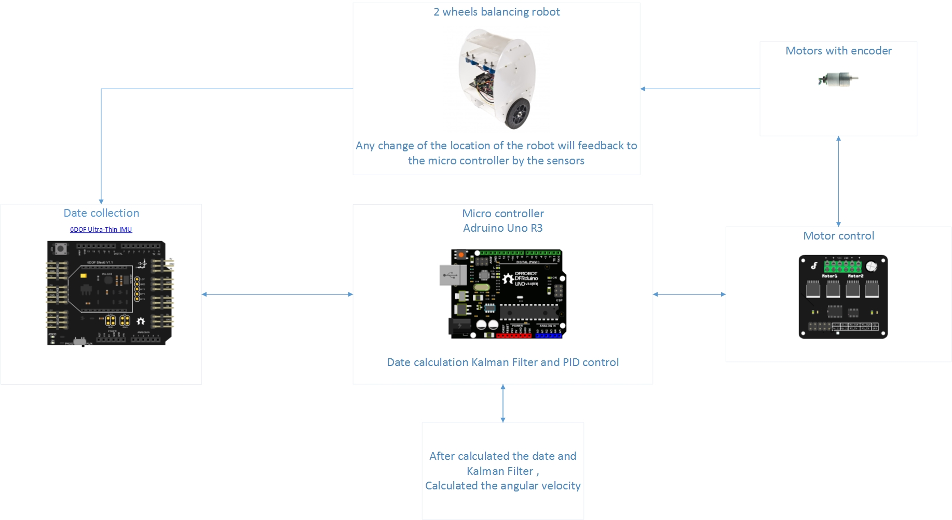

**Version history**

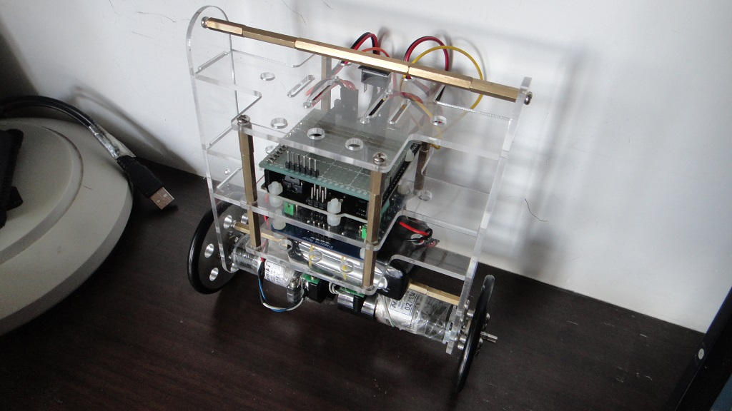

The first generation prototype balancing Robot from Kent.

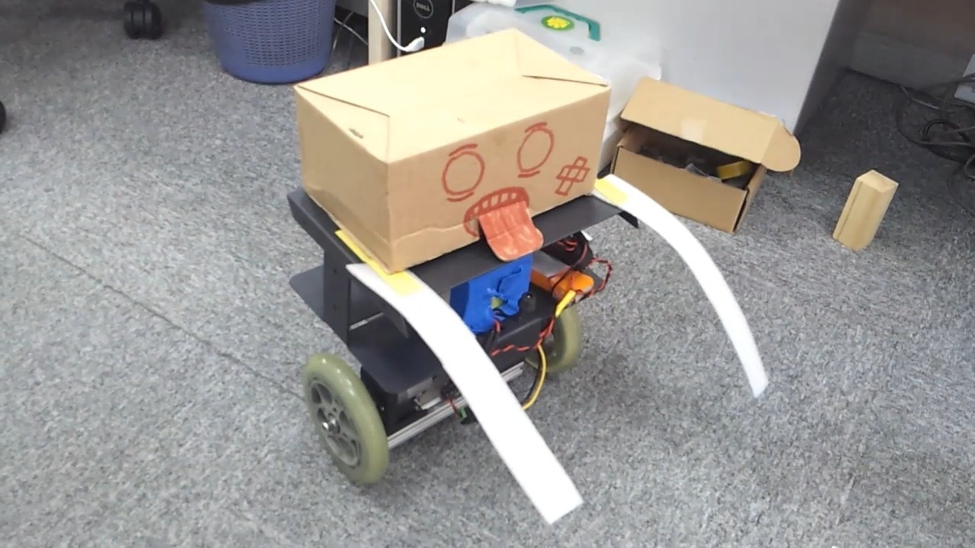

Rev 0.2 is just designed for fun. ~.

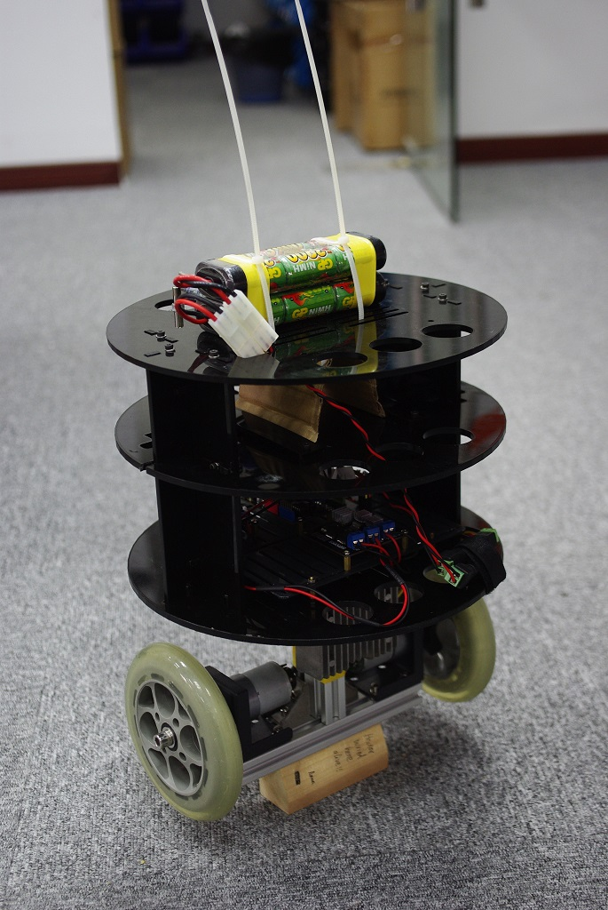

As a product, the frame design of v0.3 is too weak because of the flaws caused by mechanical design. However it should be tough for the beginners to play with it.

So we improved it a little bit and finish the latest version as you can see.

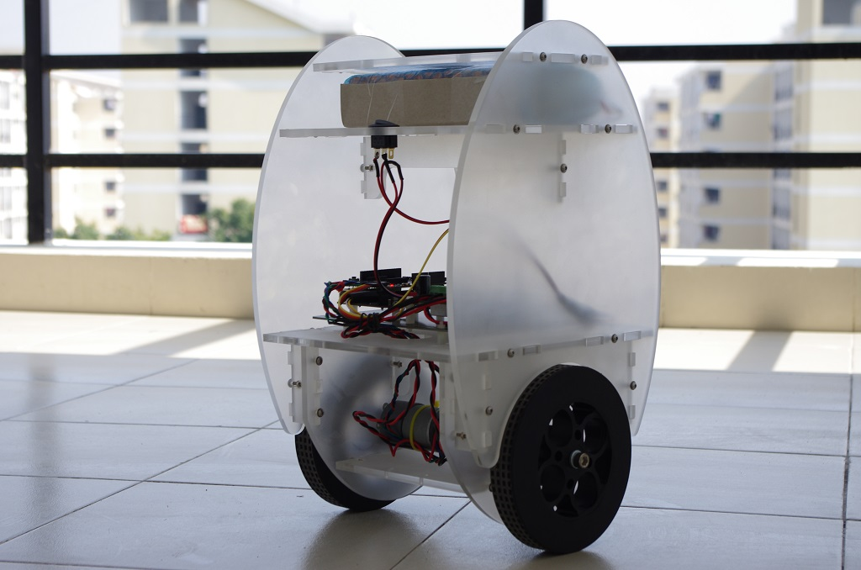

**Shipping List**

* Acrylic Case（6mm）       *1
* 12V DC Motor （122rpm w/Encoder）     *2
* DFRduino UNO R3      *1
* 6 DOF IMU Shield      *1
* DC-DC Power Module 25W       *1
* DC Motor Driver 2×15A - Lite      *1
* Selfbalance Robot Supporter      *1
* Power switch（with LED）     *1
* 5.5*2.1 Charging port      *1
* DC power supply plug      *1
* Analog Rotation Sensor      *4
* M3x6 screw low profile hex head (10pcs)      *1
* M3x12 screw low profile hex head(10pcs)      *2
* M3x16 screw low profile hex head (10pcs)      *4
* M3 Washer      *20
* M3 * 10 nylon standoff(10pcs)      *1
* M3 * 15 nylon standoff(10pcs)      *1
* Nylon cable ties（3*100mm）      *10
* Jumper Wires 9" F/F (10 Pack)      *1
* Jumper Wires 7.8" F/M (10 Pack)      *1
* Cables 250mm（black&white）      *3
* OSHW&DFRobot Sticker      *1
* Rubber Wheel 136×24mm（2pcs）      *1
* Coupling（eccentric 5mm）     *2
* Flange（HCR）     *2
* M8x16screw hex head      *2
* M8 Spring ring      *2
* M8 Washer      *2
* M3 nut      *70

**Document**

* [Hardware connection diagram](http://www.dfrobot.com/image/data/DFR0209/6dof%20recommended%20connection.jpg)
* [2-Wheel Balancing Code](http://www.dfrobot.com/image/data/KIT0040/2wheelbalancingcode.zip)
* [Sample Code](http://www.dfrobot.com/image/data/KIT0040/sample%20code.zip)
* [Assembly Guide](http://www.dfrobot.com/image/data/KIT0040/assemblyEN.pdf)
* [Test Manual](http://www.dfrobot.com/image/data/KIT0040/testingEN.pdf)
* Software for testing