FINAL REPORT FROM THE VIDEO QUALITY EXPERTS GROUP ON THE VALIDATION OF OBJECTIVE MODELS OF VIDEO QUALITY ASSESSMENT, PHASE II ©2003 VQEG

August 25, 2003
Copyright Information

VQEG Final Report of FR-TV Phase II Validation Test ©2003 VQEG
http://www.vqeg.org
For more information contact:
Philip Corriveau philip.j.corriveau@intel.com Co-Chair VQEG
Arthur Webster webster@its.bldrdoc.gov Co-Chair VQEG

Regarding the use of VQEG’s FRTV Phase II data:

Subjective data is available to the research community. Some video sequences are owned by companies and permission must be obtained from them. See the VQEG FRTV Phase II Final Report for the source of various test sequences.

Statistics from the Final Report can be used in papers by anyone but reference to the Final Report should be made.

VQEG validation subjective test data is placed in the public domain. Video sequences are available for further experiments with restrictions required by the copyright holder. Some video sequences have been approved for use in research experiments. Most may not be displayed in any public manner or for any commercial purpose. Some video sequences (such as Mobile and Calendar) will have less or no restrictions. VQEG objective validation test data may only be used with the proponent’s approval. Results of future experiments conducted using the VQEG video sequences and subjective data may be reported and used for research and commercial purposes, however the VQEG final report should be referenced in any published material.

Acknowledgments
This report is the product of efforts made by many people over the past two years. It will be impossible to acknowledge all of them here but the efforts made by individuals listed below at dozens of laboratories worldwide contributed to the report.

Editing Committee:
Greg Cermak, Verizon (USA)
Philip Corriveau, Intel (USA)
Mylène C.Q. Farias, UCSB (USA)
Taali Martin, CRC (Canada)
Margaret Pinson, NTIA (USA)
Filippo Speranza, CRC (Canada)
Arthur Webster, NTIA (USA)

List of Contributors:
Ron Renaud, CRC (Canada)
Vittorio Baroncini, FUB (Italy)
Andrezza Almeida Gusmão, CPqD (Brazil)
David Hands, BTexact Technologies (UK)
Hiroaki Ikeda, Chiba University (Japan)
Chulhee Lee, Yonsei University (Korea)
Geoff Morrison, BTexact Technologies (UK)
Harley Myler, Lamar University (USA)
Franco Oberti, Philips Research(The Netherlands)
Antonio Claudio Franca Pessoa, CPqD (Brazil)
Ann Marie Rohaly, Tektronix (USA)
Michele Van Dyke-Lewis, Teranex (USA)
Andre Vincent, CRC (Canada)
Andrew B. Watson, NASA (USA)
Stephen Wolf, NTIA/ITS (USA)
Alexander Wörner, R&S (USA)
Table of Contents

1 EXECUTIVE SUMMARY 6

2 INTRODUCTION 7

3 TEST METHODOLOGY 8
3.1 Independent Laboratories 8
3.2 Video Materials 8
3.3 Source sequence (SRC) and Hypothetical reference circuit (HRC) selection 8
3.4 Test Conditions: SRC x HRC Combinations 9
3.5 Normalization of sequences 15
3.6 Double Stimulus Continuous Quality Scale method 15
3.7 Grading scale 15
3.8 Viewers 16

4 DATA ANALYSIS 16
4.1 Subjective Data Analysis 16
4.1.1 Scaling Subjective Data 16
4.1.2 Treating “inversions” 16
4.1.3 Eliminating subjects 17
4.2 Objective Data Analysis 17
4.3 Supplementary analyses 19
4.4 Main results 19
4.5 Additional Results 23
4.5.1 Agreement of VZ and CRC results 23
4.5.2 Effect of HRC and SRC on subjective judgments 23
4.5.3 A measure of SRC ability to discriminate among HRCs 24
4.5.4 Scatter Plots 25
4.5.5 PSNR Data 32
4.6 Testing differences between models by comparing correlations vs. F-test 35
4.6.1 Correlation 35
4.6.2 F-tests based on individual ratings 35
4.6.3 An F-test based on averaged ratings, DMOS 36
4.6.4 Model assumptions for F-test 36
4.7 Costs and benefits of the logistic transformation 37

5 CONCLUSIONS 37

6 REFERENCES 38

Appendix I Definition of Terms (Glossary) 40

Appendix II Model Descriptions 42
1 Proponent A, NASA 42
2 Proponent D, British Telecom 42
3 Proponent E, Yonsei University 42
4 Proponent F, CPqD 42
5 Proponent G, Chiba University 43
6 Proponent H, NTIA 43

Appendix III Proponent Comments 45
1 Proponent A, NASA 45
2 Proponent D, British Telecom 48
3 Proponent E, Yonsei University 48
4 Proponent F, CPqD 49
5 Proponent G, Chiba University 51
6 Proponent H, NTIA 52

Appendix IV Independent Lab Group (ILG) subjective testing facilities 53
1 Display Specifications 53
2 Display Setup 54
3 Display White Balance 55
4 Display Resolution Estimates 56
5 Video Signal Distribution 59
6 Data collection method 60
7 Additional Laboratory Details 60
8 Contact information 63

Appendix V DMOS Values for all HRC-SRC Combinations 64

FINAL REPORT FROM THE VIDEO QUALITY EXPERTS GROUP ON THE VALIDATION OF OBJECTIVE MODELS OF VIDEO QUALITY ASSESSMENT, PHASE II

EXECUTIVE SUMMARY
The main purpose of the Video Quality Experts Group (VQEG) is to provide input to the relevant standardization bodies responsible for producing international Recommendations regarding the definition of an objective Video Quality Metric (VQM) in the digital domain.
The FR-TV Phase II tests are composed of two parallel evaluations of test video material. One evaluation is by panels of human observers. The other is by objective computational models of video quality. The objective models are meant to predict the subjective judgments. This Full Reference Television (FR-TV) Phase II addresses secondary distribution of digitally encoded television quality video. FR-TV Phase II contains two tests, one for 525-line video and one for 625-line video. Each test spans a wide range of quality, so that the evaluation criteria are able to determine statistical differences in model performance. The results of the tests are given in terms of Differential Mean Opinion Score (DMOS) - a quantitative measure of the subjective quality of a video sequence as judged by a panel of human observers. The 525 test had a wider range of DMOS (0 to 80) than the 625 test (3 to 55). The Phase II tests contain a broad coverage of typical content (spatial detail, motion complexity, color, etc.) and typical video processing conditions, to assess the ability of models to perform reliably over a very broad set of video content (generalizability). To address the concern that standardization bodies would prefer to recommend a complete system, models submitted to Phase II were required to supply their own video calibration (e.g., spatial registration, temporal registration, gain and level offset).
Three independent labs conducted the subjective evaluation portion of the FR-TV Phase II tests. Two labs, Communications Research Center (CRC, Canada) and Verizon (USA), performed the 525 test and the third lab, Fondazione Ugo Bordoni (FUB, Italy), performed the 625 test. In parallel, several laboratories (“proponents”) produced objective computational models of the video quality of the same video sequences tested with human observers by CRC, Verizon, and FUB. Of the initial ten proponents that expressed interest in participating, eight began the testing process and six completed the test. The six proponents in the FR-TV Phase II are Chiba University (Japan), British Telecom (UK), CPqD (Brazil), NASA (USA), NTIA (USA), and Yonsei University/ Radio Research Laboratory (Korea).
This document presents the methodology and results of Phase II of FR-TV tests.
The results of the two tests (525 and 625) are similar but not identical. According to the formula for comparing correlations in "VQEG1 Final Report" (June, 2000, p. 29), correlations must differ by 0.35 to be different in the 525 data (with 66 subjects) and must differ by 0.55 to be different in the 625 data (with 27 subjects). By this criterion, all six VQMs in the 525 test perform equally well, and all VQMs in the 625 test also perform equally well. Using the supplementary ANOVA analyses, the top two VQMs in the 525 test and the top four in the 625 test perform equally well and also better than the others in their respective tests.
The Pearson correlation coefficients for the six models ranged from 0.94 to 0.681. It should not be inferred that VQEG considers the Pearson correlation coefficient to be the best statistic. Nevertheless, the ranking of the models based upon any of the seven metrics is similar but not identical.
Using the F test, finer discrimination between models can be achieved. From the F statistic, values of F smaller than approximately 1.07 indicate that a model is not statistically different from the null (theoretically perfect) model. No models are in this category. Models D and H performed statistically better than the other models in the 525 test and are statistically equivalent to each other.
For the 625 data the same test shows that no model is statistically equal to the null (theoretically perfect) model but four models are statistically equivalent to each other and are statistically better than the others. These models are A, E, F, and H.
PSNR was calculated by BT, Yonsei and NTIA. The results from Yonsei were analyzed by six of the seven metrics used for proponents’ models. For both the 525 and 625 data sets, the PSNR model fit significantly worse than the best models. It is very likely that the same conclusions would hold for PSNR calculated by other proponents.
VQEG believes that some models in this test perform well enough to be included in normative sections of Recommendations.

INTRODUCTION
The main purpose of the Video Quality Experts Group (VQEG) is to provide input to the relevant standardization bodies responsible for producing international Recommendations regarding the definition of an objective Video Quality Metric (VQM) in the digital domain. To this end, in 1997-2000 VQEG performed a video quality test to validate the ability of full reference, objective video quality models to assess television quality impairments. This full reference television (FR-TV) Phase I test yielded inconclusive results. This gave VQEG increased motivation to pursue reliable results in a short period of time.
In 2001-2003, VQEG performed a second validation test, FR-TV Phase II, the goal being to obtain more discriminating results than those obtained in Phase I. The Phase II test contains a more precise area of interest, focused on secondary distribution of digitally encoded television quality video. The Phase II test contains two experiments, one for 525-line video and one for 625-line video. Each experiment spans a wide range of quality, so that the evaluation criteria are better able to determine statistical differences in model performance. The Phase II test contains a broad coverage of typical content (spatial detail, motion complexity, color, etc.) and typical video processing conditions, to assess the ability of models to perform reliably over a very broad set of video content (generalizability). To address the concern that standardization bodies would prefer to recommend a complete system, models submitted to the Phase II test were required to supply their own video calibration (e.g., spatial registration, temporal registration, gain and level offset).
The FR-TV Phase II test utilized three independent labs. Two labs, Communications Research Center (CRC, Canada) and Verizon (USA), performed the 525 test and the third lab, Fondazione Ugo Bordoni (FUB, Italy), performed the 625 test. Of the initial ten proponents that expressed interest in participating, eight began the testing process and six completed the test. The six proponents of the FR-TV Phase II are:
- NASA (USA, Proponent A)
- British Telecom (UK, Proponent D)
- Yonsei University / Radio Research Laboratory (Korea, Proponent E)
- CPqD (Brazil, Proponent F)
- Chiba University (Japan, Proponent G)
- NTIA (USA, Proponent H)
This document presents the methodology and results of Phase II of FR-TV tests.

TEST METHODOLOGY
This section describes the test conditions and procedures used in this test to evaluate the performance of the proposed models over a range of qualities.

Independent Laboratories
The subjective test was carried out in three different laboratories. One of the laboratories (FUB) ran the test with 625/50 Hz sequences while the other two (CRC and Verizon) ran the test with 525/60 Hz sequences. Details of the subjective testing facilities in each laboratory can be found in Appendix IV.

Video Materials
The test video sequences were in ITU Recommendation 601 4:2:2 component video format using an aspect ratio of 4:3. They were in either 525/60 or 625/50 line formats. Video sequences were selected to test the generalizability of the models’ performance. Generalizability is the ability of a model to perform reliably over a very broad set of video content. A large number of source sequences and test conditions were selected by the Independent Laboratory Group (ILG) to ensure broad coverage of typical content (spatial detail, motion complexity, color, etc.) and typical video processing conditions (see Tables 1–4).

Source sequence (SRC) and Hypothetical reference circuit (HRC) selection
For each of the 525 and 625 tests, thirteen source sequences (SRCs) with different characteristics (e.g., format, temporal and spatial information, color, etc.) were used (See Tables 1 and 2).
For both tests, the thirteen sequences were selected as follows:
- Three SRCs were selected from the VQEG Phase I video material.
- Four SRCs were selected from material provided by the ILG. This material was unknown to the proponents.
- The remaining six SRCs were selected from video material provided by proponents and Teranex.
HRCs (Hypothetical Reference Circuits) were required to meet the following technical criteria:
- Maximum allowable deviation in Peak Video Level was +/- 10%
- Maximum allowable deviation in Black Level was +/- 10%
- Maximum allowable Horizontal Shift was +/- 20 pixels
- Maximum allowable Vertical Shift was +/- 20 lines
- Maximum allowable Horizontal Cropping was 30 pixels
- Maximum allowable Vertical Cropping was 20 lines
- Temporal Alignment between SRC and HRC sequences within +/- 2 video frames
- Dropped or Repeated Frames allowed only if they did not affect temporal alignment
- No Vertical or Horizontal Re-scaling was allowed
- No Chroma Differential Timing was allowed
- No Picture Jitter was allowed
In the 625 test, ten HRCs were used; their characteristics are presented in Table 3. These HRCs were selected by the ILG as follows:
- Three HRCs were selected from the VQEG Phase I video material.
- Five HRCs were produced by the ILG, and were unknown to proponents.
- Two HRCs were selected by the ILG from a set of HRCs provided by proponents and Teranex.
In the 525 test, fourteen HRCs were used; their characteristics are presented in Table 4. These HRCs were selected by the ILG as follows:
- Three HRCs were selected from the VQEG Phase I video material.
- Seven HRCs were produced by the ILG, and were unknown to proponents.
- Four HRCs were selected by the ILG from a set of HRCs provided by proponents and Teranex.

Test Conditions: SRC x HRC Combinations
In both 625 and 525 tests, SRCs and HRCs were combined into a sparse matrix, so as to obtain 64 SRCxHRC combinations. Specifically, SRCs and HRCs were combined to obtain three matrices:
- 3X4 matrix using SRCs selected from the VQEG Phase I video material.
- 4X4 matrix using SRCs selected from material provided by the ILG.
- 6X6 matrix using SRCs selected from video material provided by proponents.
Table 5 shows the sparse matrix used in the 625 test and Table 6 shows the sparse matrix used in the 525 test. In both tables, the 3X4 matrix is represented by “A”, the 4X4 matrix by “B”, and the 6X6 matrix by “C”.
The SRCs, HRCs, and SRCxHRC combinations were selected by the ILG and were unknown to proponents. The SRCxHRC combinations were selected in such a way that their subjective quality would likely span a large range, from very low to very high.
To prevent proponents from tuning their models, all test video material was distributed to proponents only after their models had been submitted to, and verified by the ILG (see Section 4).

Table 1. 625/50 format sequences (SRCs)
Assigned number | Sequence | Characteristics | Source
1 | New York | View of skyline taken from moving boat; originated as 16:9 film, telecined to 576i/50 | SWR/ARD
2 | Dancers | Dancers on wood floor with fast motion, moderate detail; original captured in D5 format | SWR/ARD
3 | Volleyball | Indoor men’s volleyball match; captured in D5 format | SWR/ARD
4 | Goal | Women’s soccer game action with fast camera panning; captured in D5 | SWR/ARD
5 | Comics | 12fps traditional animation; source converted to 24fps film, then telecined to 576i/50 | Universal  Studios
6 | Universal | Slowly rotating wireframe globe; captured in DigiBetaCam | Teranex
7 | Big Show | Rapid in-scene and camera motion, with lighting effects
8 | Guitar | Close-up of guitar being played, with changing light effects
9 | Mobile & Calendar 2 | Colour, motion, detail | CCETT
10 | Husky | High detail, textured background, motion
11 | Mobile & Calendar 1 | Colour, motion, detail | CCETT
12 | Rugby | Outdoor rugby match; movement, colour | RAI
13 | Canoe | Motion, details, moving water | RAI
14 | Band  (training sequence) | Rapid in-scene and camera motion, with lighting effects
15 | Jump  (training sequence) | Rapid in-scene and camera motion, with lighting effects
16 | Foreman  (training sequence) | Facial close-up followed by wide shot of construction site
Table 2. 525/60 format sequences (SRCs)
Assigned number | Sequence | Characteristics | Source
1 | Football | Outdoor football match, with colour, motion, textured background | ITU
2 | Autumn_Leaves | Autumn landscape with detailed colour, slow zooming | ITU
3 | Betes_pas_Betes | Animation containing movement, colour and scene cuts | CBC/CRC
4 | Park Fountain | Highly detailed park scene with water; downconverted from HDTV source | CDTV/CRC
5 | Bike Race | Colour and rapid motion; downconverted from HDTV | CDTV/CRC
6 | Paddle Boat | Colour, large water surface; downconverted from HDTV | Telesat Canada
7 | Soccer Net | Neighbourhood soccer match, moderate motion; downconverted from HDTV | CDTV/CRC
8 | Water Child | Water amusement park; captured on DigiBetaCam | Teranex
9 | 1Fish2Fish | Amusement park ride with moderate motion, high detail, slow zoom; captured on DigiBetaCam | Teranex
10 | Colour Kitchen | Colour, motion, moderately low illumination; captured on DigiBetaCam | Teranex
11 | Woody 2 | 12fps traditional animation, converted to 24fps film and telecined to 480i/60 | Universal Studios
12 | Curious George | Detailed outdoor fountain fountain with camera zoom; captured on DigiBetaCam | Teranex
13 | Apollo13 c2 | Scene cuts from closeup of engine ignition, to distant wide shot, and back; film original telecined to 480i/60 | Universal Studios
14 | Rose  (training sequence) | Closeup shot of a rose in light breeze; motion, colour and detail; captured on DigiBetaCam | Teranex
15 | Street Scene  (training sequence) | High detail, low motion; downconverted from HDTV | Telesat Canada
16 | Monster Café  (training sequence) | Slowly rotating statues, swaying tree branches; captured on DigiBetaCam | Teranex

Table 3. 625/50 Hypothetical Reference Circuits (HRCs)
Assigned Number | Bit Rate | Resolution | Method | Comments
1 | 768 kbit/s | CIF | H.263 | full screen (HRC15 from VQEG 1)
2 | 1 Mbits/s | 320H | MPEG2 | proponent encoded
3 | 1.5 Mbit/s | 720H | MPEG2 | encoded by FUB
4 | 2.5→4 Mbit/s | 720H | MPEG2 | Cascaded by FUB
5 | 2 Mbit/s | ¾ | MPEG2 sp@ml | HRC13 from VQEG 1
6 | 2.5 Mbit/s | 720H | MPEG2 | Encoded by FUB
7 | 3 Mbit/s | full | MPEG2 | HRC9 from VQEG 1
8 | 3 Mbit/s | 704H | MPEG2 | proponent encoded
9 | 3 Mbit/s | 720H | MPEG2 | encoded by FUB
10 | 4 Mbit/s | 720H | MPEG2 | encoded by FUB

Table 4. 525/60 Hypothetical Reference Circuits (HRCs)
Assigned Number | Bit Rate | Resolution | Method | Comments
1 | 768 kbit/s | CIF | H.263 | full screen (HRC15 from VQEG 1)
2 | 2 Mbit/s | ¾ | MPEG2, sp@ml | HRC13 from VQEG 1
3 | 3 Mbit/s | full | MPEG2 | HRC9 from VQEG 1
4 | 5 Mbit/s | 720H | MPEG2 | Encoded by CRC
5 | 2 Mbit/s | 704H | MPEG2 | Encoded by CRC
6 | 3 Mbit/s | 704H | MPEG2 | Encoded by CRC
7 | 4 Mbit/s | 704H | MPEG2 | Encoded by CRC
8 | 5 Mbit/s | 704H | MPEG2 | Encoded by CRC
9 | 1 Mbit/s | 704H | MPEG2 | proponent encoded; low bitrate combined with high resolution
10 | 1 Mbit/s | 480H | MPEG2 | encoded by CRC; low bitrate, low resolution
11 | 1.5 Mbit/s | 528H | MPEG2 | proponent encoded;  64QAM modulation;  composite NTSC output converted to component
12 | 4->2 Mbit/s | 720H | MPEG2 | proponent encoded; cascaded encoders
13 | 2.5 Mbit/s | 720H | MPEG2 | Encoded by CRC
14 | 4 Mbit/s | 720H | MPEG2 | proponent encoded; using software codec

Table 5. 625/50 SRC x HRC Test Condition Sparse Matrix

 |  | HRC Number | 1 | 2 | 3 | 4 | 5 | 6 | 7 | 8 | 9 | 10
 |  | HRC Name | 768 kb/s  H.263 | 1 Mbit/s  320H | 1.5 Mbit/s  720H | 4→2.5Mbit/s  720H Transc. | 2.0 Mbit/s  ¾-sp@ml | 2.5 Mbit/s  720H | 3.0 Mbit/s | 3 Mbit/s  704H | 3.0 Mbit/s  720H | 4.0 Mbit/s  720H
SRC Number | SRC Name | Provided By | VQEG PI | Proponents (BT) | ILG | ILG | VQEG PI | ILG | VQEG PI | Proponents (TDF) | ILG | ILG
1 | New York | ARD |  | C | C | C |  | C |  | C |  | C
2 | Dancers | ARD |  | C | C | C |  | C |  | C |  | C
3 | Volleyball | ARD |  | C | C | C |  | C |  | C |  | C
4 | Goal | ARD |  | C | C | C |  | C |  | C |  | C
5 | Comics | Universal |  | C | C | C |  | C |  | C |  | C
6 | Universal Theme Park | Teranex |  | C | C | C |  | C |  | C |  | C
7 | Big Show | ILG |  |  |  | B |  | B |  |  | B | B
8 | Guitar | ILG |  |  |  | B |  | B |  |  | B | B
9 | Mobile & Calendar 2 | ILG |  |  |  | B |  | B |  |  | B | B
10 | Husky | ILG |  |  |  | B |  | B |  |  | B | B
11 | Mobile & Calendar 1 | VQEG(Phase I) | A |  |  |  | A |  | A |  |  | A
12 | Rugby | VQEG(Phase I) | A |  |  |  | A |  | A |  |  | A
13 | Canoe | VQEG(Phase I) | A |  |  |  | A |  | A |  |  | A

Table 6. 525/60 SRC x HRC Test Condition Sparse Matrix

 |  | HRC Number | 1 | 2 | 3 | 4 | 5 | 6 | 7 | 8 | 9 | 10 | 11 | 12 | 13 | 14
 |  | HRC Name | 768 kbit/s  H.263 | 2 Mbit/s  ¾-sp@ml | 3 Mbit/s | 5Mbit/s  720H | 2 Mbit/s  704H | 3Mbit/s  704H | 4Mbit/s  704H | 5Mbit/s  704H | 1 Mbit/s  704H | 1 Mbit/s  480H | 1.5 Mbit/s  528H | 4→2 Mbit/s  720H Casc. | 2.5 Mbit/s  720H | 4 Mbit/s  720H
SRC Number | SRC Name | Provided By | VQEG PI | VQEG PI | VQEG PI | ILG | ILG | ILG | ILG | ILG | Proponents (R&S) | ILG | Proponents (NTIA) | Proponents (BT) | ILG | Proponents (Yonsei)
1 | Football | VQEG (Phase I) | A | A | A | A
2 | Autumn_Leaves | VQEG (Phase I) | A | A | A | A
3 | Betes_pas_Betes | VQEG (Phase I) | A | A | A | A
4 | Park Fountain | ILG |  |  |  |  | B | B | B | B
5 | Bike Race | ILG |  |  |  |  | B | B | B | B
6 | Paddle Boat | ILG |  |  |  |  | B | B | B | B
7 | Soccer Net | ILG |  |  |  |  | B | B | B | B
8 | Water Child | Teranex |  |  |  |  |  |  |  |  | C | C | C | C | C | C
9 | 1 Fish 2 Fish | Teranex |  |  |  |  |  |  |  |  | C | C | C | C | C | C
10 | Colour Kitchen | Teranex |  |  |  |  |  |  |  |  | C | C | C | C | C | C
11 | Woody2 | Universal |  |  |  |  |  |  |  |  | C | C | C | C | C | C
12 | Curious George | Teranex |  |  |  |  |  |  |  |  | C | C | C | C | C | C
13 | Apollo13c2 | Universal |  |  |  |  |  |  |  |  | C | C | C | C | C | C

Normalization of sequences
Processed video sequences (PVSs) contained no information relative to normalization (i.e., no correction for gain and level offset, spatial shifts, or temporal shifts, and so on). In other words, unlike the Phase I test, the video sequence files did not contain any alignment patterns to facilitate the normalization operation. If the PVS required normalization, this was to be performed by the model submitted to VQEG.

Double Stimulus Continuous Quality Scale method
The Double Stimulus Continuous Quality Scale (DSCQS) method of ITU-R BT.500-10 [1] was used for subjective testing. This choice was made because DSCQS is considered the most reliable and widely used method proposed by Rec. ITU-R BT.500-10. It should be noted that this method has been shown to have low sensitivity to contextual effects, a feature that is of particular interest considering the aim of this test.
In the DSCQS method, a subject is presented with a pair of sequences two consecutive times; one of the two sequences is the source video sequence (SRC) while the other is the test video sequence (PVS) obtained by processing the source material (see Figure 1) (PVS=SRCxHRC). The subject is asked to evaluate the picture quality of both sequences using a continuous grading scale (see Figure 2).
The order by which the source and the processed sequences are shown is random and is unknown to the subject. Subjects are invited to vote as the second presentation of the second picture begins and are asked to complete the voting in the 4 seconds after that. Usually audio or video captions announce the beginning of the sequences and the time dedicated to vote. Figure 1 shows the structure and timing of a basic DSCQS test cell.
The order of presentation of basic test cells is randomized over the test session(s) to avoid clustering of the same conditions or sequences.
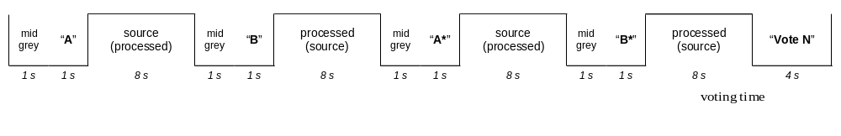 Figure 1: DSCQS basic test cell

Grading scale
The grading scale consists of two identical 10 cm graphical scales which are divided into five equal intervals with the following adjectives from top to bottom: Excellent, Good, Fair, Poor and Bad. ITU-R Rec. 500 recognizes the necessity to translate the adjectives into the language of the country where each test is performed, however it is also recognized that the use of different languages provides a slight bias due to the different meaning that each idiom gives to the translated terms. The scales are positioned in pairs to facilitate the assessment of the two sequences presented in a basic test cell. The leftmost scale is labeled “A” and the other scale “B”. To avoid loss of alignment between the votes and the basic test cells, each pair of scales is labeled with a progressive number; in this way the subjects have the opportunity to verify that they are expressing the current vote using the right pair of scales. The subject is asked to record his/her assessment by drawing a short horizontal line on the grading scale at the point that corresponds to their judgment. Figure 2, shown below, illustrates the DSCQS.
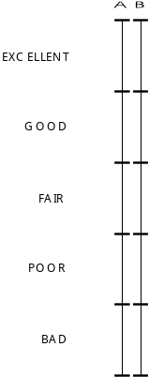

Figure 2: DSCQS grading scale.

Viewers
A total of 93 non-expert viewers participated in the subjective tests: 27 in the 625/50 Hz tests and 66 in the 525/60 Hz tests. Viewers were pre-screened for visual acuity, colorblindness, and contrast sensitivity.

DATA ANALYSIS

Subjective Data Analysis

Scaling Subjective Data
In the DSCQS a difference score is defined as the difference between the rating for the Reference sequence minus the rating for the Test sequence. The scale used by the viewers goes from 0 to 100. In this study, the raw difference score were rescaled to a 0-1 scale. Scaling was performed for each subject individually across all data points (i.e., SRCxHRC combinations). A scaled rating was calculated as follows
scaled rating = (raw difference score - Min) / (Max - Min )
where Max = largest raw difference score for that subject and Min = minimum raw difference score for that subject. Note that the Max difference corresponds to the poorest judged quality, and Min corresponds to the best judged quality. The purpose of this scaling was to further reduce uninformative variability.

Treating “inversions”
In the 625 data approximately 2% of the data were negative, i.e., the rating for the original version (i.e., Reference) of the stimulus was less than the rating for the processed version (i.e., Test). Thus, the difference score was negative. The question is how to treat data like that. We imposed the following rule: Estimate what the “just noticeable difference” (JND) is for the data in question; for negative ratings that fall within two JND’s, assume the data come from subjects making an imperfect discrimination, but not an outright mistake. Allow those data to remain negative. For negatives falling outside the estimated 2-JND bound, consider the data to be errors and convert the data point via the absolute value transformation. We took the JND to be about 0.1 on the 0-1 scale because the RMS error in the subjective judgments is about 0.1 on that scale.
The net difference between this dataset and the previous 625 data is the inclusion of 34 values between 0 and -0.2. The effect of this new treatment of the negative differences was small for the correlations, but was larger for metrics 3 and 5. The practical results of the adjustment were very small. The correlation of the 625 DMOS values before and after implementation of the “inversions” rule was 0.999.

Eliminating subjects
Section 2.3.1 of ITU-T Recommendation BT.500-10 [3] recommends using the stated procedure for eliminating subjects on the basis of extreme scores only for sample sizes less than 20: (section 2.3.1, Note 1 “.... Moreover, use of the procedure should be restricted to cases in which there are relatively few observers (e.g., fewer than 20), all of whom are non-experts.” Both the 525 and 625 samples were comfortably larger than 20.
In addition, data were collected from six subjects in the VZ lab who had not passed both the eye examinations (acuity and color). The data for these subjects were averaged, the data for the complying VZ subjects were averaged, and a variable “eyes” was constructed for ANOVA. Scores for the non-complying subjects were no different from data of the complying subjects. That is, the “eyes” variable and the eyes∗stimulus variable were both non-significant and the F statistics were very close to 1.0. Therefore, the data from all subjects were pooled for subsequent analyses.

Objective Data Analysis
4.2.1 Verification of the objective data
In order to prevent tuning of the models, the independent laboratory group (ILG) verified the objective data submitted by each proponent. This was done at CRC. Verification was performed on a random 12-sequence subset (approximately20% of sequences each in 50 Hz and 60 Hz formats) selected by the independent laboratories. The identities of the verified sequences were not disclosed to the proponents. The ILG verified that their calculated values were within 0.1% of the corresponding values submitted by the proponents.
4.2.2 Methodology for the Evaluation of Objective Model Performance
Performance of the objective models was evaluated with respect to three aspects of their ability to estimate subjective assessment of video quality:
- prediction accuracy – the ability to predict the subjective quality ratings with low error,
- prediction monotonicity – the degree to which the model’s predictions agree with the relative magnitudes of subjective quality ratings and
- prediction consistency – the degree to which the model maintains prediction accuracy over the range of video test sequences, i.e., that its response is robust with respect to a variety of video impairments.
These attributes were evaluated through 7 performance metrics specified in the objective test plan, and are discussed below.
The outputs by the objective video quality model (the Video Quality Rating, VQR) should be correlated with the viewer Difference Mean Opinion Scores (DMOS’s) in a predictable and repeatable fashion. The relationship between predicted VQR and DMOS need not be linear as subjective testing can have nonlinear quality rating compression at the extremes of the test range. It is not the linearity of the relationship that is critical, but the stability of the relationship and a data set’s error-variance from the relationship that determine predictive usefulness. To remove any nonlinearity due to the subjective rating process and to facilitate comparison of the models in a common analysis space, the relationship between each model’s predictions and the subjective ratings was estimated using a nonlinear regression between the model’s set of VQR’s and the corresponding DMOS’s.
The nonlinear regression was fitted to the [DMOS,VQR] data set and restricted to be monotonic over the range of VQR’s. The following logistic function was used:
DMOS_{p} = b1 / ( 1 + exp( - b2∗(VQR-b3) ) )
fitted to the data [DMOS,VQR].
The nonlinear regression function was used to transform the set of VQR values to a set of predicted MOS values, DMOS_{p}, which were then compared with the actual DMOS values from the subjective tests.
Once the nonlinear transformation was applied, the objective model’s prediction performance was then evaluated by computing various metrics on the actual sets of subjectively measured DMOS and the predicted DMOS_{p}.
The Test Plan mandates six metrics of the correspondence between a video quality metric (VQM) and the subjective data (DMOS). In addition, it requires checks of the quality of the subjective data. The Test Plan does not mandate statistical tests of the difference between different VQMs’ fit to DMOS.
Metrics relating to Prediction Accuracy of a model
Metric 1: The Pearson linear correlation coefficient between DMOS_{p} and DMOS.
Metrics relating to Prediction Monotonicity of a model
Metric 2: Spearman rank order correlation coefficient between DMOS_{p} and DMOS.
VQR performance was assessed by correlating subjective scores and corresponding VQR predicted scores after the subjective data were averaged over subjects yielding 64 means for the 64 HRC-SRC combinations.
The Spearman correlation and the Pearson correlation and all other statistics were calculated across all 64 HRC/SRC data simultaneously. In particular, these correlations were not calculated separately for individual SRCs or for individual HRCs. The algorithms for calculating correlations in the SAS statistical package we used conform to standard textbook definitions.
Metrics relating to Prediction Consistency of a model
Metric 3: Outlier Ratio of “outlier-points” to total points N.

Outlier Ratio = (total number of outliers)/N
where an outlier is a point for which: ABS[ Qerror[i] ] > 2∗DMOSStandardError[i].
Twice the DMOS Standard Error was used as the threshold for defining an outlier point.
Metric 4, 5, 6: These metrics were evaluated based on the method described in T1.TR.PP.72-2001 (“Methodological Framework for Specifying Accuracy and Cross-Calibration of Video Quality Metrics”)
4. RMS Error,
5. Resolving Power, and
6. Classification Errors
Note that evaluation of models using this method omitted the cross-calibration procedure described therein, as it is not relevant to measures of performance of individual models.

Supplementary analyses
Analyses of variance (ANOVA) have been added to those mandated by the Test Plan.
- An ANOVA of the subjective rating data alone shows the amount of noise in the data and shows whether the HRCs and SRCs had an effect on the subjective responses (as they should).
- Each SRC can be characterized by the amount of variance in subjective judgment across HRCs - this measures an SRC's ability to discriminate among HRCs. (The famous Mobile and Calendar discriminates among HRCs.)
- An "optimal model" of the subjective data can be defined to provide a quantitative upper limit on the fit that any objective model could achieve with the given subjective data. The optimal model defines what a "good fit" is.
Comparing residual variances from ANOVAs of the VQMs is an alternative to comparing correlations of VQMs with the subjective data that may yield finer discriminations among the VQMs.
Also, a supplementary metric (Metric 7) was added to the analyses. This metric was not mandated by the plan, but was included because it was deemed to be a more informative measure of the prediction accuracy of a model. The metric is an F-test [4] of the residual error of a model versus the residual error of an “optimal model”. The metric is explained in more detail in Section 4.6.
We considered the possibility of doing an F-test of the aggregated 525 and 625 results. This issue generated considerable discussion. Finally, an analysis variance of the patterns of results for the 525 and 625 data (e.g., see Fig. 21, p. 38) showed that the patterns were significantly different from each other. Therefore the conservative conclusion was that we could not assume the 525 and 625 experiments were functionally identical. Therefore we do not present analyses based on the aggregated data from these two sub-experiments.

Table 7. Summary of 525 Analyses

Line Number | Metric | A525 | D525 | E525 | F525 | G525 | H525 | PSNR525
1 | 1. Pearson correlation | 0.759 | 0.937 | 0.857 | 0.835 | 0.681 | 0.938 | 0.804
2 | 2. Spearman correlation | 0.767 | 0.934 | 0.875 | 0.814 | 0.699 | 0.936 | 0.811
3 | 3. Outlier ratio | 50/63=0.79 | 33/63=0.52 | 44/63 = 0.70 | 44/63 = 0.70 | 44/63 = 0.70 | 29/63=0.46 | 46/63=0.73
4 | 4. RMS error, 63 data points | 0.139 | 0.075 | 0.11 | 0.117 | 0.157 | 0.074 | 0.127
5 | 5. Resolving power, delta VQM  ( smaller is better) | 0.3438 | 0.2177 | 0.2718 | 0.3074 | 0.3331 | 0.2087 | 0.3125
6 | 6. Percentage of classification errors  (Minimum over delta VQM) | 0.3569 | 0.1889 | 0.2893 | 0.3113 | 0.4066 | 0.1848 | 0.3180
7 | 7. MSE model/MSE optimal model | 1.955 | 1.262 | 1.59 | 1.68 | 2.218 | 1.256 | 1.795
8 | F = MSE model/MSE Proponent H | 1.557 | 1.005 | 1.266 | 1.338 | 1.766 | 1 | 1.429
9 | MSE model, 4219 data points | 0.0375 | 0.02421 | 0.03049 | 0.03223 | 0.04255 | 0.02409 | 0.03442
10 | MSE optimal model, 4219 data points | 0.01918 | 0.01918 | 0.01918 | 0.01918 | 0.01918 | 0.01918 | 0.01918
11 | MSE model, 63 data points | 0.01936 | 0.00559 | 0.01212 | 0.01365 | 0.02456 | 0.00548 | 0.01619
12 | F= MSE63 model / MSE63 Prop H | 3.533 | 1.02 | 2.212 | 2.491 | 4.482 | 1 | 2.954
Note 1: Metrics 5 and 6 were computed using the Matlab® code published in T1.TR.72-2001.
Note 2: Metric 5 estimated by eye from scatter plots in output documents.
Note 3: Values of metric 7 smaller than 1.07 indicate the model is not reliably different from the optimal model.
Note 4: Values in line 8 larger than 1.07 indicate the model has significantly larger residuals than the top proponent model, H in this case.
Note 5: Values in line 12 larger than 1.81 indicate the model has significantly larger residuals than the top proponent model, H in this case.

Table 8. Summary of 625 Analyses

Line Number | Metric | A625 | D625 | E625 | F625 | G625 | H625 | PSNR625
1 | 1. Pearson correlation | 0.884 | 0.779 | 0.87 | 0.898 | 0.703 | 0.886 | 0.733
2 | 2. Spearman correlation | 0.89 | 0.758 | 0.866 | 0.883 | 0.712 | 0.879 | 0.74
3 | 3. Outlier ratio | 18/64=0.28 | 28/64=0.44 | 24/64=0.38 | 21/64=0.33 | 34/64=0.53 | 20/64=0.31 | 30/64=0.47
4 | 4. RMS error, 64 data points | 0.084 | 0.113 | 0.089 | 0.079 | 0.128 | 0.083 | 0.122
5 | 5. Resolving power, delta VQM  ( smaller is better) | 0.277 | 0.321 | 0.281 | 0.270 | 0.389 | 0.267 | 0.313
6 | 6. Percentage of classification errors  (Minimum over delta VQM) | 0.207 | 0.305 | 0.232 | 0.204 | 0.352 | 0.199 | 0.342
7 | 7. MSE model/MSE null model | 1.345 | 1.652 | 1.39 | 1.303 | 1.848 | 1.339 | 1.773
8 | F = MSE model/MSE Proponent F | 1.033 | 1.268 | 1.067 | 1 | 1.418 | 1.028 | 1.361
9 | MSE model, 1728 data points | 0.02404 | 0.02953 | 0.02484 | 0.02328 | 0.03302 | 0.02393 | 0.03168
10 | MSE null model, 1728 data points | 0.01787 | 0.01787 | 0.01787 | 0.01787 | 0.01787 | 0.01787 | 0.01787
11 | MSE model, 64 data points | 0.00704 | 0.0127 | 0.00786 | 0.00625 | 0.01631 | 0.00693 | 0.01493
12 | F= MSE64 model / MSE64 Prop F | 1.126 | 2.032 | 1.258 | 1 | 2.61 | 1.109 | 2.389
Note 1: Metrics 5 and 6 were computed using the Matlab® code published in T1.TR.72-2001.
Note 2: Metric 5 estimated by eye from scatter plots in output documents.
Note 3: Values of metric 7 smaller than 1.12 indicate the model is not reliably different from the optimal model.
Note 4: Values in line 8 larger than 1.12 indicate the model has significantly larger residuals than the top proponent model, F in this case.
Note 5: In the case of the 625 data with 1728 observations, the critical value of the F statistic is 1.12.
Note 6: Values in line 12 larger than 1.81 indicate the model has significantly larger residuals than the top proponent model, F in this case.

Main results
The main results of FRTV2 are presented in Tables 7 and 8, one for the 525-line data and one for the 625-line data.
All seven metrics in the tables agree almost perfectly. A VQM that fits well under one metric fits well for all seven. A VQM that fits less well for one metric fits less well for all seven.
The ranking of the VQMs by the different metrics is essentially identical. Therefore, even the largest effect; the HRCs were deliberately chosen to span a large range of bit rates. The though the seven metrics provide somewhat different perspectives on the fit of a VQM to DMOS data, they are quite redundant. Redundancy can be useful, but it also can be expensive.
The results of the two tests (525 and 625) are similar but not identical. There were a few apparent changes in ranking from one experiment to the other. According to the formula for comparing correlations in "VQEG1 Final Report" (June, 2000, p. 29), correlations must differ by 0.35 to be different in the 525 data (with 66 subjects) and must differ by 0.55 to be different in the 625 data (with 28 subjects). By this criterion, all six VQMs in the 525 data perform equally well, and all VQMs in 625 data also perform equally well. Using the supplementary ANOVA analyses, the top two VQMs in the 525 test and the top four in the 625 test perform equally well and also better than the others in their respective tests.

Additional Results

Agreement of VZ and CRC results
Although CRC and Verizon lab procedures both complied with the Test Plan, they differed in detail. CRC used somewhat higher quality playback equipment, ran subjects in groups, and used university students as subjects. Verizon used older playback equipment, ran subjects singly, and used subjects chosen to represent a broad spectrum of consumers - they were not students and spanned the ages 20 to 75. How well do the data for these two parts of the 525 study agree? The average of the raw response data for each stimulus for the two labs correlates 0.97. This large correlation indicates that the response data were not noisy, in addition to being very similar across the two labs. In an ANOVA of the response data in which “Lab” was a variable, the “interaction” of Lab∗stimulus accounted for less than 1% of the variance in the responses.

Effect of HRC and SRC on subjective judgments
The VQEG members who designed the Phase II Test Plan expected the choice of HRCs and SRCs to have a very marked effect on subjective video quality. By analyzing the subjective judgments as a function of HRC and SRC, one can determine whether this expectation turned out to be true. It did.
The analysis of HRC and SRC effects on the DMOS response data must deal with the fact that HRCs and SRCs were chosen to be correlated with each other. Hard SRCs were paired with high bit rate HRCs and vice versa. To de-couple the effects of variables in an analysis, the designer of experiments usually arranges to have variables that are uncorrelated with each other. That means that high bit rate HRCs would have to be paired sometimes with easy SRCs, and hard SRCs would have to be paired with low bit rate HRCs. In the present case, it was felt that such pairings would be unrealistic and would provide very little information.
With uninformative pairings of SRCs and HRCs eliminated, the remaining set were correlated. Some analysis procedures are able to de-couple the effects of correlated variables, as long as they are not perfectly correlated. The General Linear Model (GLM) analysis procedure of SAS can be used for unbalanced and partially correlated experimental designs. The “Type III” sum of squares separates the uncorrelated component of the variables from their correlated component (see [2] pag.467).
For the 525 data, the variables HRC, SRC, and the HRC-SRC “interaction” were all highly significant and accounted for 73% of the variance in the raw subjective responses. HRC had HRC-SRC interaction was a small effect, but it means that some HRCs had particular trouble with certain SRCs, while other HRCs did not - even among the restricted set of HRCs and SRCs used in the test.
Results for the 625 data were nearly identical: HRC, SRC and the interaction were all significant. HRC again had the largest effect, the interaction the smallest effect, and together they (with the variable “Subject”) accounted for 73% of the variance in the raw response data.

Table 9. 525 SRCs measured by standard deviation of DMOS scores.

SRC (Scene) | Standard Deviation | HRC Mbit/s
Autumn leaves | 24.2 | 0.7 - 5.0
Football | 22.8 | 0.7 - 5.0
Betes pas betes | 21.8 | 0.7 - 5.0
Park fountain | 27.4 | 1.5 - 4.0
Paddle boat | 25.7 | 1.5 - 4.0
Bike race | 24.6 | 1.5 - 4.0
Soccer net | 13.1 | 1.5 - 4.0
Colour kitchen | 20.9 | 1.0 - 3.0
Water child | 18.7 | 1.0 - 3.0
Apollo | 18.4 | 1.0 - 3.0
1 Fish 2 Fish | 17.8 | 1.0 - 3.0
Woody | 17.6 | 1.0 - 3.0
Curious George | 16.8 | 1.0 - 3.0

Table 10. 625 SRCs measured by standard deviation of DMOS scores.

SRC (Scene) | Standard Deviation | HRC Mbit/s
M&C | 17.6 | 0.7 - 4.0
Canoa | 14.9 | 0.7 - 4.0
Rugby | 7.5 | 0.7 - 4.0
Husky | 10.4 | 2.5 - 4.0
Big show | 8.6 | 2.5 - 4.0
MC_2 | 4.8 | 2.5 - 4.0
Guitar | 2.3 | 2.5 - 4.0
Dancers | 16.7 | 1.0 - 4.0
Volley | 15.8 | 1.0 - 4.0
Goal | 15.8 | 1.0 - 4.0
Comics | 14.1 | 1.0 - 4.0
New York | 12.9 | 1.0 - 4.0
Universal | 8.2 | 1.0 - 4.0

A measure of SRC ability to discriminate among HRCs
The mark of a good SRC is that it looks different depending on which HRC processes it. The present data provide a well-defined measure of exactly this concept. Consider the DMOS values in Tables 13 and 14, Appendix V. Any SRC is represented by a row. The amount of variation in the DMOS values in a row is attributed to HRC differences, and to differential effects of SRCs on HRCs. If the amount of variation in the DMOS values within a row were the same for each row, then the SRCs would have equal power to discriminate among HRCs. We compute the amount of variation of the values within each row and observe whether the SRCs are indeed equal. (The significant SRC-HRC interaction in the analysis above shows that the amount of variation within each row is not equal.)
In Table 9 it appears that the SRC “Soccer net” does less well in discriminating among HRCs than the other SRCs in its group. In Table 10 the SRCs “Rugby,” “MC_2,” and “Guitar” seem less discriminating than the other SRCs in their respective groups.

Scatter Plots
Figures 3-14 depict the scatter plots of DMOS versus VQR for all proponent models. The confidence intervals are also shown on these graphs. Outlier points (as defined by metric 3) are plotted with a red confidence interval. Figures 3-8 correspond to the 525 test, while Figures 9-14 correspond to the 625 test.
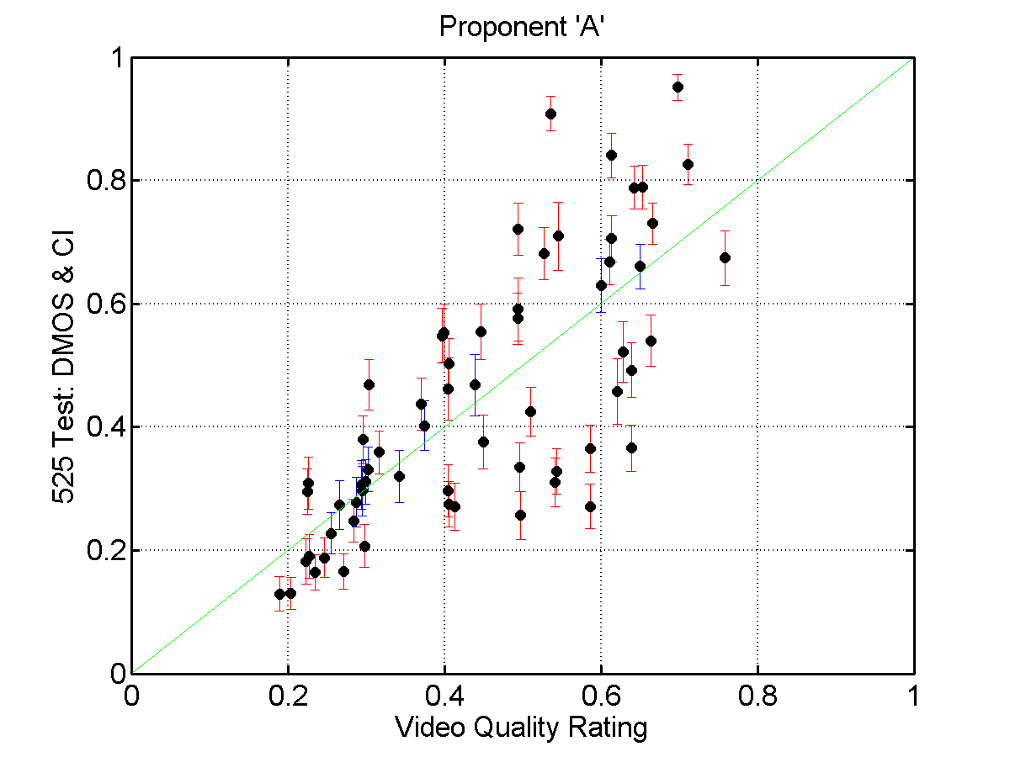
Figure 3: 525Test - DMOS & CI versus VQR (Proponent ‘A’)
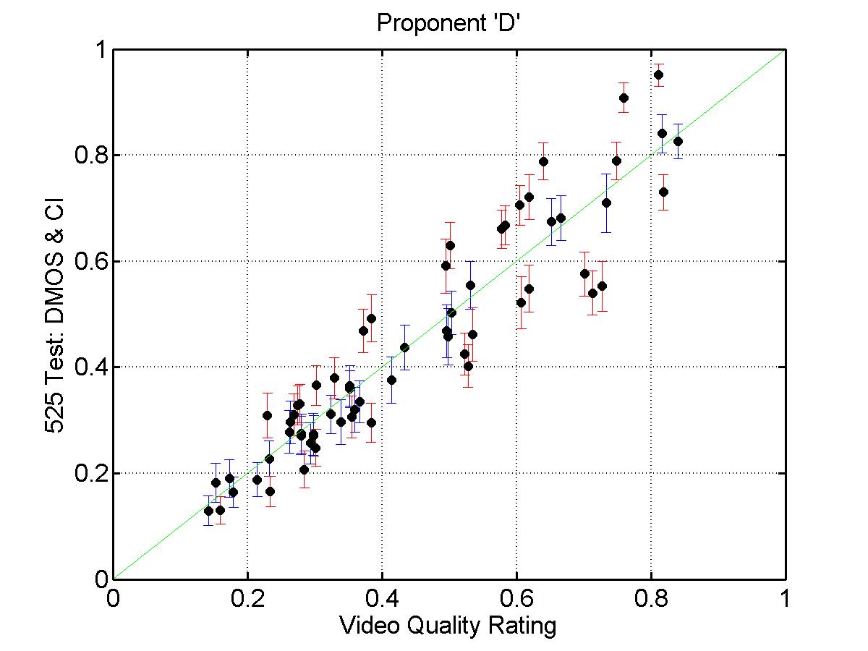
Figure 4: 525Test - DMOS & CI versus VQR (Proponent ‘D’)

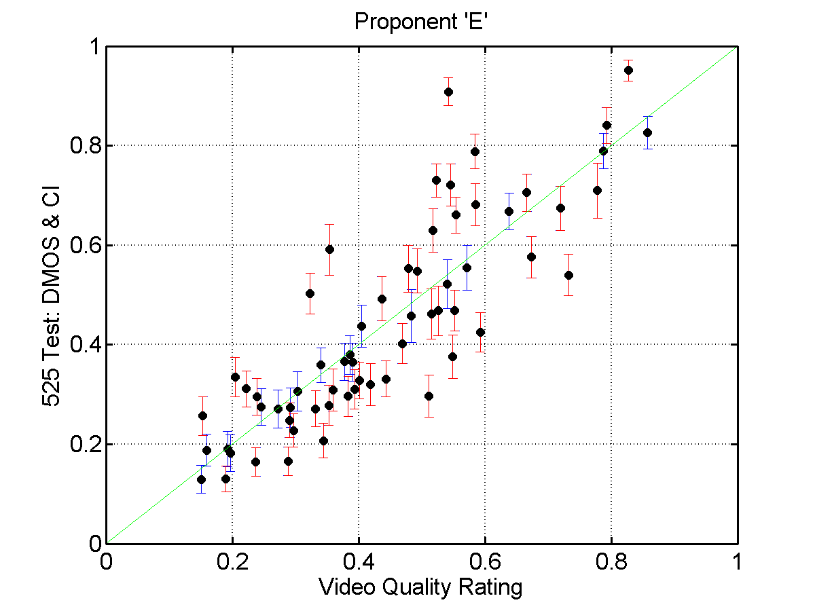
Figure 5: 525Test - DMOS & CI versus VQR (Proponent ‘E’)
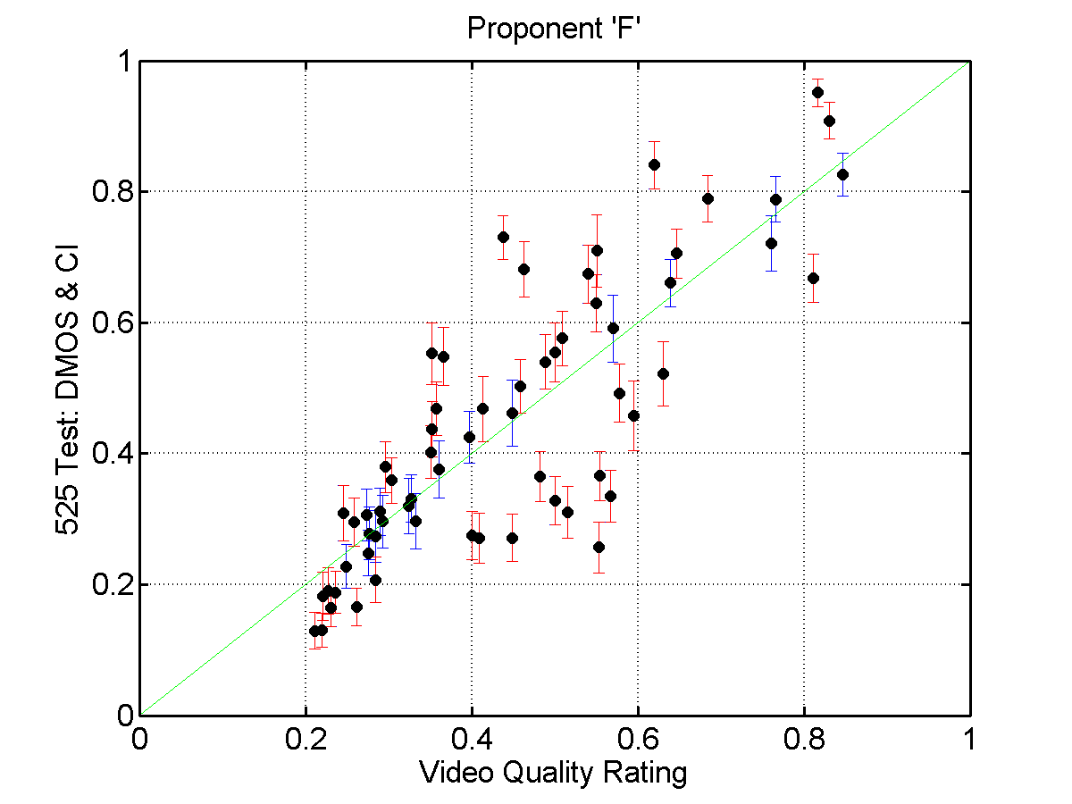
Figure 6: 525Test - DMOS & CI versus VQR (Proponent ‘F’)
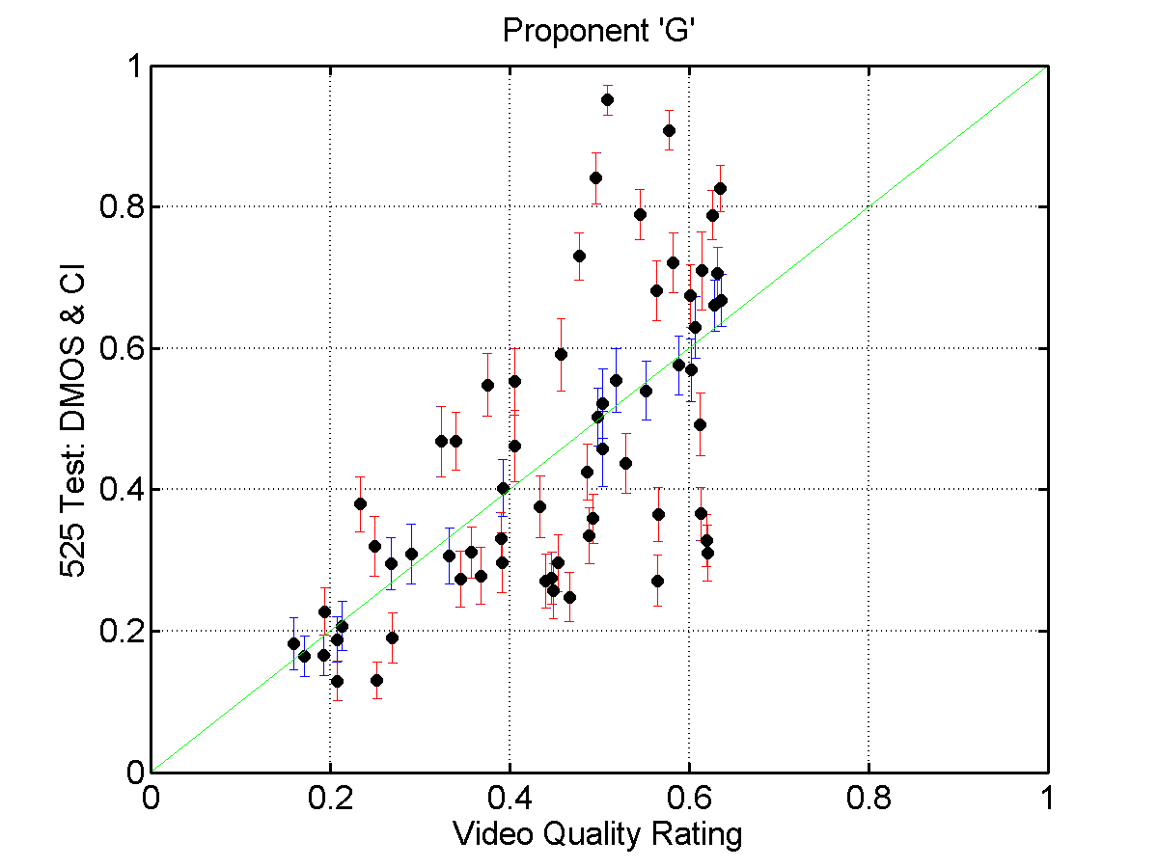
Figure 7: 525Test - DMOS & CI versus VQR (Proponent ‘G’)
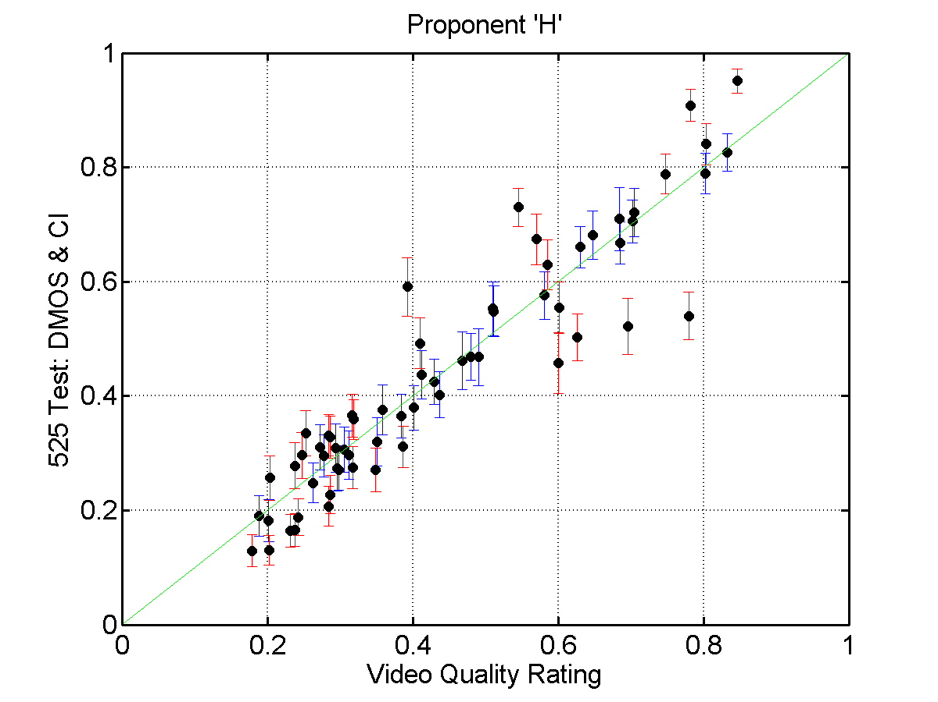
Figure 8: 525Test - DMOS & CI versus VQR (Proponent ‘H’)
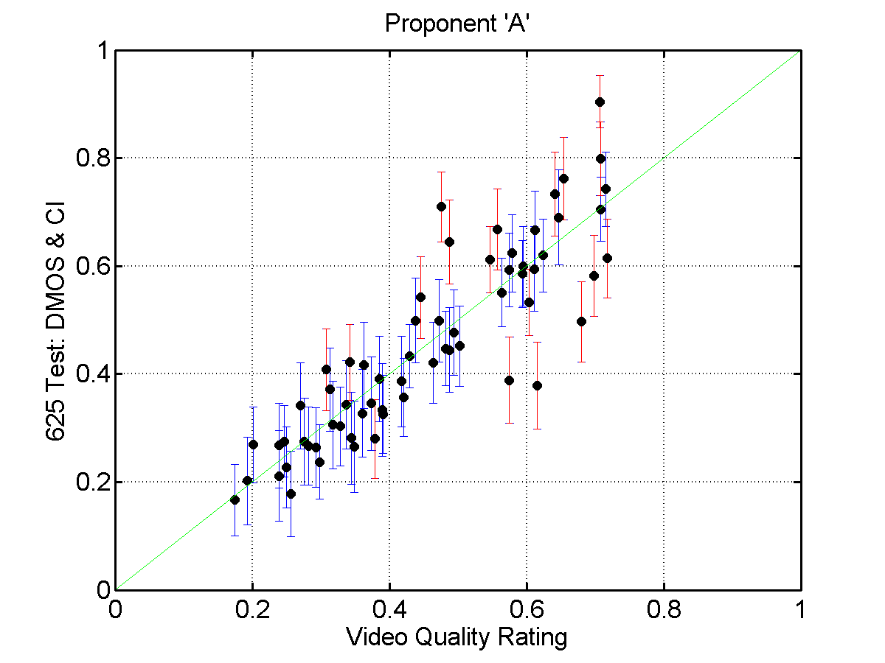
Figure 9: 625Test - DMOS & CI versus VQR (Proponent ‘A’)
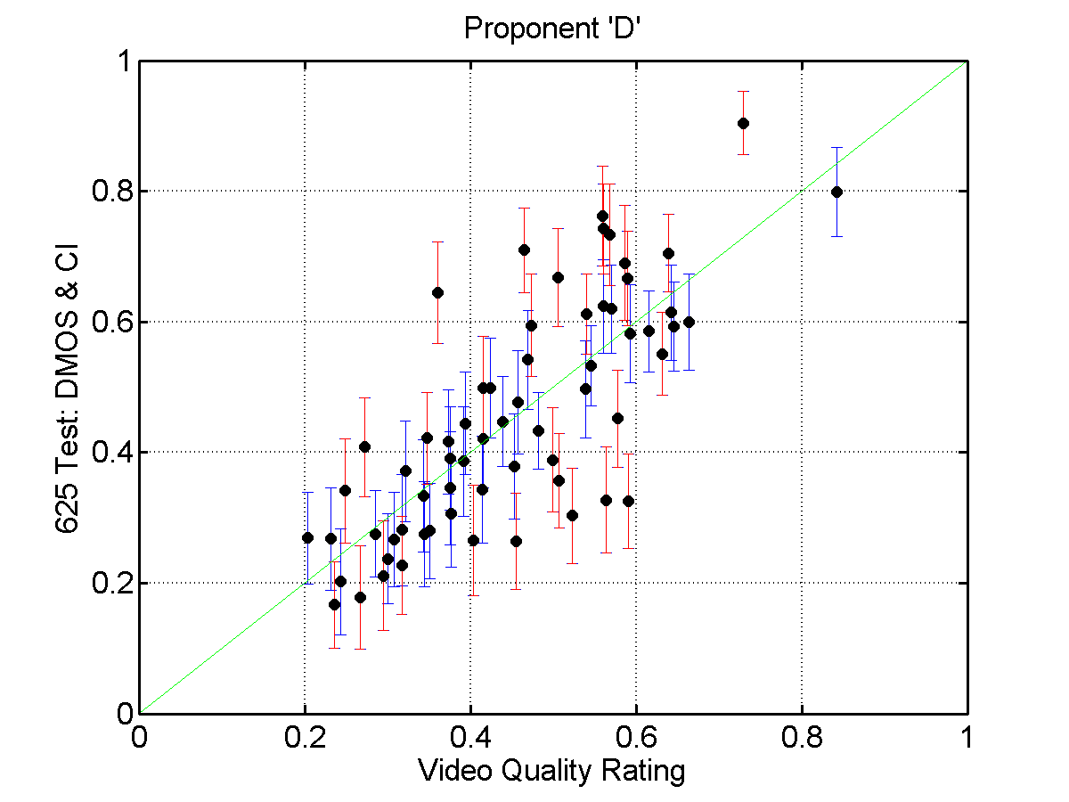
Figure 10: 625Test - DMOS & CI versus VQR (Proponent ‘D’)

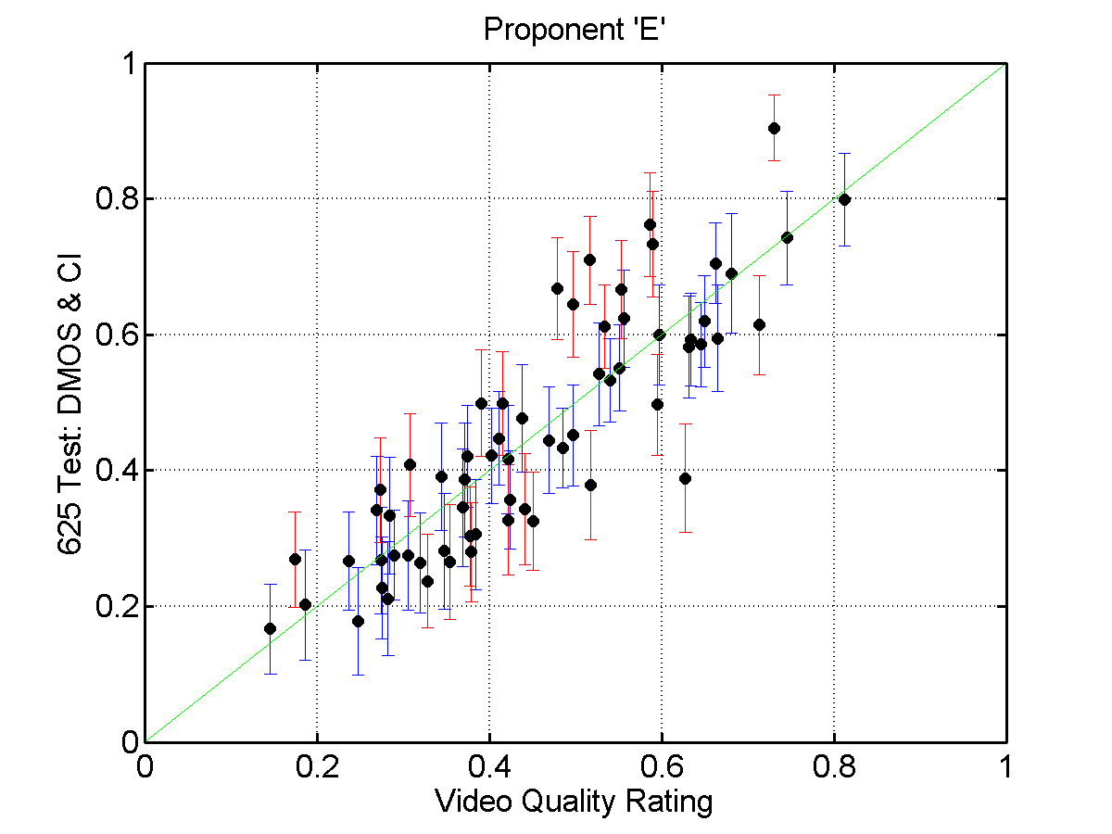
Figure 11: 625Test - DMOS & CI versus VQR (Proponent ‘E’)

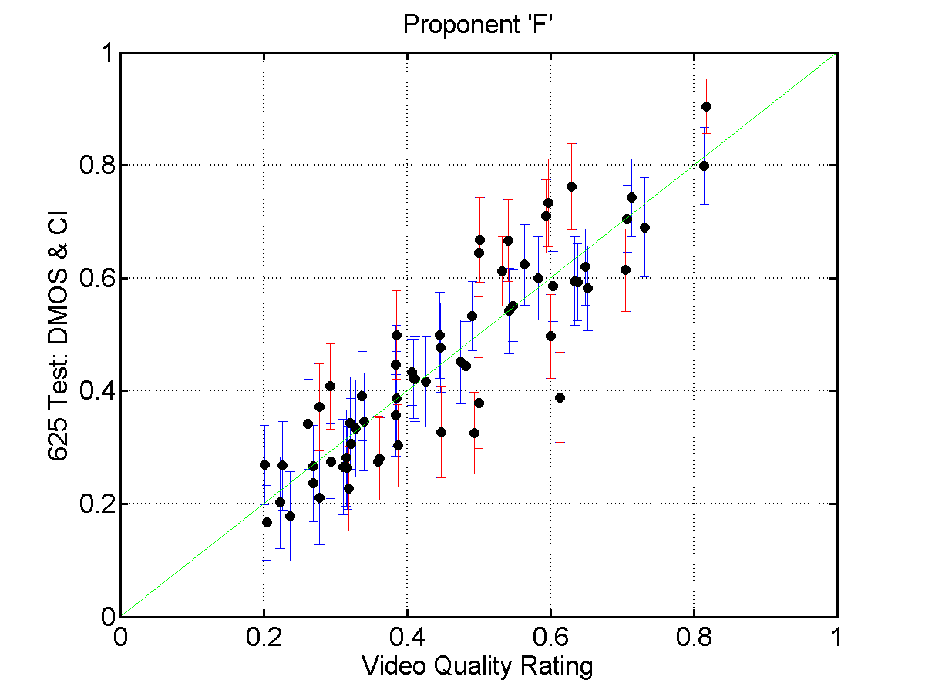
Figure 12: 625Test - DMOS & CI versus VQR (Proponent ‘F’)

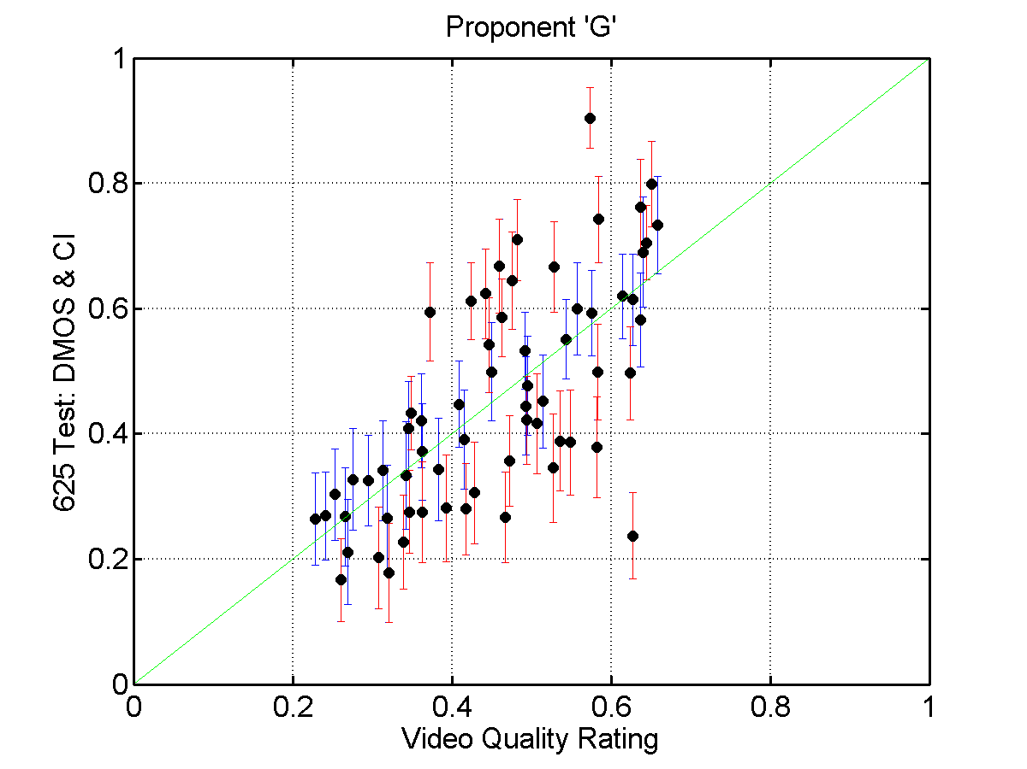
Figure 13: 625Test - DMOS & CI versus VQR (Proponent ‘G’)
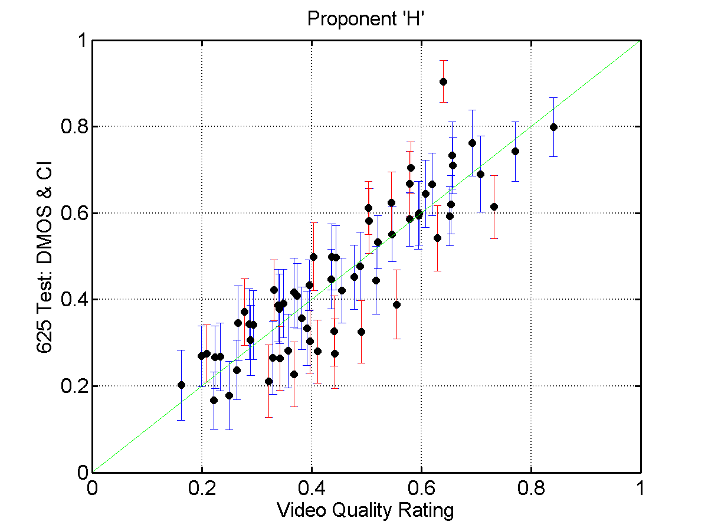
Figure 14: 625Test - DMOS & CI versus VQR (Proponent ‘H’)

PSNR Data
The peak signal to noise ratio, PSNR, is a simple video quality metric. The performance of the VQM’s can be compared to the performance of PSNR. Initial results for PSNR were performed by BT, NTIA and Yonsei, using different registration algorithms. Table 11 shows the Pearson correlation matrix for the 525 and 625 tests. These results show that the correlations of the PSNR measures are lower than the best models for both 525 and 625. Figures 15-20 show the scatter plots for the DMOS versus PSNR using the results calculated by BT, NTIA and Yonsei. Figures 15-18 correspond to the 525 test, while Figures 15-20 correspond to the 625 test.

Table 11. PEARSON CORRELATION MATRIX
 | 625 |  |  | 525
 | NTIA PSNR | BT PSNR | Yonsei PSNR | NTIA PSNR | BT PSNR | Yonsei PSNR
NTIA PSNR
BT PSNR | 0.954 |  |  | 0.760
Yonsei PSNR | 0.998 | 0.952 |  | 0.948 | 0.764
DMOS | -0.707 | -0.707 | -0.720 | -0.699 | -0.613 | -0.785
Notes:
All PSNR values are calculated using only the Y-channel.
BT and Yonsei used 255 as peak Y signal.
NTIA used 235 as peak Y signal.

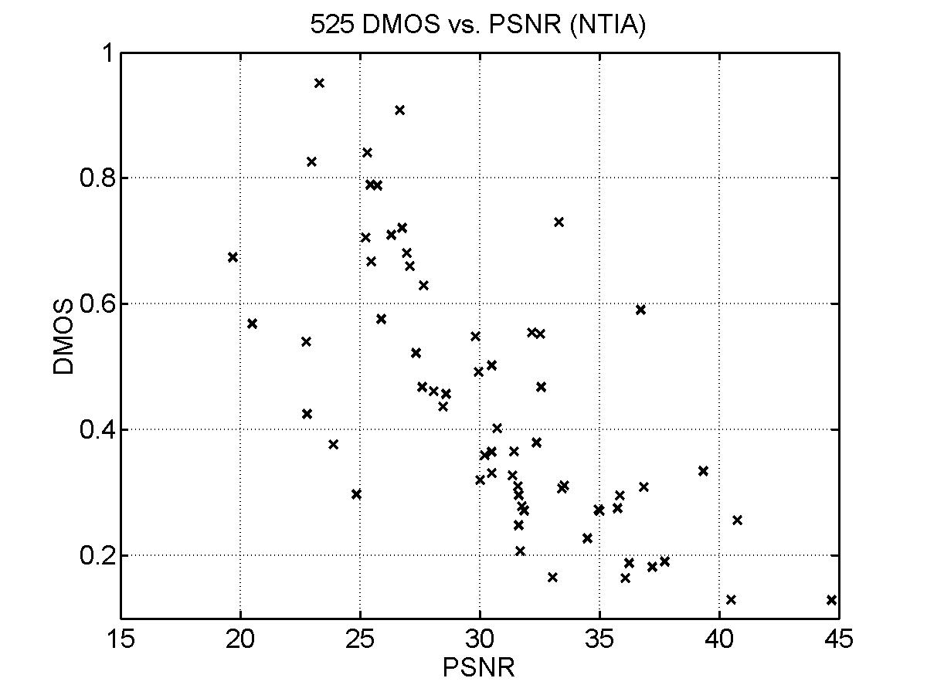
Figure 15: 525Test - DMOS versus PSNR (results from NTIA)

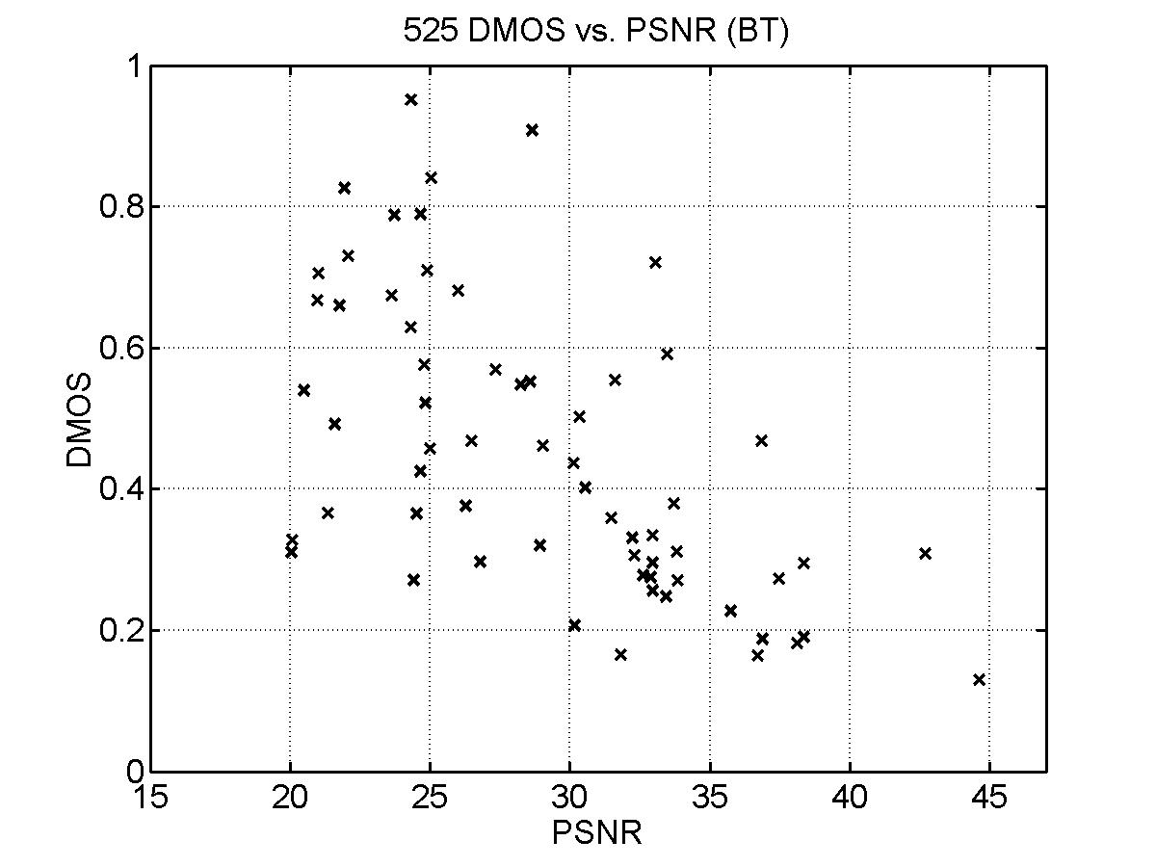
Figure 16: 525Test - DMOS versus PSNR (results from BT)
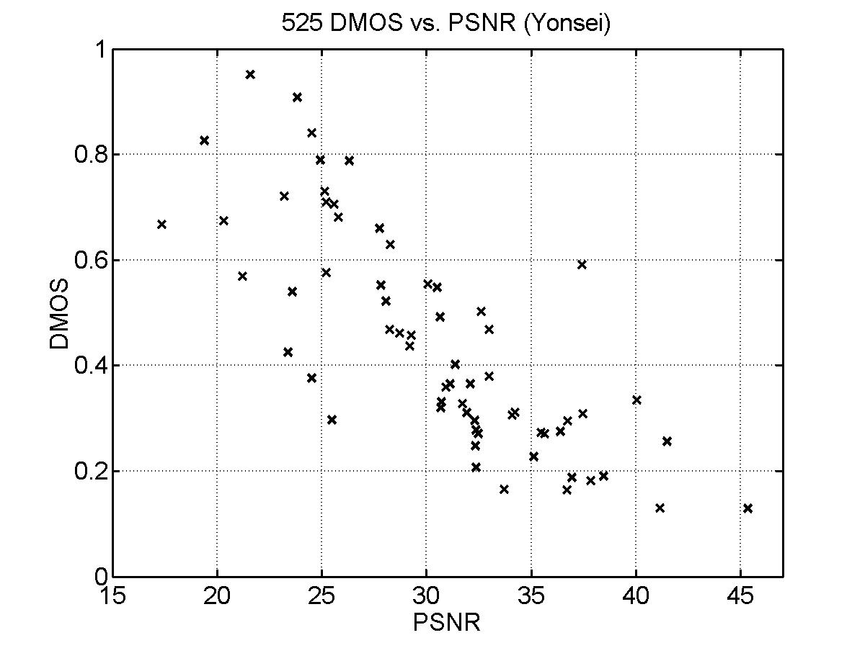
Figure 17: 525Test - DMOS versus PSNR (results from Yonsei)

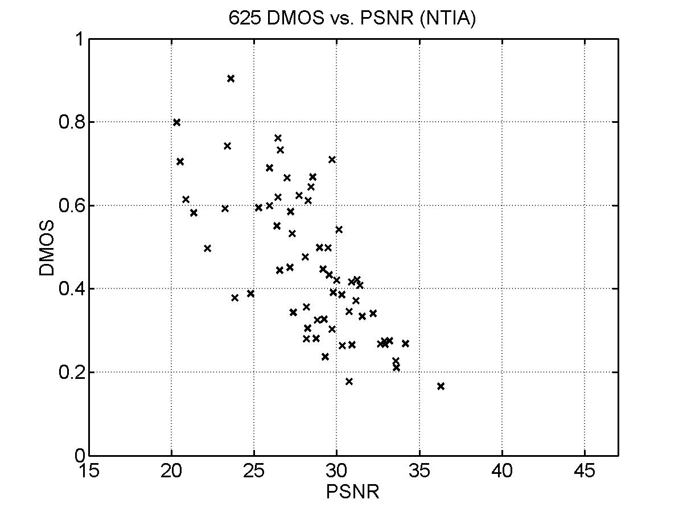
Figure 18: 625Test - DMOS versus PSNR (results from NTIA)
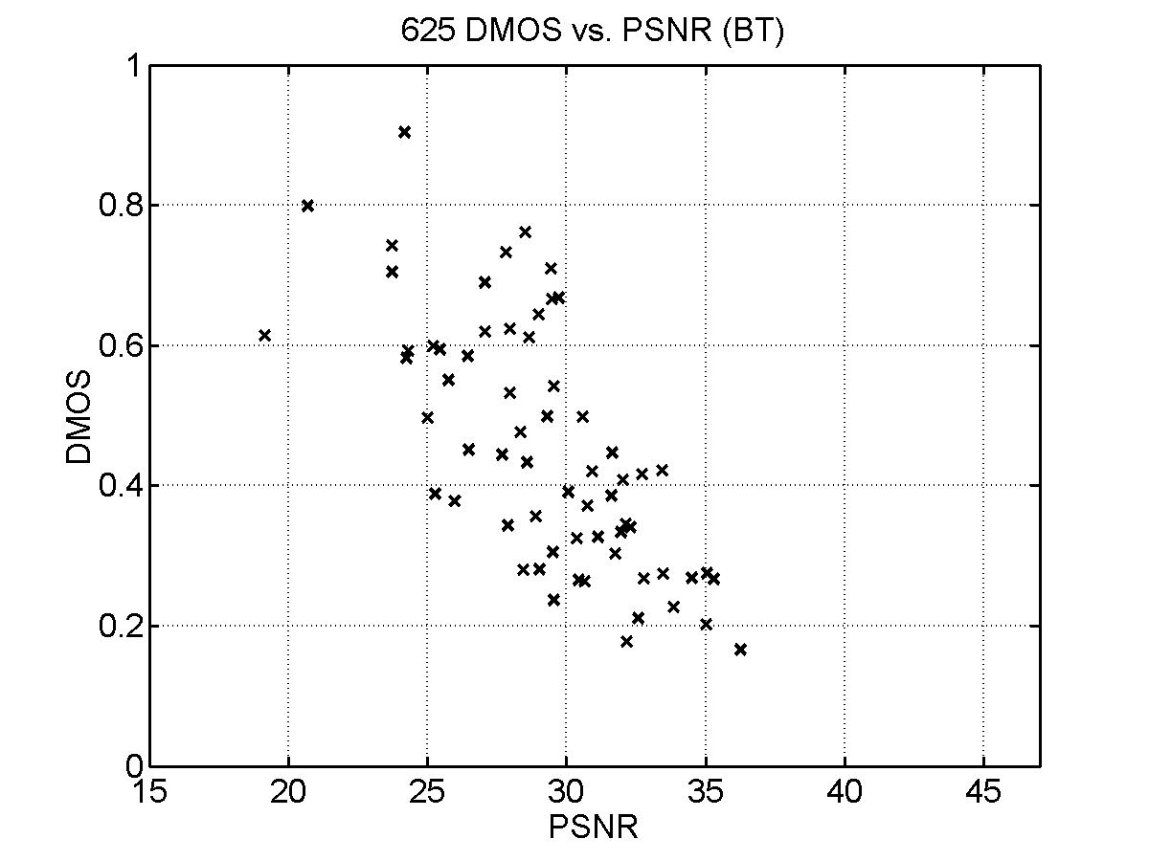
Figure 19: 625Test - DMOS versus PSNR (results from BT)
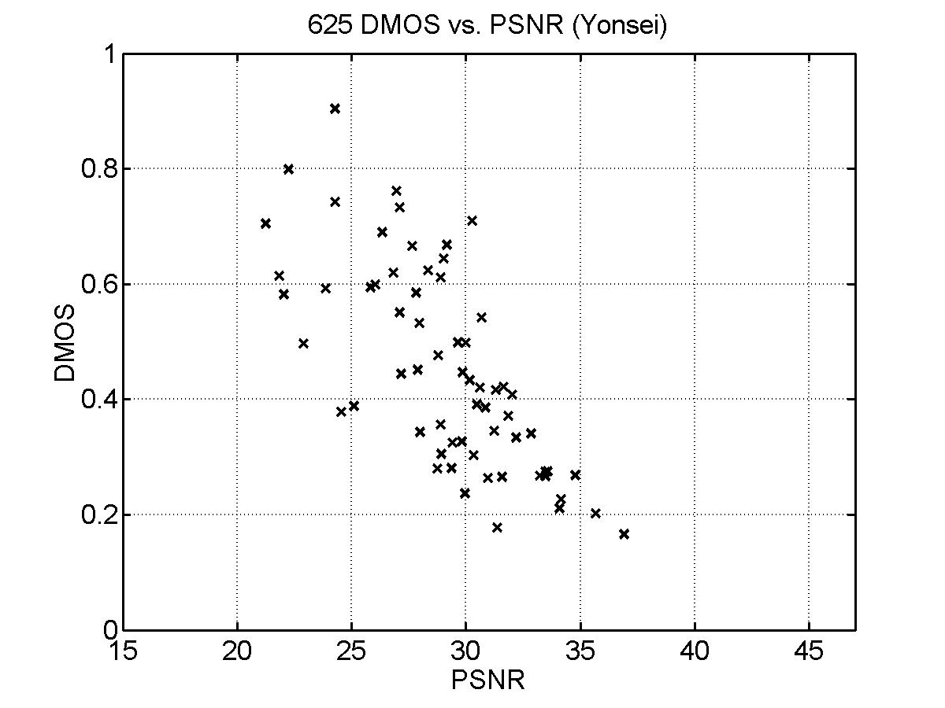
Figure 20: 625Test - DMOS versus PSNR (results from Yonsei)

Testing differences between models by comparing correlations vs. F-test

Correlation
The fit metrics for the various models in Tables 7 and 8 appear to show differences among the models. Which of the differences are statistically significant? A test for differences between correlation coefficients was suggested in the Phase 1 Final Report (p. 29). The sensitivity of this test statistic depends on the size of the sample of observations or subjects, N - which is true of many statistics. For two correlations, both based on 66 subjects, the test for the difference is
sigma(R1 - R2) = SQRT ( 1/63 + 1/63) = 0.178 (see [4] pag. 532).
For 27 subjects, the sigma is SQRT (1/24 + 1/24) = 0.289.
Usually differences of two sigmas are taken as significant. Thus, the correlations in tables 7 and 8 must differ by very large amounts to be considered significant.

F-tests based on individual ratings
Another approach to testing significance of differences uses the idea of an optimal model and the F-tests used in analysis of variance. An optimal model would predict each of the DMOS values for the 64 stimuli exactly. The residual differences of individual subjects’ ratings from the 64 DMOS scores cannot be predicted by any objective model. (An objective model makes one prediction for an HRC-SRC combination, yet there are 66 possibly different subjects’ ratings for that same combination.) This residual is the baseline against which any objective model is tested.
The optimal model is also a “null” model in the sense that it uses no information about an HRC-SRC combination (or “stimulus”) except that it is different from the others. The null model achieves its optimal fit to the subjective data by not doing any predicting at all: The mean rating for the particular stimulus is what the null model “predicts.”
When an objective model is tested against the individual subjective responses, a residual variance is obtained (line 9 of Tables 7 and 8). When the “null” model: Response = Stimulus is computed, the residual variance is calculated around the mean or DMOS for each stimulus. Here, stimulus is just an identifier variable, with one degree of freedom for each HRC-SRC combination. The residual for the null model is the baseline minimal residual. It is given in line 10. The ratio of these two residual variances is an F statistic, which is Metric 7. Considering the distribution of the F statistic, values of F smaller than about 1.07 indicate that a model is not statistically different from the null or optimal model (for the 525-line data set with 4219 data points). None of the objective models meet this strict criterion.
Similarly, the fits of two objective models can be compared by taking the ratios of their residual variances. Two models whose residuals form a ratio of greater than 1.07 are statistically different for the 525 data set. Comparing each model to the one with the smallest residual in Table 7, the model of proponent H is tied with the model of proponent D (line 8 of Table 7).
The reason the F-test is able to discriminate between model performances better than when one compares correlation coefficients is that the F-test directly makes use of the number of stimuli as well as the number of subjects; the correlation sensitivity test depends only on the number of subjects.

An F-test based on averaged ratings, DMOS
Each objective model also has a residual when predicting the 64 DMOS values (which are also the optimal model or null model). These residuals can also be compared using an F-test. In this case, the “degrees of freedom” in the test are 63 and 63, rather than 4218 and 4218. The F value required for significance at the 1% level for (63, 63) is 1.81 - which is much looser than with the larger number of degrees of freedom. On the other hand, the 64 data points are themselves not very noisy. So, this could be a reasonable test. Line 12 shows this test for each model against the model with the smallest residual. Results are the same as those for the 4219 individual data points (line 8). This test unequivocally meets the assumption of normality, so might be taken as more persuasive than the test with 4218 data points (see below).

Model assumptions for F-test
The F-test assumes that the residuals come from a “normal” Gaussian distribution. That assumption is tested as part of the analysis for each model. The SAS analysis software reports different statistics depending on the size of the dataset, and it happens that the 625 and 525 datasets fall on opposite sides of the dividing line (2000 data points).
As an example, the analysis of model E for the 625 data reports the Shapiro-Wilks statistic W for the residual of the optimal model as 0.989, with an associated probability of 0.763. Larger values of W indicate a closer approximation to a normal distribution, and this residual is very likely to have come from a normal distribution. W is defined so it lies between 0 and 1. The reported W for the residual of model E is 0.985, which is declared to be not from a normal distribution - but from the size of the statistic, obviously the residual could not be very far from normal.
For the larger 525 dataset, SAS reports the Kolmogorov D statistic, which can range over 0-1, with smaller values indicating good fit to a target distribution, in this case the normal distribution. For the null model, the statistic is 0.024, which for 4219 data points is enough to declare the distribution not normal. For model E the statistic is 0.021, also declared not normal. The tests for normality of residuals from the individual rating data showed that four of the six 525 models and five of six of the 625 models were reliably non-normal - but were very close to being normal. However, tests for normality of residuals for the averaged DMOS data showed that all of the models for both 525 and 625 data had normal residuals. It is well known that when there are large numbers of data points it is easy to reject a model, such as that the residuals come from a normal distribution. It is likely that the residuals for both the individual rating data and the DMOS data are normal, but the statistics only support normality for the relatively fewer DMOS data. Therefore the F-tests presented meet strict assumptions for the DMOS data, and are probably “close enough” for the larger sets of individual rating data.

Costs and benefits of the logistic transformation
For the 525 data, the correlations for the top three models improved by 0.003, 0.007, and 0.008 by including the logistic transformation rather than using the original VQM data. For the models that had correlations with DMOS of 0.7 or less the improvements were larger. For the 625 data, the four models with correlations greater than 0.8 (actually, greater than 0.87), the improvements in correlation by using the logistic transformation were 0.002, 0.011, 0.015, and 0.098. For the models with correlations less than 0.7, the improvements due to the logistic transformation tended to be larger.
That is, models that perform well tend to be nearly linear with respect to subjective data. Models that require a severely nonlinear transformation do improve, but that improvement does not get the models’ performance up to the level of the top models.
The cost of using the logistic transformation is complexity in the analysis and uncertainty about the result. The Test Plan (p. 20) originally called for a five-parameter logistic model (although the T1A1 data analysis report called for 4-parameter models, see p. 12). We began with the 5-parameter model in the test plan, found that it failed to converge, tried the 4-parameter model in the T1A1 report, found that it failed to converge, and ended with the 3-parameter model dmos1 = b1/(1 + exp(-b2∗(vqm - b3))). This model converges for all the sets of data, although it is not the “correct” model for all the data. The indicators of an incorrect model are that two or more parameters are highly correlated and that error bounds on parameters are very large. In such cases, using a 2-parameter model is indicated. However, we used three parameters on all models, so that no model would be “disadvantaged” by having fewer parameters in the transformation.
The logistic transformation is actually fitted with one of a family of nonlinear fitting procedures. The one used here is known as the “secant method” or “DUD” for “doesn’t use derivatives” (see SAS Proc NLIN). Generally, nonlinear fitting procedures do not find a single, optimal solution. They usually find “good” solutions, but they do not guarantee optimality, and they do not produce the same result if the input conditions change in some minor way, e.g., changing the initial parameter estimates. So, the results reported are not perfectly stable. If some of the other fitting methods are used that require the input of partial derivatives of the function with respect to each of the fitted parameters, the opportunities for errors are even greater.

CONCLUSIONS
The results of the two tests (525 and 625) are similar but not identical. There were a few apparent changes in ranking from one experiment to the other. According to the formula for comparing correlations in "VQEG1 Final Report" (June, 2000, p. 29), correlations must differ by 0.35 to be different in the 525 data (with 66 subjects) and must differ by 0.55 to be different in the 625 data (with 28 subjects). By this criterion, all six VQMs in the 525 data perform equally well, and all VQMs in 625 data also perform equally well. Using the supplementary ANOVA analyses, the top two VQMs in the 525 test and the top four in the 625 test perform equally well and also better than the others in their respective tests.
The Figure 21 shows the Pearson correlation coefficient for the six models that completed the test. This graph is offered to supply a simple display of the results. It should not be considered to imply that VQEG considers it the best statistic. Nevertheless, the rankings of the models based upon any of the seven metrics are similar but not identical.
Using the F test, finer discrimination between models can be achieved. From the F statistic, values of F smaller than about 1.07 indicate that a model is not statistically different from the null (theoretically perfect) model. No models are in this category. Models D and H performed statistically better than the other models in the 525 test and are statistically equivalent to each other.
For the 625 data (Table 8) the same test shows that no model is statistically equal to the null (theoretically perfect) model but four models are statistically equivalent to each other and are statistically better than the others. These models are A, E, F, and H.
PSNR was calculated by BT, Yonsei and NTIA. The PSNR results from Yonsei were analyzed using the same metrics used with the proponent models. For both the 525 and 625 data sets, the PSNR model fit significantly worse than the best models. It is very likely that the same conclusions would hold for PSNR calculated by other proponents.

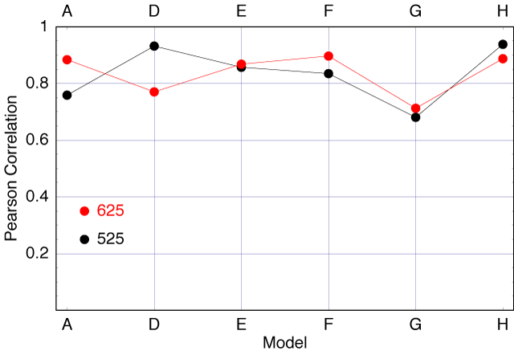
Figure 21: Pearson correlation coefficient for the six models.

REFERENCES
[1] ITU-T Study Group 9 Contribution 80, Final Report from the Video Quality Experts Group on the Validation of Objective Models of Video Quality, June 2000.
[2] SAS Institute Inc., SAS User’s Guide: Statistics, Version 5 Edition. Cary, NC: SAS Institute Inc., 1985.
[3] ITU-T Recommendation BT.500-10, Methodology for the Subjective Assessment of the Quality of Television Pictures, 2000.
[4] William L. Hays, Statistics for Psychologists, New York: Holt, Rinehart and Winston, 1963.
[5] ATIS Technical Report T1.TR.72-2001, Methodological Framework for Specifying Accuracy and Cross-Calibration of Video Quality Metrics, Alliance for Telecommunications Industry Solutions, 1200 G Street, NWn Suite 500, Washington DC, October 2001.

- Definition of Terms (Glossary)

ANOVA Analyses of variance
ARD Arbeitsgemeinschaft der öffentlichen Rundfunkanstalten der Bundesrepublik Deutschland (Federal German Public Broadcasting Association)
BT British Telecom
CBC Canadian Broadcasting Corporation
CCETT Centre Commun d’Études de Télédiffusion et de Télécommunication
CDTV Canadian Digital Television
CIF Common Intermediate Format (352 pixels x 288 lines)
Clip Digital representation of a video sequence that is stored on computer medium.
CPqD Centro de Pesquisa e Desenvolvimento
CRC Communications Research Center
DMOS Difference Mean Opinion Scores, difference mean opinion score between a mean opinion score for a source video data and a mean opinion score for the processed video data.
DSCQS The Double Stimulus Continuous Quality Scale method of ITU-R Rec. BT.500-10
Executable Model Realization of a model as computer program or computer system.
FR-TV Full Reference Television
FUB Fondazione Ugo Bordoni
GLM General Linear Model
H.263 Abbreviation for ITU-T Recommendation H.263
ILG Independent Lab Group
JND Just Noticeable Difference
kbit/s Kilobits per second
HRC Hypothetical Reference Circuits: the system under test, or classes of test conditions
Mbit/s Megabits per second
Model Algorithm to estimate a DMOS
MPEG Moving Pictures Expert Group, a working group of ISO / IEC in charge of the development of standards for coded representations of digital audio and video (e.g., MPEG2).
NASA National Aeronautics and Space Administration
NTIA National Telecommunication and Information Administration
NTSC National Television System Committee. The 525-line analog color video composite system adopted by the US and most other countries (excluding Europe).
PAL Phase-Altering Line. The 625-line analog color video composite adopted predominantly in Europe, with the exception of a few other countries in the world.
PSNR Peak Signal-to-Noise Ratio
PVS Processed Video Sequence
R&S Rohde & Schwarz
RAI Radio Televisione Italiana
Rec. 601 Abbreviation for the ITU-R Recommendation BT.601, a common 8-bit video sampling standard
SAS® A statistical analysis software package, a product of the SAS Institute, Inc. Version 6.1
Scene A sequence of video frames.
Sequence Digital representation of contiguous video frames that is stored on computer medium.
SRC Source: the source video sequence.
SWR Südwestrundfunk (Federal German Public Broadcasting Station)
UCSB University of California Santa Barbara
VQEG Video Quality Experts Group
VQM Video Quality Metric, or Video Quality Model
VQR Video Quality Rating: Result of execution of an executable model, which is expected to be estimation of the DMOS corresponding to a pair of video data

- Model Descriptions
Note: The model descriptions are not endorsed by VQEG. They are presented in this Appendix so that the Proponents can describe their respective models and should not be quoted out of this context.
  - Proponent A, NASA
The NASA model, referred to here as VSO (Video Standard Observer), was designed as a minimal model requiring very little computation and no training whatsoever.
Offsets between reference and test sequences were estimated based on a few early frames, and test and reference were then registered. The sequences were converted to contrast, and subtracted. The difference sequence is filtered by a spatial filter derived from previous research on spatial contrast sensitivity. The filtered difference is subjected to a simple local spatial masking operation. The masked errors are pooled non-linearly over space. The sequence of frame errors are filtered in time and pooled non-linearly to yield the VSO score.
  - Proponent D, British Telecom
The model works by searching each region of the degraded signal, and then identifying its best matching region in the reference. For each match, features such as PSNR, color PSNR, difference in spatial complexity, are extracted. The sequences are processed through an edge detector and a pyramidal transform, and further comparisons are performed using matching vectors. Finally, all the extracted parameters are pooled by a linear function to form the predicted opinion score. This approach allows the model to accommodate most changes that can occur in the geometry of the frame, while comparing aspects of the sequence that are perceptually relevant to the user.
  - Proponent E, Yonsei University
The model works by first calculating robust features that represent human perception of degradation by analyzing the source video sequence. The method is very easy to implement and fast. Once the source video sequence is analyzed, the actual computation of VQM can be faster than the computation of the conventional PSNR.
  - Proponent F, CPqD
The CPqD’s model presented to VQEG Phase II is named CPqD-IES (Image Evaluation based on Segmentation) version 2.3. The first version of this objective quality evaluation system, CPqD-IES v.1.0, was a system designed to provide quality prediction over a set of predefined scenes. CPqD-IES v.2.0 was a scene independent objective model and was submitted to the VQEG Phase I tests, where it was the best method for low bit rates. CPqD-IES v.2.3 incorporated the VQEG Phase I results in its databases.
CPqD-IES v.2.3 implements video quality assessment using objective parameters based on image segmentation. Natural scenes are segmented into plane, edge and texture regions, and a set of objective parameters is assigned to each of these contexts. A perceptual-based model that predicts subjective ratings is defined by computing the relationship between objective measures and results of subjective assessment tests, applied to a set of natural scenes processed by video processing systems. In this model, the relationship between each objective parameter and the subjective impairment level is approximated by a logistic curve, resulting an estimated impairment level for each parameter. The final result is achieved through a combination of estimated impairment levels, based on their statistical reliabilities. A scene classifier is used in order to get a scene independent evaluation system. Such classifier uses spatial information (based on DCT analysis) and temporal information (based on segmentation changes) of the input sequence to obtain model parameters from a database of natural scenes.
  - Proponent G, Chiba University
The model developed by Chiba University in collaboration with Mitsubishi Electric Co. and presented to VQEG Phase II is named MVMC (Mixed Variable Model developed by Chiba University) version B. It is based on an idea of the multiple regression analysis generally applicable to statistical variables such as subjective scores for video quality together with related mathematical knowledge on how to select less number of significant variables. The model relies on a priori know subjective scores together with video data used in the corresponding subjective tests and tries to estimate an unknown subjective score for a new incoming video, based on a database created from the set of subjective scores and a set of multiple parameters extracted from each of the corresponding video data, which is called a training dataset.
One of the features of MVMC is to have an autonomous function that additional information (knowledge) on relationship between subjective scores and video data will enhance its capability of estimation and trains itself so that the model accounts not only correctly estimates previous subjective scores (such as in VQEG FRTV test Phase I), but also new set of subjective scores (such as in VQEG FRTV test Phase II) without knowing them. In this respect, the model MVMC inherently enhances its power by itself using additional training videos.
The version B of MVMC uses the material available for the past VQEG FRTV test Phase I as an initial training of the model. Multiple variables extracted from the video data in this version are one set in the amplitude domain such as root mean square errors between corresponding frames of a source video and a processed video; and the other set in spatial frequency domain obtainable by Wavelet Transform. Temporal averages of these parameters are also taken into account to result necessary and sufficient numbers of variables to be processed by the multiple regression analysis in agreement with standard deviations of the mean subjective score (DMOS) used in training. It uses three colour video channels Y, U and V.
  - Proponent H, NTIA
During 2000 and 2001, NTIA/ITS developed four fully automated objective video quality models; (1) general, (2) television, (3) video conferencing, and (4) developer. The general model was designed to be a general purpose VQM for video systems that span a very wide range of quality and bit rates. The television model was specifically optimized for television impairments (e.g., MPEG-2) while the video conferencing model was specifically optimized for video conferencing impairments (e.g., H.263, MPEG-4). The developer’s model was optimized using the same wide range of video quality and bit rates as the general model but with the added constraint of fast computation. These four models together with the peak-signal-to-noise-ratio (PSNR) model and automatic calibration techniques (e.g., spatial registration, temporal registration, gain / offset estimation and correction) have been completely implemented in user friendly software. This software, plus user’s manuals and a full technical disclosure of the algorithms, is available to all interested parties via a no-cost evaluation license agreement. See www.its.bldrdoc.gov/n3/video/vqmsoftware.htm for more information.
The general model was selected for submission to the VQEG full reference phase-2 test since it provides the most robust, general purpose metric that can be applied to the widest range of video systems. While the VQEG phase-2 test only evaluated the performance of the general model for television systems, the general model has been designed and tested to work for many types of coding and transmission systems (e.g., bit rates from 10 Kbits to 45 Mbit/s, MPEG-1/2/4, digital transmission systems with errors, analog transmission systems, and tape-based systems). The general model utilizes patented reduced-reference technology and produces quality estimation results that closely emulate human perception. The reduced reference parameters utilize features extracted from spatial-temporal regions of the video sequence. While the general model’s spatial-temporal regions are optimally-sized, the objective-to-subjective correlation has been found to drop off slowly as the size of the spatial-temporal regions increases. Thus, the feature transmission bandwidth requirements of the general model described herein can be reduced significantly while having minimal impact on the ability of the video quality model to track human perception. In this manner, the general VQM could be easily extended to perform in-service video quality monitoring for many different types of 525-line and 625-line video systems.

- Proponent Comments
Note: The proponent comments are not endorsed by VQEG. They are presented in this Appendix to give the Proponents a chance to discuss their results and should not be quoted out of this context.
  - Proponent A, NASA
    - Comments on performance of all models
All of the models performed reasonably well, as pictured in Figure 22. Based on the results of this simple and assumption-free statistic (Spearman Rank Correlation), it would be difficult to characterize any model as significantly better than the rest. The more elaborate statistical tests in this report (e.g. F-Tests) show that at least five models cannot be distinguished from the leaders in their category (525 or 625). The F-tests that aggregate across 525 and 625 are problematic, for reasons detailed below.
It would also be difficult to argue that the VGEQ2 models perform better than those in VQEG1, since the largest average correlations differ so little (0.803 vs 0.91) and since VQEG1 arguably contained a broader and more challenging range of sequences, as well as many more observers.
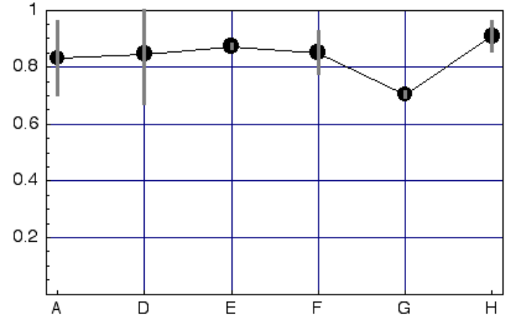
Figure 22: Spearman Rank Correlation for each model, averaged over 525 and 625 results. Error bars indicate ± 2 standard errors of the mean, a typical 95% confidence limit.
    - Comments on NASA model performance
The NASA model performed well overall, and especially well on the 625 data. It was the best model in the 625 condition, based on the Spearman Rank Correlation. The performance of the model is particularly good considering that 1) the model was designed to be as simple as possible, and 2) the model requires no training whatsoever.
We examined the few outliers for our model, and determined that they were all the result of either 1) frame misalignment (as discussed below), or 2) use of the H.263 HRC, which was outside the purview of our model, and nominally outside the focus of VQEG2, defined in the introduction to this document as “digitally encoded television quality video.”
In the 525 data set, the conditions yielding the largest errors were largely due to sequences provided by Teranex that were captured on DigiBetaCam, and subsequently processed by HRCs 12 and 13. Due to the short time between release of the data and submission of this report, we have not ascertained the basis for these errors, though we suspect registration, rather than the model, may be the culprit (see below).
    - Registration
Our single severe outlier (SRC 04, HRC 05) was due to varying frame registration within the duration of the sequence. Our registration algorithm derived row, column, and frame offsets from a set of early frames, and assumed those offsets were constant throughout the sequence. In this case, we estimated a frame offset of 2 frames. In fact, later in the sequence, frame offset reverts to 0 frames. As a result, our model computed a result on mis-aligned frames and consequently yielded a value much too large. Re-computing the model with the correct alignment yielded a value of 9151.4 versus the old value of 17270.4, and placed the data point well within the normal range.
Our registration assumed the registration rules adopted in VQEG1. In VQEG1, mis-registration was analyzed from a brief segment at the start of the sequence, and was assumed to be constant throughout. It was then corrected for the proponents by an independent body. In VQEG2, proponents were responsible for their own registration. While this relieved VQEG of the responsibility for registration, it confounded the quite separate problems of registration and model performance, with the result that we do not know at this point how well the models themselves perform.
Post-hoc analysis of the sequences showed that frame alignment varied erratically within many of the sequences, so that models applying a simple VQEG1-style registration were penalized. Timing of this report does not allow us to examine this further at this time, but we plan in the near future to re-compute the predictions of our model with a registration algorithm matched to the more relaxed rules of VQEG2.
    - Comments on VQEG2 Test Design
While the VQEG2 study represents a commendable effort and an important increase in the quantity of subjective data available for analysis, it is worth noting some shortcomings of the study, in hope that they might be remedied in future work.
- Inclusion of HRCs outside the stated domain
The focus of VQEG2 was “digitally encoded television quality video,” yet the study included H.263 as an SRC in both 525 and 625 conditions. This departure from the stated focus of the test may have altered the outcome of the test, since some models may have assumed there would be no H.263 HRC.
- Different number of observers in 525 and 625 conditions
As a matter of experimental design, and effort should have been made to ensure an equal number of observers in 525 and 625 conditions. The differing numbers of observers in 525 and 625 conditions raise difficult statistical issues. While it may be desirable to produce one overall statistic for the two conditions, doing so is problematic. If data are combined based on individual observers, then metrics which perform better on 625 data are penalized, because there were fewer observers in the 625 condition. On the other hand, if the data are combined based only on the means from the two conditions, then the combined result does not properly weigh the number of observers.
- Proponents HRCs
One problematic aspect of the design of the VQEG2 experiment was the contribution of HRCs by the proponents. This decision was motivated by the need to rapidly secure sequences for the experiment, but it allowed some proponents to have possibly valuable information not available to the others. As an example, details of HRC-related frame mis-alignment, as discussed above, would have been known to the proponent contributing the HRC, but not to others. The three proponents contributing HRCs were ranked 1, 2, and 4, based on the correlations plotted above.
- PSNR
Because registration was computed independently by each proponent, there was no single agreed-upon set of registered sequences upon which the PSNR model could be applied. This prevents VQEG2 from having this important benchmark for comparison. This defect could be remedied in the future, but the results would not be available for this report.
- Viewing Distance
One way in which models may be distinguished from PSNR is through collection of data at several viewing distances. This was proposed for VQEG2, but not adopted. Use of several viewing distances is important if the models are to be useful in charactering viewer satisfaction in diverse settings, and also if the models are to extend their application to other applications, such as HDTV, digital cinema, and Internet video.
NASA has proposed to collect data on the VQEG2 conditions at a second viewing distance in the near future. This will allow a test of whether the current models are able to predict changes in apparent quality with viewing distance, an important requirement for any standard.
- Data Analysis Schedule
The schedule of the VQEG2 test did not allow sufficient time between release of the data and completion of the final report. This compressed schedule did not allow proponents to make meaningful analyses of the sequences, or of the response of their models to the sequences. In a typical scientific experiment, the time allocated to analysis is more nearly equal to the time allocated for planning and execution.
- Complexity
Neither VQEG1 nor VQEG2 considered the complexity of models. In part this was due to the difficulty of assessing complexity in an objective way. However, in real-world application, complexity is very much an issue, especially when dealing with the inherently large computation burden of digital video. It would be unfortunate if a standard was established based on a model that was too difficult, time-consuming, or expensive to compute.
The NASA model was designed to be as simple as possible, so that it could be implemented cheaply and could run in real time, but also so that it would be robust to future changes in codecs. It is likely that complex models designed or trained to deal with a particular set of artifacts will fare poorly when the nature of those artifacts change. On the other hand, a model which employs only simple, generic, vision-based processing will do equally well with the artifacts of today and tomorrow.
- A Performance Standard
Given that no single model from either VQEG1 or VQEG2 performs much better than all others, and given that future models may exceed today’s performance, it might be better for standards-setting bodies to consider establishing a “performance” standard, rather than an algorithm standard. In this approach, the standard might state that any model achieving a certain level of performance (e.g. correlation), relative to some subset of VQEG1 and VQEG2 data sets, would be considered acceptable. This approach would allow future improvements in models to occur, while ensuring a specified level of accuracy. It would also allow applications and vendors to consider other model aspects, such as complexity, in their decision as to what model to adopt.
  - Proponent D, British Telecom
The full reference metric for the measurement of broadcast video submitted by BT to the VQEG tests performed very well. For the 525 test data, BT's model produced correlations with the subjective scores of .937 based on the scaled data and .934 based on the raw data. Over the past two years BT's full reference video model for broadcast has consistently achieved correlations with test data of between .85 and .95 on both 525 and 625 datasets. These internal tests performed by BT have employed controlled test material covering a representative range of both video content and broadcast degradation forms. The tests run in VQEG Phase II were weaker than Phase I in terms of the number of test laboratories who performed testing, number of test subjects and number of test sequences. In Phase II, two laboratories performed the 525 test and a high correlation was found between the test data from both laboratories. This finding supports the conclusion that the 525 subjective results are reliable.
  - Proponent E, Yonsei University
We found several problems with our final model (yonsei1128c.exe), including registration and operator errors. It appears that the third version (yonsei1128.exe), which we submitted just before we submitted the final version, was less adversely affected, though it also had some problems. The following figures (Figs. 23 and 24) compare the results of the final model and the third model for the 525 and 625 videos. The performances with the 625 videos are essentially the same. However, the performance of the third version (yonsei1128.exe) is noticeably better than that of the final model (the Pearson correlation: from 0.848 to 0.878, without curve fitting) for the 525 data.

(a) (b)
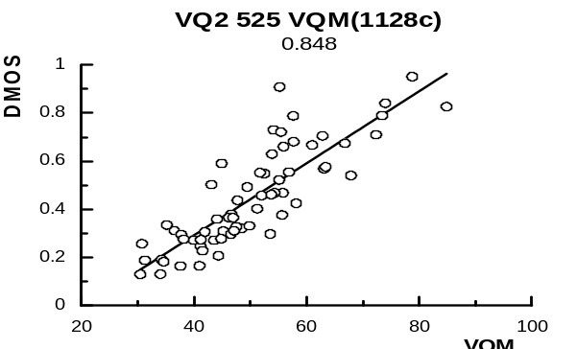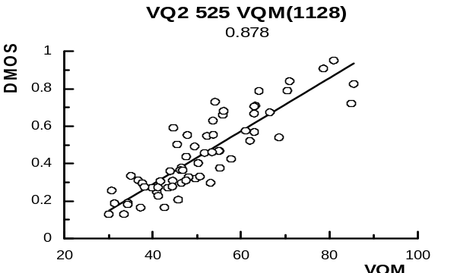

Figure 23: Scatter plots and the Pearson correlation coefficients (525 videos). No curve fitting. (a) the final version (yonsei1128c.ext) the Pearson correlation: 0.848 , (b) the third version (yonsei1128.exe), the Pearson correlation: 0.878.

(a) (b)
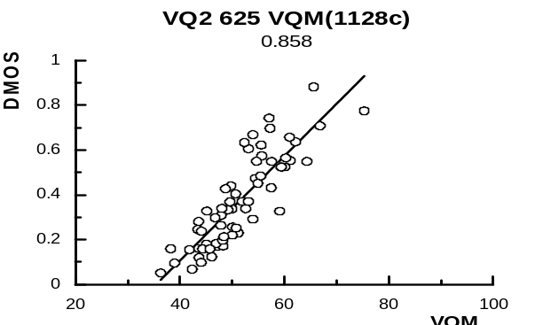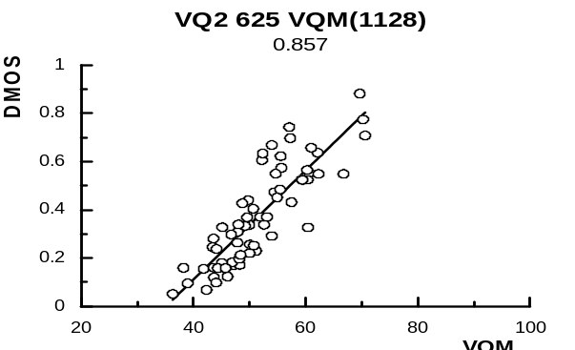
Figure 24: Scatter plots and the Pearson correlation coefficients (625 videos). No curve fitting. (a) the final version (yonsei1128c.ext) the Pearson correlation: 0.858 , (b) the third version (yonsei1128.exe), the Pearson correlation: 0.857.

Table 1 shows the summary of the 525 analysis when the third version (yonsei1128.exe) is used. With the small improvement in the mean square error statistics, the third version is in a statistical tie with Proponents D, F (new results), and H according to the test using the 63 mean data points.

Table 1. Summary of 525 Analyses
Line Number | Metric | 525 Lines
Line Number | Metric | Old  (1128c) | New  (1128)
1 | 1. Pearson correlation | 0.857 | 0.878
2 | 2. Spearman correlation | 0.875 | 0.884
3 | 3. Outlier ratio | 0.70 | 0.70
4 | 4. RMS error, 63 data points | 0.110 | 0.099
5 | 5. Resolving power, delta VQM
6 | 6. Percentage of classification errors | 0.29 | 0.28
7 | 7. MSE model/MSE optimal model | 1.590 | 1.471
8 | F=MSE model/MSE Proponet H | 1.266 | 1.171
9 | MSE model, 4153 data points | 0.03049 | 0.028213
10 | MSE optimal model, 4219 data | 0.01918 | 0.01918
11 | MSE model, 63 data points | 0.01212 | 0.00973
12 | F=MSE63 model/ MSE63 Proponent H | 2.212 | 1.776
Note1: Values of metric 7 smaller that 1.075 indicate the model is not reliably different from the optimal model.
Note2: Values in line 8 larger than 1.075 indicate the model has significantly larger residuals than the top Prop. model, H in this case.
Note3: Values in line 12 larger than 1.81 indicate the model has significantly larger residuals than the top Prop. model, H in this case.

  - Proponent F, CPqD
In the CPqD-IES software that was submitted to FR-TV Phase 2 was identified a minor calibration problem during the normalization stage that adversely impacted the results, and only after the submission process the problem was detected by CPqD.
The problem occurred because the normalization module of the program carried out spatial shift estimation, but the corrections were not performed. This fault impacted the final results, mainly for 525-line videos because 24 conditions (SRCxHRC) were detected with some spatial shift. For 625-line videos the results weren’t significantly affected because only 2 conditions were detected with some spatial shift.
The code was corrected (8 source-code lines per component Y, Cb and Cr) and all test conditions reprocessed. Mr. Greg Cemark ran the analyses for CPqD new data and confirmed the results. These results are presented in Tables 1, 2 and 3. Tables 1 and 2 present the old and new results, for the 525-lines data and 625-lines data, respectively.
For 525-line videos the Pearson and Spearman correlation increased substantially when spatial shift correction was included. Pearson correlation raised from 0.835 to 0.895 and Spearman correlation raised from 0.814 to 0.885 (Table 1).
In Tables 1 and 2, metrics 5 and 6 were not included because these methods omitted the cross-calibration procedure, as it is not relevant to measures of performance of individual models (see Section 4.2.2 this document).

Table 1. Summary of 525 Analyses

Line Number | Metric | 525 Lines
Line Number | Metric | Old | New
1 | 1. Pearson correlation | 0.835 | 0.895
2 | 2. Spearman correlation | 0.814 | 0.885
3 | 3. Outlier ratio | 0.70 | 0.62
4 | 4. RMS error, 63 data points | 0.117 | 0.096
5 | 5. Resolving power, delta VQM | 0.3074 | -
6 | 6. Percentage of classification errors | 0.3113 | -
7 | 7. MSE model/MSE optimal model | 1.68 | 1.442
8 | F=MSE model/MSE Proponet H | 1.338 | 1.148
9 | MSE model, 4153 data points | 0.03223 | 0.02765
10 | MSE optimal model, 4219 data | 0.01918 | 0.01918
11 | MSE model, 63 data points | 0.01365 | 0.00914
12 | F=MSE63 model/ MSE63 Proponent H | 2.491 | 1.297
Note1: Values of metric 7 smaller that 1.075 indicate the model is not reliably different from the optimal model.
Note2: Values in line 8 larger than 1.075 indicate the model has significantly larger residuals than the top Prop. model, H in this case.
Note3: Values in line 12 larger than 1.81 indicate the model has significantly larger residuals than the top Prop. model, H in this case.
Table 2. Summary of 625 Analyses

Line Number | Metric | 625 Lines
Line Number | Metric | Old | New
1 | 1. Pearson correlation | 0.898 | 0.898
2 | 2. Spearman correlation | 0.883 | 0.885
3 | 3. Outlier ratio | 0.33 | 0.62
4 | 4. RMS error, 64 data points | 0.079 | 0.096
5 | 5. Resolving power, delta VQM | 0.270 | -
6 | 6. Percentage of classification errors | 0.204 | -
7 | 7. MSE model/MSE optimal model | 1.303 | 1.442
8 | F=MSE model/MSE Proponet F | 1 | 1.148
9 | MSE model, 1728 data points | 0.02328 | 0.02765
10 | MSE optimal model, 1728 data | 0.01787 | 0.01918
11 | MSE model, 64 data points | 0.00625 | 0.00914
12 | F=MSE64 model/ MSE64 Proponent F | 1 | 1.297
Note1: Values of metric 7 smaller that 1.119 indicate the model is not reliably different from the optimal model.
Note2: Values in line 8 larger than 1.119 indicate the model has significantly larger residuals than the top Prop. model, F in this case.
Note3: Values in line 12 larger than 1.81 indicate the model has significantly larger residuals than the top Prop. model, F in this case.

According to Mr. Greg Cemark, the new results the CPqD 525 model performance is close to the models of BT and NTIA. The correlation to the data is 0.895, and for the F-test the CPqD model is tied with the performance of the NTIA model – but only for the DMOS data (63 data points). For the 4153 raw data points, CPqD is still different from NTIA.
Pearson and Spearman correlations for 625-line test have changed only in the third decimal place and therefore they were not significant.

  - Proponent G, Chiba University
The model MVMC version B was developed to be as generally applicable as possible; not only applicable to a set of videos in Phase 2, but also applicable to the set of videos used in Phase 1. In line with this baseline, in other words generalizability in wider sense, taking into account standard deviations of the DMOSs, accountability of DMOS by the output of the model was intentionally limited to approximately 0.8 in Pearson’s correlation factor for training of the model using the data obtainable in the final report from VQEG FR-TV test phase 1. As a result of this constraint, correlation factors for the set of videos in phase 2 should be less than 0.8. The actual evaluation results were about the same values as expected.
Taking into account the results of the other models, the MVMC can be tuned to provide higher values than the initial setting that may lead to an improvement of the model. However, according to our point of view, the target of the value of correlation factor should be decided in line with the standard deviation of the DMOS’s to be estimated. For the sake of future reference, distribution of the difference opinion scores (DOS) versus their mean (DMOS) was plotted for 525 videos tested subjectively by one of the laboratories of the ILG (Figure 25).
Further details would be found in a paper submitted to Special Session on Video Quality Assessment: Methods, Metrics and Applications – Video Communications and Image Processing 2003 to be held in July in Lugano. The paper will be entitled, “Mixed variables modeling method to estimate network video quality. ”

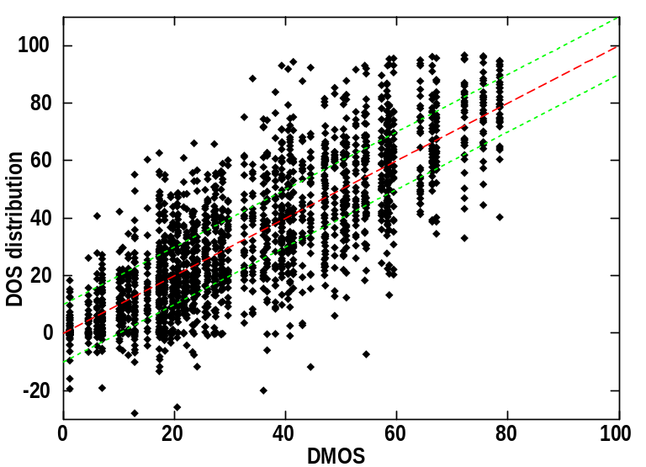
Figure 23: Distribution of difference opinion scores corresponding to 525 line videos.

  - Proponent H, NTIA
In the 525-line test, the NTIA model was one of only two models that performed statistically better than the other models. In the 625-line test, the NTIA model was one of four models that performed statistically better than the other models. Overall, the NTIA model was the only model that performed statistically better than the other models in both the 525-line and 625-line tests. Obtaining an average Pearson correlation coefficient over both tests of 0.91, the NTIA model was the only model to break the 0.9 threshold.
The worst 525-line outlier for the NTIA video quality model was for source 1/HRC 1. This outlier has been determined to have resulted from a spatial/temporal registration error that incorrectly estimated the processed video to be reframed for this video clip (i.e., shifted by one field). For the other scenes of HRC 1, spatial/temporal registration was correctly estimated. In non-VQEG implementations of our video quality model, median filtering of the calibration results over all scenes of a given HRC is used to produce more robust calibration estimates for an HRC. However, the VQEG Phase II test plan specified that submitted models must produce a single quality estimate for each clip independently. Thus, median filtering of calibration numbers over all scenes for a given HRC was not allowed by the VQEG test plan. Had we been allowed to activate this normally used calibration option for the VQEG Phase II tests, the objective quality score for source 1/HRC 1 would have been considerably closer to the subjective mean opinion score, and the overall Pearson correlation for the 525-line data set would have increased to 94.5%.

- Independent Lab Group (ILG) subjective testing facilities
  - Display Specifications

    - Verizon
    - CRC
Specification |  | Value
Make and model |  | Ikegami TM20-20R
CRT size (diagonal size of active area) |  | 19 inch (482 mm)
Resolution (TV-b/w Line Pairs) |  | >700 TVL (center, at 35 Ft-L)
Dot-pitch (mm) |  | 0.43mm
Phosphor chromaticity (x, y), measured in white area | R | 0.641, 0.343
Phosphor chromaticity (x, y), measured in white area | G | 0.310, 0.606
Phosphor chromaticity (x, y), measured in white area | B | 0.158, 0.070
Specification |  | Value Monitor A | Value Monitor B
Make and model |  | Sony BVM-1910 | Sony BVM-1911
CRT size (diagonal) |  | 482 mm (19 inch) | 482 mm (19 inch)
Resolution (TVL) |  | >900 TVL (center, at 30fL)¹ | >900 TVL (center, at 103 cd/m²)
Dot pitch |  | 0.3 mm | 0.3 mm
Phosphor chromaticity (x, y),  measured in white area | R | 0.630 , 0.340 | 0.630 , 0.340
Phosphor chromaticity (x, y),  measured in white area | G | 0.310 , 0.595 | 0.310 , 0.595
Phosphor chromaticity (x, y),  measured in white area | B | 0.155 , 0.070 | 0.155 , 0.070
¹30fL approximately equals 103cd/m²

    - FUB
Specification |  | Value
Make and model |  | Sony BVM20E1E
CRT size (diagonal size of active area) |  | 20 inch
Resolution (TVL) |  | 1000
Dot-pitch (mm) |  | 0.25
Phosphor chromaticity (x, y),  measured in white area | R | 0.640, 0.330
Phosphor chromaticity (x, y),  measured in white area | G | 0.290, 0.600
Phosphor chromaticity (x, y),  measured in white area | B | 0.150, 0.060
  - Display Setup
    - Verizon
Measurement | Value
Luminance of the inactive screen  (in a normal viewing condition) | 0.2 cd/m²
Maximum obtainable peak luminance  (in a dark room, measured after black-level adjustment  before or during peak white adjustment) | 860 cd/m²
Luminance of the screen for white level  (using PLUGE in a dark room) | 72.1 cd/m²
Luminance of the screen when displaying only black level  (in a dark room) | 0.2 cd/m²
Luminance of the background behind a monitor  (in a normal viewing condition) | 7.2 cd/m²
Chromaticity of background  (in a normal viewing condition) | 4600 ºK
    - CRC
Measurement | Value
 | BVM-1910 | BVM-1911
Luminance of the inactive screen  (in a normal viewing condition) | 0.17 cd/m² | 0.19 cd/m²
Maximum obtainable peak luminance  (in a dark room, measured after black-level adjustment  before or during peak white adjustment) | 577 cd/m² | 718 cd/m²
Luminance of the screen for white level  (using PLUGE in a dark room) | 70.8 cd/m² | 70.4 cd/m²
Luminance of the screen when displaying  only black level (in a dark room) | 0.05 cd/m² | 0.04 cd/m²
Luminance of the background behind a monitor  (in a normal viewing condition) | 9.8 cd/m² | 9.7 cd/m²
Chromaticity of background  (in a normal viewing condition) | 6500 ºK | 6500 ºK
    - FUB
Measurement | Value
Luminance of the inactive screen  (in a normal viewing condition) | 0 cd/m²
Maximum obtainable peak luminance  (in a dark room, measured after black-level adjustment before or during peak white adjustment) | 500 cd/m²
Luminance of the screen for white level  (using PLUGE in a dark room) | 70 cd/m²
Luminance of the screen when displaying only black level (in a dark room) | 0.4 cd/m²
Luminance of the background behind a monitor  (in a normal viewing condition) | 10 cd/m²
Chromaticity of background  (in a normal viewing condition) | 6500 ºK
  - Display White Balance
A specialized test pattern was used to characterize the gray-scale tracking. The pattern consisted of nine spatially uniform boxes, each being approximately 1/5 the screen height and 1/5 the screen width. All pixel values within a given box are identical, and all pixel values outside the boxes are set to a count of 170. From the luminance measurements of these boxes, it is possible to estimate the system gamma for each monitor.

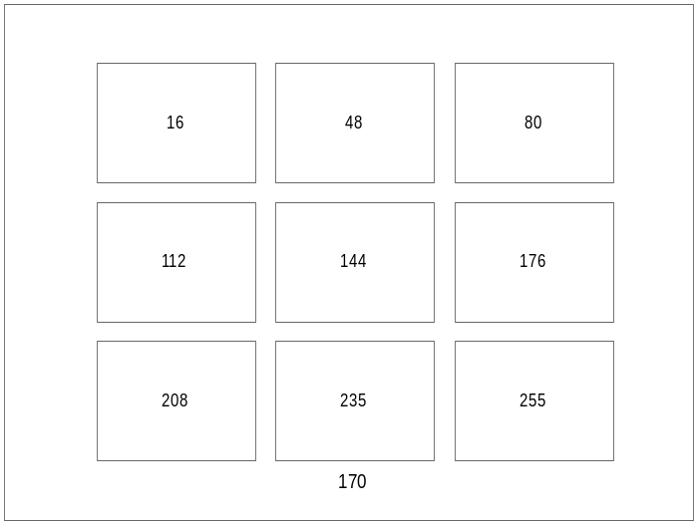

    - Verizon

Video level | Luminance (cd/m²) | Chromaticity (x, y) | Color Temperature [ºK]
255 | 91.5 | 0.312, 0.337 | 6497
235 (white) | 78.6 | 0.311, 0.337 | 6525
208 | 54.4 | 0.310, 0.337 | 6556
176 | 41.7 | 0.312, 0.341 | 6438
144 | 27.0 | 0.314, 0.342 | 6366
112 | 14.4 | 0.315, 0.340 | 6345
80 | 8.5 | 0.317, 0.340 | 6241
48 | 4.3 | 0.300, 0.336 | 7147
16 (black) | 2.2 | 0.288, 0.334 | 7890

    - CRC

Video level | Luminance (cd/m²) |  | Chromaticity (x, y) |  | Color Temperature [ºK]
 | BVM-1910 | BVM-1911 | BVM-1910 | BVM-1911 | BVM-1910 | BVM-1911
255 | 77.5 | 85.8 | 0.312, .325 | 0.317,0.334 | 6580 | 6240
235 | 67.1 | 74.5 | 0.312,0.325 | 0.313,0.333 | 6560 | 6480
208 | 48.0 | 55.5 | 0.310,0.323 | 0.310,0.333 | 6680 | 6630
176 | 34.4 | 31.5 | 0.313,0.328 | 0.320,0.336 | 6500 | 6100
144 | 21.5 | 21.1 | 0.314,0.331 | 0.316,0.338 | 6420 | 6260
112 | 11.4 | 12.2 | 0.313,0.328 | 0.312,0.338 | 6510 | 6480
80 | 5.10 | 4.48 | 0.315,0.333 | 0.318,0.335 | 6360 | 6190
48 | 1.64 | 1.62 | 0.314,0.331 | 0.310,0.330 | 6400 | 6670
16 | 0.59 | 0.68 | 0.298,0.321 | 0.290,0.311 | 7400 | 8270

    - FUB

Video level | Luminance (cd/m²) | Chromaticity (x, y) | Color Temperature [ºK]
255 | 87.0
235 (white) | 71.0
208 | 54.4
176 | 38.3
144 | 22.0 | 302, 331
112 | 12.1
80 | 5.23
48 | 1.60 | 295, 334
16 (black) | 0.40

  - Display Resolution Estimates
To visually estimate the limiting resolution of the displays, a special Briggs test pattern was used. This test pattern is comprised of a 5 rows by 8 columns grid. Each row contains identical checkerboard patterns at different luminance levels, with different rows containing finer checkerboards. The pattern is repeated at nine different screen locations.
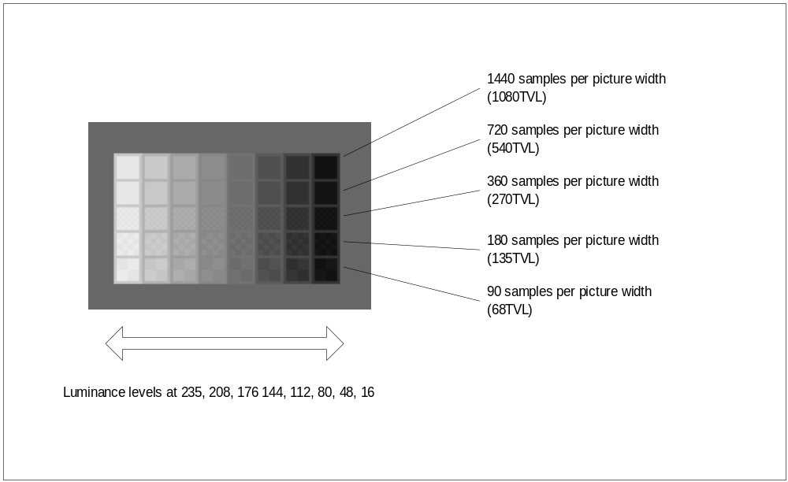

The subsections below show the estimated resolution in TVLs from visual inspection of the Briggs Pattern for each monitor used in the test. At a minimum, the Mid Center values must be reported.

    - Verizon

Level | Top Left | Top Center | Top Right | Mid Left | Mid Center | Mid Right | Bottom Left | Bottom Center | Bottom Right
16 | 0 | 0 | 0 | 0 | 0 | 0 | 0 | 0 | 0
48 | >270 | >270 | >270 | >270 | >270 | >270 | >270 | >270 | >270
80 | >270 | >270 | >270 | >270 | >270 | >270 | >270 | >270 | >270
112 | >270 | >270 | >270 | >270 | >270 | >270 | >270 | >270 | >270
144 | >270 | >270 | >270 | >270 | >270 | >270 | >270 | >270 | >270
176 | >270 | >270 | >270 | >270 | >270 | >270 | >180 | >270 | >270
208 | >180 | >180 | >180 | >180 | >180 | >180 | >180 | >180 | >180
235 | >180 | >180 | >180 | >180 | >180 | >180 | >180 | >180 | >180

    - CRC
Estimated Resolution in TVLs from visual inspection of the Briggs Pattern for BVM-1910.
Level | Top Left | Top Center | Top Right | Mid Left | Mid Center | Mid Right | Bottom Left | Bottom Center | Bottom Right
16 | 0 | 0 | 0 | 0 | 0 | 0 | 0 | 0 | 0
48 | >540 | >540 | >540 | >540 | >540 | >540 | >540 | >540 | >540
80 | >270 | >540 | >270 | >540 | >540 | >540 | >270 | >540 | >270
112 | >270 | >270 | >270 | >270 | >270 | >270 | >270 | >270 | >270
144 | >270 | >270 | >270 | >270 | >270 | >270 | >270 | >270 | >270
176 | >270 | >270 | >270 | >270 | >270 | >270 | >270 | >270 | >270
208 | >270 | >270 | >270 | >270 | >270 | >270 | >270 | >270 | >270
235 | >270 | >270 | >270 | >270 | >270 | >270 | >270 | >270 | >270
Estimated Resolution in TVLs from visual inspection of the Briggs Pattern for BVM-1911
Level | Top Left | Top Center | Top Right | Mid Left | Mid Center | Mid Right | Bottom Left | Bottom Center | Bottom Right
16 | 0 | 0 | 0 | 0 | 0 | 0 | 0 | 0 | 0
48 | >540 | >540 | >540 | >540 | >540 | >540 | >540 | >540 | >540
80 | >540 | >540 | >540 | >540 | >540 | >540 | >540 | >540 | >540
112 | >270 | >540 | >270 | >270 | >540 | >270 | >270 | >270 | >270
144 | >270 | >270 | >270 | >270 | >270 | >270 | >270 | >270 | >270
176 | >270 | >270 | >270 | >270 | >270 | >270 | >270 | >270 | >270
208 | >270 | >270 | >270 | >270 | >270 | >270 | >270 | >270 | >270
235 | >270 | >270 | >270 | >270 | >270 | >270 | >270 | >270 | >270

    - FUB
Level | Top Left | Top Center | Top Right | Mid Left | Mid Center | Mid Right | Bottom Left | Bottom Center | Bottom Right
16 | 0 | 0 | 0 | 0 | 0 | 0 | 0 | 0 | 0
48 | >270 | >270 | >270 | >270 | >270 | >270 | >270 | >270 | >270
80 | >270 | >270 | >270 | >270 | >270 | >270 | >270 | >270 | >270
112 | >270 | >270 | >270 | >270 | >270 | >270 | >270 | >270 | >270
144 | >270 | >270 | >270 | >270 | >270 | >270 | >270 | >270 | >270
176 | >270 | >270 | >270 | >270 | >270 | >270 | >270 | >270 | >270
208 | >270 | >270 | >270 | >270 | >270 | >270 | >270 | >270 | >270
235 | >270 | >270 | >270 | >270 | >270 | >270 | >270 | >270 | >270
  - Video Signal Distribution
    - Verizon
BTS DCR300 D1 cassette player → Ikegami TM20-20R 19” monitor.
Distribution entirely via SDI.

    - CRC

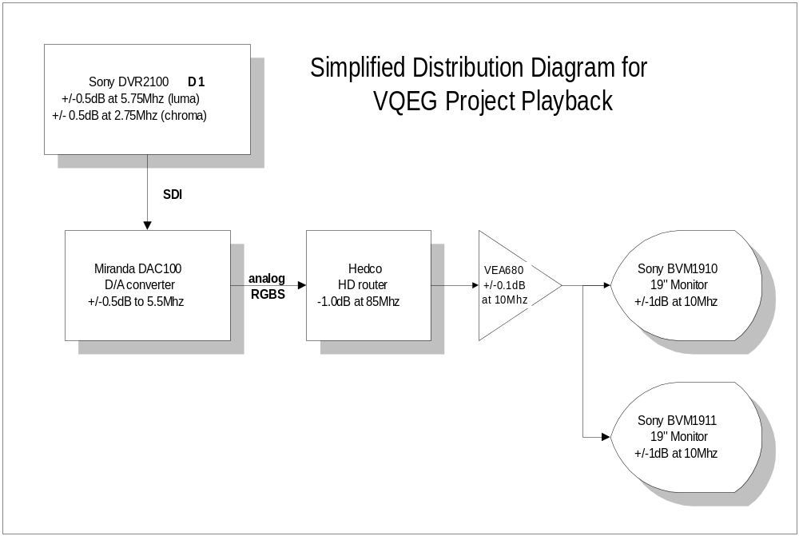

To characterize the video distribution system, a Tektronix TSG1001 test signal generator output was fed to the analog inputs of the Hedco router, using an 1125I/60 signal. A Tektronix 1780WFM was used to obtain measurements at the BVM-1911 input.

Characterization of the Distribution System
Item | Result | Comment
Frequency response | 0.5 to 10 MHz (+/- 0.1 dB) | For each color channel  Using fixed frequency horizontal sine wave zone plates.
Interchannel Gain Difference | -3 mv on Blue channel  -1 mv on Red channel | Distributed Green channel as reference  Using 2T30 Pulse & Bar and subtractive technique
Nonlinearity | < 0.5% worst case on Green channel | Direct output of signal generator as reference (Green channel)  Using full amplitude ramp and subtractive technique
Interchannel Timing | Blue channel: 1.5 ns delay  Red channel: 0.25 ns delay | Relative to Green channel output  Using HDTV Bowtie pattern

    - FUB
The D1 DVTR is connected directly to the monitors through SDI coax cables; this connection is therefore fully transparent.
  - Data collection method
There are two accepted methods for collecting subjective quality rating data. The classical method uses pen and paper while a newer method uses an electronic capture device. Each lab used whichever method was available to them and these are listed in the table below.

Laboratory | Method
Verizon | Paper
CRC | Paper
FUB | Electronic

  - Additional Laboratory Details
    - Verizon
One chair was placed 48” (4H) from the monitor. The chair was behind a heavy table (so that the subject’s position was fixed); table and chair were arranged so that in a normal viewing posture, subjects’ heads were 48” from the monitor screen. Walls were covered with gray felt. The table was covered with dark gray carpeting. The room dimensions were 12 ft x 10 ft. The monitor screen was 4 ft from the wall behind it. Background illumination was provided by Ott fluorescent lamps. An experimenter was present during testing. All luminance measurements were made with a PTV PM 5639 Colour Analyzer.
    - CRC
The Viewing Environment
The viewer environment is summarized in the following diagram. The ambient light levels were maintained at 6 – 7 lux, and filtered to approximately 6500 degrees Kelvin. The monitor surround was maintained at 10cd/m2, also at 6500 degrees. No aural or visual distractions were present during testing.
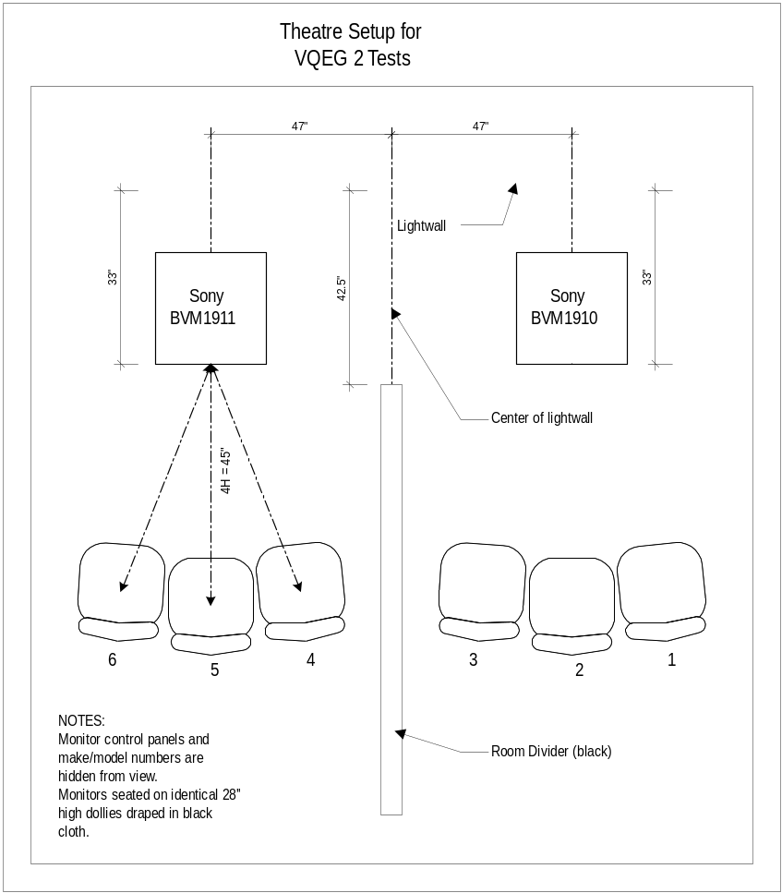

Monitor Matching
Additional measurements were obtained to ensure adequate color matching of the two monitors used in testing.

Displaying Full Field Colorbars
 | Yellow |  |  | Cyan |  |  | Green
Monitor | x | y | Y | x | y | Y | x | y | Y
1910 | 0.424 | 0.502 | 62.4 | 0.220 | 0.321 | 53.2 | 0.303 | 0.596 | 48.9
1911 | 0.415 | 0.509 | 74.1 | 0.227 | 0.336 | 65.0 | 0.307 | 0.594 | 57.1
 | Magenta |  |  | Red |  |  | Blue
 | x | y | Y | x | y | Y | x | y | Y
1910 | 0.322 | 0.159 | 21.4 | 0.624 | 0.331 | 15.7 | 0.144 | 0.059 | 4.64
1911 | 0.326 | 0.162 | 21.0 | 0.629 | 0.326 | 15.2 | 0.146 | 0.063 | 4.20

The following grayscale measurements utilize a 5 box pattern, with luminance values set to 100%, 80%, 60%, 40% and 20%. Each box contains values for luminance in cd/m² and color temperature in degrees Kelvin.

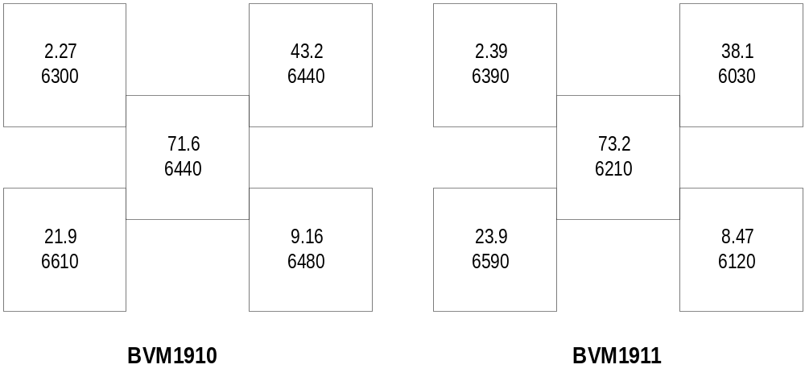

Schedule of Technical Verification

Complete monitor alignment and verification is conducted prior to the start of the test program.
Distribution system verification is performed prior to, and following completion of, the test program.
Start of test day checks include verification of monitor focus/sharpness, purity, geometry, aspect ratio, black level, peak luminance, grayscale, and optical cleanliness. In addition, the room illumination and monitor surround levels are verified.
Prior to the start of each test session, monitors are checked for black level, grayscale and convergence. Additionally, the VTR video levels are verified.
During each test session, the video playback is also carefully monitored for any possible playback anomalies.

    - FUB

No additional details provided.

  - Contact information

CRC  Filippo Speranza  Research Scientist  Broadcast Technologies Research, Advanced Video Systems  Communications Research Centre Canada  3701 Carling Ave., Box 11490, Station H  Ottawa, Ontario K2H 8S2  Canada | Tel: 1-613-998-7822  Fax: 1-613-990-6488 | filippo.speranza@crc.ca
Verizon Laboratories  Gregory Cermak  Distinguished Member of Technical Staff  Verizon Laboratories  Mailcode LAOMS38  40 Sylvan Rd  Waltham, MA 02451, USA | Tel: (781) 466-4132  Fax: (781) 466-4035 | greg.cermak@verizon.com
FUB  Vittorio Baroncini  FONDAZIONE UGO BORDONI  via B. Castiglione,59 00142 ROMA ITALIA | Tel. +390654802134  Fax +390654804405 | vittorio@fub.it

- DMOS Values for all HRC-SRC Combinations

Table 13. 525 DMOS Matrix
SRC (Image) | HRC=1 | HRC=2 | HRC=3 | HRC=4 | HRC=5 | HRC=6 | HRC=7 | HRC=8 | HRC=9 | HRC=10 | HRC=11 | HRC=12 | HRC=13 | HRC=14
1 | 0.5402368 | 0.5483205 | 0.4024097 | 0.3063528
2 | 0.5025558 | 0.3113346 | 0.1881739 | 0.1907347
3 | 0.4682724 | 0.3088831 | 0.1300389 | 0.1293293
4 |  |  |  |  | 0.6742005 | 0.4250873 | 0.3762656 | 0.2972294
5 |  |  |  |  | 0.4682559 | 0.3203024 | 0.2071702 | 0.1652752
6 |  |  |  |  | 0.5690291* | 0.4370961 | 0.3591788 | 0.2482169
7 |  |  |  |  | 0.3796362 | 0.2276934 | 0.1644409 | 0.1819566
8 |  |  |  |  |  |  |  |  | 0.9513387 | 0.789748 | 0.8405916 | 0.5221555 | 0.4572049 | 0.4614104
9 |  |  |  |  |  |  |  |  | 0.8262912 | 0.660339 | 0.7100111 | 0.4921708 | 0.3656559 | 0.2960957
10 |  |  |  |  |  |  |  |  | 0.9084171 | 0.5908784 | 0.7302376 | 0.3345703 | 0.2565459 | 0.2953144
11 |  |  |  |  |  |  |  |  | 0.6675853 | 0.7054929 | 0.5761193 | 0.32761 | 0.310495 | 0.331051
12 |  |  |  |  |  |  |  |  | 0.7883371 | 0.6295301 | 0.6809288 | 0.3651402 | 0.2714356 | 0.2782449
13 |  |  |  |  |  |  |  |  | 0.7211194 | 0.5545722 | 0.5525494 | 0.2708744 | 0.27549 | 0.2733771
Note: The SRC=6, HRC =5 (*) value was taken out of the analysis because it exceeded the temporal registration requirements of the test plan.

Table 14. 625 DMOS Matrix
SRC (Image) | HRC=1 | HRC=2 | HRC=3 | HRC=4 | HRC=5 | HRC=6 | HRC=7 | HRC=8 | HRC=9 | HRC=10
1 |  | 0.59461 | 0.64436 | 0.40804 |  | 0.34109 |  | 0.2677 |  | 0.26878
2 |  | 0.54173 | 0.70995 | 0.27443 |  | 0.22715 |  | 0.21133 |  | 0.16647
3 |  | 0.73314 | 0.76167 | 0.49848 |  | 0.38613 |  | 0.34574 |  | 0.26701
4 |  | 0.58528 | 0.90446 | 0.62361 |  | 0.61143 |  | 0.43329 |  | 0.26548
5 |  | 0.61973 | 0.68987 | 0.41648 |  | 0.4218 |  | 0.27543 |  | 0.2022
6 |  | 0.38852 | 0.44457 | 0.27983 |  | 0.28106 |  | 0.23726 |  | 0.17793
7 |  |  |  | 0.59953 |  | 0.55093 |  |  | 0.45163 | 0.35617
8 |  |  |  | 0.32528 |  | 0.32727 |  |  | 0.30303 | 0.26366
9 |  |  |  | 0.47656 |  | 0.49924 |  |  | 0.39101 | 0.37122
10 |  |  |  | 0.70492 |  | 0.58218 |  |  | 0.49711 | 0.37854
11 | 0.79919 |  |  |  | 0.59256 |  | 0.34337 |  |  | 0.30567
12 | 0.61418 |  |  |  | 0.6661 |  | 0.53242 |  |  | 0.44737
13 | 0.74225 |  |  |  | 0.66799 |  | 0.42065 |  |  | 0.33381

SRC (Image) | HRC=1 | HRC=2 | HRC=3 | HRC=4 | HRC=5 | HRC=6 | HRC=7 | HRC=8 | HRC=9 | HRC=10 | HRC=11 | HRC=12 | HRC=13 | HRC=14
1 | 0.02109499 | 0.0223858 | 0.0202654 | 0.0200377
2 | 0.02072424 | 0.0186353 | 0.0164296 | 0.0179823
3 | 0.02075164 | 0.021336 | 0.0131301 | 0.0141977
4 |  |  |  |  | 0.0224479 | 0.0200094 | 0.0221945 | 0.0216022
5 |  |  |  |  | 0.0254351 | 0.0217278 | 0.0179396 | 0.0145813
6 |  |  |  |  |  | 0.0215159 | 0.0176766 | 0.0180308
7 |  |  |  |  | 0.0197204 | 0.0171224 | 0.0147712 | 0.0188843
8 |  |  |  |  |  |  |  |  | 0.010892 | 0.0180687 | 0.0185947 | 0.0249537 | 0.0272349 | 0.0258362
9 |  |  |  |  |  |  |  |  | 0.0167711 | 0.018702 | 0.0281708 | 0.0226776 | 0.0193788 | 0.0203533
10 |  |  |  |  |  |  |  |  | 0.0144376 | 0.0263593 | 0.0171287 | 0.0202314 | 0.01996 | 0.018688
11 |  |  |  |  |  |  |  |  | 0.0186046 | 0.0189571 | 0.0213137 | 0.0188185 | 0.020292 | 0.0183653
12 |  |  |  |  |  |  |  |  | 0.0175106 | 0.0223805 | 0.0216039 | 0.0192717 | 0.0183 | 0.0202472
13 |  |  |  |  |  |  |  |  | 0.0213225 | 0.023069 | 0.0238845 | 0.0196748 | 0.0187747 | 0.0201108
Note 1: To convert to standard deviations, multiply by the square root of the number of observations, 66
Note 2: The SRC=6, HRC =5 value was taken out of the analysis because it exceeded the temporal registration requirements of the test plan.

Table 15. 525 Standard Errors Matrix

Table 16. 625 Standard Errors Matrix
SRC (Image) | HRC=1 | HRC=2 | HRC=3 | HRC=4 | HRC=5 | HRC=6 | HRC=7 | HRC=8 | HRC=9 | HRC=10
1 |  | 0.040255 | 0.039572 | 0.038567 |  | 0.040432 |  | 0.040014 |  | 0.036183
2 |  | 0.038683 | 0.033027 | 0.040957 |  | 0.038301 |  | 0.042618 |  | 0.033956
3 |  | 0.039502 | 0.039111 | 0.039109 |  | 0.042553 |  | 0.044151 |  | 0.036685
4 |  | 0.031762 | 0.024408 | 0.036375 |  | 0.031371 |  | 0.02973 |  | 0.042911
5 |  | 0.034299 | 0.044757 | 0.0407 |  | 0.03597 |  | 0.033742 |  | 0.041272
6 |  | 0.040602 | 0.040035 | 0.03707 |  | 0.043341 |  | 0.035289 |  | 0.040621
7 |  |  |  | 0.037894 |  | 0.032156 |  | 0.038034 |  | 0.036946
8 |  |  |  | 0.036819 |  | 0.041563 |  | 0.036988 |  | 0.037467
9 |  |  |  | 0.040289 |  | 0.040265 |  | 0.04015 |  | 0.039649
10 |  |  |  | 0.030283 |  | 0.038334 |  | 0.037966 |  | 0.041339
11 | 0.034761 |  |  |  | 0.034838 |  | 0.041778 |  |  | 0.041516
12 | 0.037332 |  |  |  | 0.036964 |  | 0.031253 |  |  | 0.035114
13 | 0.035205 |  |  |  | 0.038385 |  | 0.038371 |  |  | 0.043687
Note: To convert to standard deviations, multiply by the square root of the number of observations, 27.

The data for SRC6-HRC5 was found not to be in conformity with the HRC criteria outlined in section 3.3. Accordingly, this data point was excluded from the statistical analysis.

