My Reproducible Manuscript

Su Li

# Load penguins  
library(ggplot2)  
library(readr)

# Results

# Read data  
penguins <- read.csv("/Users/xiaokui/Documents/第三学期/Mark_Up/week4/my-reproducible-manuscript/data/data.csv")  
# It should work with read.csv("data/data.csv"), but I don't know why mine get error "can't find the file', so I use absolute path

# Plot penguins  
ggplot(penguins,   
 aes(x = `Flipper.Length..mm.`, y = `Culmen.Length..mm.`)) +  
 geom_point(aes(color = Species, shape = Species)) +  
 scale_color_manual(values = c("darkorange","purple","cyan4")) +  
 labs(  
 title = "Flipper and Culmen length",  
 subtitle = "Dimensions for penguins at Palmer Station LTER",  
 x = "Flipper length (mm)", y = "Culmen length (mm)",  
 color = "Penguin species", shape = "Penguin species"  
 ) +  
 theme_minimal()

Warning: Removed 2 rows containing missing values or values outside the scale range  
(`geom_point()`).

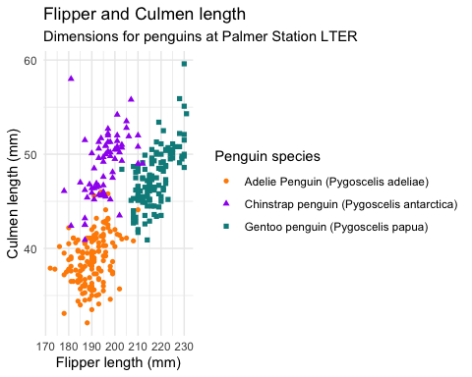

# Inline Code

There are 0 penguins of the Adelie species in the dataset. 1. Simple calculation: 50 2. There are 0 penguins of the Gentoo species in the dataset, and 0 of Chinstrap. 3. There are 0 unique penguin species.

# Sourcing Code

source("/Users/xiaokui/Documents/第三学期/Mark_Up/week4/my-reproducible-manuscript/scripts/do_addition.R")  
#source("scripts/do_addition.R")  
do_addition(2,2)

[1] 4

# Meet Quarto

Quarto enables you to weave together content and executable code into a finished document. To learn more about Quarto see [https://quarto.org](https://quarto.org/).

# Meet the penguins

The penguins data from the [palmerpenguins](https://allisonhorst.github.io/palmerpenguins/) package (M. Horst, Presmanes Hill, and B. Gorman 2022) contains size measurements for 344 penguins from three species observed on three islands in the Palmer Archipelago, Antarctica. According to Kuhn (2019), this method is useful.

The plot below shows the relationship between flipper and bill lengths of these penguins. 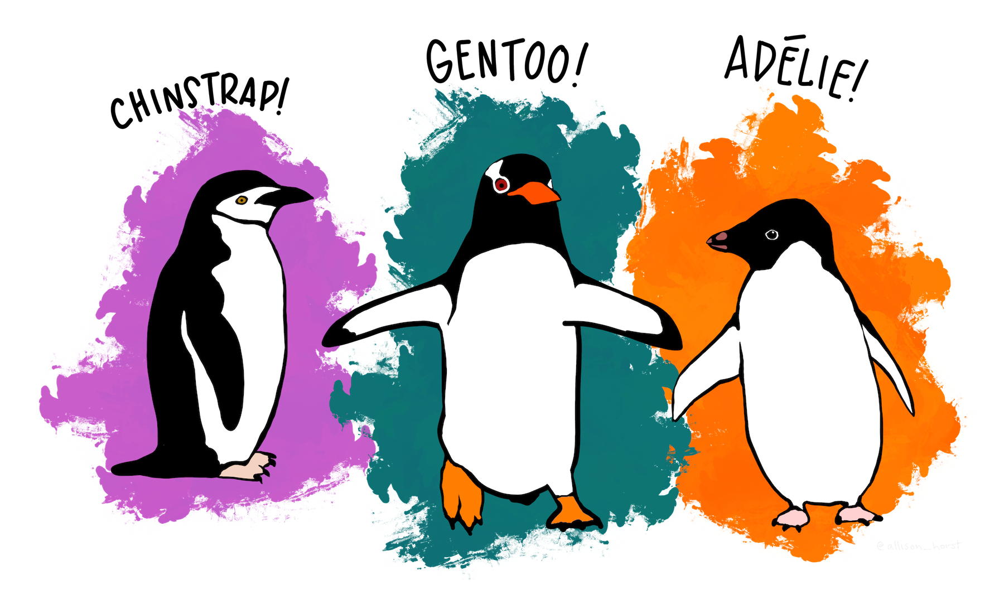

Kuhn, Max. 2019. “Modeldata: Data Sets Useful for Modeling Examples.” Comprehensive R Archive Network. <https://doi.org/10.32614/CRAN.package.modeldata>.

M. Horst, Allison, Alison Presmanes Hill, and Kristen B. Gorman. 2022. “Palmer Archipelago Penguins Data in the Palmerpenguins R Package - An Alternative to Anderson’s Irises.” *The R Journal* 14 (1): 244–54. <https://doi.org/10.32614/RJ-2022-020>.